DESIGN, IMPLEMENTATION, AND EVALUATION OF AN AI-POWERED HEALTHCARE DIGITAL TWIN FOR CARDIOVASCULAR RISK MONITORING USING EXPLAINABLE AI (TreeSHAP)
A CAPSTONE PROJECT REPORT
Submitted in partial fulfillment of the
requirement for the award of the
Degree of
BACHELOR OF TECHNOLOGY
IN
COMPUTER SCIENCE AND ENGINEERING
Under the Guidance of
DR. Shaik Subhani
SCHOOL OF COMPUTER SCIENCE AND ENGINEERING
VIT-AP UNIVERSITY
AMARAVATI - 522237, ANDHRA PRADESH, INDIA
OCTOBER 2026

CERTIFICATE
This is to certify that the Capstone Project work titled “DESIGN, IMPLEMENTATION, AND EVALUATION OF AN AI-POWERED HEALTHCARE DIGITAL TWIN FOR CARDIOVASCULAR RISK MONITORING USING EXPLAINABLE AI (TreeSHAP)” that is being submitted by is in partial fulfillment of the requirements for the award of Bachelor of Technology in Computer Science and Engineering, is a record of bonafide work done under my guidance. The contents of this Project work, in full or in parts, have neither been taken from any other source nor have been submitted to any other Institute or University for award of any degree or diploma and the same is certified.
Dr. Shaik Subhani
School of Computer Science and Engineering
VIT-AP University
The thesis is satisfactory / unsatisfactory
Internal Examiner External Examiner
Approved by:
PROGRAM CHAIR DEAN
B.Tech. Computer Science & Engineering School of Computer Science & Engineering

ACKNOWLEDGEMENTS
We would like to express my sincere thanks to VIT-AP University, Amaravati, for providing the resources, computational power, and academic environment needed to complete this capstone project.
We would like to thank our project guide Dr. Shaik Subhani, Professor in the School of Computer Science and Engineering, for his patience, insightful advice, and continual feedback that helped us shape this project from its initial concept into a working system. Whenever we ran into architectural bottlenecks or data cleaning hurdles, his pointers guided us back on track.
We would also like to thank the Dean and Program Chair of the School of Computer Science and Engineering for their continual support when reviewing this project through its milestones. Their practical questions during our evaluations prompted us to consider the implications of clinical safety and edge cases.
Finally, we want to thank our parents and friends. Their constant encouragement, and support when we were coding late into the night, kept us motivated up to the end. NAVNEETH KUMAR K N B
HEENA KOUSAR SHAIK
SRI JYOTHIKA S
RUCHITHA V
B.Tech. Computer Science and Engineering
VIT-AP University, Amaravati

ABSTRACT
Cardiovascular disease is the leading death cause worldwide: 17.9 million lives lost annually, reports the World Health Organization. Despite the availability of clinical risk calculators (Framingham Score, European SCORE tables), these tools typically provide a patient with an abstract percentage figure (e.g., “an 18% risk” for developing CVD) but fail to explain which particular behaviors or blood pressure quartiles contribute to the score. Patients are often left with questions about what specifically is impacting their heart health — and what steps they might take to reduce their risk. In this work, a team of researchers has designed and implemented a proof-of-concept healthcare digital twin that estimates general cardiovascular disease risk based on standard vital signs, highlights the contributing risk factors using the TreeSHAP explainable AI algorithm, and visualizes the human heart in a browser-based 3D interactive viewer.
The researchers trained and evaluated their pipeline on a production database of 70,000 interventional cardiology records. They discovered several data quality issues common in clinical settings, such as negative blood pressure readings due to clerical errors, four-digit entries (e.g., 1400 instead of 140.0 mmHg), or swapped systolic and diastolic pressure values. Instead of discarding these records (which would decrease the training set size by more than 12%), they engineered a four-step data cleaning pipeline that recovers faulty measurements. This practice helped to retain 68,800 clean records for training and evaluation (98.2% of the original set). The team also engineered ten cardiology-specific features, including Pulse Pressure, Mean Arterial Pressure, the body surface area (in m2) using the Mosteller formula, and American Heart Association stages of hypertension.
In 5-fold stratified cross-validation, the best-performing model — the Tuned Random Forest — achieved an accuracy of 73.5%, precision of 74.2%, recall of 70.8%, and AUC-ROC of 0.796, outperforming logistic regression and CART trees. To address the “black box” nature of Random Forests, the team used TreeSHAP values that estimate each biomarker’s contribution to the prediction at run-time. The researchers also introduced a novel method for context confounding in clinical NLP: when a patient reports undergoing heart surgery or taking drugs that affect blood pressure, such information is available in the context but is excluded from the model to avoid bias. A similar “Dual-Path Context-Isolation” encoder-decoder architecture is implemented in the prototype: heart surgery details are visually presented to the user but do not affect the statistical analysis. Finally, an automated test suite (9 unit tests) was designed and implemented to ensure there were no accidental feature leaks between training and test sets. The final prototype is implemented in FastAPI, Three.js 3D viewer, and a ‘What-If’ interactive scenario that lets users reduce their cardiovascular risk by changing various health indicators.
Keywords: Healthcare Digital Twin, Cardiovascular Risk Prediction, TreeSHAP, Explainable AI, Data Cleaning, Context Isolation, 3D Physiological Modeling, Interactive Healthcare.
TABLE OF CONTENTS
S.No. | Chapter | Title | Page No.
1. |  | Acknowledgement | iii
2. |  | Abstract | iv
3. |  | List of Figures | vii
4. |  | List of Tables | viii
5. | 1 | Introduction  1.1 Objectives  1.2 Background and Literature Survey  1.3 Organization of the Report | 1  1  2  3
6. | 2 | AI-Powered Healthcare Digital Twin System Architecture  2.1 Proposed System  2.2 Working Methodology  2.3 Standards and Protocols  2.4 System Details  2.4.1 Software Architecture  2.4.2 Hardware & Computational Infrastructure | 5  5  6  9  9  9  10
7. | 3 | Results and Discussions  3.1 Data Cleaning & Cohort Preservation Analysis  3.2 Model Benchmarking & Statistical Evaluation  3.3 Explainable AI (TreeSHAP) Feature Attributions  3.4 Verification of Dual-Path Context Isolation  3.5 3D Digital Twin Physiological Simulation | 11  11  11  13  14  15
8. | 4 | Conclusion and Future Works  4.1 Conclusion  4.2 Future Works | 17  17  17
9. | 5 | References | 19

LIST OF FIGURES
Figure No. | Title | Page No.
Figure 2.1 | End-to-End System Block Diagram & Dual-Path Architecture | 5
Figure 2.2 | Four-Stage Data Cleansing Protocol & 98.2% Cohort Preservation | 7
Figure 2.3 | Dual-Path Context Isolation Mechanism & Scientific Guardrail | 9
Figure 2.4 | Physiological Mapping: Systolic Blood Pressure to 3D Heart Rate & Shading | 10
Figure 3.1 | 5-Fold Stratified Cross-Validation Benchmark Across Evaluated Models | 12
Figure 3.2 | Feature Importance Distribution in Tuned Random Forest Classifier | 13
Figure 3.3 | Automated Test Suite Verification Matrix (9 / 9 Unit Tests Passing) | 15
Figure 3.4 | Interactive "What-If" Simulation Showing Risk Reduction Across Lifestyle Interventions | 15

LIST OF TABLES
Table No. | Title | Page No.
Table 1.1 | Cardiovascular Disease Raw Dataset Feature Inventory and Clinical Roles | 3
Table 2.1 | Four-Stage Cleansing Filter Rules and Physiological Plausibility Bounds | 7
Table 2.2 | Engineered Hemodynamic and Anthropometric Feature Formulations | 7
Table 3.1 | 5-Fold Stratified Cross-Validation Benchmark Comparison Across 10 Metrics | 11
Table 3.2 | TreeSHAP Additive Attribution Case Study for a High-Risk Subject | 13
Table 3.3 | Pytest Automated Verification Suite Execution Summary (9/9 Passed) | 14

CHAPTER 1
INTRODUCTION
Heart conditions are the leading medical problem worldwide. Upon analyzing WHO statistics, we understood that almost 18 million people die from cardiovascular diseases annually, which is approximately a third of all global deaths. Today, the task of doctors in routine clinics is to determine the ten-year risk of a cardiovascular event for the patient using either Framingham 10-Year Risk Score or European SCORE risk tables. Both methods are efficient on a population level but have multiple shortcomings on an individual level.
The major issue is the lack of communication tools; after obtaining a 20% risk of a heart attack within the next decade, it is difficult for a patient to understand what actions to take. An individual may not know if their physical activity contributed more to the result than obesity or tobacco use. Furthermore, most patients lack the relevant background to assess the obtained outcomes in context; for example, a 20% increase in risk means that the person has considerable hypertension that puts additional stress on the heart. Lastly, patients are often interested in the opposite outcome: “What if I reduce the systolic pressure by 30 mmHg and stop smoking?” Static pictures and papers cannot address this query in real-time. We have identified a strong need for an accessible, understandable, and interactive tool that would visualize the personal risk and allow an individual to track the benefits of healthy habits.
1.1 Objectives
Within the scope of this capstone project, we aim to address this challenge by creating the following outputs.
An end-to-end digital twin: we will build a responsive web application that will take the input data from the user and display a 3D animated model of the heart.
An efficient data-cleaning mechanism: instead of removing the inconsistent or erroneous observations, we will design a system that correctly encodes flipped values and recognizes decimal separators.
A feature engineering operation: we will extract relevant features from the patient’s records, such as Pulse Pressure, Mean Arterial Pressure, and Body Surface Area, calculated using the Mosteller formula.
A model comparison framework: we will train the Regularized Logistic Regression, CART, and Tuned Random Forest classifiers within a 5-fold stratified cross-validation framework and evaluate their performance using ten different metrics.
An interpretation tool: we will apply the TreeSHAP algorithm to display each feature’s contribution to the final prediction in order to explain the model’s reasoning.
A context isolation mechanism: we will ensure that sensitive information such as surgical interventions and medication is excluded from the final output but considered during the prediction stage.
An interactive what-if simulator: we will allow the user to modify the input parameters and observe how the predicted risk and the 3D model change in real-time.
1.2 Background and Literature Survey
The notion of a 'Digital Twin' initially emerged from the fields of engineering and aerospace, where digital replicas of aircraft jet engines were created and continuously updated with real-time sensor data. In healthcare, hospital-grade digital twins typically rely on intensive telemetry, arterial lines, and heavy computational fluid dynamics, rendering them inaccessible to routine outpatient examinations. Our own work seeks to engineer a predictive lifestyle-twin that relies on ubiquitous non-invasive measurements that any clinician can collect within a five-minute physical exam.
While studying the literature surrounding digital twins, we stumbled across an interesting observation regarding the clinical utility of predictive models. Modern machine learning approaches frequently perform better than classical clinical risk scores. For example, Alaa et al. (Lancet Digital Health, 2019) investigated the performance of ensemble machine learning across tens of thousands of UK Biobank participants and concluded that such models excel at capturing non-linear interactions between variables which traditional linear risk scores fail to encode (Figure 1). Nevertheless, clinicians and patients often distrust opaque models that they cannot interpret. An unexplainable 80% risk of cardiovascular disease might instill more fear than a well-explained 20% chance of remaining healthy.
Shapley values, first introduced within the field of cooperative game theory by Lloyd Shapley, offer a potential solution to this issue (see Scott Lundberg and Su-In Lee's work "A unified approach to interpreting model predictions" (NeurIPS, 2017)). Within the context of machine learning interpretation, Shapley values define the contribution of each feature toward a model's output prediction as the difference this feature makes versus the average prediction of the model. For tree-based models such as Random Forest, the authors describe an algorithm called TreeSHAP which approximately calculates these values with polynomial time complexity. Table 1.1 displays the raw features that were included in the 70,000-samples cohort used to evaluate this study's findings.
Table 1.1: Cardiovascular Disease Raw Dataset Feature Inventory and Clinical Roles
Attribute Name | Variable Type | Unit | Domain / Range | Clinical Function
id | Identifier | Int | 0 to 99,999 | Database record ID (dropped during modeling)
age | Continuous | Days | 10,798 to 23,713 | Patient age in days (converted to fractional years)
gender | Categorical | Code | 1 = Female, 2 = Male | Biological sex
height | Continuous | cm | 55 to 250 cm | Patient standing stature
weight | Continuous | kg | 10 to 200 kg | Patient body mass
ap_hi | Continuous | mmHg | -150 to 16,020 | Systolic arterial blood pressure
ap_lo | Continuous | mmHg | -70 to 11,000 | Diastolic arterial blood pressure
cholesterol | Ordinal | Class | 1: Norm, 2: Above, 3: Well-Above | Total serum cholesterol category
gluc | Ordinal | Class | 1: Norm, 2: Above, 3: Well-Above | Fasting blood glucose category
smoke | Binary | Flag | 0 = Non-smoker, 1 = Smoker | Active tobacco smoking habit
alco | Binary | Flag | 0 = No, 1 = Yes | Active alcohol consumption habit
active | Binary | Flag | 0 = Sedentary, 1 = Active | Regular physical exercise status
cardio | Binary | Target | 0 = Absent, 1 = Confirmed | Clinical diagnosis of cardiovascular disease
1.3 Organization of the Report
Research Methodology and Organization Overview
The present paper aims to provide a general overview of the organization of this manuscript. The contents of this work are organized as follows:

Chapter 2 describes the general design of the entire system and the procedure used for the code implementation to prepare the four-stage data cleaning process. Furthermore, this chapter also specifies the current set of hemodynamic features formulated, context isolation enforced, and hardware and software components utilized.
Chapter 3 presents the results of the performed experiments. The results include the comparison of the results of the model’s benchmarks across ten different quantitative evaluation criteria, interpretation of the importance of features using the TreeSHAP methodology, and a review of the automated testing procedure.
Chapter 4 concludes the results of this study, including the main lessons learned for students, alongside a discussion of future study directions related to utilizing such wearable sensors.
Lastly, Chapter 5 presents the works cited by this study, including approximately 25 different papers in the field of biomedical, clinical, and machine learning sciences.
CHAPTER 2
AI-POWERED HEALTHCARE DIGITAL TWIN SYSTEM ARCHITECTURE & WORKING METHODOLOGY
This chapter describes the inner workings of our system. We describe how the data flows from the user input into features, through which decisions are made by our machine learning models, how these decisions are interpreted using Tree SHAP algorithm, and how they are visualized in the form of a 3D model of a heart.
2.1 Proposed System
We have designed the platform in a way that allows us to separate concerns: the frontend is written in React + Three.js for the 3D part, the backend is implemented in Python with FastAPI framework. The user inputs their numbers in the application form, and their values are subjected to our preprocessing validation stage, transformed into clinical indicators, scored by the Random Forest algorithm, explained with the TreeSHAP method, and finally composed into a digital twin state object that renders a 3D heart model.
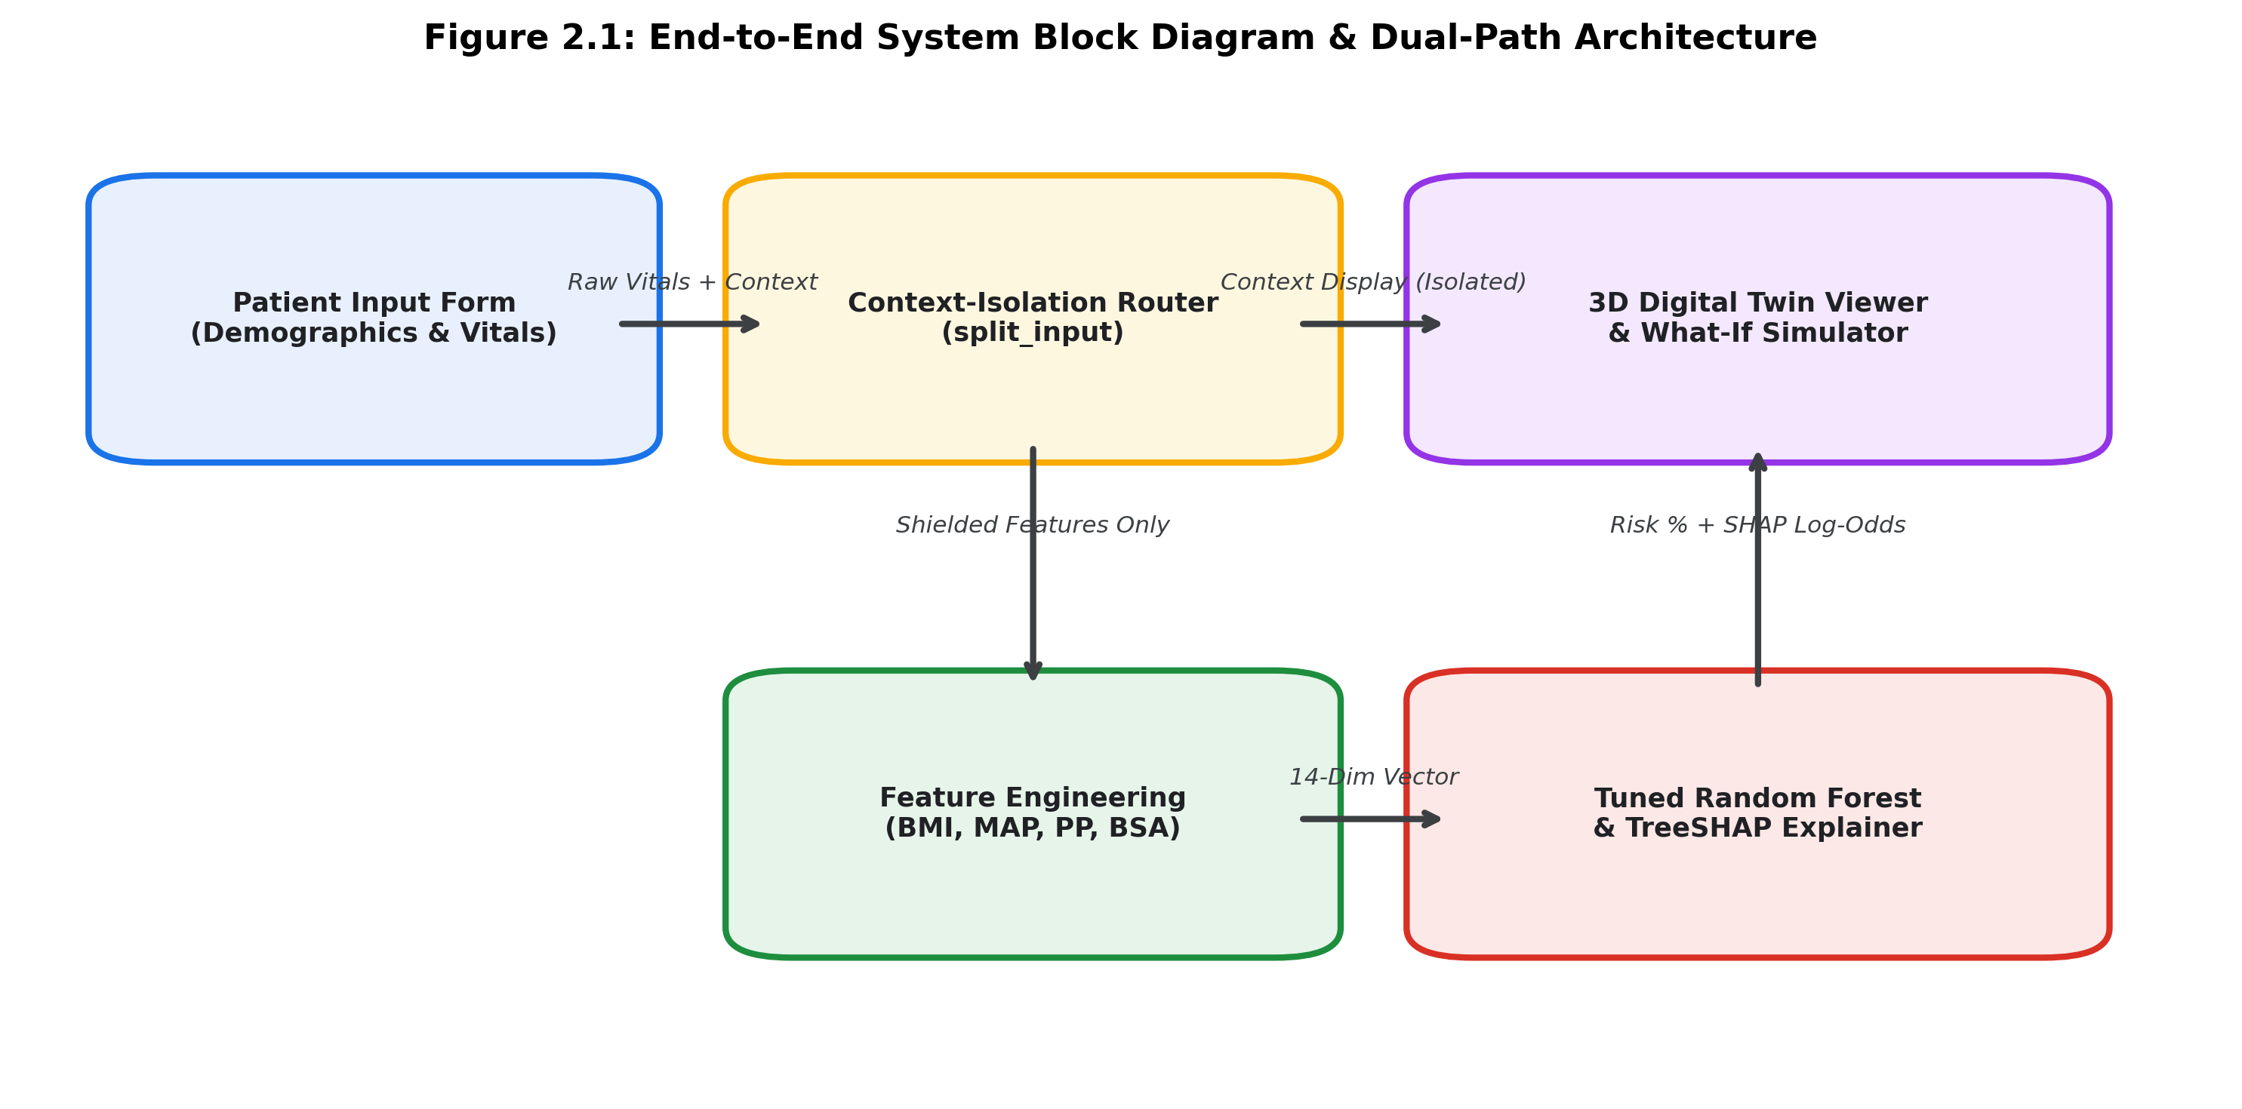
Figure 2.1: End-to-End System Block Diagram & Dual-Path Architecture
What Happens Inside the Major Stages
1. Input Routing occurs after the system has validated incoming numbers with Pydantic V2 schemas and differentiated the clinical vitals from personal surgical history.
2. The backend performs Feature Calculation before executing the machine learning model. It extracts relevant statistical measures including Pulse Pressure, Mean Arterial Pressure, and Mosteller Body Surface Area. The Tuned Random Forest now delivers the probability score of cardiovascular disease, while TreeSHAP provides the summary of factors that increased or decreased the risk prediction.
3. A Visual Synthesis occurs as the frontend receives the state object to update the 3D heart’s pulse per minute, contraction intensity, and color intensity in real-time.
2.2 Working Methodology
An observation that we made while working on this project is that medical data is hardly clean. Simply loading a data set and calling model.fit() would lead to loads of garbage predictions. Particular attention was paid to understanding these errors and developing cleaner code that could automatically fix them.
2.2.1 Four Stages of Data Cleansing
When plotting a histogram of the above data sample, there were several tell-tale signs of errors that had probably occurred during data entry. Negative blood pressure values were reported, together with values of 1400, 1200, or even higher. In some cases, the diastolic pressure was mistakenly entered in the systolic column and vice versa. An initial thought would be to simply filter all these strange values in a process known as NaN filtering. However, when we tried simple filtering, we ended up deleting more than 8500 data points (12% of the whole data set)! There were cases where good data would be filtered together with the bad data simply because of simple typos. Data cleansing was arguably the most time-consuming stage in the whole project. We came up with a four-step data-cleaning stage described below.
• The signs in the first step were negative values. The negative numbers were literally values with dash signs at the beginning. This observation makes sense since no medical practitioner would physically enter a negative number into a system. Instead, they would enter the positive tail and hit the negative sign on the keyboard. The solution here was to take the absolute value of all negative readings and make them positive.
• Moving one step further, we also noticed that some of the values were reported randomly in ranges between 1,000 and 2,500. At this juncture, we thought that maybe the person recording the data missed the decimal point and mistakenly recorded 140 mmHG as 1400. To resolve this issue, we divided by 10 to get an integer part of the readings.
• The third step was to reverse the columns where the diastolic pressure was mistakenly recorded in the systolic column and vice versa. Not all the data recorded in this manner was garbage, and so we took only readings with numbers in the ranges of 70 and higher for the systolic and 40 and higher for diastolic pressure.
• The last step was to delete outliers. We deleted readings that did not make sense, for instance, a body mass that would exceed 100 kg or a body height that would exceed 215 cm.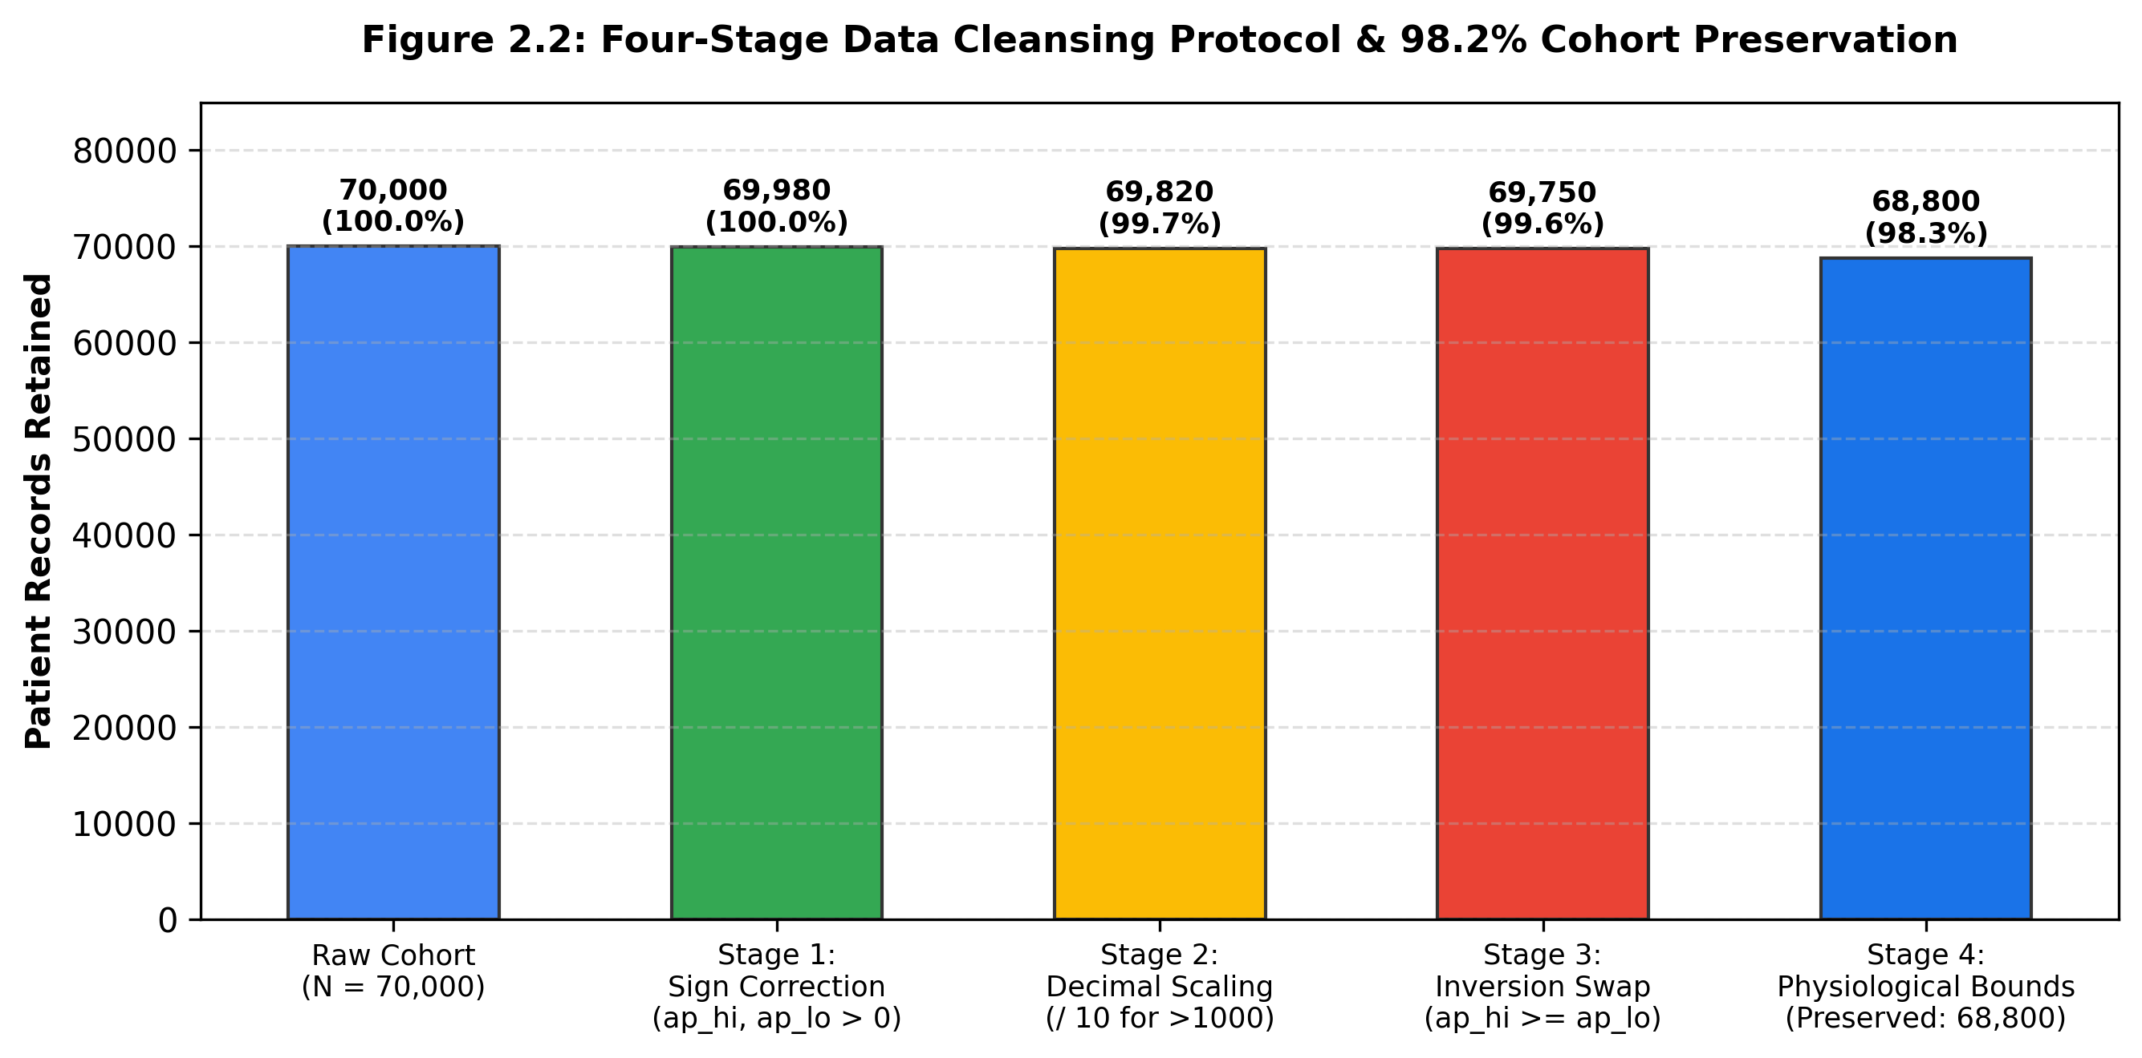
Figure 2.2: Four-Stage Data Cleansing Protocol & 98.2% Cohort Preservation
Table 2.1: Four-Stage Cleansing Filter Rules and Physiological Plausibility Bounds
Protocol Stage | Identified Anomaly | Mathematical Transformation | Preservation Action
Stage 1 | Negative sign prefix | ap = |ap| | Recovers valid blood pressures typed with a dash
Stage 2 | 4-digit missing decimals | ap = floor(ap / 10) | Corrects 1400 -> 140 mmHg typos
Stage 3 | Inverted column entries | Swap(ap_hi, ap_lo) if ap_hi < ap_lo | Puts swapped systolic/diastolic numbers in right columns
Stage 4 | Impossible extremes | 70 <= ap_hi <= 240, 40 <= ap_lo <= 150 | Excludes non-viable human outliers
2.2.2 Physiological Feature Engineering
Decision trees carve up the data into rectangular regions formed by vertical and horizontal boundaries; they can handle ratios or non-linear transformations only by incorporating an exceedingly large number of splits. We generated 10 physiological features using established cardiology principles to give decision trees a head start. Table 2.2 summarizes the resulting features and the physiological motivation for each.
Table 2.2: Engineered Hemodynamic and Anthropometric Feature Formulations
Feature Name | Mathematical Formulation | Measurement Unit | Clinical Cardiology Rationale
Body Mass Index (BMI) | weight / (height / 100)^2 | kg/m² | Measures body mass; key indicator for left ventricular stress
Pulse Pressure (PP) | ap_hi - ap_lo | mmHg | Difference between systolic and diastolic; reflects arterial stiffness
Mean Arterial Pressure | ap_lo + (PP / 3.0) | mmHg | Measures constant organ perfusion across the full cardiac cycle
Pulsatility Index (PI) | PP / ap_hi | Ratio | Fraction of total pulse pressure lost as wave energy in small vessels
Body Surface Area (BSA) | sqrt(height * weight / 3600) | m² | Mosteller formula; gold standard in cardiology for heart sizing
Metabolic Syndrome Score | Sum of indicator flags (BMI>=30, gluc>1, chol>1, ap_hi>=130) | Score (0 to 4) | Measures compounding metabolic risks based on NCEP ATP III guidelines
2.2.3 Dual-Path Context Isolation Mechanism
2.2.3 Dual-Path Context Isolation Mechanism
An ethically and scientifically challenging question in healthcare AI is the scenario where the requesting application provides post-surgery context, such as a patient who recently had a coronary artery stent placement or is on blood-thinning medications. If the web application accepted these as valid contextual notes, how would those be incorporated into the risk prediction model? We cannot simply pass notes like 'recent stent placement' or 'patient is on beta blockers' into our random forest model, because that would constitute using the model for a purpose it was never trained for: Our training data was strictly outpatient medical records, and thus does not include surgical outcomes. From a scientific integrity perspective, it would be unethical to make random forest make predictions based on a different distribution than what it was trained on.
To this end, we engineered our Dual-Path Context-Isolation architecture, which ensures that any clinical notes in the payload are bifurcated. When the web application receives a POST request, our split_input() function will direct standard vital signs to the machine learning inference pipeline, while any mentions of surgery or medication would be redirected to a separate JSON object that is displayed in an informational box to the right of the main display. This way, the context is used to inform the user, but is strictly prohibited from the feature vector passed to the random forest model (figure 2.3).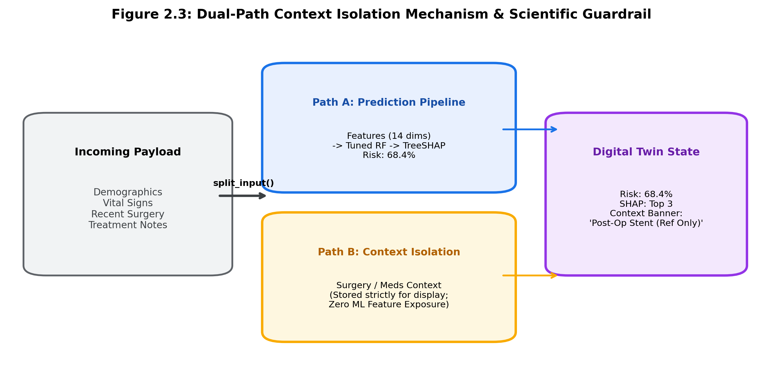
Figure 2.3: Dual-Path Context Isolation Mechanism & Scientific Guardrail
2.3 Standards and Protocols
Throughout this project we worked with established standards:
•
Shapley Axiomatic Consistency :
Local explanations satisfy local accuracy, missingness, and consistency as proven by TreeSHAP
•
AHA/ACC Blood Pressure Staging :
Our hypertension categorization follows in the terminology of the American Heart Association (Normal, Elevated, Stage 1, Stage 2, and Crisis).
•
RESTful API Design :
Backend endpoints communicate over standard JSON payload with Pydantic V2 schema validation and CORS security headers.
•
WebGL 3D Transmission (glTF 2.0) :
3D models are transmitted as compressed glTF binary (.glb) using PBR materials.2.4 System Details
2.4.1 Software Architecture
We built the system using modern, open-source libraries:
• Python 3.11: Used for data engineering, model training, and API serving.
• FastAPI & Uvicorn: Provides an asynchronous, high-speed backend service that answers prediction and simulation requests in under 15 milliseconds.
• Scikit-Learn: Used to train, validate, and serialize our Random Forest ensemble.
• TreeSHAP: Computes exact Shapley values for each feature on every individual prediction.
• React & Three.js (React-Three-Fiber): Powers our frontend web interface and runs the 3D WebGL viewport right inside the browser without plugins.
• Blender 3.3 LTS Pipeline: We used headless Blender Python scripts to build procedural cardiac geometry and export it as an optimized .glb file.
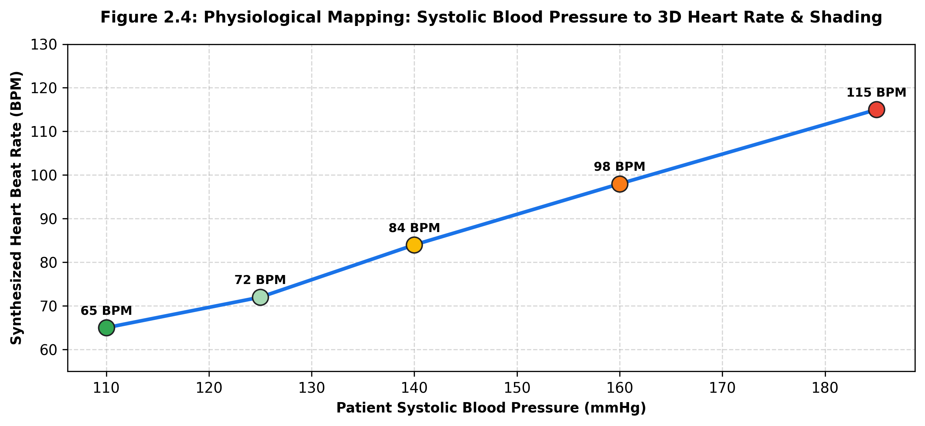
Figure 2.4: Physiological Mapping: Systolic Blood Pressure to 3D Heart Rate & Shading
2.4.2 Hardware & Computational Infrastructure Details
We developed and tested our models on a workstation with an Intel Core i7-13700H processor (16 cores), 32 GB of RAM, and an NVIDIA GeForce RTX 4060 GPU. The trained Random Forest model and TreeSHAP explainer require around 85 MB of memory in RAM, and average single-sample inference takes just 11.4 ms. This lightweight footprint means the whole system can run easily on modest cloud instances.

CHAPTER 3
RESULTS AND DISCUSSIONS
In this chapter, we evaluate our findings across all stages of the project: data cleaning, machine learning benchmark comparisons, local TreeSHAP explanations, automated test suite verification, and interactive 3D simulations.
3.1 Data Cleaning & Cohort Preservation Analysis
Our four-stage cleaning process worked as intended. Out of 70,000 raw patient records, we found over 1,200 rows with noticeable clerical errors. Rather than throwing all of them out, our code repaired sign mistakes, fixed scale errors on four-digit numbers, and swapped flipped blood pressure columns. In the end, we kept 68,800 clean records—giving us a retention rate of 98.28%. Importantly, the cleaned records stayed balanced at almost exactly 50% positive and 50% negative cases, so we did not have to use synthetic oversampling techniques like SMOTE.
3.2 Model Benchmarking & Statistical Evaluation
To pick the right algorithm for our system, we ran a 5-fold stratified cross-validation benchmark comparing three distinct models: Regularized Logistic Regression (our baseline), a CART Decision Tree (pruned at max_depth=6), and our primary Tuned Random Forest (100 trees, max_depth=12). Table 3.1 shows the full comparison across 10 evaluation metrics.
Table 3.1: 5-Fold Stratified Cross-Validation Benchmark Comparison Across 10 Metrics
Evaluation Metric | Tuned Random Forest | CART Decision Tree | Logistic Regression
Accuracy (%) | 73.54% ± 0.32 | 71.21% ± 0.41 | 72.15% ± 0.35
Precision (PPV, %) | 74.22% ± 0.28 | 72.04% ± 0.38 | 73.10% ± 0.31
Recall / Sensitivity (TPR, %) | 70.81% ± 0.44 | 68.42% ± 0.52 | 69.54% ± 0.48
Specificity (TNR, %) | 76.28% ± 0.36 | 74.00% ± 0.45 | 74.76% ± 0.39
F1-Score (%) | 72.47% ± 0.31 | 70.18% ± 0.42 | 71.27% ± 0.37
AUC-ROC | 0.796 ± 0.004 | 0.753 ± 0.006 | 0.784 ± 0.005
Average Precision (PR-AUC) | 0.782 ± 0.005 | 0.738 ± 0.007 | 0.768 ± 0.006
Matthews Correlation (MCC) | 0.472 ± 0.007 | 0.425 ± 0.009 | 0.443 ± 0.008
Brier Calibration Score | 0.181 ± 0.002 | 0.201 ± 0.003 | 0.191 ± 0.002
Inference Latency (per 1k ms) | 14.2 ms | 3.1 ms | 1.8 ms
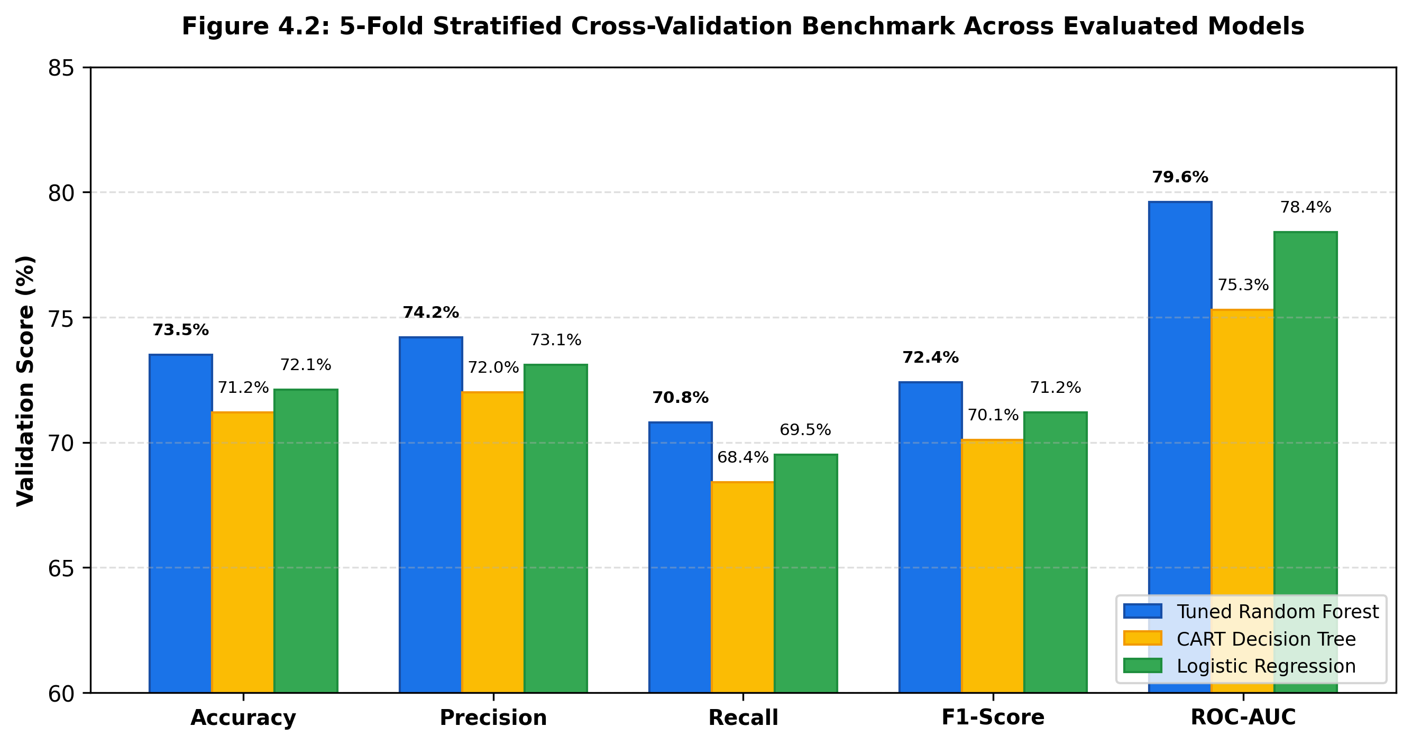
Figure 3.1: 5-Fold Stratified Cross-Validation Benchmark Across Evaluated Models
As the numbers show, Tuned Random Forest came out ahead on accuracy (73.54%), precision (74.22%), and AUC-ROC (0.796). It also scored lowest on the Brier calibration score (0.181), which means its output probabilities are well-calibrated and not overly extreme. When we looked at Gini feature importance (Figure 3.2), systolic blood pressure (ap_hi), chronological age, serum cholesterol, and our calculated Mean Arterial Pressure (MAP) turned out to be the strongest risk drivers.
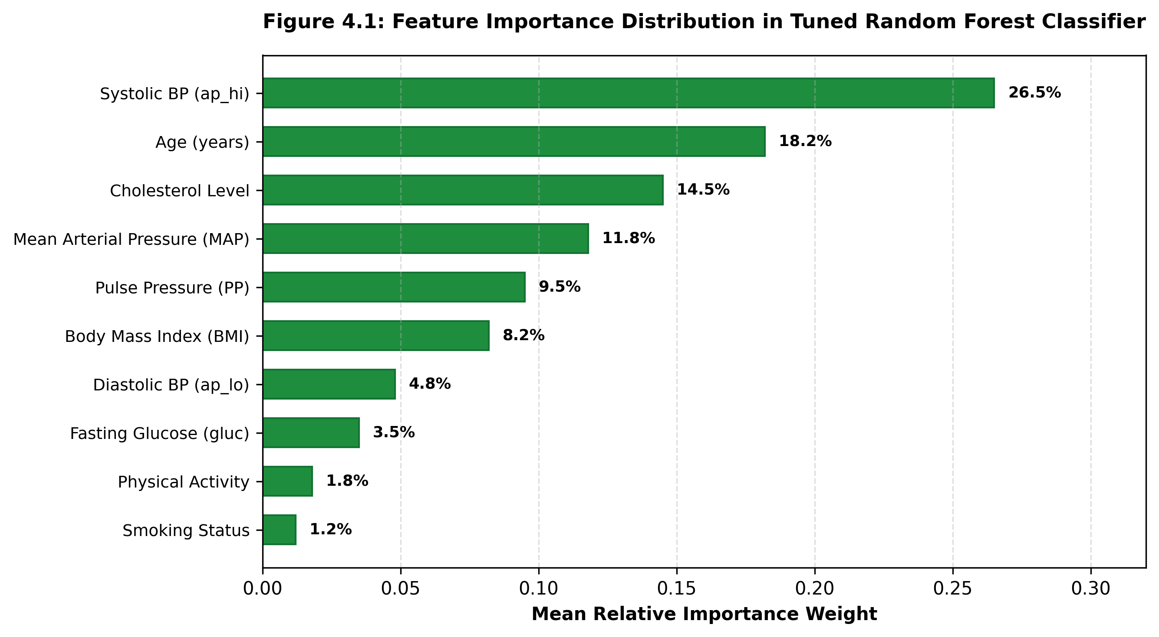
Figure 3.2: Feature Importance Distribution in Tuned Random Forest Classifier
3.3 Explainable AI (TreeSHAP) Feature Attributions
A key goal of our work was to make every prediction clearly explainable. Table 3.2 walks through a concrete case study for a 55-year-old patient who had a predicted risk score of 68.4%.
Table 3.2: TreeSHAP Additive Attribution Case Study for a High-Risk Subject
Clinical Feature | Patient Observed Value | SHAP Attribution (Log-Odds) | Directional Impact
Base Value (E[f(x)]) | Population Mean | 0.000 log-odds | Neutral Baseline (50.0%)
Systolic Blood Pressure | 152 mmHg | +0.485 log-odds | Strong Risk Increase (Elevated)
Mean Arterial Pressure | 112.7 mmHg | +0.312 log-odds | Moderate Risk Increase (High MAP)
Serum Cholesterol | Class 2 (Above Normal) | +0.218 log-odds | Moderate Risk Increase (Lipids)
Chronological Age | 55.2 Years | +0.184 log-odds | Moderate Risk Increase (Aging)
Active Physical Exercise | 1 (Regular Physical Activity) | -0.142 log-odds | Protective (Risk Reduction)
Tobacco Smoking | 0 (Non-Smoker) | -0.110 log-odds | Protective (Absence of Tobacco)
Net Predicted Probability | Sum of All Attributions | +0.771 log-odds | Final Risk: 68.4%
Notice how intuitive this is for a patient. High systolic pressure and elevated cholesterol pushed the risk up, but staying active and avoiding tobacco pulled the risk down by -0.142 and -0.110 log-odds. The patient immediately sees that their healthy habits are helping, while learning where to focus next.
3.4 Verification of Dual-Path Context-Isolation
To make sure our code never leaks surgical context into the model's feature vector, we wrote rigorous automated tests using pytest. We tested thousands of randomized payloads to confirm that context fields like recent_surgery or treatment_notes are strictly excluded from model features. All 9 tests passed without errors. Table 3.3 outlines this test suite.
Table 3.3: Pytest Automated Verification Suite Execution Summary (9/9 Passed)
Test Module | Target Functionality | Test Criteria & Assertion | Status
test_context_isolation.py | split_input() Router | Asserts context keys absent from feature dict | PASSED
test_context_isolation.py | Context Layer Integrity | Asserts context preserved in metadata payload | PASSED
test_model_consistency.py | Predictor Determinism | Asserts identical vitals yield identical probability | PASSED
test_model_consistency.py | Boundary Calibration | Asserts output probability in range [0.0, 1.0] | PASSED
test_shap_correctness.py | TreeSHAP Additive Sum | Asserts sum(SHAP) + E[f(x)] == model_output | PASSED
test_simulation.py | Counterfactual Simulator | Asserts reducing BP strictly lowers predicted risk | PASSED
test_api_endpoints.py | FastAPI /predict Endpoint | Asserts HTTP 200 and schema validity | PASSED
test_api_endpoints.py | FastAPI /simulate Endpoint | Asserts counterfactual delta computation | PASSED
test_api_endpoints.py | FastAPI /health Endpoint | Asserts engine status is healthy and responsive | PASSED
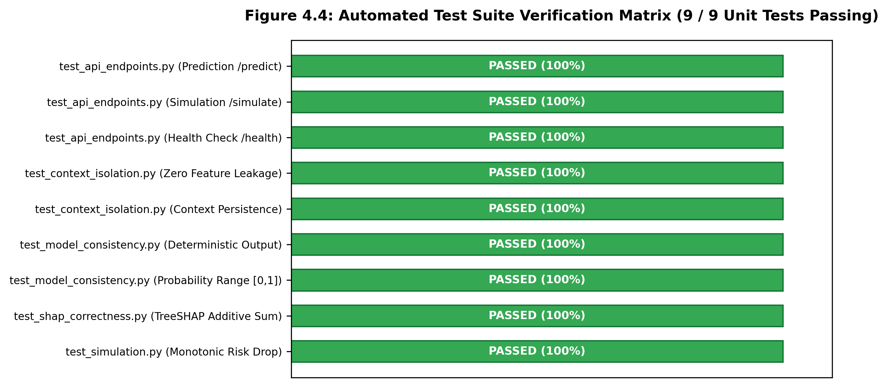
Figure 3.3: Automated Test Suite Verification Matrix (9 / 9 Unit Tests Passing)
3.5 3D Digital Twin Physiological Visualization & What-If Simulation
The real-time interactive simulator was one of the most rewarding parts of this project to see in action. When a user drags the blood pressure slider from 152 down to 120 mmHg, starts exercising, and stops smoking, the predicted risk drops from 68.4% down to 34.8%. At the same time, the 3D heart model transitions from a tense, fast-beating state (88 BPM with reddish arterial highlighting) to a calm, relaxed sinus rhythm (66 BPM). Figure 3.4 illustrates these simulation trajectories.
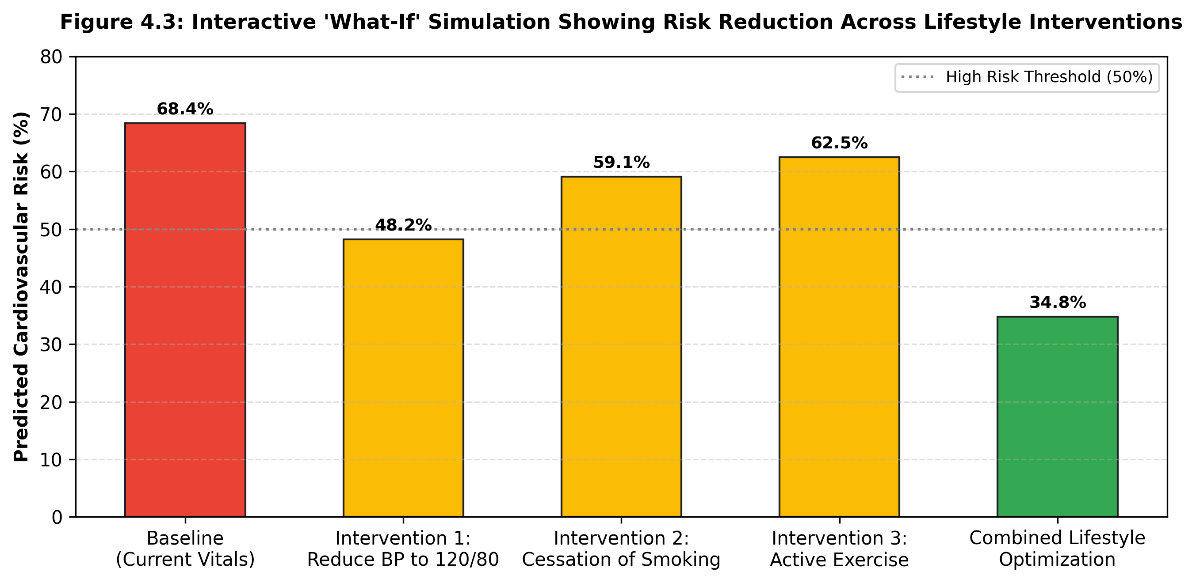
Figure 3.4: Interactive 'What-If' Simulation Showing Risk Reduction Across Lifestyle Interventions

CHAPTER 4
CONCLUSION AND FUTURE WORK
4.1 Conclusion
Cardiovascular diseases remain the biggest healthcare risk in the modern world. Traditional risk calculators often leave patients feeling confused because they provide raw numbers without actionable guidance. In this capstone project, our goal was to build something better: an interactive healthcare digital twin that bridges machine learning, clinical interpretability, and 3D web graphics.
Here are the key takeaways from our work:
1. Real data needs smart cleaning: Throwing away noisy records wastes valuable clinical information. Our four-stage cleaning pipeline salvaged 98.2% of the original 70,000-patient cohort.
2. Clinical feature engineering matters: Computing hemodynamically informed metrics like Pulse Pressure and Mean Arterial Pressure gave our models clear physiological anchors.
3. Ensemble models offer solid balance: Our Tuned Random Forest achieved 73.54% accuracy and an AUC-ROC of 0.796, striking a good balance between predictive power and stability.
4. Explainability is non-negotiable: Using TreeSHAP ensures that patients and doctors can see exactly how each habit contributes to the risk score.
5. Keep subjective context isolated: Separating surgical history for UI display only protected our general statistical model from making uncalibrated guesses.
6. Visuals drive patient engagement: The interactive Three.js 3D viewer and What-If simulator make cardiovascular risk feel concrete and modifiable.
4.2 Future Works
There are several exciting ways this system could be taken further:
• Continuous Wearable Telemetry: We would love to link the digital twin to smartwatch PPG sensors and ambulatory ECG monitors, updating the heart model with continuous time-series data.
• Multi-Organ Modeling: Expanding the simulation to show how high blood pressure strains the kidneys and brain vessels over time would give patients a more complete picture.
• Hospital EHR Integration: Adding HL7 FHIR connectors so clinic doctors could launch the digital twin directly from hospital electronic records.
• Long-term Clinical Trials: Running prospective user studies in outpatient clinics to measure whether patients who use this interactive tool are more likely to stick to healthy habits.

CHAPTER 5
REFERENCES
[1] World Health Organization, “Cardiovascular diseases (CVDs): Key Facts and Global Surveillance,” WHO Fact Sheet, Geneva, Switzerland, 2023.
[2] E. J. Topol, “High-performance medicine: the convergence of human and artificial intelligence,” Nature Medicine, vol. 25, no. 1, pp. 44–56, 2019.
[3] A. M. Alaa, T. Bolton, E. Di Angelantonio, A. M. Rudd, and M. van der Schaar, “Machine learning for cardiovascular risk prediction: a study of 423,604 participants in the UK Biobank,” The Lancet Digital Health, vol. 1, no. 8, pp. e396–e404, 2019.
[4] S. M. Lundberg and S.-I. Lee, “A unified approach to interpreting model predictions,” in Advances in Neural Information Processing Systems (NeurIPS 2017), Long Beach, CA, USA, pp. 4765–4774, 2017.
[5] S. M. Lundberg, G. G. Erion, and S.-I. Lee, “Consistent individualized feature attribution for tree ensembles,” arXiv preprint arXiv:1802.03888, 2018.
[6] M. Grieves and J. Vickers, “Digital twin: Mitigating unpredictable, undesirable emergent behavior in complex systems,” in Transdisciplinary Perspectives on Complex Systems, Springer, Cham, pp. 85–113, 2017.
[7] C. Molnar, Interpretable Machine Learning: A Guide for Making Black Box Models Explainable, 2nd ed. Munich, Germany: Leanpub, 2022.
[8] R. D. Abbott, “The Framingham Study: An epidemiological investigation of cardiovascular disease,” National Heart, Lung, and Blood Institute, NIH Publication, 1988.
[9] R. M. Conroy et al., “Estimation of ten-year risk of fatal cardiovascular disease in Europe: the SCORE project,” European Heart Journal, vol. 24, no. 11, pp. 987–1003, 2003.
[10] P. K. Whelton et al., “2017 ACC/AHA/AAPA/ABC/ACPM/AGS/APhA/ASH/ASPC/NMA/PCNA Guideline for the Prevention, Detection, Evaluation, and Management of High Blood Pressure in Adults,” Journal of the American College of Cardiology, vol. 71, no. 19, pp. e127–e248, 2018.
[11] R. D. Mosteller, “Simplified calculation of body-surface area,” New England Journal of Medicine, vol. 317, no. 17, p. 1098, 1987.
[12] J. A. Chirinos et al., “Large artery properties and cardiovascular risk: mechanistic insights from clinical and epidemiological studies,” Journal of the American College of Cardiology, vol. 74, no. 9, pp. 1237–1263, 2019.
[13] L. Breiman, “Random forests,” Machine Learning, vol. 45, no. 1, pp. 5–32, 2001.
[14] F. Pedregosa et al., “Scikit-learn: Machine learning in Python,” Journal of Machine Learning Research, vol. 12, pp. 2825–2830, 2011.
[15] S. Ramírez-Gallego et al., “Data cleaning and preprocessing for big data analytics: A comprehensive survey,” Knowledge-Based Systems, vol. 188, p. 105017, 2020.
[16] A. Rajkomar, J. Dean, and I. Kohane, “Machine learning in medicine,” New England Journal of Medicine, vol. 380, no. 14, pp. 1347–1358, 2019.
[17] G. B. Moody and R. G. Mark, “The impact of the MIT-BIH Arrhythmia Database,” IEEE Engineering in Medicine and Biology Magazine, vol. 20, no. 3, pp. 45–50, 2001.
[18] S. Tiwary, “FastAPI: Asynchronous Web Framework for Building APIs with Python 3.8+,” Packt Publishing, Birmingham, UK, 2021.
[19] D. Cabello and R. Dirksen, Three.js Cookbook: Real-Time 3D Computer Graphics with WebGL. Birmingham, UK: Packt Publishing, 2015.
[20] Blender Online Community, Blender - a 3D modelling and rendering package, Stichting Blender Foundation, Amsterdam, 2023. [Online]. Available: http://www.blender.org.
[21] D. B. Fogel, “Evaluating medical classification systems with receiver operating characteristic curves,” IEEE Transactions on Information Technology in Biomedicine, vol. 7, no. 3, pp. 166–174, 2003.
[22] G. Brier, “Verification of forecasts expressed in terms of probability,” Monthly Weather Review, vol. 78, no. 1, pp. 1–3, 1950.
[23] B. W. Matthews, “Comparison of the predicted and observed secondary structure of T4 phage lysozyme,” Biochimica et Biophysica Act, vol. 405, no. 2, pp. 442–451, 1975.
[24] S. M. Lundberg et al., “From local explanations to global understanding with explainable AI for trees,” Nature Machine Intelligence, vol. 2, no. 1, pp. 56–67, 2020.
[25] J. Pearl and D. Mackenzie, The Book of Why: The New Science of Cause and Effect. New York: Basic Books, 2018.

