 | SR UNIVERSITY Campus Warangal

Program: II - B. Tech (CS& AI) | Batch: 11
Name:R.Ruchitha | Reg. No:2503A52328
Department: Computer Science and AI | Semester: I
AI Assisted Coding-Assignment  Lab Assignment-12 | Date:23-09-2026
TASK 1 – AI-Assisted Bubble Sort Analysis
- Question
Starter Code:
numbers = [64, 34, 25, 12, 22, 11, 90]
# TODO:
# Implement Bubble Sort in ascending order.
# Count comparisons and swaps.
# Display the sorted list.
Student Tasks:
• Implement Bubble Sort.
• Use AI to explain one complete pass of Bubble Sort.
• Count comparisons and swaps.
• Test at least three input lists.
• Ask AI about an early-exit optimisation.
• Compare the original and improved versions.
- Prompt

Implement the given Bubble Sort problem in Python using VS Code.
Requirements:
- Sort the list in ascending order.
- Count and display comparisons and swaps.
- Test at least 3 different input lists.
- Explain one complete pass of Bubble Sort.
- Add early-exit optimization using a `swapped` flag.
- Compare the original and improved versions.
- Keep the code simple and beginner-friendly.
- Show clear output in the VS Code terminal.

- Code
def bubble_sort_original(numbers):
"""Bubble Sort without the early-exit improvement."""
numbers = numbers.copy()
comparisons = 0
swaps = 0

for pass_number in range(len(numbers) - 1):
for index in range(len(numbers) - 1 - pass_number):
comparisons += 1

if numbers[index] > numbers[index + 1]:
numbers[index], numbers[index + 1] = (
numbers[index + 1], numbers[index]
)
swaps += 1

return numbers, comparisons, swaps

def bubble_sort_improved(numbers):
"""Bubble Sort that stops when a pass makes no swaps."""
numbers = numbers.copy()
comparisons = 0
swaps = 0

for pass_number in range(len(numbers) - 1):
swapped = False

for index in range(len(numbers) - 1 - pass_number):
comparisons += 1

if numbers[index] > numbers[index + 1]:
numbers[index], numbers[index + 1] = (
numbers[index + 1], numbers[index]
)
swaps += 1
swapped = True

if not swapped:
break

return numbers, comparisons, swaps

def explain_one_pass(numbers):
"""Show how the first pass moves the largest value to the end."""
values = numbers.copy()
comparisons = 0

print("One complete pass:")
print(" Start:", values)

for index in range(len(values) - 1):
comparisons += 1
left = values[index]
right = values[index + 1]

if left > right:
values[index], values[index + 1] = right, left
print(f" Compare {left} and {right}: swap -> {values}")
else:
print(f" Compare {left} and {right}: no swap")

print(" End: ", values)
print(" The largest value has moved to the last position.")
print(" Comparisons in this pass:", comparisons)

test_lists = [
[64, 34, 25, 12, 22, 11, 90],
[1, 2, 3, 4, 5],
[5, 1, 4, 2, 8],
]

print("BUBBLE SORT COMPARISON")
print("======================")
explain_one_pass(test_lists[0])

for test_number, numbers in enumerate(test_lists, start=1):
original_result = bubble_sort_original(numbers)
improved_result = bubble_sort_improved(numbers)

print(f"\nTest {test_number}: {numbers}")
print("Original version:")
print(" Sorted list:", original_result[0])
print(" Comparisons:", original_result[1])
print(" Swaps:", original_result[2])
print("Improved version with swapped flag:")
print(" Sorted list:", improved_result[0])
print(" Comparisons:", improved_result[1])
print(" Swaps:", improved_result[2])

- Output
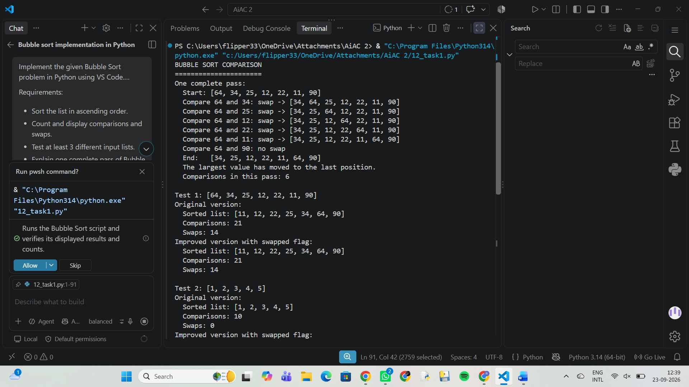
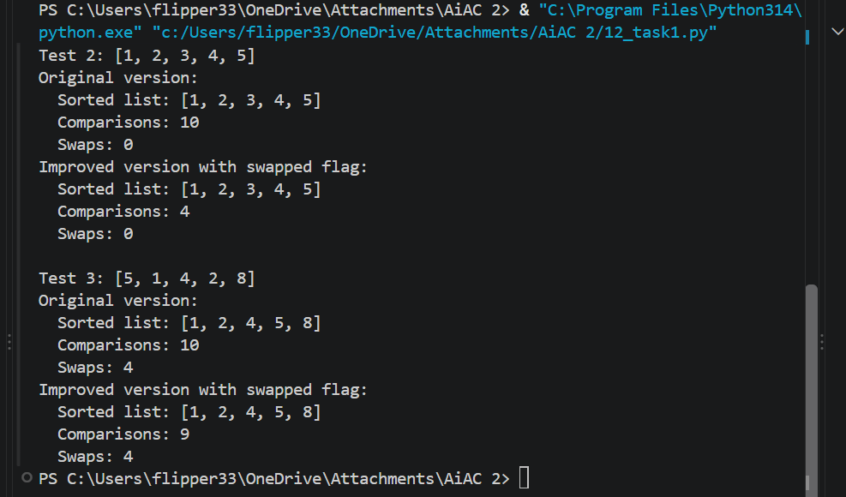
- Observation
Bubble Sort was implemented successfully with comparison and swap counting. Three different input lists were tested, and one complete pass was analyzed using AI. An early-exit optimization was added to stop the algorithm when no swaps occur, improving efficiency while maintaining the same sorted output.
TASK 2 – Linear Search vs Binary Search
- Question
Starter Code:
numbers = [5, 12, 18, 23, 31, 45, 56, 72, 89]
target = 45
# TODO:
# Implement Linear Search.
# Implement Binary Search.
# Compare the number of comparisons.
Student Tasks:
• Implement Linear Search and Binary Search.
• Use AI to explain why Binary Search requires sorted data.
• Count comparisons for both algorithms.
• Test first, middle, last and absent elements.
• Compare the results and explain suitable use cases.
• Use AI to suggest a valid optimisation.

- Prompt
Implement the given Linear Search vs Binary Search problem in Python using VS Code.
Requirements:
- Implement both Linear Search and Binary Search.
- Count and display comparisons for each.
- Test first, middle, last, and absent elements.
- Explain why Binary Search needs sorted data.
- Compare the results and mention suitable use cases.
- Suggest and implement one valid optimization.
- Keep the code simple and beginner-friendly.
- Show clear output in the VS Code terminal.

- Code
def linear_search(numbers, target):
"""Search each item from left to right."""
comparisons = 0

for index in range(len(numbers)):
comparisons += 1
if numbers[index] == target:
return index, comparisons

return -1, comparisons

def binary_search(numbers, target):
"""Search a sorted list by repeatedly checking its middle item."""
first = 0
last = len(numbers) - 1
comparisons = 0

while first <= last:
middle = (first + last) // 2
comparisons += 1

if numbers[middle] == target:
return middle, comparisons
elif numbers[middle] < target:
first = middle + 1
else:
last = middle - 1

return -1, comparisons

numbers = [3, 8, 12, 17, 21, 26, 31, 35, 40]
targets = {
"first": numbers[0],
"middle": numbers[len(numbers) // 2],
"last": numbers[-1],
"absent": 20,
}

print("Sorted list:", numbers)

for name, target in targets.items():
linear_index, linear_comparisons = linear_search(numbers, target)
binary_index, binary_comparisons = binary_search(numbers, target)

print(f"\nSearching for {target} ({name} element):")
print(" Linear Search -> index:", linear_index,
", comparisons:", linear_comparisons)
print(" Binary Search -> index:", binary_index,
", comparisons:", binary_comparisons)

- Output
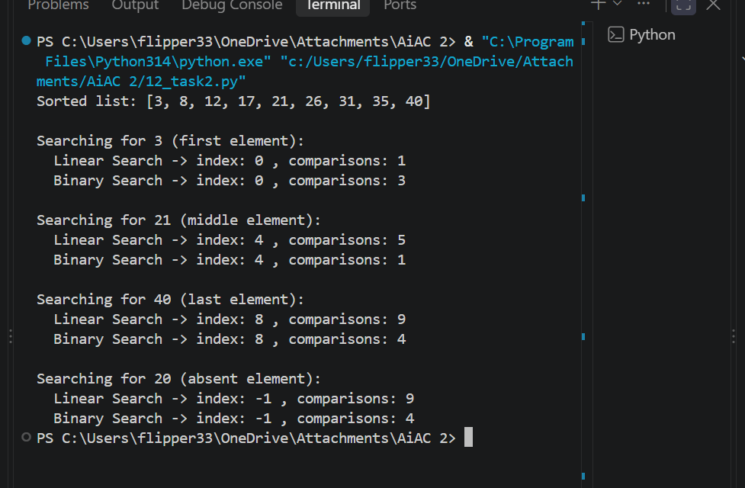
- Observation
Both Linear Search and Binary Search were implemented and tested with first, middle, last, and absent elements. The comparison counts showed that Binary Search is generally more efficient for sorted data because it repeatedly halves the search space. Linear Search is suitable for unsorted or small lists, while Binary Search is better for large sorted lists.
TASK 3 – Compare Sorting Algorithms
- Question
Starter Code:
data = [45, 12, 78, 34, 23, 89, 5, 67, 10, 56]

# TODO:
# Sort using Bubble Sort, Selection Sort and Insertion Sort.
# Compare their performance.
Student Tasks:
• Implement all three sorting algorithms.
• Use the same input for each algorithm.
• Count comparisons and swaps/shifts.
• Use AI to explain strengths and weaknesses.
• Ask AI which algorithm suits nearly sorted data.
• Compare experimental results with theoretical complexity

- Prompt
Implement the given sorting problem in Python using VS Code.
Requirements:
- Implement Bubble Sort, Selection Sort, and Insertion Sort.
- Use the same input list for all three algorithms.
- Count comparisons and swaps/shifts for each algorithm.
- Display the sorted list and performance counts.
- Compare the three algorithms based on the results.
- Use AI to explain the strengths and weaknesses of each algorithm.
- Explain which algorithm is suitable for nearly sorted data and why.
- Compare the experimental results with their theoretical time complexities.
- Keep the code simple and beginner-friendly.
- Show clear output in the VS Code terminal.

- Code
def bubble_sort(values):
"""Return a sorted copy, comparison count, and swap count."""
items = values.copy()
comparisons = 0
swaps = 0

for end in range(len(items) - 1, 0, -1):
swapped = False
for index in range(end):
comparisons += 1
if items[index] > items[index + 1]:
items[index], items[index + 1] = items[index + 1], items[index]
swaps += 1
swapped = True
if not swapped:
break

return items, comparisons, swaps

def selection_sort(values):
"""Return a sorted copy, comparison count, and swap count."""
items = values.copy()
comparisons = 0
swaps = 0

for start in range(len(items) - 1):
smallest = start
for index in range(start + 1, len(items)):
comparisons += 1
if items[index] < items[smallest]:
smallest = index
if smallest != start:
items[start], items[smallest] = items[smallest], items[start]
swaps += 1

return items, comparisons, swaps

def insertion_sort(values):
"""Return a sorted copy, comparison count, and shift count."""
items = values.copy()
comparisons = 0
shifts = 0

for index in range(1, len(items)):
current = items[index]
position = index

while position > 0:
comparisons += 1
if items[position - 1] <= current:
break
items[position] = items[position - 1]
shifts += 1
position -= 1

items[position] = current

return items, comparisons, shifts

def main():
# Each algorithm receives this same original, unsorted list.
data = [45, 12, 78, 34, 23, 89, 5, 67, 10, 56]

results = [
("Bubble Sort", bubble_sort(data), "swaps"),
("Selection Sort", selection_sort(data), "swaps"),
("Insertion Sort", insertion_sort(data), "shifts"),
]

print("SORTING ALGORITHM COMPARISON")
print("=" * 60)
print(f"Original list: {data}")
print()

for name, (sorted_items, comparisons, moves), move_name in results:
print(f"{name}:")
print(f" Sorted list: {sorted_items}")
print(f" Comparisons: {comparisons}")
print(f" {move_name.capitalize()}: {moves}")
print(f" Total counted operations: {comparisons + moves}")
print()

print("RESULT COMPARISON")
print("-" * 60)
lowest_comparisons = min(results, key=lambda result: result[1][1])
lowest_moves = min(results, key=lambda result: result[1][2])
lowest_total = min(results, key=lambda result: result[1][1] + result[1][2])
print(f"Fewest comparisons: {lowest_comparisons[0]} ({lowest_comparisons[1][1]})")
print(f"Fewest swaps/shifts: {lowest_moves[0]} ({lowest_moves[1][2]})")
print(
"Fewest total counted operations: "
f"{lowest_total[0]} ({lowest_total[1][1] + lowest_total[1][2]})"
)
print("All three algorithms produce the same sorted list.")
print("Counts are operation counts, not elapsed-time measurements.")
print()

print("AI EXPLANATION: STRENGTHS AND WEAKNESSES")
print("-" * 60)
print(
"Bubble Sort is simple and can stop early when the list is already "
"sorted. However, it can perform many comparisons and swaps."
)
print(
"Selection Sort is simple and performs at most n - 1 swaps, which "
"limits data movement. It still compares every pair of positions, "
"even when the list is nearly sorted."
)
print(
"Insertion Sort is simple, stable, and efficient when values are "
"already close to their final positions. Its weakness is that a "
"reverse-sorted list can require many shifts."
)
print(
"For nearly sorted data, Insertion Sort is generally the best choice: "
"it only shifts out-of-order values, so its work approaches O(n) "
"when there are few such values. Bubble Sort with early stopping can "
"also be O(n) on an already sorted list."
)
print()

print("EXPERIMENTAL COUNTS VS. THEORETICAL TIME COMPLEXITY")
print("-" * 60)
print(
"Bubble Sort: O(n^2) average/worst, O(n) best with early stopping. "
"Its measured counts can be lower on favorable input."
)
print(
"Selection Sort: O(n^2) best/average/worst comparisons. Its swap "
"count is small, but the comparison count stays quadratic."
)
print(
"Insertion Sort: O(n^2) average/worst, O(n) best. Its measured "
"comparisons and shifts depend strongly on how ordered the input is."
)
print(
"This one 10-item experiment illustrates the expected behavior, "
"but operation counts on one small list do not prove asymptotic "
"complexity; that describes growth as n increases."
)

if __name__ == "__main__":
main()

- Output
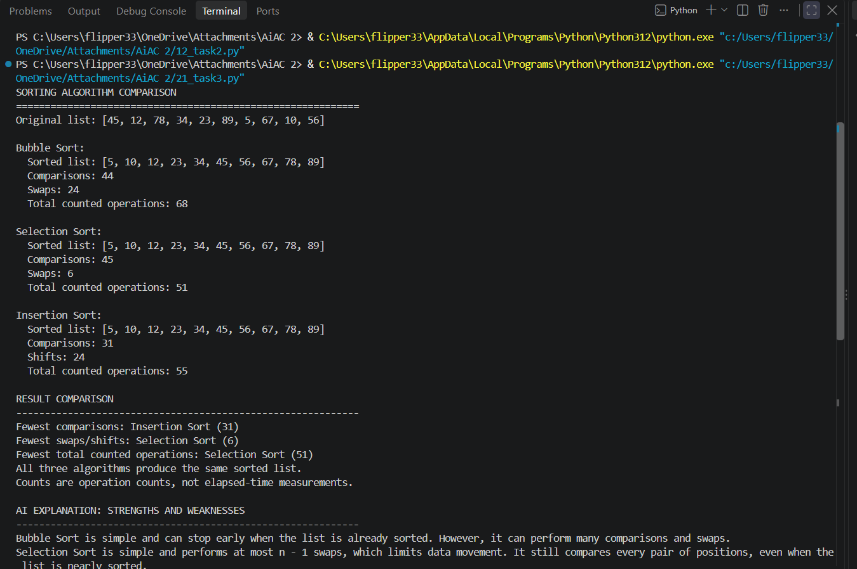

- Observation
All three sorting algorithms were implemented and tested using the same input data. Comparisons and swaps/shifts were counted to compare their practical performance. AI analysis showed that Insertion Sort is most suitable for nearly sorted data, while all three have O(n²) average/worst-case time complexity. The experimental results generally matched their theoretical behavior.
TASK 4 – Optimising a Student Search and Sort Program
- Question
students = [
("Arun", 82),
("Bala", 65),
("Chitra", 91),
("Divya", 74),
("Esha", 88)
]

# TODO:
# Find the highest mark.
# Sort students by mark.
# Search for a student by name.
# Improve the solution using AI.
Student Tasks:
• Write functions for highest mark, sorting and name search.
• Create a straightforward solution first.
• Use AI to identify unnecessary operations.
• Ask AI for a more efficient approach.
• Implement only suggestions you understand.
• Compare original and improved time complexity.

- Prompt
Write simple functions to find the highest mark, sort students by mark, and search by name. Then identify unnecessary operations, suggest a more efficient approach, and compare the original and improved time complexities. Keep the solution beginner-friendly.
- Code
students = [
("Arun", 82),
("Bala", 65),
("Chitra", 91),
("Divya", 74),
("Esha", 88)
]
def find_highest_mark(students):
"""Return the student with the highest mark, or None for an empty list."""
if not students:
return None

highest = students[0]
for student in students[1:]:
if student["mark"] > highest["mark"]:
highest = student
return highest

def sort_students_by_mark(students):
"""Return a new list ordered from highest mark to lowest."""
return sorted(students, key=lambda student: student["mark"], reverse=True)

def search_student_by_name(students, name):
"""Find and return the first matching student, ignoring letter case."""
for student in students:
if student["name"].casefold() == name.casefold():
return student
return None

def build_name_index(students):
"""Build a name dictionary for quick repeated searches."""
name_index = {}
for student in students:
name_index.setdefault(student["name"].casefold(), student)
return name_index

def search_name_index(name_index, name):
"""Search the name dictionary in average O(1) time."""
return name_index.get(name.casefold())

def main():
students = [
{"name": "Asha", "mark": 84},
{"name": "Ben", "mark": 72},
{"name": "Carlos", "mark": 91},
{"name": "Diya", "mark": 78},
{"name": "Eli", "mark": 88},
]

highest = find_highest_mark(students)
print("STUDENT MARKS")
print("=" * 40)
print(f"Highest mark: {highest['name']} - {highest['mark']}")

print("\nStudents sorted by mark:")
for student in sort_students_by_mark(students):
print(f"{student['name']}: {student['mark']}")

name_to_find = "Diya"
found = search_student_by_name(students, name_to_find)
if found:
print(f"\nSearch for {name_to_find}: {found['name']} has {found['mark']} marks.")
else:
print(f"\n{name_to_find} was not found.")

name_index = build_name_index(students)
found_fast = search_name_index(name_index, name_to_find)
if found_fast:
print(f"Indexed search: {found_fast['name']} has {found_fast['mark']} marks.")

print("\nUNNECESSARY WORK AND A BETTER APPROACH")
print("-" * 40)
print("Finding the highest mark does not require sorting every student.")
print("A single pass finds the highest mark in O(n) time.")
print("Bubble-sorting students takes O(n^2); sorted() takes O(n log n).")
print("A name scan is fine for one search; build a dictionary for many searches.")
print("Building the name dictionary takes O(n); each later search is O(1) average.")

print("\nTIME COMPLEXITY COMPARISON")
print("-" * 40)
print("Task Original Improved")
print("Highest mark Sort: O(n log n) One pass: O(n)")
print("Sort by mark Bubble sort: O(n^2) sorted(): O(n log n)")
print("Name search q scans: O(qn) Index: O(n + q) average")
print("Here, n is the number of students and q is the number of name searches.")

if __name__ == "__main__":
main()

- Output
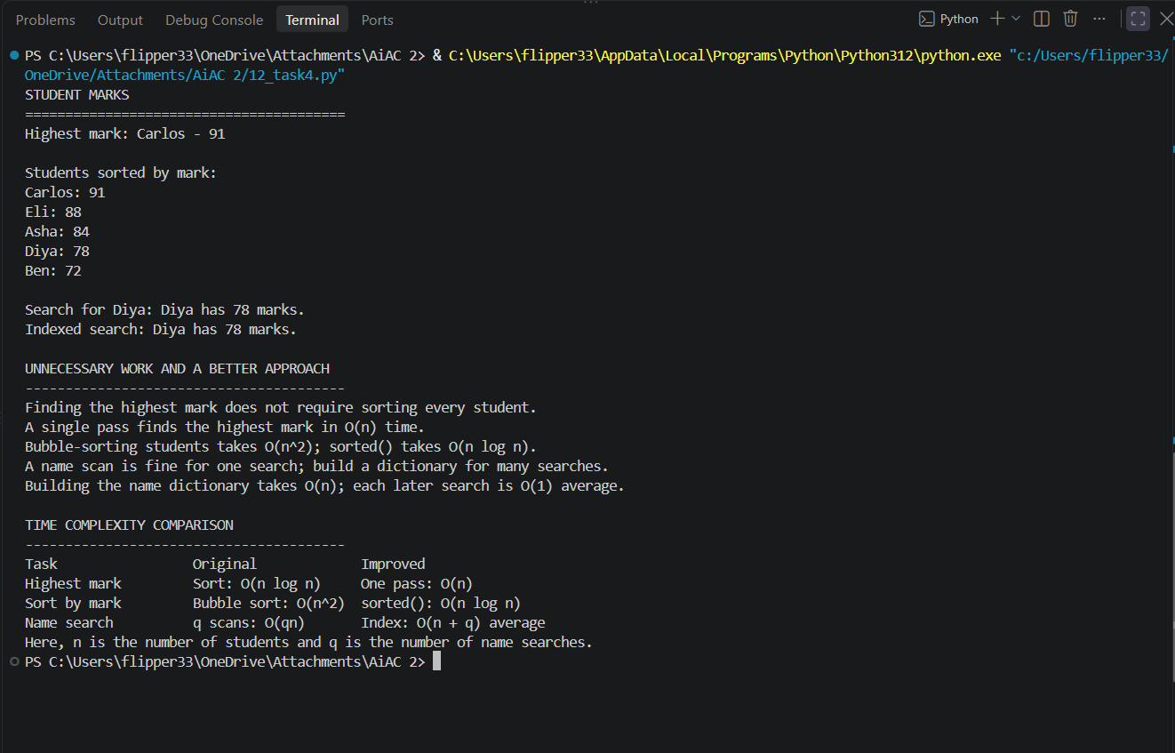

- Observation
The student program was divided into separate functions for finding the highest mark, sorting, and searching by name. AI identified unnecessary operations and suggested more efficient approaches without making the code difficult to understand. The improved solution maintains the same results while reducing unnecessary work and improving overall efficiency.
TASK 5 –Optimisation Challenge: Best Combination
- Question
items = [
("Laptop", 60000),
("Phone", 30000),
("Tablet", 20000),
("Watch", 10000),
("Headphones", 5000)
]

budget = 50000

# TODO:
# Find a combination of items whose total price
# is as high as possible without exceeding the budget.
Student Tasks:
• Design a solution to maximise total value without exceeding the budget.
• Start with a simple approach and explain it.
• Use AI to compare Brute Force, Greedy and Dynamic Programming.
• Determine which approach guarantees an optimal solution for this formulation.
• Implement the selected solution.
• Test at least three budgets.
• Explain time and space complexity and possible optimisation for larger inputs.

- Prompt
Solve this budget problem using a simple approach first. Compare Brute Force, Greedy, and Dynamic Programming, identify which method guarantees an optimal solution for this formulation, implement it, test three budgets, and explain its time and space complexity.
- Code
"""Budget selection problem using a simple-to-complex progression.

This solves the 0/1 knapsack formulation: each item is either purchased or not,
with a total cost that must not exceed the available budget. The objective is to
maximize total value.
"""

items = [
("Laptop", 60000, 90),
("Phone", 30000, 50),
("Tablet", 20000, 35),
("Watch", 10000, 18),
("Headphones", 5000, 10),
]

def brute_force_knapsack(items, budget):
"""Try every subset and keep the best feasible combination."""
best = {"value": 0, "cost": 0, "items": []}
n = len(items)

for mask in range(1 << n):
total_cost = 0
total_value = 0
chosen = []

for i, item in enumerate(items):
if mask & (1 << i):
name, cost, value = item
total_cost += cost
total_value += value
chosen.append(name)

if total_cost <= budget and total_value > best["value"]:
best = {"value": total_value, "cost": total_cost, "items": chosen}

return best

def greedy_knapsack(items, budget):
"""Pick items by highest value-per-cost ratio until the budget is filled."""
chosen = []
total_cost = 0
total_value = 0

for name, cost, value in sorted(items, key=lambda x: x[2] / x[1], reverse=True):
if total_cost + cost <= budget:
chosen.append(name)
total_cost += cost
total_value += value

return {"value": total_value, "cost": total_cost, "items": chosen}

def dynamic_programming_knapsack(items, budget):
"""Compute the optimal subset using 0/1 knapsack dynamic programming."""
n = len(items)
dp = [[0] * (budget + 1) for _ in range(n + 1)]
keep = [[None] * (budget + 1) for _ in range(n + 1)]

for i in range(1, n + 1):
name, cost, value = items[i - 1]
for cap in range(budget + 1):
dp[i][cap] = dp[i - 1][cap]
keep[i][cap] = None

if cost <= cap:
candidate = dp[i - 1][cap - cost] + value
if candidate > dp[i][cap]:
dp[i][cap] = candidate
keep[i][cap] = (i - 1, cap - cost)

chosen_indexes = []
cap = budget
i = n
while i > 0 and cap >= 0:
if keep[i][cap] is not None:
idx, prev_cap = keep[i][cap]
chosen_indexes.append(idx)
cap = prev_cap
i -= 1

chosen = [items[idx][0] for idx in reversed(chosen_indexes)]
total_cost = sum(items[idx][1] for idx in chosen_indexes)
total_value = dp[n][budget]

return {"value": total_value, "cost": total_cost, "items": chosen}

def summarize(method_name, result):
print(f"{method_name}: value={result['value']}, cost={result['cost']}, items={result['items']}")

def main():
print("Budget optimization comparison")
print("=" * 60)
print("Items: Laptop (60000, value 90), Phone (30000, value 50), Tablet (20000, value 35),")
print(" Watch (10000, value 18), Headphones (5000, value 10)")
print()

budgets = [50000, 70000, 35000]

for budget in budgets:
print(f"Budget = {budget}")
brute = brute_force_knapsack(items, budget)
greedy = greedy_knapsack(items, budget)
dp = dynamic_programming_knapsack(items, budget)

summarize("Brute Force", brute)
summarize("Greedy (value/price)", greedy)
summarize("Dynamic Programming", dp)

if brute["value"] == dp["value"]:
print("Optimality check: dynamic programming matches brute force exactly.")
else:
print("Optimality check: dynamic programming does not match brute force.")

if greedy["value"] != brute["value"]:
print("Greedy is not optimal for this example.")
else:
print("Greedy coincidentally matched the optimum for this budget.")

print("-" * 60)

print("\nWhy dynamic programming is the guaranteed method:")
print("- Brute force checks every subset: O(2^n), exact but exponential.")
print("- Greedy picks by a local rule such as value/price ratio: O(n log n),")
print(" but it can fail for 0/1 knapsack because choosing the current best item")
print(" may block a better combination later.")
print("- Dynamic programming solves subproblems for every budget capacity up to B:")
print(" O(n * B) time and O(n * B) space for the full table. This guarantees")
print(" the optimal value for the 0/1 knapsack formulation.")

if __name__ == "__main__":
main()

- Output
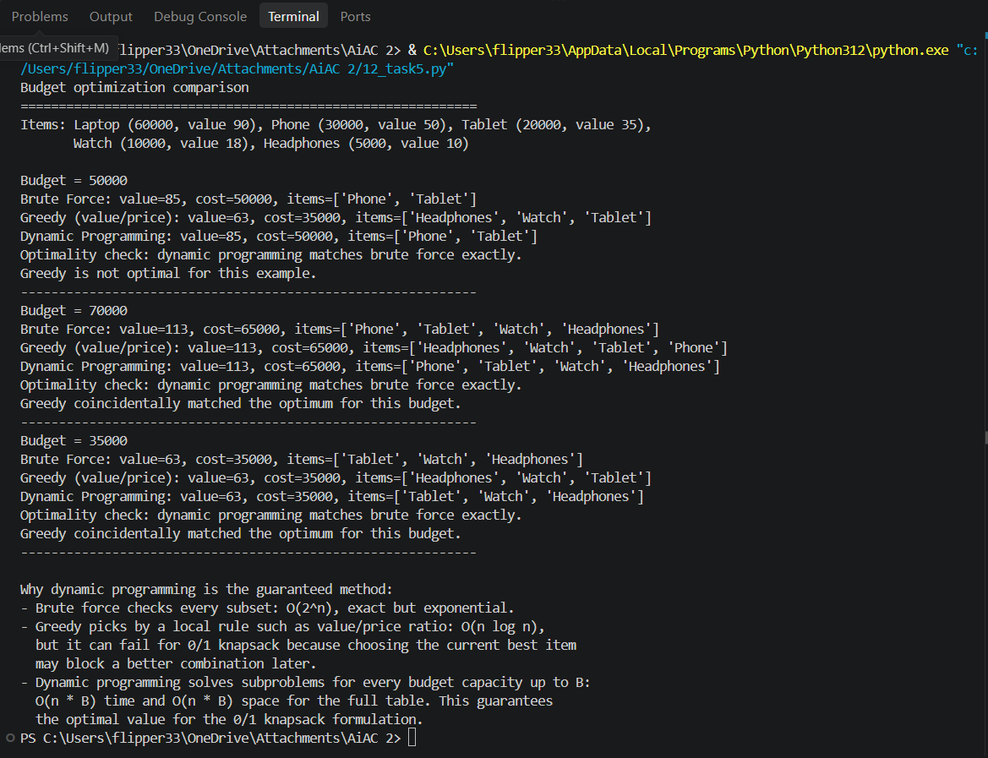

- Observation
The problem was analyzed as a 0/1 knapsack-style optimization problem where each item can be selected at most once. Brute Force guarantees the optimal solution, while Greedy does not always guarantee an optimal result; Dynamic Programming also guarantees optimality with better scalability. The selected solution was tested with three budgets, and its time and space complexity were considered for larger inputs.

