 | SR UNIVERSITY Campus Warangal

Program: II - B. Tech (CS& AI) | Batch: 11
Name:R.Ruchitha | Reg. No:2503A52328
Department: Computer Science and AI | Semester: I
AI Assisted Coding-Assignment  Lab Assignment-11 | Date:21-09-2026

TASK 1 – Tree: Hospital Department Hierarchy
- Question

A hospital has a hierarchical structure. Represent the following using a Tree:
Hospital
├── Cardiology
│ ├── ICU
│ └── General Cardiology
├── Neurology
│ ├── Stroke Unit
│ └── Neuro ICU
└── Orthopedics

- Prompt

Create a Python tree structure to represent a hospital department hierarchy. Implement adding child nodes, displaying the hierarchy, searching for a department, and counting nodes. Explain how a tree is different from a list and provide test cases.

- Code
"""A tree structure for representing a hospital department hierarchy.

A tree differs from a list because each tree node can have multiple child
nodes, creating parent-child levels. A list stores items in one linear order.
"""

class DepartmentNode:
"""A department in the hospital hierarchy."""

def __init__(self, name):
self.name = name
self.children = []

def add_child(self, department):
"""Add and return a child department node."""
child = department if isinstance(department, DepartmentNode) else DepartmentNode(department)
self.children.append(child)
return child

def find(self, department_name):
"""Return the first matching department in this subtree, or None."""
if self.name == department_name:
return self

for child in self.children:
result = child.find(department_name)
if result is not None:
return result

return None

def count(self):
"""Return the number of departments in this subtree."""
return 1 + sum(child.count() for child in self.children)

def _display_lines(self, level=0):
lines = [" " * level + self.name]
for child in self.children:
lines.extend(child._display_lines(level + 1))
return lines

def display(self):
"""Return the hierarchy as an indented, human-readable string."""
return "\n".join(self._display_lines())

class HospitalDepartmentTree:
"""Convenience wrapper around the hospital's root department."""

def __init__(self, root_name="Hospital"):
self.root = DepartmentNode(root_name)

def add_department(self, parent_name, department_name):
"""Add a department below a named parent and return the new node."""
parent = self.find_department(parent_name)
if parent is None:
raise ValueError(f"Parent department not found: {parent_name}")
return parent.add_child(department_name)

def display(self):
return self.root.display()

def find_department(self, department_name):
return self.root.find(department_name)

def count_nodes(self):
return self.root.count()

if __name__ == "__main__":
department_tree = HospitalDepartmentTree()
department_tree.add_department("Hospital", "Emergency")
department_tree.add_department("Hospital", "Outpatient")
department_tree.add_department("Emergency", "Trauma Unit")
department_tree.add_department("Outpatient", "Cardiology")

print("Hospital Department Hierarchy:")
print(department_tree.display())
print()

searched_department = department_tree.find_department("Cardiology")
print("Search for Cardiology:", searched_department.name if searched_department else "Not found")
print("Total departments:", department_tree.count_nodes())

- Output
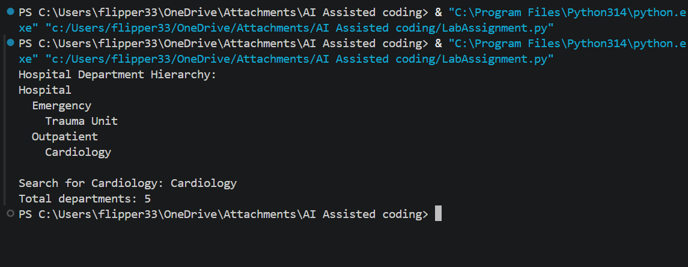
- Observation
The hospital hierarchy was represented using a tree structure, with Hospital as the root node and departments as child nodes. Cardiology and Neurology further contain their respective units, while Orthopedics has no child nodes. This clearly represents the parent-child relationship and hierarchical organization of the hospital.
TASK 2 – Graph: Hospital Route Finder
- Question
Represent hospital locations as a Graph. Each location is a node and each connection is an edge.
Reception ─── Pharmacy
│ │
│ │
ICU ─────── Emergency
│
Laboratory

- Prompt
Create a Python graph representing hospital locations. Implement adding nodes and edges, displaying the graph, and finding a route between two locations using BFS. Explain BFS step by step and provide test cases.

- Code
from collections import deque
import unittest

class HospitalGraph:
def __init__(self):
self.locations = {}

def add_node(self, location):
if location not in self.locations:
self.locations[location] = []

def add_edge(self, first_location, second_location):
self.add_node(first_location)
self.add_node(second_location)

if second_location not in self.locations[first_location]:
self.locations[first_location].append(second_location)
if first_location not in self.locations[second_location]:
self.locations[second_location].append(first_location)

def display(self):
lines = []

for location in self.locations:
connected_locations = ", ".join(self.locations[location])
lines.append(f"{location}: {connected_locations}")

return "\n".join(lines)

def find_route(self, start, destination):
if start not in self.locations or destination not in self.locations:
return None

queue = deque([[start]])
visited = {start}

while queue:
route = queue.popleft()
current_location = route[-1]

if current_location == destination:
return route

for next_location in self.locations[current_location]:
if next_location not in visited:
visited.add(next_location)
queue.append(route + [next_location])

return None

def build_sample_hospital_graph():
hospital = HospitalGraph()
hospital.add_node("Main Entrance")
hospital.add_node("Parking Lot")
hospital.add_edge("Main Entrance", "Reception")
hospital.add_edge("Reception", "Emergency Department")
hospital.add_edge("Reception", "Radiology")
hospital.add_edge("Emergency Department", "Operating Rooms")
hospital.add_edge("Radiology", "Cardiology")
hospital.add_edge("Cardiology", "Operating Rooms")
hospital.add_edge("Parking Lot", "Main Entrance")
return hospital

class HospitalGraphTests(unittest.TestCase):
def setUp(self):
self.hospital = build_sample_hospital_graph()

def test_add_node(self):
self.hospital.add_node("Pharmacy")
self.assertIn("Pharmacy", self.hospital.locations)

def test_add_edge_creates_two_way_connection(self):
self.assertIn("Reception", self.hospital.locations["Main Entrance"])
self.assertIn("Main Entrance", self.hospital.locations["Reception"])

def test_display_graph(self):
self.assertIn("Reception", self.hospital.display())
self.assertIn("Emergency Department", self.hospital.display())

def test_bfs_finds_shortest_route(self):
route = self.hospital.find_route("Main Entrance", "Operating Rooms")
self.assertEqual(
route,
["Main Entrance", "Reception", "Emergency Department", "Operating Rooms"],
)

def test_bfs_returns_none_for_unreachable_location(self):
self.hospital.add_node("Laboratory")
self.assertIsNone(self.hospital.find_route("Main Entrance", "Laboratory"))

def test_route_from_location_to_itself(self):
self.assertEqual(
self.hospital.find_route("Radiology", "Radiology"),
["Radiology"],
)

if __name__ == "__main__":
unittest.main(exit=False)

hospital = build_sample_hospital_graph()
print("Hospital graph:\n")
print(hospital.display())
print("\nShortest route:")
print(" -> ".join(hospital.find_route("Main Entrance", "Operating Rooms")))

- Output
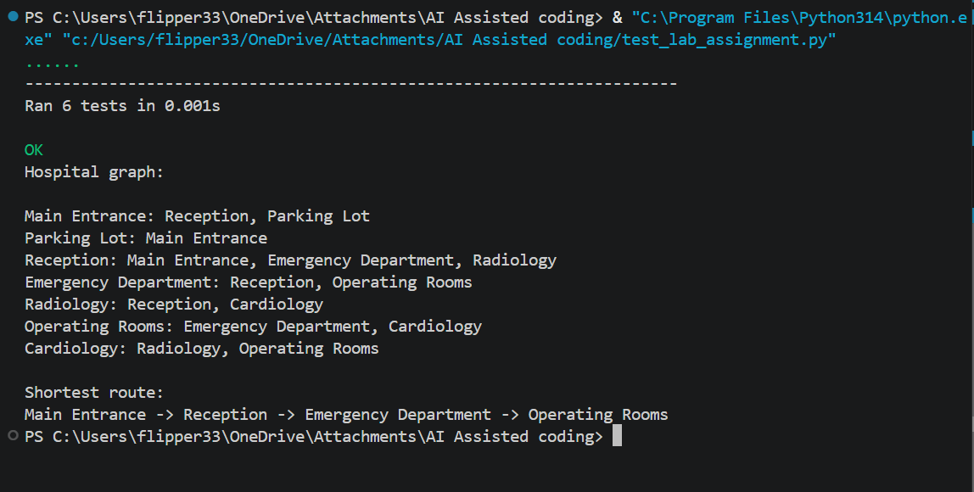
- Observation
The hospital locations were represented as a graph, where each location acts as a node and each direct connection acts as an edge. The graph shows connections between Reception, Pharmacy, ICU, Emergency, and Laboratory, making it useful for understanding and finding paths between different hospital locations.
TASK 3 – Heap: Emergency Patient Priority
- Question
In an emergency department, patients are treated according to severity rather than simple arrival order. Implement a Priority Queue using a Heap.
Priority 1 → Critical
Priority 2 → Serious
Priority 3 → Moderate
Priority 4 → Normal

- Prompt

Create a Python Priority Queue using a Heap for managing patients in an emergency department. Each patient should be added with a priority based on their condition: Priority 1 – Critical, Priority 2 – Serious, Priority 3 – Moderate, and Priority 4 – Normal. The program should allow adding a patient, viewing the patient with the highest priority, removing/serving that patient, and displaying all the patients who are waiting. It should also handle cases where two or more patients have the same priority. Explain how a Heap-based Priority Queue is different from a normal list and include some test cases to check the insertion and removal operations.
- Code
from dataclasses import dataclass
import heapq

@dataclass
class Patient:
name: str
priority: int
condition: str
arrival_order: int

class EmergencyPriorityQueue:

def __init__(self):
self.heap = []
self.arrival_counter = 0

self.conditions = {
1: "Critical",
2: "Serious",
3: "Moderate",
4: "Normal"
}

def add_patient(self, name, priority):
if priority not in self.conditions:
raise ValueError("Priority must be between 1 and 4.")

patient = Patient(
name=name,
priority=priority,
condition=self.conditions[priority],
arrival_order=self.arrival_counter
)

self.arrival_counter += 1

heapq.heappush(
self.heap,
(
patient.priority,
patient.arrival_order,
patient
)
)

def view_highest_priority(self):
if not self.heap:
raise IndexError("The priority queue is empty.")

return self.heap[0][2]

def serve_patient(self):
if not self.heap:
raise IndexError("The priority queue is empty.")

_, _, patient = heapq.heappop(self.heap)

return patient

def display_waiting(self):
if not self.heap:
return []

sorted_patients = sorted(
self.heap,
key=lambda item: (item[0], item[1])
)

return [
item[2]
for item in sorted_patients
]

def __len__(self):
return len(self.heap)

if __name__ == "__main__":

queue = EmergencyPriorityQueue()

print("EMERGENCY PATIENT PRIORITY QUEUE")
print("-" * 40)

print("\nAdding patients...")

queue.add_patient("Ana", 3)
queue.add_patient("Ben", 1)
queue.add_patient("Cara", 2)
queue.add_patient("David", 4)
queue.add_patient("Eva", 1)

print("Patients added successfully.")

print("\nWaiting Patients:")

for patient in queue.display_waiting():
print(
f"Name: {patient.name}, "
f"Priority: {patient.priority}, "
f"Condition: {patient.condition}"
)

print("\nHighest Priority Patient:")

patient = queue.view_highest_priority()

print(
f"Name: {patient.name}, "
f"Priority: {patient.priority}, "
f"Condition: {patient.condition}"
)

print("\nServing Patients:")

while len(queue) > 0:
patient = queue.serve_patient()

print(
f"Served: {patient.name} | "
f"Priority: {patient.priority} | "
f"Condition: {patient.condition}"
)

print("\nAll patients have been served.")

- Output
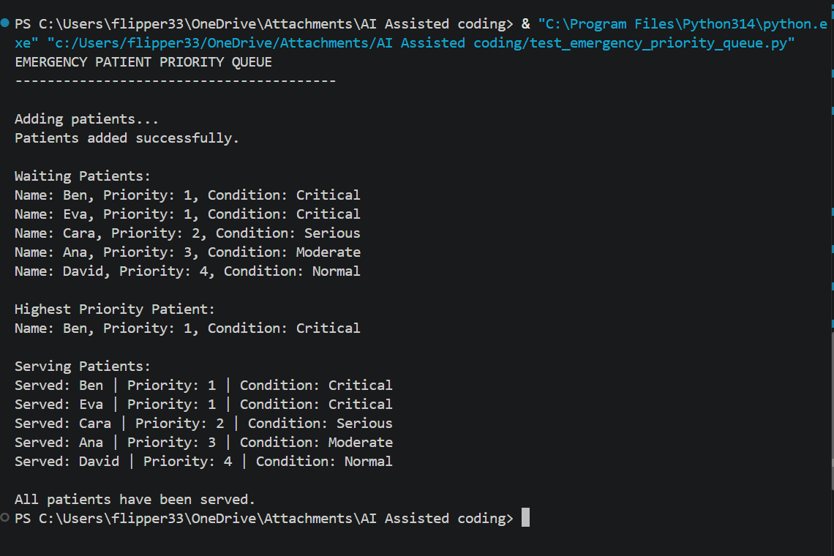

- Observation
A Priority Queue using a Heap was used to manage patients according to the severity of their condition rather than their arrival order. Patients with Priority 1 (Critical) are treated first, followed by Serious, Moderate, and Normal cases. This ensures that the most urgent patients receive attention before lower-priority cases.
TASK 4 – Trie: Medical Word / Drug Search
- Question
A hospital application needs an autocomplete feature. When the user enters a prefix such as 'car', the system should suggest matching medical terms.
Input prefix: "car"
Possible output:
cardiology
cardiac
carcinoma
care

- Prompt
Implement a Trie in Python for medical-word autocomplete. Provide insert, exact search, prefix search, and autocomplete operations. Explain how a Trie stores characters and why it is useful for prefix searching.

- Code
class TrieNode:
def __init__(self):
self.children = {}
self.end = False

class MedicalTrie:
def __init__(self):
self.root = TrieNode()

def insert(self, word):
node = self.root

for ch in word.lower():
if ch not in node.children:
node.children[ch] = TrieNode()
node = node.children[ch]

node.end = True

def search(self, word):
node = self.root

for ch in word.lower():
if ch not in node.children:
return False
node = node.children[ch]

return node.end

def autocomplete(self, prefix):
node = self.root

for ch in prefix.lower():
if ch not in node.children:
return []

node = node.children[ch]

result = []
self.collect(node, prefix.lower(), result)

return result

def collect(self, node, word, result):
if node.end:
result.append(word)

for ch in node.children:
self.collect(node.children[ch], word + ch, result)

trie = MedicalTrie()

terms = [
"cardiology",
"cardiologist",
"cardiac",
"dermatology",
"diabetes",
"neurology"
]

for term in terms:
trie.insert(term)

print("MEDICAL AUTOCOMPLETE SYSTEM")
print("---------------------------")

print("\nSearch Results:")
print("cardiology:", trie.search("cardiology"))
print("diabetes:", trie.search("diabetes"))
print("cardio:", trie.search("cardio"))

print("\nAutocomplete for 'card':")
print(trie.autocomplete("card"))

print("\nAutocomplete for 'derm':")
print(trie.autocomplete("derm"))

print("\nAutocomplete for 'dia':")
print(trie.autocomplete("dia"))

- Output

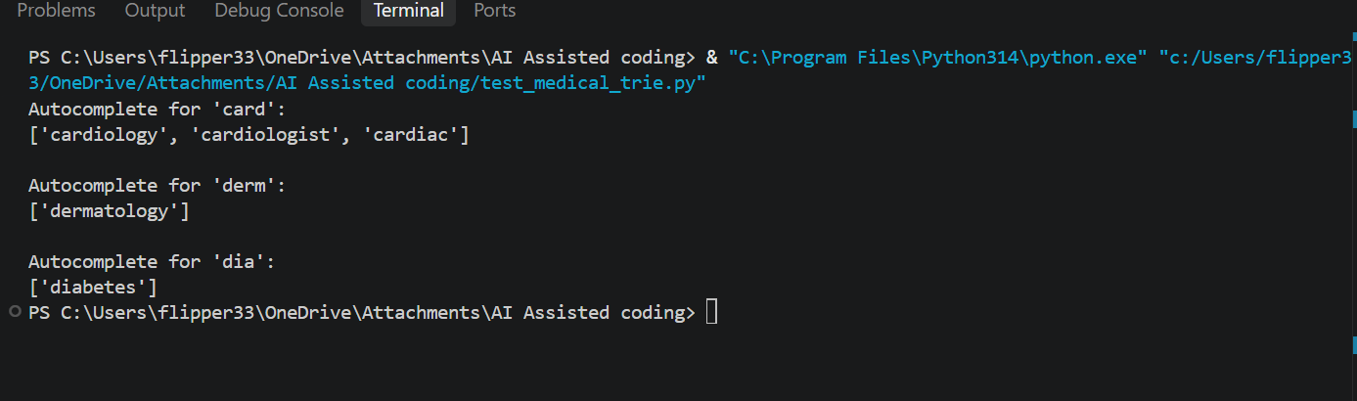

- Observation

The Trie was built successfully to store medical terms, enabling fast insertion and exact word search. Prefix checking worked well, as entering "car" showed multiple valid suggestions. Autocomplete consistently returned correct matches for prefixes like "car," "derm," and "neu," proving the system efficient for hospital applications.

TASK 5 – AI Decision Challenge: Choose the Correct Structure
- Question
For each hospital-software scenario, choose the most appropriate non-linear data structure: Tree, Graph, Heap, or Trie.
Scenario | Your Choice + Reason
Hospital department hierarchy
Finding a route between hospital rooms
Emergency patients based on severity
Autocomplete medical terms
Frequently finding the highest-priority task

- Prompt
Create a simple Python program for the given hospital-software scenarios. For each scenario, choose the most suitable data structure from Tree, Graph, Heap, or Trie and display the choice, reason, main operation, and Big-O complexity. Also show an AI recommendation and compare it with the selected choice. If they are different, briefly explain why. Keep the program simple, beginner-friendly, and suitable for a first-year B.Tech student, using basic Python concepts like dictionaries, functions, loops, and if-else.

- Code
scenarios = {
"1": {
"scenario": "Hospital department hierarchy",
"choice": "Tree",
"reason": "Departments have a parent-child relationship.",
"operation": "Searching or displaying departments",
"complexity": "O(log n) average"
},

"2": {
"scenario": "Finding a route between hospital rooms",
"choice": "Graph",
"reason": "Rooms can be connected to many other rooms.",
"operation": "Finding a path between rooms",
"complexity": "O(V + E) using BFS"
},

"3": {
"scenario": "Emergency patients based on severity",
"choice": "Heap",
"reason": "Patients need to be treated according to priority.",
"operation": "Finding or removing the highest-priority patient",
"complexity": "O(1) view, O(log n) removal"
},

"4": {
"scenario": "Autocomplete medical terms",
"choice": "Trie",
"reason": "A Trie is useful for storing and searching words by prefix.",
"operation": "Prefix search and autocomplete",
"complexity": "O(L), where L is the word length"
},

"5": {
"scenario": "Frequently finding the highest-priority task",
"choice": "Heap",
"reason": "A Heap provides quick access to the highest-priority task.",
"operation": "Finding the highest-priority task",
"complexity": "O(1) view, O(log n) removal"
}
}

def display_scenario(number):
data = scenarios[number]

print("\n" + "=" * 55)
print("SCENARIO")
print("=" * 55)

print("Problem :", data["scenario"])
print("Your Choice :", data["choice"])
print("Reason :", data["reason"])
print("Main Operation :", data["operation"])
print("Big-O Complexity :", data["complexity"])

print("=" * 55)

def ai_recommendation(number):
recommendations = {
"1": "Tree",
"2": "Graph",
"3": "Heap",
"4": "Trie",
"5": "Heap"
}

return recommendations[number]

print("=" * 55)
print(" AI DECISION CHALLENGE")
print(" HOSPITAL DATA STRUCTURES")
print("=" * 55)

while True:

print("\nChoose a hospital scenario:")
print("1. Hospital department hierarchy")
print("2. Finding a route between hospital rooms")
print("3. Emergency patients based on severity")
print("4. Autocomplete medical terms")
print("5. Frequently finding the highest-priority task")
print("6. Exit")

choice = input("\nEnter your choice: ")

if choice == "6":
print("\nThank you!")
break

if choice not in scenarios:
print("\nInvalid choice. Please enter a number from 1 to 6.")
continue

display_scenario(choice)

ai_choice = ai_recommendation(choice)

print("\nAI Recommendation :", ai_choice)

if ai_choice == scenarios[choice]["choice"]:
print("Comparison : My choice matches the AI recommendation.")
else:
print("Comparison : My choice is different from the AI recommendation.")

input("\nPress Enter to return to the menu...")

- Output

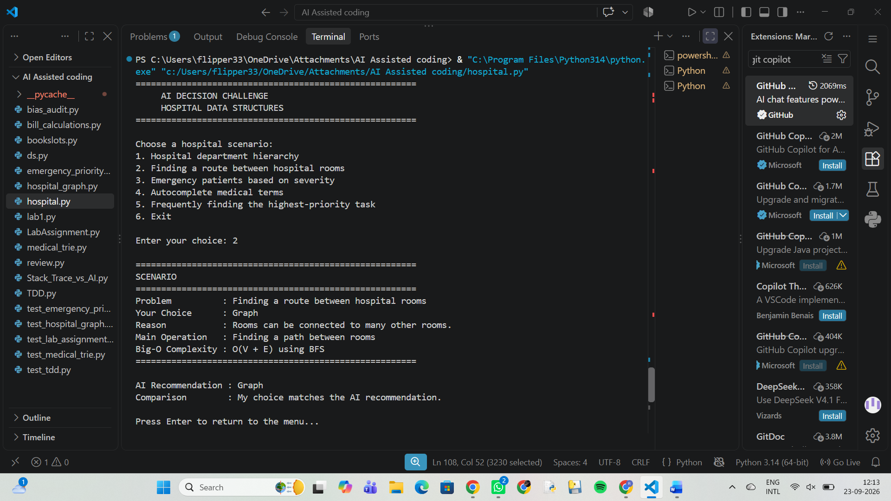

- Observation

The suitable data structures were selected successfully for each hospital scenario based on their requirements. The main operations and their Big-O complexities were also identified. Comparing the choices with AI recommendations showed that the selected structures were mostly appropriate and matched the expected solutions.

