 | SR UNIVERSITY Campus Warangal

Program: II - B. Tech (CS& AI) | Batch: 11
Name:R.Ruchitha | Reg. No:2503A52328
Department: Computer Science and AI | Semester: I
AI Assisted Coding-Assignment  Lab Assignment-13 | Date:05-10-2026
TASK 1 – Improve Readability
- Question
Legacy code:
a=80
b=70
c=90
x=(a+b+c)/3
if x>=50:
print("pass")
else:
print("fail")

Student Requirements:
1. Ask AI to use meaningful variable names.
2. Create a function such as calculate_average().
3. Improve formatting and readability.
4. Run both versions and verify the same result.
5. Explain the improvements.
Submit: Original Code → AI Prompt → AI Suggestion → Refactored Code → Test Output → Explanation.

- Prompt

Use meaningful variable names, create a function such as calculate_average(), and improve formatting and readability.

- Code
def calculate_average(score_1, score_2, score_3):
"""Calculate the average of three scores."""
return (score_1 + score_2 + score_3) / 3

score_1 = 80
score_2 = 70
score_3 = 90

average_score = calculate_average(score_1, score_2, score_3)

if average_score >= 50:
print(f"Average score: {average_score:.2f} -> pass")
else:
print(f"Average score: {average_score:.2f} -> fail")

- Output
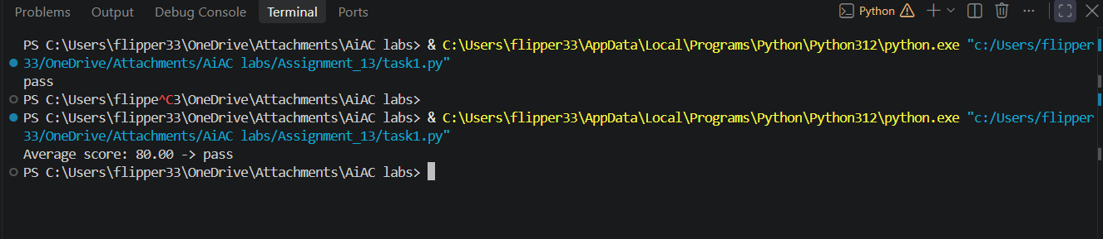

- Observation
The legacy code was successfully refactored using meaningful variable names and a separate calculate_average() function. The formatting and structure were improved, making the code easier to read and maintain. Both the original and refactored versions produced the same result, “Pass,” confirming that the functionality was preserved. AI assistance helped improve the code quality without changing its output.

TASK 2 – Remove Repeated Code
- Question
Legacy code:
name1 = "Arun"
marks1 = 85
if marks1 >= 50:
print(name1, "Pass")
else:
print(name1, "Fail")
name2 = "Priya"
marks2 = 72
if marks2 >= 50:
print(name2, "Pass")
else:
print(name2, "Fail")

Student Requirements
1. Ask AI to identify duplicated logic.
2. Refactor the repeated logic into a reusable function.
3. Test the function with at least four students.
4. Explain why removing duplication improves maintainability.
5. Verify that output remains correct.
Submit: Original Code → AI Prompt → AI Suggestion → Refactored Code → Test Output → Explanation.

- Prompt
Identify the duplicated logic in this code and refactor it into a reusable function. Test the function with four students and verify that the output remains correct. Briefly explain how removing duplication improves maintainability.

- Code
def check_result(student_name, marks):
"""Return pass/fail status for a given student and marks."""
if marks >= 50:
return f"{student_name} Pass"
return f"{student_name} Fail"

students = [
("Arun", 85),
("Priya", 72),
("Karthik", 45),
("Nisha", 60),
]

for student_name, marks in students:
print(check_result(student_name, marks))

- Output
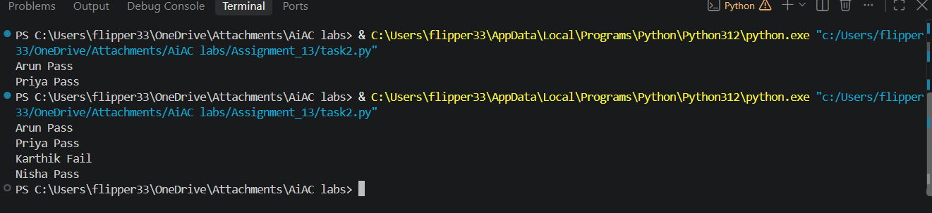
- Observation
The duplicated pass/fail logic was identified and converted into a reusable function. The function was tested with four students and produced the correct results. Removing repetition makes the code shorter, clearer, and easier to maintain.
TASK 3 – Refactor a Long Conditional
- Question
Legacy code:
age = 68
temperature = 39
if age >= 60 and temperature >= 38:
print("High Priority")
elif age >= 60 and temperature < 38:
print("Medium Priority")
elif age < 60 and temperature >= 38:
print("Medium Priority")
else:
print("Normal Priority")

Student Requirements
1. Ask AI to simplify the conditional logic.
2. Create determine_priority().
3. Test at least four age/temperature combinations.
4. Compare original and refactored logic.
5. Explain whether AI preserved the original behavior.
Submit: Original Code → AI Prompt → AI Suggestion → Refactored Code → Test Output → Explanation.

- Prompt
Simplify the conditional logic and create a `determine_priority()` function. Test it with four age/temperature combinations and verify that the refactored code gives the same results as the original.

- Code
def determine_priority(age, temperature):
"""Return the patient priority based on age and temperature."""
if age >= 60 and temperature >= 38:
return "High Priority"
if age >= 60 or temperature >= 38:
return "Medium Priority"
return "Normal Priority"

test_cases = [
(68, 39),
(60, 37),
(55, 39),
(45, 36),
]

for age, temperature in test_cases:
print(f"Age: {age}, Temperature: {temperature} -> {determine_priority(age, temperature)}")

- Output
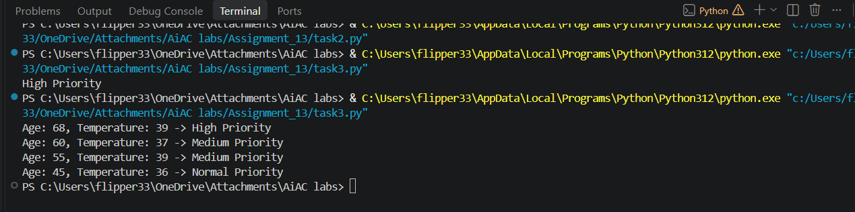

- Observation
The conditional logic was simplified and moved into a reusable determine_priority() function. The function was tested with four different age and temperature combinations. The refactored code produced the same results as the original, confirming that AI preserved the original behavior while making the code clearer and easier to maintain.
TASK 4 – Refactor Inefficient List Processing
- Question
Legacy code:
patient_ids = [101, 205, 309, 412, 518, 623]
target = 412
found = False
for patient_id in patient_ids:
if patient_id == target:
found = True
if found:
print("Patient Found")
else:
print("Patient Not Found")

Student Requirements
1. Ask AI to improve readability.
2. Ask whether a set or dictionary is better for frequent lookups.
3. Implement the justified suggestion.
4. Test existing and missing IDs.
5. Compare typical list and set lookup complexity.
Submit: Original Code → AI Prompt → AI Suggestion → Refactored Code → Test Output → Explanation.

- Prompt
Improve the readability of this code and suggest whether a set or dictionary is better for frequent patient ID lookups. Implement the better option, test with an existing and a missing ID, and briefly compare list and set lookup complexity.

- Code
patient_ids = {101, 205, 309, 412, 518, 623}

def is_patient_present(patient_id, patient_id_set):
"""Check whether a patient ID exists in the set of known IDs."""
return patient_id in patient_id_set

for target_patient_id in (412, 999):
if is_patient_present(target_patient_id, patient_ids):
print(f"Patient {target_patient_id}: Found")
else:
print(f"Patient {target_patient_id}: Not Found")

- Output

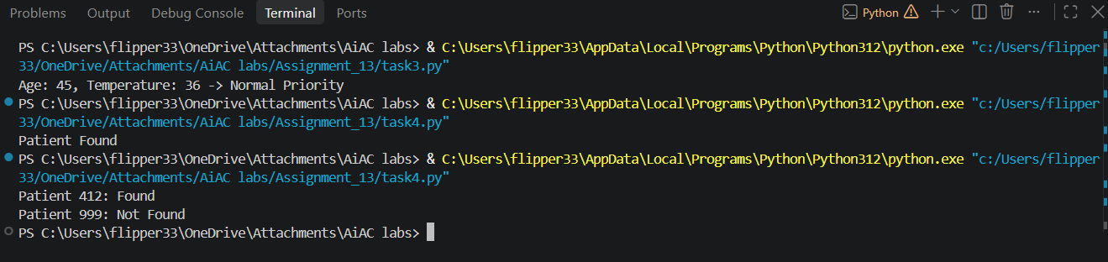

- Observation
The code was refactored using a set, which is more suitable for frequent membership lookups. Both existing and missing patient IDs were tested successfully. A list typically requires O(n) lookup time, while a set provides O(1) average lookup time, making the refactored solution more efficient.
TASK 5 – Complete Legacy Code Review with AI
- Question
Legacy code:
students = [("Arun", 78), ("Priya", 45), ("Rahul", 88), ("Meena", 52)]
total = 0
for s in students:
total = total + s[1]
avg = total / len(students)
for s in students:
if s[1] >= 50:
print(s[0], "Pass")
else:
print(s[0], "Fail")
print("Average =", avg)

Student Requirements
1. Ask AI to identify at least five improvements.
2. Refactor using meaningful names and reusable functions.
3. Use suitable Python features when they improve clarity.
4. Run both versions and verify equivalent results.
5. Record AI suggestions as accepted/rejected with reasons.
6. Identify the most useful refactoring change and justify it.
Submit: Original Code → AI Prompt → AI Suggestion → Refactored Code → Test Output → Explanation.
- Prompt
Review this code and suggest at least five improvements. Refactor it using meaningful names, reusable functions, and suitable Python features. Run both versions and verify the same output. Also explain which suggestions you accepted or rejected and identify the most useful improvement.

- Code
PASSING_SCORE = 50

students = [("Arun", 78), ("Priya", 45), ("Rahul", 88), ("Meena", 52)]

def calculate_average(student_records):
"""Return the mean score for the supplied student records."""
total_score = sum(score for _, score in student_records)
return total_score / len(student_records)

def print_student_results(student_records, passing_score=PASSING_SCORE):
"""Print each student's pass/fail result."""
for student_name, score in student_records:
result = "Pass" if score >= passing_score else "Fail"
print(student_name, result)

def main():
print_student_results(students)
average_score = calculate_average(students)
print("Average =", average_score)

if __name__ == "__main__":
main()

- Output
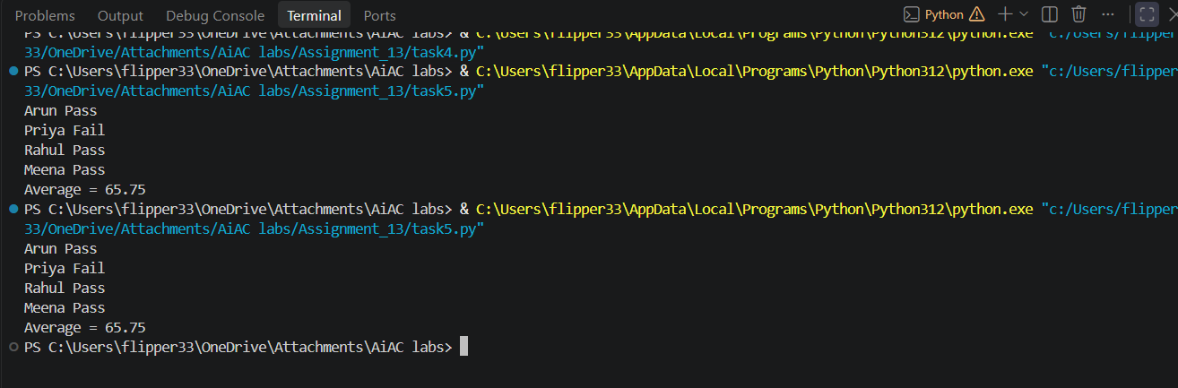

- Observation

The code was reviewed and improved in several areas, including meaningful variable names, reusable functions, and clearer Python features. The original and refactored versions produced equivalent results. The most useful change was creating reusable functions, as it improves readability, reduces repetition, and makes the code easier to maintain.

