WEEK 10: **Working with minikube and Nagios**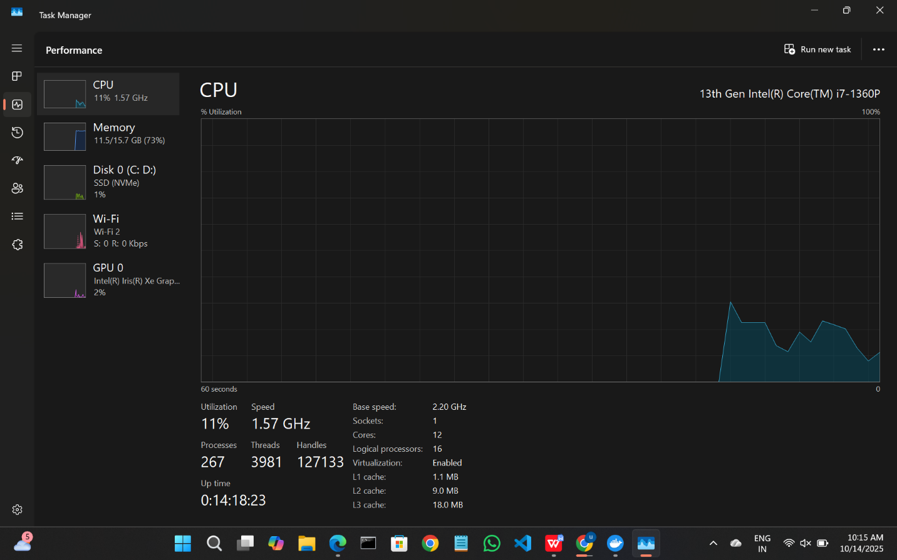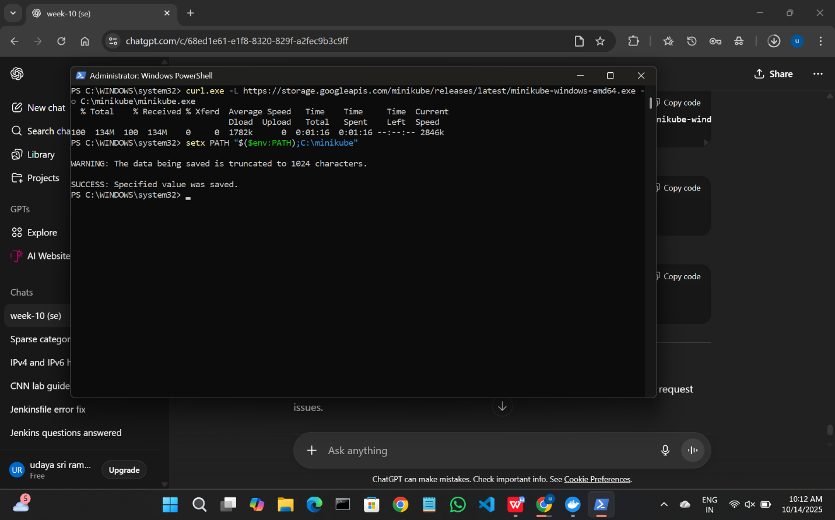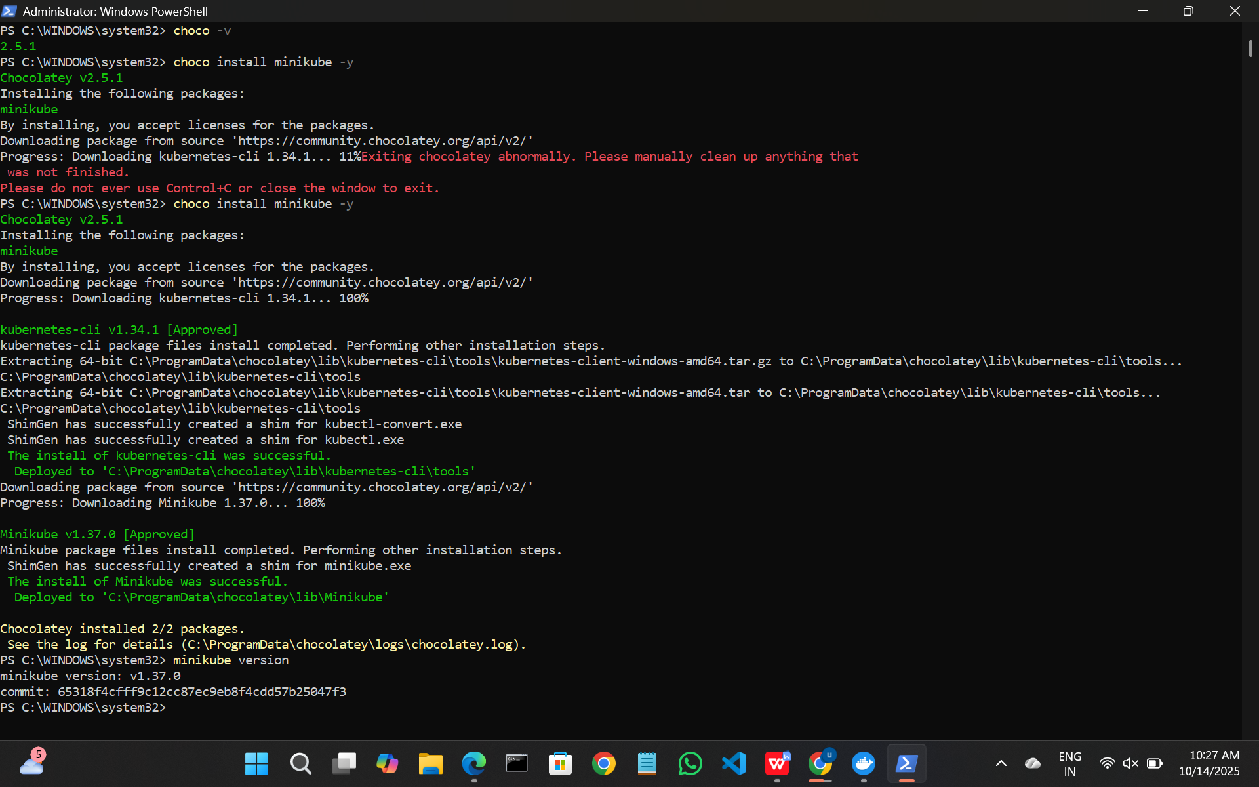

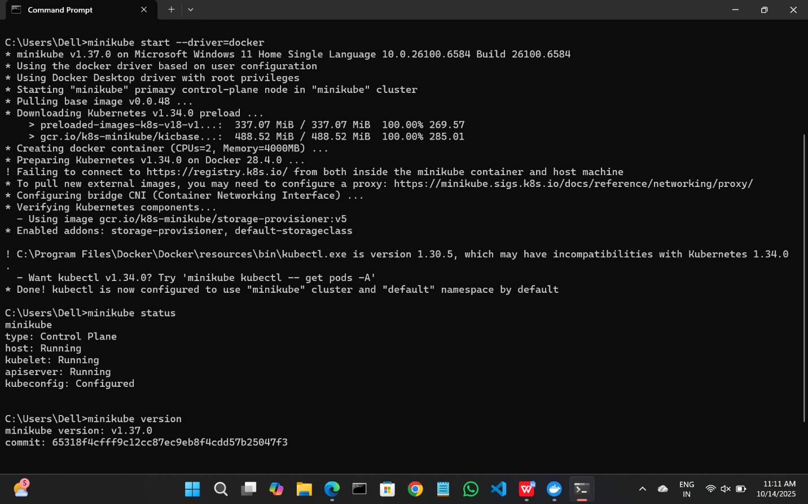

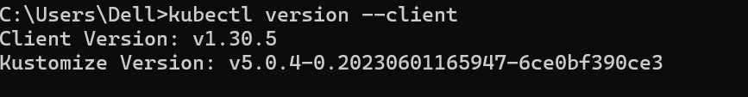

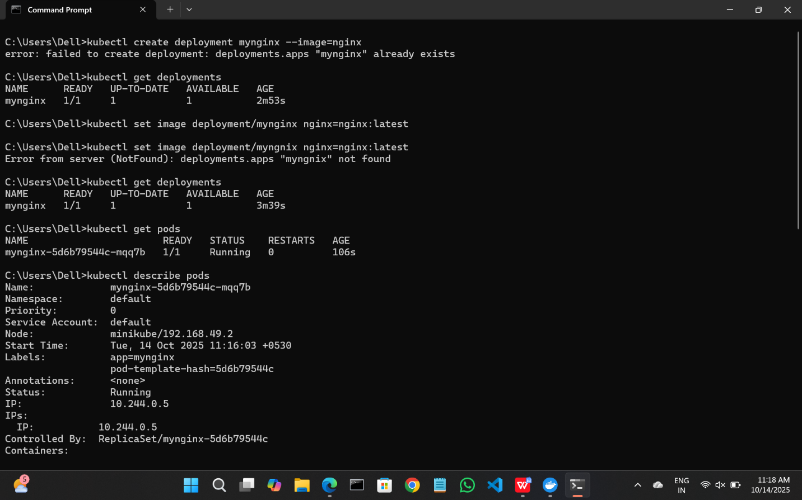



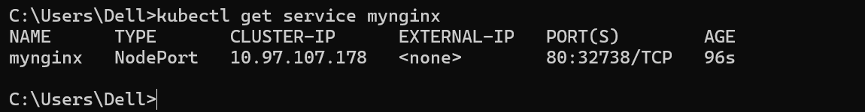

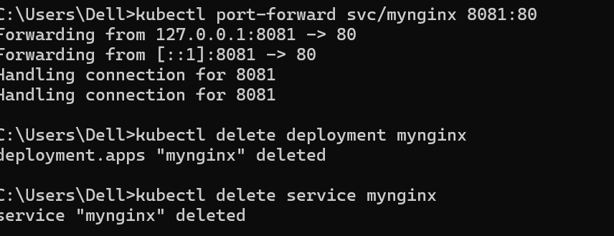

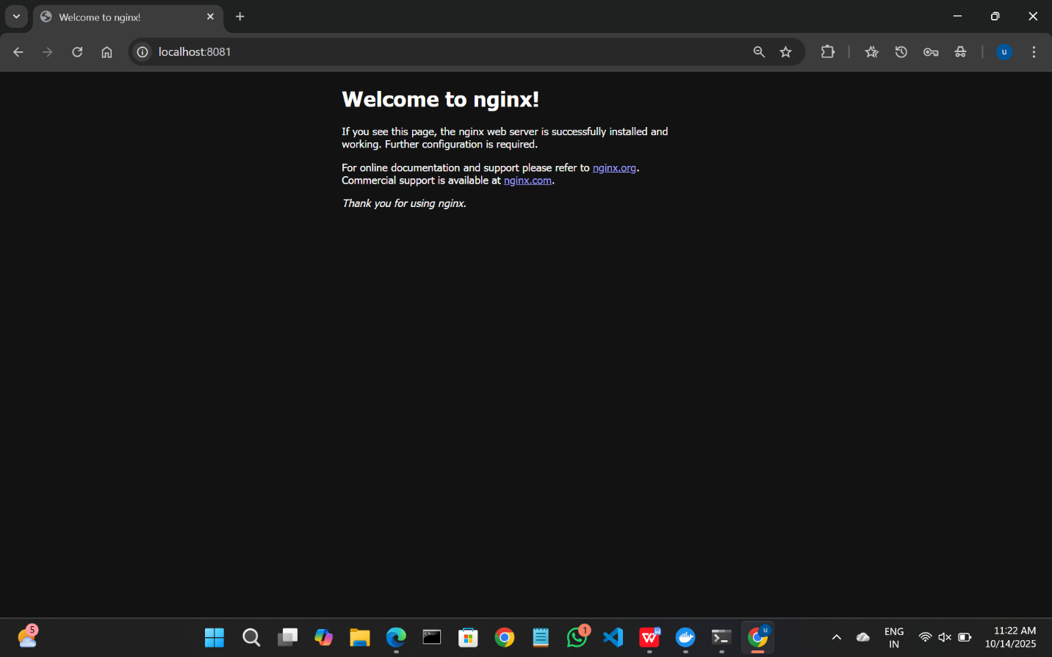

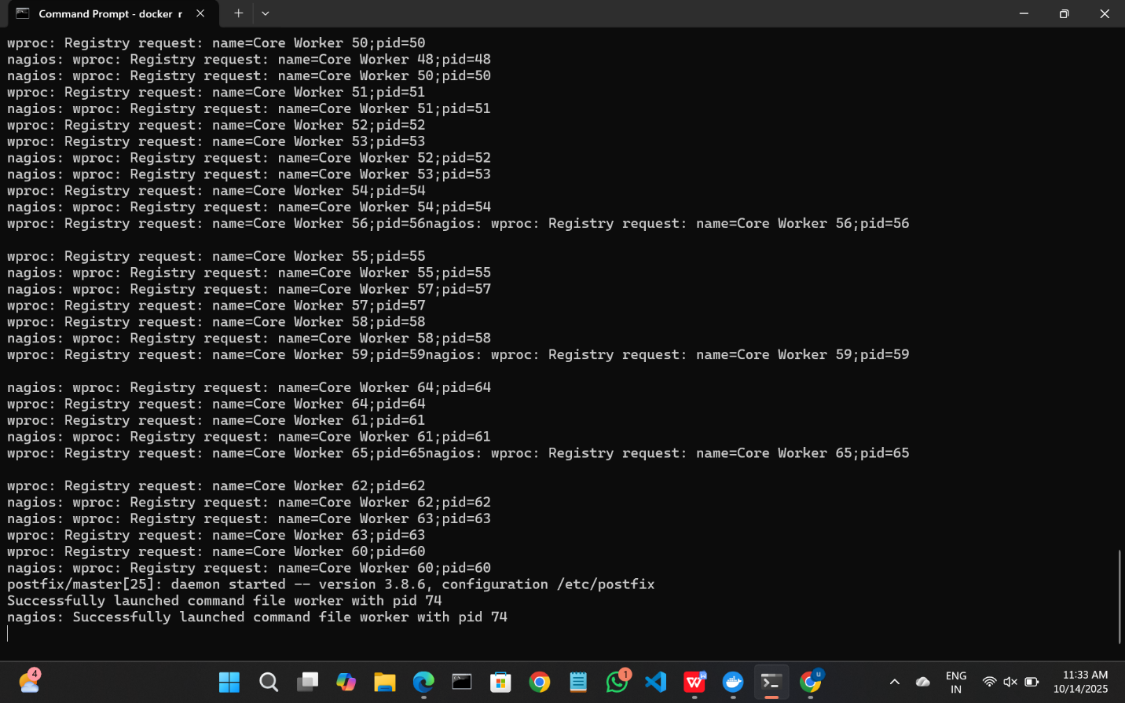

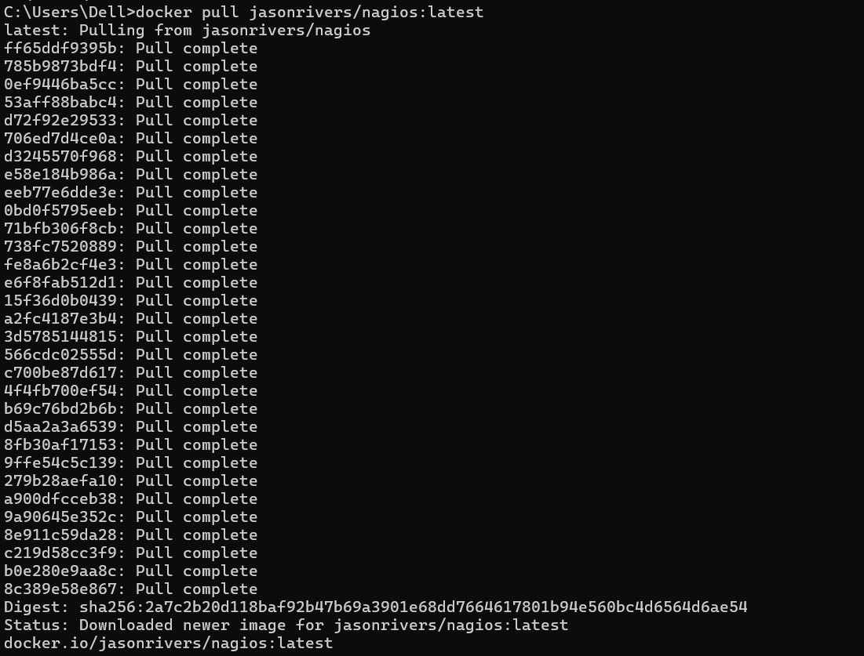

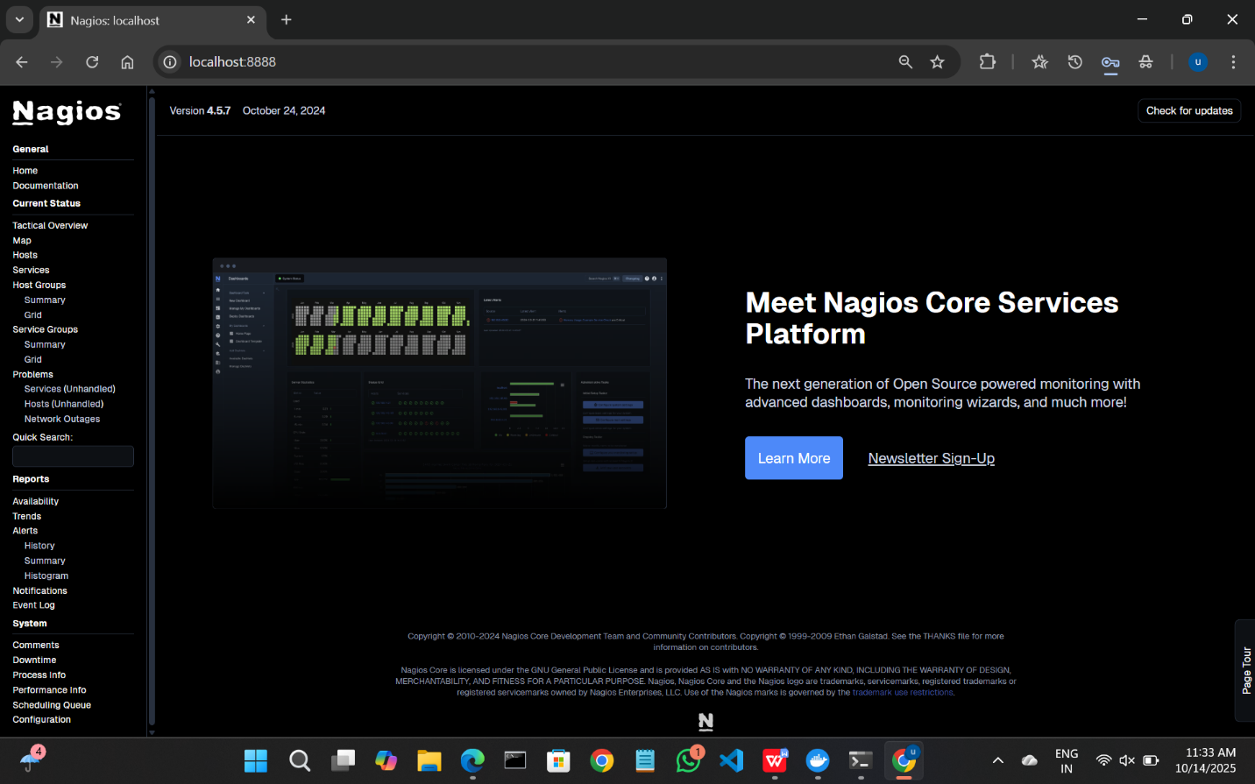

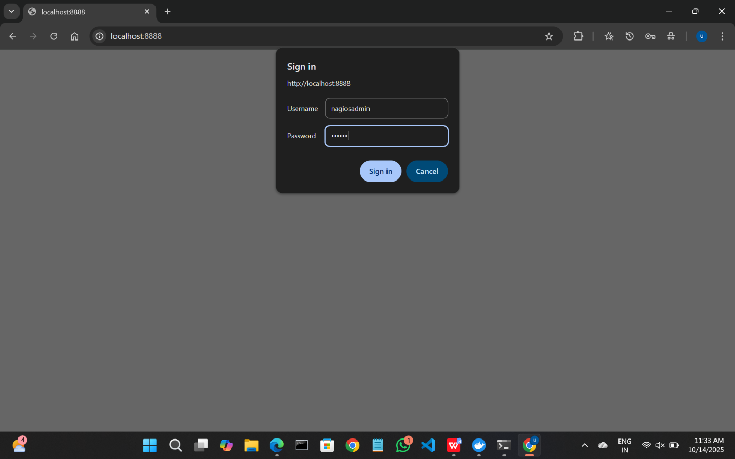

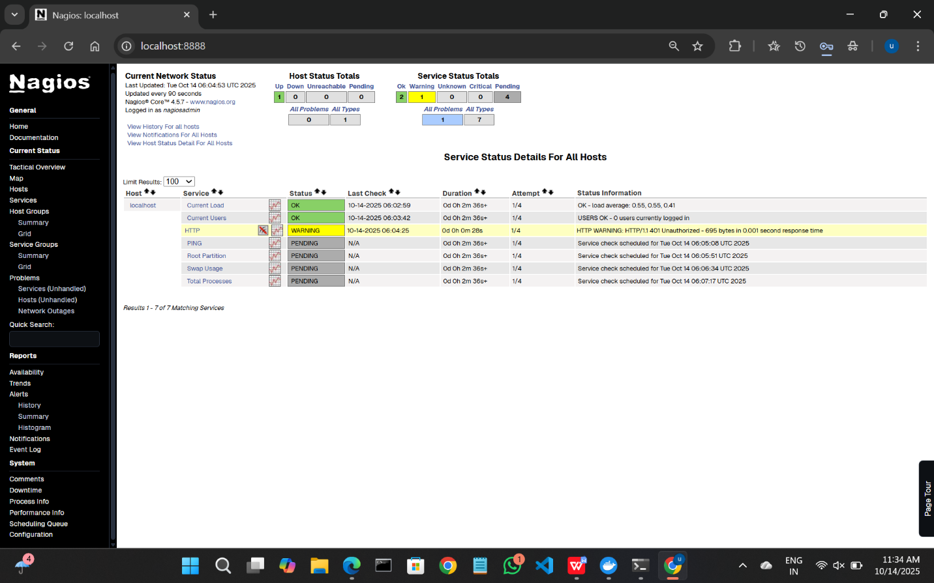

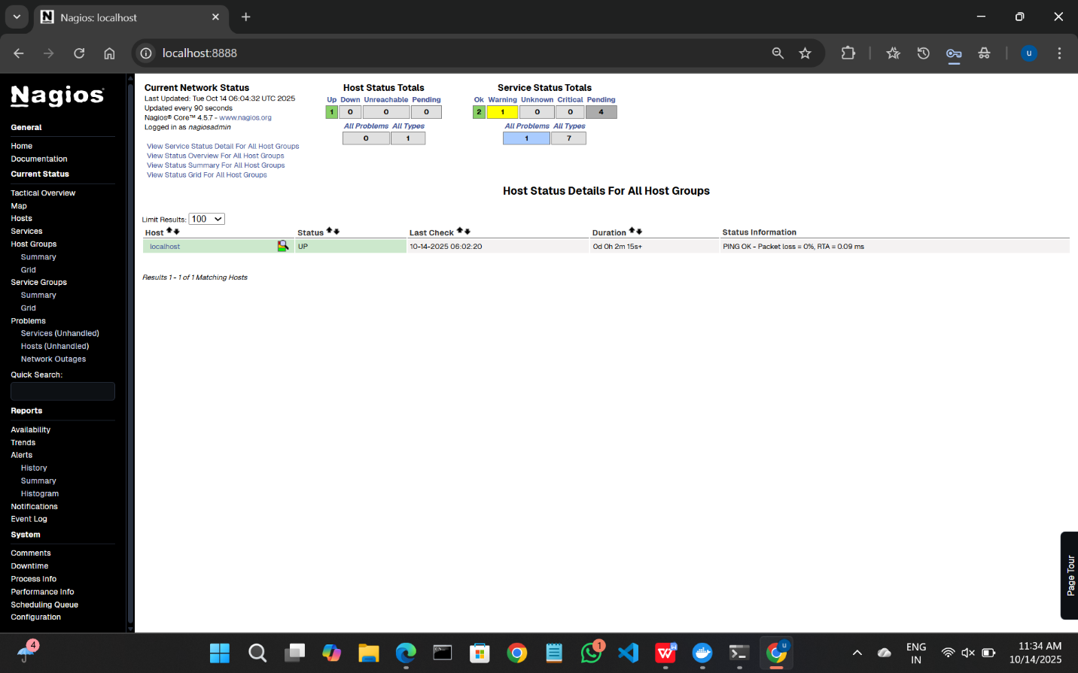

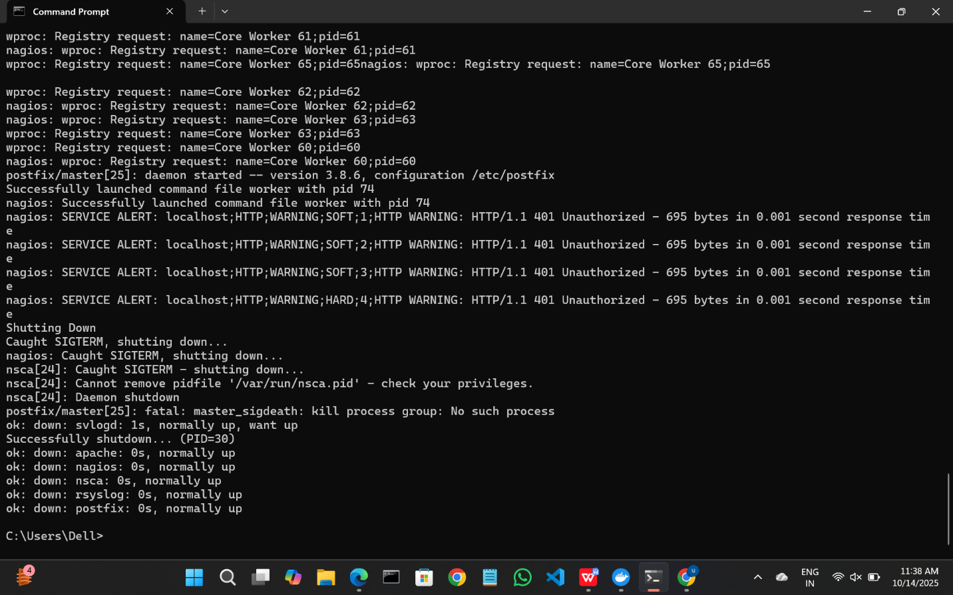

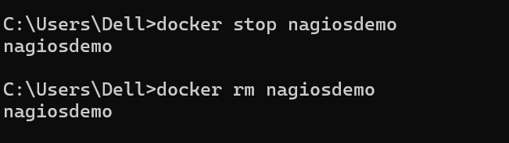

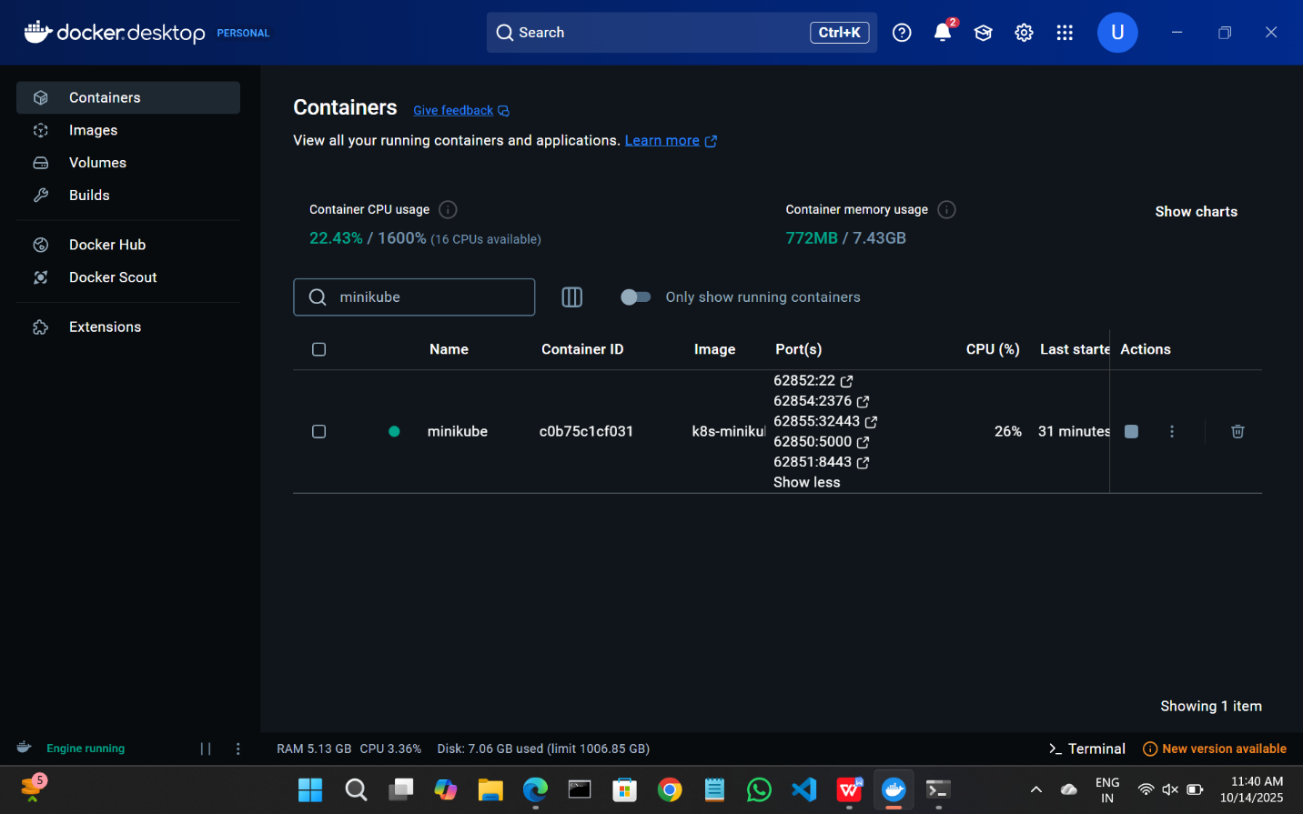

SBQ:

1. **Your Pod keeps restarting repeatedly. What will you do?**

*Check the pod status and events:

kubectl describe pod <pod-name>

kubectl get pod <pod-name> -o wide

*View container logs:

kubectl logs <pod-name>

1. **A Kubernetes pod is stuck in a "Pending" state. What could be the possible reasons, and how would you troubleshoot it?**

**Possible reasons:**

* Insufficient resources on nodes (CPU/memory)
* No node matches pod constraints (nodeSelector, taints, tolerations)
* PersistentVolumeClaim not bound

**Troubleshoot:**

kubectl describe pod <pod-name>

kubectl get events

kubectl get nodes

kubectl describe node <node-name>

1. **How would you debug a failed deployment in Kubernetes?**

kubectl get deployments

kubectl describe deployment <deployment-name>

1. **You have a Kubernetes Deployment with multiple replicas, and some pods are failing health checks. How would you identify the root cause and fix it?**

* Check pods status:

kubectl get pods

kubectl describe pod <pod-name>

kubectl logs <pod-name>

*Check liveness/readiness probes in deployment spec:

kubectl get deployment <deployment-name> -o yaml

*Fix probe configuration or container issues.

1. **How do you roll back a faulty deployment?**

kubectl rollout undo deployment/<deployment-name>

kubectl rollout status deployment/<deployment-name>

kubectl rollout history deployment/<deployment-name>

1. **How do you debug a running Pod?**

kubectl logs <pod-name>

kubectl logs -f <pod-name>

1. **You need to expose a local service externally.How to do?**

kubectl expose deployment <deployment-name> --type=NodePort --port=<port>

kubectl get svc

minikube service <service-name> # for local Minikube

1. **How to Start and stop Nagios**

Start-Service nagios # Start

Stop-Service nagios # Stop

Restart-Service nagios # Restart

Get-Service nagios # Check status

1. **You installed Nagios but the web interface shows *“Unable to connect to Nagios process”*.how to resolve this?**

Get-Service nagios

Restart-Service nagios

1. **You added a new host in Nagios, but it’s not appearing on the web interface.how to check?**

Restart-Service nagios

1. **How can you check whether Nagios is running properly?**

Get-Service nagios

1. **How do you view Nagios logs in real-time**

Get-Content "C:\Nagios\var\nagios.log" -Wait

1. **What are the advantages of using Nagios?**

* Monitors hosts, services, and networks in real-time
* Sends alerts via email/SMS when issues occur
* Scalable and extensible via plugins
* Tracks uptime, performance, and availability
* Open-source and widely supported