

ABSTRACT
This project presents the design and implementation of an AI-based hand gesture controlled media system deployed on the NVIDIA Jetson Nano platform. The system enables touchless control of media playback functions using real-time hand gesture recognition. A USB camera captures live video input, which is processed using OpenCV and MediaPipe to detect and classify hand gestures. The recognized gestures are mapped to media control commands executed through the mpv media player.
To enhance system observability, an OLED display module is integrated via I2C to display detected gestures, real-time frames per second (FPS), and processing latency. Performance optimization techniques are implemented to maintain stable frame rates and low latency on the embedded platform. The project demonstrates effective edge AI deployment with efficient hardware utilization and real-time processing capabilities.

INTRODUCTION
Human-computer interaction is increasingly shifting toward natural and contactless
interfaces. Traditional input devices such as keyboards and remote controls limit flexibility and hygiene. Gesture recognition offers an intuitive and interactive solution by enabling users to control systems using hand movements.
Embedded AI platforms such as the NVIDIA Jetson Nano allow deployment of real-time
computer vision applications at the edge. This project aims to implement a gesture-controlled media system capable of real-time detection and low-latency response. The system integrates vision processing, embedded hardware interfacing, and media playback control into a unified architecture.

OBJECTIVES
- To develop a real-time hand gesture recognition system.
- To deploy the system on NVIDIA Jetson Nano.
- To integrate mpv media player for gesture-based media control.
- To display system performance metrics using an OLED module.
- To optimize FPS and minimize processing latency.

SYSTEM ARCHITECTURE
The system consists of the following modules:
- Image Acquisition Module
- Hand Landmark Detection Module
- Gesture Classification Module
- Media Control Module
- OLED Display Module 6. Performance Monitoring Module Data Flow:
Camera → OpenCV Frame Capture → MediaPipe Landmark Detection → Gesture Logic → mpv Command Execution → OLED Update
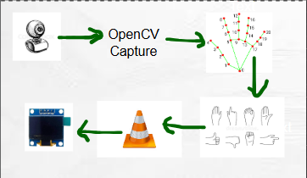

HARDWARE COMPONENTS
- NVIDIA Jetson Nano.
Quad-core ARM CPU with 128-core Maxwell GPU.
- USB Camera
Used for real-time video capture.
- OLED Display (I2C Interface)
Displays gesture name, FPS, and latency.
- HDMI Monitor
Used for debugging and visualization.

- MicroSD Card
Contains JetPack OS and software environment.

SOFTWARE COMPONENTS
- Ubuntu (JetPack 4.6.1)
- Python 3
- OpenCV
- MediaPipe 5.Pynput 6.mpv
- I2C OLED Library
- Socket/System Command Integration

METHODOLOGY
Step 1: Video Capture
OpenCV captures frames from USB camera. Step 2: Frame Preprocessing
Frames are resized and converted to RGB format. Step 3: Hand Landmark Detection
MediaPipe detects 21 hand landmarks. Step 4: Gesture Recognition
Finger positions are analysed to identify predefined gestures such as: Open palm, fist, one finger, peace sign, point right, point left.
Step 5: Media Control
Recognized gestures trigger mpv commands such as play, pause, and volume control.
Step 6: OLED Update
Detected gesture name, FPS, and latency are displayed on OLED screen.

Step 7: Performance Monitoring
FPS is calculated using frame time difference. Latency is computed as processing time per frame.
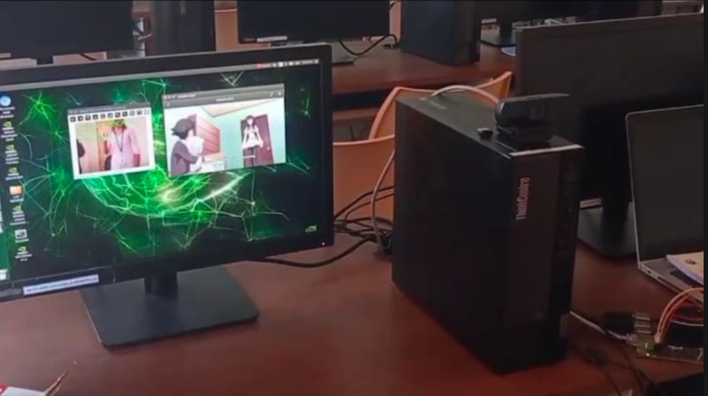
Fig: Performance Monitoring

PERFORMANCE METRICS
Frame Rate (FPS):
Calculated as the inverse of time difference between consecutive frames. Latency:
Measured as total processing time from frame capture to gesture execution.

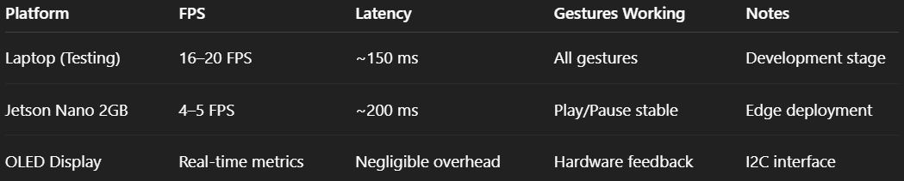
System maintains stable FPS under moderate resolution settings. Latency remains within real-time interaction limits.

OPTIMIZATION TECHNIQUES
- Frame resizing to reduce computational load.
- Single-hand detection mode for faster processing.
- Lightweight mpv player for reduced CPU usage.
- Controlled OLED refresh rate to minimize I2C overhead.
- Efficient landmark filtering logic.

CHALLENGES FACED AND TROUBLESHOOTING

During the deployment of the gesture-controlled media system on Jetson Nano 2GB, several practical challenges were encountered:

Hardware Constraints
Jetson Nano’s limited 2GB RAM caused lower FPS compared to laptop testing.
Solution: Reduced camera resolution, used single-hand detection, and optimized MediaPipe settings.

Package Installation Issues
Some libraries (MediaPipe, dependencies) were difficult to install due to ARM architecture compatibility.
Solution: Installed compatible versions and resolved missing system dependencies.

Media Player Stability
VLC showed instability during testing on Jetson Nano.
Solution: Focused on reliable keyboard-based media control and tested lightweight alternatives.

Camera Initialization Problems
Camera sometimes failed to open, especially during remote access.
Solution: Verified drivers, permissions, and tested both local display and remote sessions.

OLED Integration
Initial OLED setup failed due to wiring/I2C configuration issues.
Solution: Verified connections, confirmed device address, and adjusted initialization.

Key Takeaway
These challenges provided valuable experience in real-world edge AI deployment, system optimization, and hardware–software integration under resource constraints.

CONCLUSION
The system successfully detects hand gestures and controls media playback in real time. OLED display accurately reflects gesture state and system performance metrics. The implementation demonstrates stable operation with minimal lag. The combination of embedded AI processing and real-time feedback confirms effective hardwaresoftware integration.

