PHARMACY MANAGEMENT SYSTEM

-A PROJECT BASED ON DATABASE MANAGEMENT SYSTEM

**ABSTRACT**

In modern world, manually recording and organizing is time consuming and error-prone. So, adopting automated system and computerized technologies is very necessary. So, we are developing ‘Pharmacy management system’ to automate the existing manual system by the help of computerized equipment and full- fledged computer software the data or the information can be stored for the short or long period of time with easy access and manipulation of the data. The required software and hardware requirements are easy to work with. It can assist the user to concentrate on the other activities rather than record keeping. Thus, it will help the pharmacy in better utilization of its resources. The pharmacy can maintain computerized record without redundant entries, it discards the irrelevant data. Basically, this project describes how to manage for good performance and better service.

Traditionally, it was done manually. The main function of the system is register and store customer details, prescription details, staff details, payment details and retrieve these details as and when required, and also to manipulate these details meaningfully. The Pharmacy Management System can be entered using a username and password. It is accessible by an administrator as well as staffs. Only they can add data into the database. The data can be retrieved easily. The data are well protected for personal use and makes the data processing very fast.

The main objective of the management system is to automate the manually maintained records of medicines, sales, stocks, supplies, customer details and other related transactions. The system can lead to error free, reliable, secure and faster management. There are no formal requirements needed to operate this system hereby making it a user-friendly

**PROBLEM STATEMENT**

The Pharmacy Management system is the system that stores pharmacy details. It is important for pharmacist to remember new batches of drugs, prescriptions and expired drugs and also the transactions related to purchases, sales and returns that are maintained manually and these are to be automated and an application is required so the current system can be replaced and accepted without any major changes or challenges. The application should provide quick access to the records maintained and must expose the important reviews about the business growth and improvements so that the important decision could be easily taken.

**INTRODUCTION**

The pharmacy management system has been developed to override the problems occurring in the management of a pharmacy records and manual systems. This database system is designed to reduce or eliminate the problems faced by the existing system. The Pharmacy Management system is the system that stores pharmacy details. It is important for pharmacist to remember new batches of drugs, prescriptions and expired drugs and also the transactions related to purchases, sales and returns that are maintained manually and these are to be automated and an application is required so the current system can be replaced and accepted without any major changes or challenges. The application should provide quick access to the records maintained and must expose the important reviews about the business growth and improvements so that the important decision could be easily taken. This system will have all the basic necessities to manage and operate a fully accomplished pharmacy.

The main objective of the management system is to automate the manually maintained records of medicines, sales, stocks, supplies, customer details and other related transactions. It allows the pharmacists to receive new batches of drugs, delete the expired drugs, store the physician prescription of the patient and also to modify and identify the dosage of drugs. It ensures the availability of drugs from companies and inventories, tracks usage, less wastage and also keeps data secure. The system can lead to error free, reliable, secure and faster management. There are no formal requirements needed to operate this system hereby making it a user-friendly.

The project has admin, cashier, pharmacist, manager modules. Admin modules provides a username and password for manager, pharmacist and cashier. User is provided with name, address, phone number, proof identification number by admin to access even without password. An admin can also remove, add or view the user. The managers can view users, prescription and also manages the stocks. Pharmacist gives the prescription and manages the update and removal of expired stocks and the cashier manages the payment process.

The information can be stored for a shorter or long period of time with easy access. This reduces errors while entering data and also provides error messages when invalid data is entered. No background knowledge is required to operate this hence making this a user-friendly system. This leads to secure, safe, error free and faster management of the pharmacy system.

**LITERATURE WORK**

The system is web-based application and developed using HTML (Hyper Text Markup Language), CSS (Cascading Style Sheets), MySQL and PHP.

**SOFTWARE REQUIREMENTS**

Operating System: WINDOWS 8 or higher

Software : WAMPP

Front End : PHP

Back End : MySQL

**HARDWARE REQUIREMENTS**

RAM : 1GB or greater

Processor : minimum Intel® Core™ i3 1005G1 CPU @ 1.20 GHz or higher

**WAMP (Web Application Messaging protocol)**

Wamp is an application server platform and a network protocol that provides Remote Procedure Calls and Publish & Subscribe in one WebSocket based protocol and Wamp Server refers to a solution stack for Microsoft Windows operating system, created by Romain Bourdon and consisting of the Apache web server, OpenSSL for SSL support, MYSQL database and PHP programming language.

**PHP (Hypertext Preprocessor)**

PHP is a widely used open-source scripting language and it is free to download and use. PHP files can contain text, HTML, CSS, JavaScript and PHP code. PHP can generate dynamic page content .PHP can create, open, read, write, delete, and close files on the server, PHP can collect form data, PHP can send and receive cookies, PHP can add, delete, modify data in your database, PHP can be used to control user-access and also PHP can encrypt data

**MySQL (Structured Query Language)**

SQL is a standard computer language for relational database management and data manipulation. Structure Query Language is used to query, insert, delete and modify data. Most relational database support SQL, which is added to benefit for database administrators as they are often required to support databases across several different platform. The uses of SQL include modifying database table and index structure, adding, updating and deleting rows of data retrieving subsets of information from which the database for transaction processing and analysis.

**HTML (Hypertext Markup Language)**

**HTML** (Hyper Text Markup Language) it is a standard markup language used to create web pages. HTML was created in 1991 by Tim Berners-Lee. The purpose of web browser is to read the HTML documents and compose them into visible web page. The browser does not display the HTML tags, but uses the tags to interpret the content of the pages. HTML describes the structure of the website semantically along with clues for presentation, making it a markup language rather than a programming language. HTML can be assisted by technologies such as Cascading Style Sheets (CSS) and scripting languages such as Java Script. Web browsers receive HTML documents from a web server or from local storage and render the documents into multimedia web pages. HTML elements are the building blocks of HTML pages. With HTML constructs, images and other objects such as interactive forms may be embedded into rendered page. HTML provides means to create structured documents by denoting structural semantics for text such as headings, paragraphs, lists, links, quotes and other items.

**CSS (Cascading Style Sheets)**

**Cascading Style Sheets** (**CSS**) is a [style sheet language](https://en.wikipedia.org/wiki/Style_sheet_language) used for describing the [presentation](https://en.wikipedia.org/wiki/Presentation_semantics) of a document written in a [markup language](https://en.wikipedia.org/wiki/Markup_language) such as [HTML](https://en.wikipedia.org/wiki/HTML). CSS is a cornerstone technology of the [World Wide Web](https://en.wikipedia.org/wiki/World_Wide_Web), alongside HTML and [JavaScript](https://en.wikipedia.org/wiki/JavaScript). CSS was first proposed by [Håkon Wium Lie](https://en.wikipedia.org/wiki/H%C3%A5kon_Wium_Lie) on October 10, 1994. Several other style sheet languages for the web were proposed around the same time, and discussions on public mailing lists and inside [World Wide Web Consortium](https://en.wikipedia.org/wiki/World_Wide_Web_Consortium) resulted in the first W3C CSS Recommendation (CSS1) being released in 1996. In particular, a proposal by [Bert Bos](https://en.wikipedia.org/wiki/Bert_Bos) was influential; he became co-author of CSS1, and is regarded as co-creator of CSS. Style sheets have existed in one form or another since the beginnings of Standard Generalized Markup Language ([SGML](https://en.wikipedia.org/wiki/SGML)) in the 1980s, and CSS was developed to provide style sheets for the web. One requirement for a web style sheet language was for style sheets to come from different sources on the web. Therefore, existing style sheet languages like [DSSSL](https://en.wikipedia.org/wiki/Document_Style_Semantics_and_Specification_Language) and [FOSI](https://en.wikipedia.org/wiki/Formatting_Output_Specification_Instance) were not suitable. CSS, on the other hand, let a document's style be influenced by multiple style sheets by way of "cascading" styles.

CSS is designed to enable the separation of presentation and content, including [layout](https://en.wikipedia.org/wiki/Page_layout), [colors](https://en.wikipedia.org/wiki/Color), and [fonts](https://en.wikipedia.org/wiki/Typeface). This separation can improve content [accessibility](https://en.wikipedia.org/wiki/Accessibility), provide more flexibility and control in the specification of presentation characteristics, enable multiple [web pages](https://en.wikipedia.org/wiki/Web_page) to share formatting by specifying the relevant CSS in a separate .CSS file which reduces complexity and repetition in the structural content as well as enabling the .CSS file to be [cached](https://en.wikipedia.org/wiki/Cache_(computing)) to improve the page load speed between the pages that share the file and its formatting. Separation of formatting and content also makes it feasible to present the same markup page in different styles for different rendering methods, such as on-screen, in print, by voice (via speech-based browser or [screen reader](https://en.wikipedia.org/wiki/Screen_reader)), and on [Braille-based](https://en.wikipedia.org/wiki/Braille_display) tactile devices. CSS also has rules for alternate formatting if the content is accessed on a [mobile device](https://en.wikipedia.org/wiki/Mobile_device). The name *cascading* comes from the specified priority scheme to determine which style rule applies if more than one rule matches a particular element. This cascading priority scheme is predictable.

**PHP (Hypertext Preprocessor)**

**PHP** is a [general-purpose](https://en.wikipedia.org/wiki/General-purpose_programming_language) [scripting language](https://en.wikipedia.org/wiki/Scripting_language) especially suited to [web development](https://en.wikipedia.org/wiki/Web_development). It was originally created by Danish-Canadian [programmer](https://en.wikipedia.org/wiki/Programmer) [Rasmus Lerdorf](https://en.wikipedia.org/wiki/Rasmus_Lerdorf) in 1994. The PHP [reference implementation](https://en.wikipedia.org/wiki/Reference_implementation) is now produced by The PHP Group. PHP originally stood for *Personal Home Page*, but it now stands for the [recursive initialism](https://en.wikipedia.org/wiki/Recursive_initialism) *PHP: Hypertext Preprocessor*.PHP code is usually processed on a [web server](https://en.wikipedia.org/wiki/Web_server) by a PHP [interpreter](https://en.wikipedia.org/wiki/Interpreter_(computing)) implemented as a [module](https://en.wikipedia.org/wiki/Plugin_(computing)), a [daemon](https://en.wikipedia.org/wiki/Daemon_(computing)) or as a [Common Gateway Interface](https://en.wikipedia.org/wiki/Common_Gateway_Interface) (CGI) executable. On a web server, the result of the interpreted and executed PHP code – which may be any type of data, such as generated [HTML](https://en.wikipedia.org/wiki/HTML) or binary image data – would form the whole or part of an [HTTP](https://en.wikipedia.org/wiki/Hypertext_Transfer_Protocol) response. Various [web template systems](https://en.wikipedia.org/wiki/Web_template_system), web [content management systems](https://en.wikipedia.org/wiki/Content_management_system), and [web frameworks](https://en.wikipedia.org/wiki/Web_framework) exist which can be employed to orchestrate or facilitate the generation of that response.

Additionally, PHP can be used for many programming tasks outside of the web context, such as standalone [graphical applications](https://en.wikipedia.org/wiki/Graphical_user_interface) and robotic [drone](https://en.wikipedia.org/wiki/Unmanned_aerial_vehicle) control. Arbitrary PHP code can also be interpreted and executed via [command-line interface](https://en.wikipedia.org/wiki/Command-line_interface) (CLI). The standard PHP interpreter, powered by the [Zend Engine](https://en.wikipedia.org/wiki/Zend_Engine), is [free software](https://en.wikipedia.org/wiki/Free_software) released under the [PHP License](https://en.wikipedia.org/wiki/PHP_License). PHP has been widely ported and can be deployed on most web servers on almost every [operating system](https://en.wikipedia.org/wiki/Operating_system) and [platform](https://en.wikipedia.org/wiki/Computing_platform), free of charge. The PHP language evolved without a written [formal specification](https://en.wikipedia.org/wiki/Formal_specification) or standard until 2014, with the original implementation acting as the [*de facto*](https://en.wikipedia.org/wiki/De_facto) standard which other implementations aimed to follow. Since 2014, work has gone on to create a formal PHP specification.

**ER-DIAGRAM**

The logical view of the system from the data perspective can be designed using ER model. The components of ER modules are, entity, attributes, relationships etc. The entity may be an object with a physical existence or it may be an object with the conceptual existence.

The entity is an object of entity type and set of all entities is called as entity set. The entities are represented using rectangles. In our ER diagram user, login, stock, medicine and inventory are the entities. Attributes are the properties which define the entity type.

There are several types of attributes, key attributes, composite attributes, multivalued attributes and derived attributes. The attribute which uniquely identifies each entity in the entity set is called key attribute. The key attributes in our ER diagram are user_id, username, m_id, s_id, i_id.

An attribute composed of many other attributes is called composite attributes. There is no composite attribute in our ER diagram. An attribute consisting of more than one value for a given entity is known as multivalued attribute.

There is no multivalued attribute in our ER diagram. An attribute which can be derived from other attributes of the entity type is known as derived attribute. There is no derived attribute in our ER diagram. The way in which the two or more entities are linked is known as Relationship. The relationship type represents the association between the entity types.

There are three types of relationships. They are unary, binary and n-ary relationships. If there is only one entity set participating in relation, then such a relationship is known as unary relationship.

If there are two entity sets participating in the relation then such type if relation is known as binary relation. If there are ‘n’ entity sets participating in the relation then such type of relationship is known as n-ary relationship. In our ER model it only consists of Binary relationship and n-ary relationship.

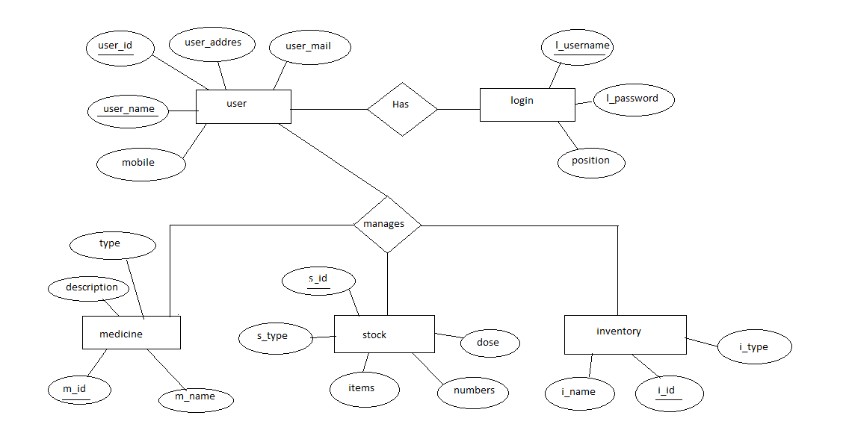

**SCHEMA DIAGRAM**

The database schema of a database is a structure described in a formal language supported by the database management system (DBMS).

The term schema refers to the organization of data as a blueprint of how the database is constructed (divided into tables in case of relational database). The formal definition of a database schema is a set of formulas or sentences called integrity constraints imposed on a database.

These integrity constraints ensure compatibility between parts of the schema. All constraints are expressible in the same language. A database can be considered as a structure in realization of the database language. The states of a created conceptual schema are transformed into an explicit mapping, the database schema.

This describes how real-world entities are modelled in a database. A database schema specifies, based on the database administrator’s knowledge of possible applications, the facts that can enter the database, or those of interest to the possible end users. In a relational database the schema defines the tables, fields, relationships, views, indexes, packages, procedures, functions, queues, triggers, types, sequences and other elements. A database generally stores its schema in its data dictionary.

Although a schema is defined in text database language, the term is often used to refer to a graphical depiction of the database structure. In other words, schema is the structure of the database that defines the objects in the database.

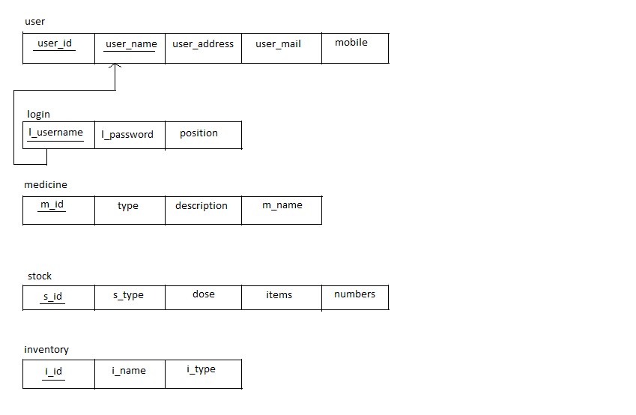

**IMPLEMENTATION**

**//login page-**

The user has to get his username and password from the admin by providing the name, address, phone no, id proof and can get the access to the application without the username and password he cannot get the access to the application.

In this application we have four types of users who have their specified work to perform and while logging in to the application he should know his designation to log in.

#main {

height: auto;}

</style>

</head>

<link rel="stylesheet" href="pmsc.css">

<body>

<div id="content">

<div id="header">

<h1><imgsrc="images/hd_logo.jpg" height="150" width="200"></h1>

</div>

<div class="pmc" id="main">

<section class="container">

<div class="login">

<h1><strong>Pharmacy Management system</strong></h1>

<form method="post" action="index.php">

<p><input type="text" name="username" value="" placeholder="Username"></p>

<p><input type="password" name="password" value="" placeholder="Password"></p>

<p><select name="position">

<option>--Select position--</option>

<option>Admin</option>

<option>Pharmacist</option>

<option>Cashier</option>

<option>Manager</option>

</select></p>

<p><button type="button" name="signup-btn">Login</button></p>

</form>

</div>

</section>

</div>

<div id="footer" align="Center"></div>

</div>

</body>

</html>

User can be either Admin, Pharmacist, Cashier and Manager. Username and password are provided by the admin and position which they are assigned to them and then login to the enter into the dashboard.

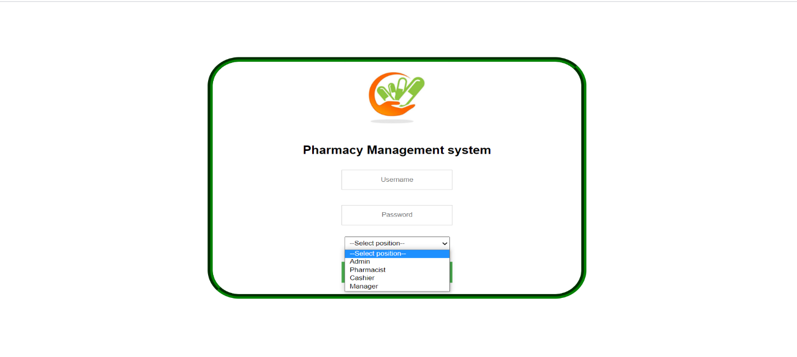

**//admin page-**

|  |  |
| --- | --- |
|  | <!DOCTYPE html> |
|  | <html> |
|  | <head> |
|  | <title><?php echo $user;?> - Pharmacy Management System</title> |
|  | <link rel="stylesheet" type="text/css" href="style/mystyle.css"> |
|  | <link rel="stylesheet" href="style/style.css" type="text/css" media="screen" /> |
|  | <link rel="stylesheet" type="text/css" href="style/dashboard_styles.css" media="screen" /> |
|  | <script src="js/function.js" type="text/javascript"></script> |
|  | <style> |
|  | #left_column{ |
|  | height: 470px; |
|  | } |
|  |  |
|  | </style> |
|  | </head> |
|  | <body> |
|  | <div id="content"> |
|  | <div id="header"> |
|  | <h1><a href="#"><img src="images/hd_logo.jpg"></a> Pharmacy Management Systen</h1></div> |
|  | <div id="left_column"> |
|  | <div id="button"> |
|  | <ul> |
|  | <li><a href="admin.php">Dashboard</a></li> |
|  | <li><a href="admin_pharmacist.php">Pharmacist</a></li> |
|  | <li><a href="admin_manager.php">Manager</a></li> |
|  | <li><a href="admin_cashier.php">Cashier</a></li> |
|  | <li><a href="logout.php">Logout</a></li> |
|  | </ul> |
|  | </div> |
|  | </div> |
|  | <div id="main"> |
|  |  |
|  | <!-- Dashboard icons --> |
|  | <div class="grid_7"> |
|  | <a href="admin.php" class="dashboard-module"> |
|  | <img src="images/admin_icon.jpg" width="75" height="75" alt="edit" /> |
|  | <span>Dashboard</span> |
|  | </a> |
|  | <a href="admin_pharmacist.php" class="dashboard-module"> |
|  | <img src="images/pharmacist_icon.jpg" width="75" height="75" alt="edit" /> |
|  | <span>Pharmacist</span> |
|  | </a> |
|  |  |
|  | <a href="admin_manager.php" class="dashboard-module"> |
|  | <img src="images/manager_icon.png" width="75" height="75" alt="edit" /> |
|  | <span>Manager</span> |
|  | </a> |
|  |  |
|  | <a href="admin_cashier.php" class="dashboard-module"> |
|  | <img src="images/cashier_icon.jpg" width="75" height="75" alt="edit" /> |
|  | <span>Cashier</span> |
|  | </a> |
|  | </div> |
|  | </div> |
|  | <div id="footer" align="Center"></div> |
|  | </div> |
|  | </body> |
|  | </html> |
|  |  |

Here admin provides a username and password for manager, pharmacist, and cashier. Admin can also view, add and remove the user. Admin has the access to dashboard, pharmacist, manager and cashier.

**Dashboard**

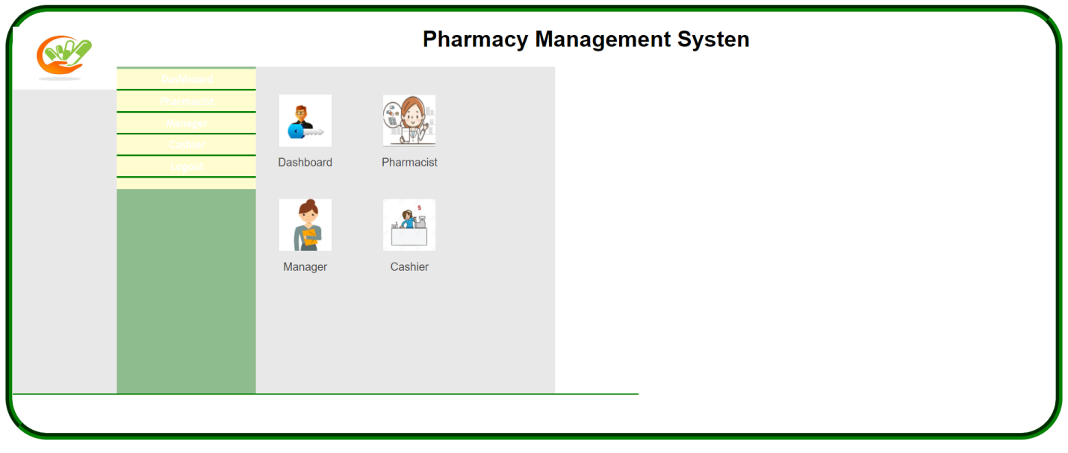

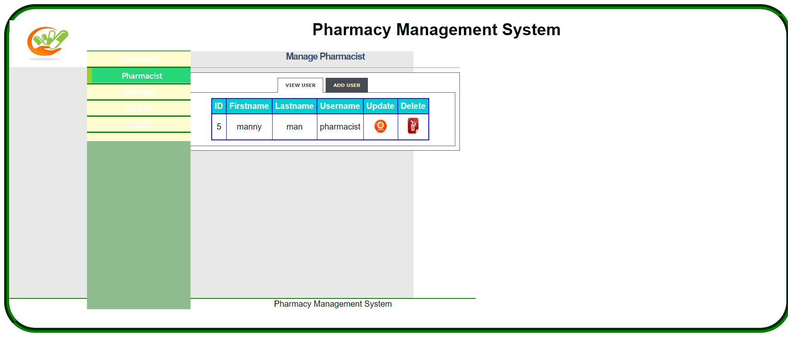

**Manage** **Manager**

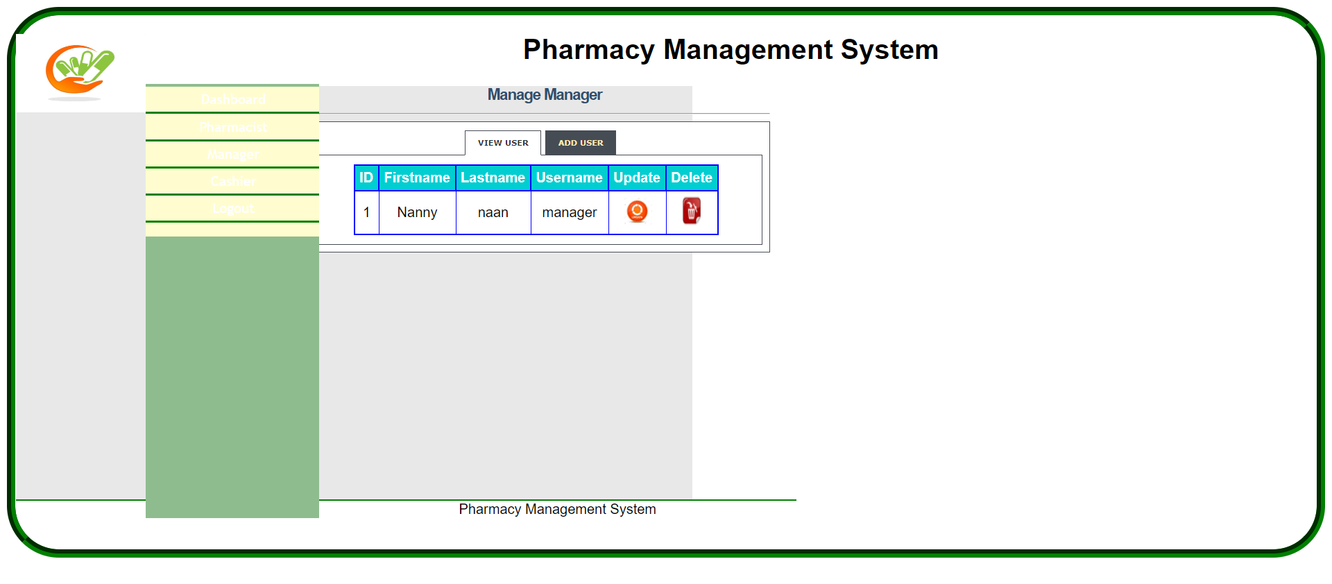

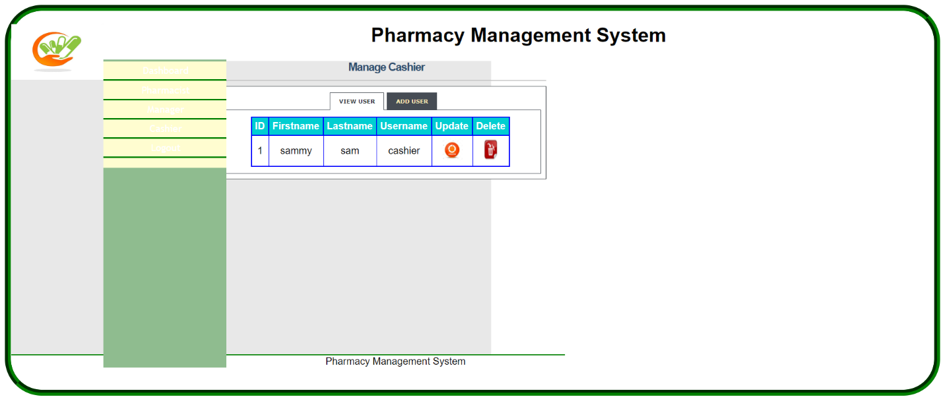

**//cashier page-**

|  |  |
| --- | --- |
|  | <!DOCTYPE html> |
|  | <html> |
|  | <head> |
|  | <title><?php echo $user;?> - Pharmacy Management System</title> |
|  | <link rel="stylesheet" type="text/css" href="style/mystyle.css"> |
|  | <link rel="stylesheet" href="style/style.css" type="text/css" media="screen" /> |
|  | <link rel="stylesheet" type="text/css" href="style/dashboard_styles.css" media="screen" /> |
|  | <script src="js/function.js" type="text/javascript"></script> |
|  | <style> |
|  | #left_column{ |
|  | height: 470px; |
|  | } |
|  | </style> |
|  | </head> |
|  | <body> |
|  | <div id="content"> |
|  | <div id="header"> |
|  | <h1><a href="#"><img src="images/hd_logo.jpg"></a> Pharmacy Management System</h1></div> |
|  | <div id="left_column"> |
|  | <div id="button"> |
|  | <ul> |
|  | <li><a href="cashier.php">Dashboard</a></li> |
|  | <li><a href="payment.php"target="_top">Process payment</a></li> |
|  | <li><a href="logout.php">Logout</a></li> |
|  | </ul> |
|  | </div> |
|  | </div> |
|  | <div id="main"> |
|  | <!-- Dashboard icons --> |
|  | <div class="grid_7"> |
|  | <a href="cashier.php" class="dashboard-module"> |
|  | <img src="images/cashier_icon.jpg" width="100" height="100" alt="edit" /> |
|  | <span>Dashboard</span> |
|  | </a> |
|  | <a href="payment.php"target="_top" class="dashboard-module"> |
|  | <img src="images/payment.png" width="100" height="100" alt="edit" /> |
|  | <span>Process Payment</span> |
|  | </a> |
|  | </div> |
|  | </div> |
|  | <div id="footer" align="Center"> Pharmacy Management System</div> |
|  | </div> |
|  | </body> |
|  | </html> |
|  |  |

The cashier is responsible for processing the payment. Cashier can manipulate the payment methods and payment process and also cashier saves the details about the payment.

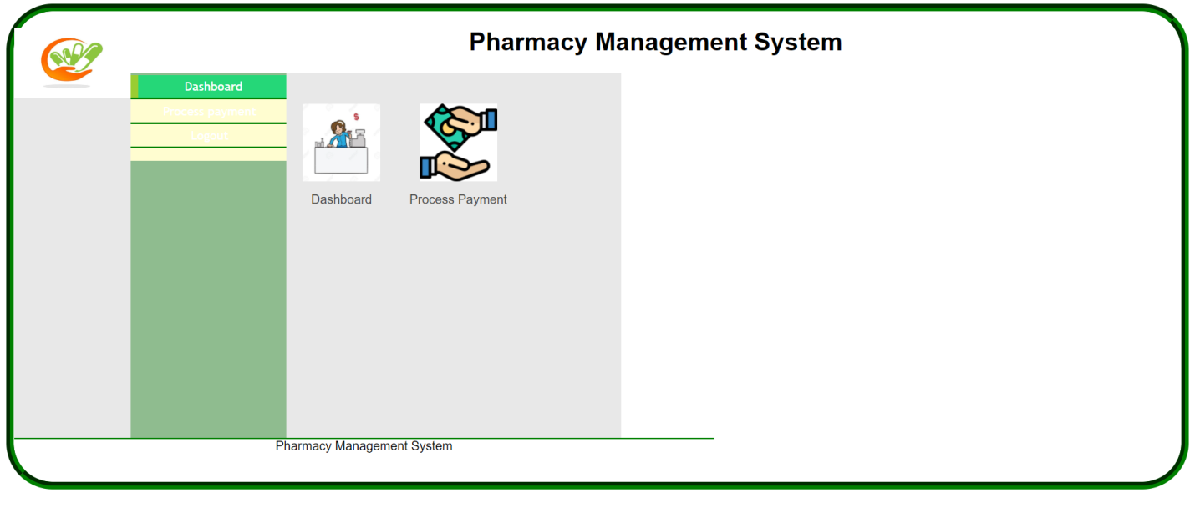

**Payment process**

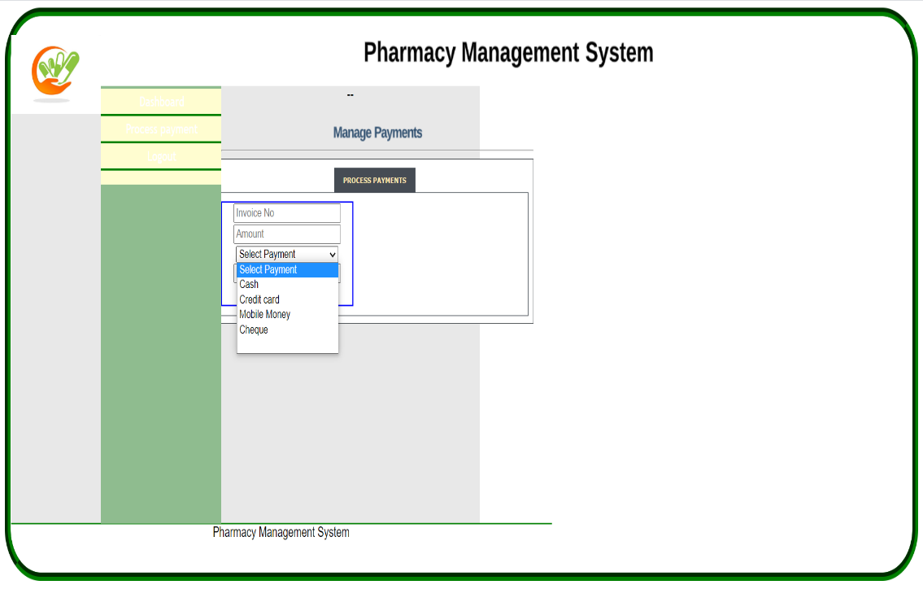

**//manager page-**

|  |  |
| --- | --- |
|  | <!DOCTYPE html> |
|  | <html> |
|  | <head> |
|  | <title><?php echo $user;?> - Pharmacy Sys</title> |
|  | <link rel="stylesheet" type="text/css" href="style/mystyle.css"> |
|  | <link rel="stylesheet" href="style/style.css" type="text/css" media="screen" /> |
|  | <link rel="stylesheet" type="text/css" href="style/dashboard_styles.css" media="screen" /> |
|  | <script src="js/function.js" type="text/javascript"></script> |
|  | <style> |
|  | #left_column{ |
|  | height: 470px; |
|  | } |
|  | </style> |
|  | </head> |
|  | <body> |
|  | <div id="content"> |
|  | <div id="header"> |
|  | <h1><a href="#"><img src="images/hd_logo.jpg"></a> Pharmacy Management System</h1></div> |
|  | <div id="left_column"> |
|  | <div id="button"> |
|  | <ul> |
|  | <li><a href="manager.php">Dashboard</a></li> |
|  | <li><a href="view.php">View Users</a></li> |
|  | <li><a href="view_prescription.php">View Prescription</a></li> |
|  | <li><a href="stock.php">Manage Stock</a></li> |
|  | <li><a href="logout.php">Logout</a></li> |
|  | </ul> |
|  | </div> |
|  | </div> |
|  | <div id="main"> |
|  | <!-- Dashboard icons --> |
|  | <div class="grid_7"> |
|  | <a href="manager.php" class="dashboard-module"> |
|  | <img src="images/manager_icon.png" width="100" height="100" alt="edit" /> |
|  | <span>Dashboard</span> |
|  | </a> |
|  | <a href="view.php" class="dashboard-module"> |
|  | <img src="images/patients_1.png" width="100" height="100" alt="edit" /> |
|  | <span>View Users</span> |
|  | </a> |
|  | <a href="#" class="dashboard-module"> |
|  | <img src="images/Invoice.png" width="100" height="100" alt="edit" /> |
|  | <span>View Invoices</span> |
|  | </a> |
|  | <a href="view_prescription.php" class="dashboard-module"> |
|  | <img src="images/prescri.jpg" width="100" height="100" alt="edit" /> |
|  | <span>View Prescription</span> |
|  | </a> |
|  | <a href="stock.php" class="dashboard-module"> |
|  | <img src="images/stock_icon.jpg" width="100" height="100" alt="edit" /> |
|  | <span>Manage Stock</span> |
|  | </a> |
|  | </div> |
|  | </div> |
|  | <div id="footer" align="Center"> Pharmacy Management System</div> |
|  | </div> |
|  | </body> |
|  | </html> |
|  |  |

The manager can view users, view prescription and manage the stock. The manager can also view admin, pharmacist and cashiers. The manager has the access to admin, pharmacist and cashier, and also manager can manipulate all these.

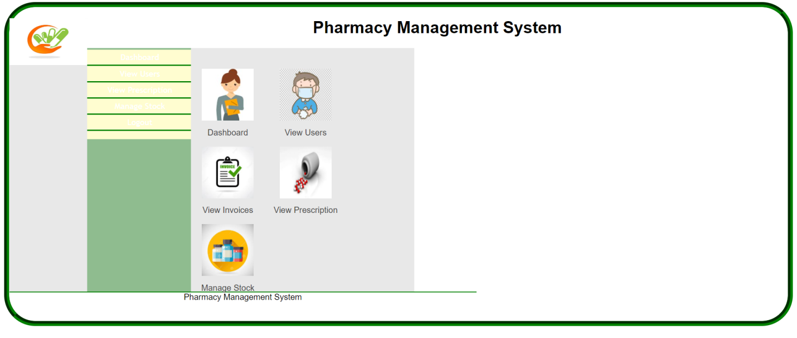

**Views prescription**

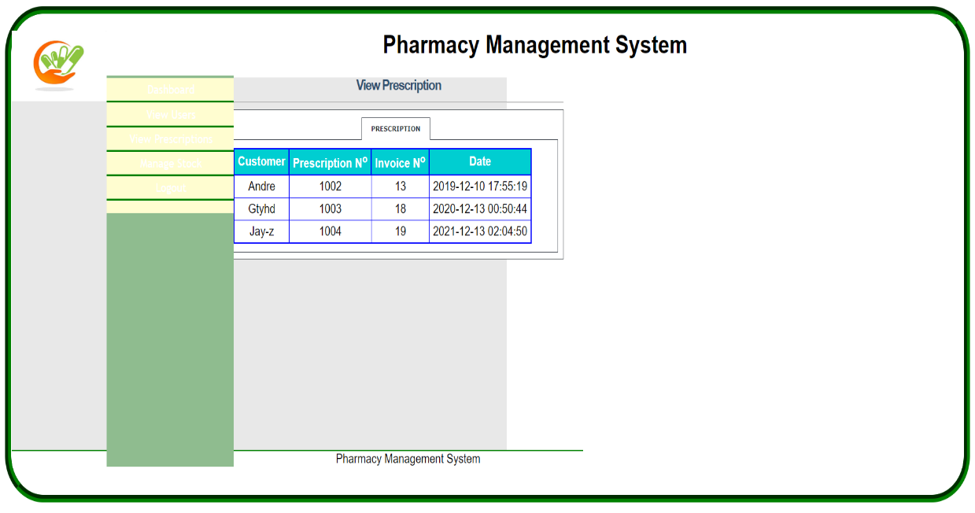

**Views user**

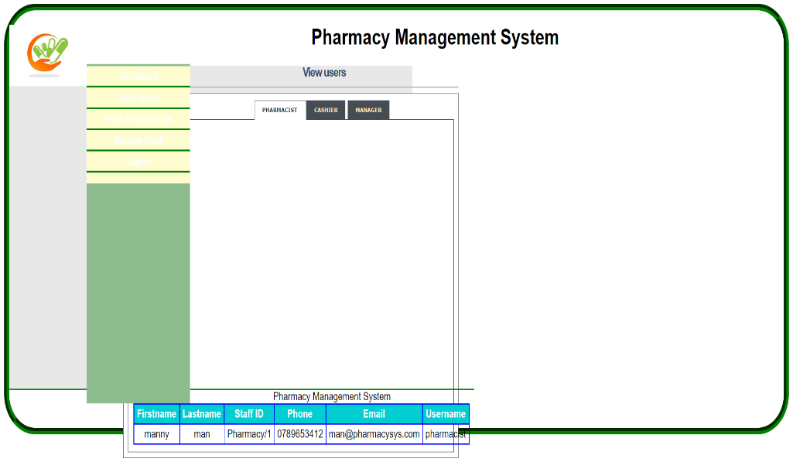

**Manages stock**

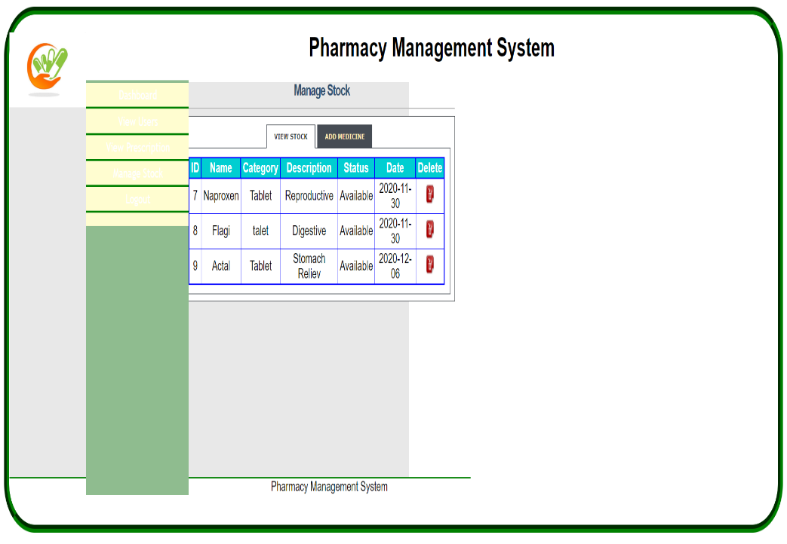

**//pharmacist page-**

|  |  |
| --- | --- |
|  | <!DOCTYPE html> |
|  | <html> |
|  | <head> |
|  | <title><?php echo $user;?> - Pharmacy Sys</title> |
|  | <link rel="stylesheet" type="text/css" href="style/mystyle.css"> |
|  | <link rel="stylesheet" href="style/style.css" type="text/css" media="screen" /> |
|  | <link rel="stylesheet" type="text/css" href="style/dashboard_styles.css" media="screen" /> |
|  | <script src="js/function.js" type="text/javascript"></script> |
|  | <style> |
|  | #left_column{ |
|  | height: 470px; |
|  | } |
|  | </style> |
|  | </head> |
|  | <body> |
|  | <div id="content"> |
|  | <div id="header"> |
|  | <h1><a href="#"><img src="images/hd_logo.jpg"></a> Pharmacy Management System</h1></div> |
|  | <div id="left_column"> |
|  | <div id="button"> |
|  | <ul> |
|  | <li><a href="pharmacist.php">Dashboard</a></li> |
|  | <li><a href="prescription.php">Prescription</a></li> |
|  | <li><a href="stock_pharmacist.php">Stock</a></li> |
|  | <li><a href="logout.php">Logout</a></li> |
|  | </ul> |
|  | </div> |
|  | </div> |
|  | <div id="main"> |
|  | <!-- Dashboard icons --> |
|  | <div class="grid_7"> |
|  | <a href="pharmacist.php" class="dashboard-module"> |
|  | <img src="images/pharmacist_icon.jpg" width="100" height="100" alt="edit" /> |
|  | <span>Dashboard</span> |
|  | </a> |
|  |  |
|  | <a href="prescription.php" class="dashboard-module"> |
|  | <img src="images/prescri.jpg" width="100" height="100" alt="edit" /> |
|  | <span>Prescription</span> |
|  | </a> |
|  | <a href="stock_pharmacist.php" class="dashboard-module"> |
|  | <img src="images/stock_icon.jpg" width="100" height="100" alt="edit" /> |
|  | <span>Stock</span> |
|  | </a> |
|  | </div> |
|  | </div> |
|  | <div id="footer" align="Center"> Pharmacy Management System</div> |
|  | </div> |
|  | </body> |
|  | </html> |
|  |  |

The pharmacist is given access to stock. The pharmacist has the rights to manipulate the medicine stock and also the prescription. Pharmacist gives the prescription and manages the stock. The pharmacist can also create and view the given prescription. And pharmacist can view the stock and can also add medicines.

**dashboard**

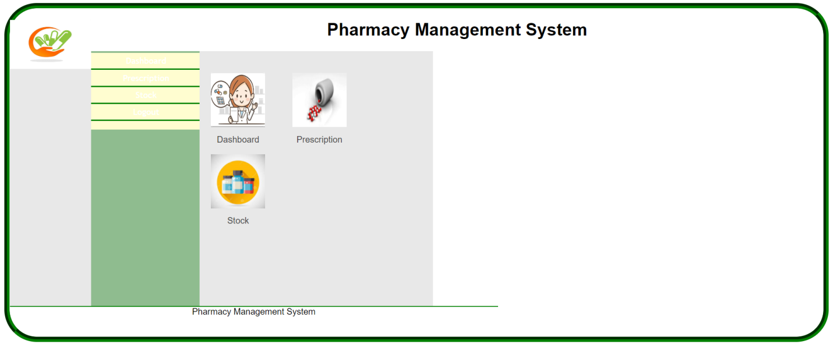

**Manages prescription**

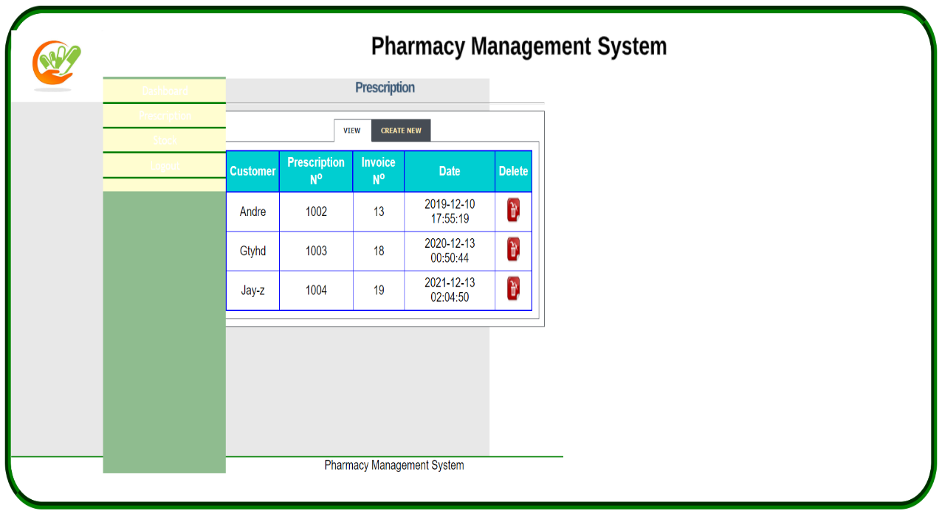

**Manages stock**

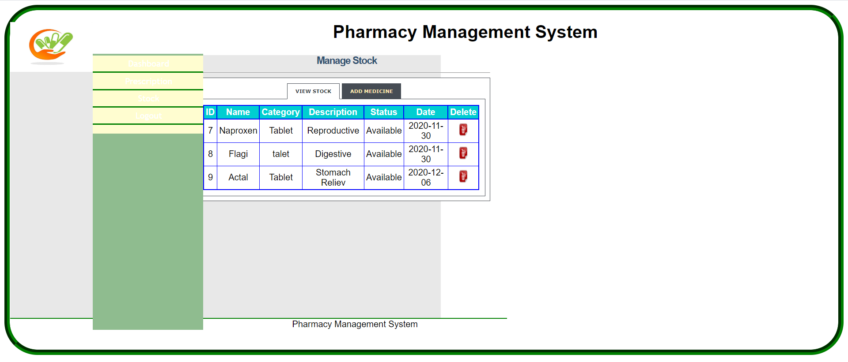

**CONCLUSION**

* The "pharmacy management system" is actually a software which handle the essential data and save the data about the database of a pharmacy and its management.
* This software help in effective management of the pharmaceutical store or shop.
* It provides the statistics about medicine or drugs which are in stocks which data can also be uploaded and edited.
* It works as per the requirement of the user and have options accordingly.
* It allows user to enter manufacturing as well as the expiry date of the medicine placing in stock and for sales transaction.
* This software also has ability to invoice.
* The main purpose is effectively and easily handling of pharmacy data and its management.
* The online pharmacy management system is eminent that the system provides a safe, secure and verified platform for all parties which help to bridge the communication gap and provide legitimate drugs. Because drugs are harmful when abused or misused by individuals or organizations, security checks have been added to the design logic. Therefore, if all recommendations are strictly adhered to, there will be strict monitoring and regulation of how drugs are circulated and decrease in the spread of fake drugs.

**REFERENCES**

* [1] w3schools.com/HTML fundementals, URL: <https://www.w3schools.com/html>
* [2] w3schools.com/SQL fundementals, URL: https://www.w3schools.com/sql
* [3] w3schools.com/CSS fundementals, URL: https://www.w3schools.com/css
* [4] w3schools.com/PHP fundementals, URL: https://www.w3schools.com/php
* [5] youtube.com/Overall Reference, URL: https://www.youtube.com