FindMyStuff-Image-Based Lost & Found Matching System (UniTrack)

A PROJECT REPORT

Submitted by
MAVANI RUCHIT (2403051057034)
PATEL UNNATI (2403051057126)
PATEL KASHISH (2403051057120)
PATEL DHRUVI (2403051057119)

In Partially fulfilment for the award of the degree

Of

BACHELOR OF TECHNOLOGY

In

COMPUTER SCIENCE & ENGINEERING

Under the Guidance of

Mr. NITIN PAL

Assistant Professor

Computer Science & Engineering Department

Parul Institute of Technology


Parul University, Vadodara

2026-27

PARUL UNIVERSITY

CERTIFICATE

This is to certify that Project-II - 303105423 of 7th Semester entitled “FindMyStuff-Image-Based Lost & Found Matching System (UniTrack)” of Group No. PUCSE311 has been successfully completed by

MAVANI RUCHIT (2403051057034)

PATEL UNNATI (2403051057126)

PATEL KASHISH (2403051057120)

PATEL DHRUVI (2403051057119)

under my guidance in fulfillment of the Bachelor of Technology (B. TECH) in Computer Science & Engineering of Parul University in Academic Year 2026-2027

Mr. NITIN PAL
Project Guide
Ms. ARNIKA PATEL
Project Coordinator

Prof. Sumitra Menaria
Head of Department
CSE/IT/ICT External Examiner

DECLARATION

We the undersigned solemnly declare that the project report “FindMyStuff-Image-Based Lost & Found Matching System (UniTrack)” is based on my own work carried out during the course of our study under the supervision of Prof. Nitin Pal, Asst.Prof., CSE.

We assert the statements made and conclusions drawn are the outcomes of my own work. I further certify that

1. The work contained in the report is original and has been done by us under the general supervision of our supervisor.

2. The work has not been submitted to any other Institution for any other degree / diploma / certificate in this university or any other University of India or abroad.

3. We have followed the guidelines provided by the university in writing the report.

Whenever we have used materials from other sources, we have given due credit to them in the text of the report and giving their details in the references.

MAVANI RUCHIT [2403051057034] :- _________________

PATEL UNNATI [2403051057126]:- ________________

PATEL KASHISH [2403051057120]:- ________________

PATEL DHRUVI [2403051057119]:- _________________
ACKNOWLEDGEMENT

Behind any major work undertaken by an individual there lies the contribution of the people who helped him to cross all the hurdles to achieve his goal.

It gives us the immense pleasure to express our sense of sincere gratitude towards our respected guide Assistant Professor Mr. Nitin Pal for his persistent, outstanding, invaluable co-operation and guidance. It is our achievement to be guided under him.

He is a constant source of encouragement and momentum that any intricacy becomes simple. We gained a lot of invaluable guidance and prompt suggestions from him during entire project work. We will be indebted of him forever and We take pride to work under him.

We also express our deep sense of regards and thanks to Prof. Sumitra Menaria, Assistant Professor and Head of CSE/IT/ICT Engineering Department. We feel very privileged to have had their precious advices, guidance and leadership.

Last but not the least, our humble thanks to the Almighty God.

Place: Vadodara
Date: September 2026
MAVANI RUCHIT [2403051057034]

PATEL UNNATI [2403051057126]

PATEL KASHISH [2403051057120]

PATEL DHRUVI [2403051057119]

LIST OF FIGURES
S. No. | Figure No. | Name of Figure | Page No.
1 | Fig. 3.5.1 | System Architecture
2 | Fig. 3.5.2 | GPS Tracking Architecture
3 | Fig. 3.5.3 | Data Flow Diagram (DFD) – Level 0, Level 1 and Level 2
4 | Fig. 3.5.4 | Entity Relationship Diagram (ER Diagram)
5 | Fig. 3.5.5 | Use Case Diagram
6 | Fig. 4.3.1 | Android Application Project Structure
7 | Fig. 4.3.2 | Application Adapters, Fragments and Model Structure
8 | Fig. 4.3.3 | Backend Project Source Code Structure
9 | Fig. 5.1 | Student and Driver Role Selection Screen
10 | Fig. 5.2 | Student Registration and Driver Login Screen
11 | Fig. 5.3 | Student Route, Lost & Found and Profile Screens
12 | Fig. 5.4 | Driver Dashboard and GPS Tracking Screens
13 | Fig. 5.5 | Driver Bus Assignment, Emergency and Profile Screens

LIST OF ABBREVIATIONS
Sr. No. | Abbreviation | Full Form
1 | AI | Artificial Intelligence
2 | API | Application Programming Interface
3 | GPS | Global Positioning System
4 | GUI | Graphical User Interface
5 | UI | User Interface
6 | UX | User Experience
7 | DFD | Data Flow Diagram
8 | ERD | Entity Relationship Diagram
9 | DBMS | Database Management System
10 | DB | Database
11 | SQL | Structured Query Language
12 | ETA | Estimated Time of Arrival
13 | HTTP | Hypertext Transfer Protocol
14 | HTTPS | Hypertext Transfer Protocol Secure
15 | URL | Uniform Resource Locator
16 | JSON | JavaScript Object Notation
17 | REST | Representational State Transfer
18 | CRUD | Create, Read, Update, Delete
19 | IDE | Integrated Development Environment
20 | SDK | Software Development Kit
21 | OS | Operating System
22 | IP | Internet Protocol
23 | TCP | Transmission Control Protocol
24 | JS | JavaScript
25 | RN | React Native
26 | ML | Machine Learning
27 | GPS API | Global Positioning System Application Programming Interface
28 | ER | Entity Relationship
29 | UML | Unified Modeling Language
30 | IoT | Internet of Things

LIST OF TABLES

S. No. | Table No. | Name of Table | Page No.
1 | Table 3.4.1 | Software Requirements
2 | Table 3.4.2 | Hardware Requirements

ABSTRACT
The Real-Time Bus Tracking System with AI-Powered Lost & Found is a university transportation management system designed to improve the safety, efficiency, transparency, and convenience of campus transportation services. The system provides real-time bus tracking, route management, driver management, trip monitoring, estimated arrival time (ETA), notifications, emergency alerts, and an AI-assisted Lost & Found facility.
The system consists of one React Native Android mobile application that supports two roles: Student and Driver. Students can log in, view available buses and routes, track buses in real time on Google Maps, receive ETA information, report lost or found items, receive notifications, and submit claims for found belongings. Drivers use the same application through a separate role-based interface to view their assigned bus and route, start and stop trips, transmit GPS information, receive notifications, and send emergency alerts.
A separate React-based Admin Web Panel provides administrators with centralized control over students, drivers, buses, routes, trips, lost-and-found reports, claims, emergency alerts, notifications, and analytics.
The backend is developed using Node.js, Express.js, TypeScript, REST APIs, JWT authentication, Socket.IO, and MySQL. Socket.IO enables real-time communication between the driver's mobile device, backend server, students, and administrators. GPS coordinates are transmitted from the driver's device to the backend and broadcast to authorized users.
The system also introduces an AI-assisted Lost & Found module that evaluates textual similarity, image similarity, bus and route information, date and time, location, and seat information to generate a match score. AI is used only as decision-support technology, while the administrator retains final authority for ownership verification and claim approval.
The proposed system aims to replace traditional manual bus monitoring and lost-and-found procedures with an integrated digital platform that provides real-time transportation information, improved emergency response, and intelligent assistance for recovering lost belongings.

INDEX
CHAPTER | TOPIC | PAGE NO.
Chapter I | INTRODUCTION
 | 1.1 Overview
 | 1.2 Problem Statement
 | 1.3 Objective of Project
 | 1.4 Applications or Scope
Chapter II | LITERATURE SURVEY
 | 2.1 Introduction
 | 2.2 Existing Systems
 | 2.3 Limitations of Existing Systems
 | 2.4 Proposed System – CivicSnap
Chapter III | METHODOLOGY
 | 3.1 Overview of Methodology
 | 3.2 Platforms and Technologies Used
 | 3.3 Proposed Methodology & Workflow
 | 3.4
 | 3.5
 | 3.4 Project Modules
 | 3.5 Diagrams
Chapter IV | IMPLEMENTAION / GUI
 | 4.1 Module Description
 | 4.2 Pseudo Code of Module
 | 4.3 Screen short of Module
Chapter V | RESULTS
Chapter VI | CONCLUSION & FUTURE SCOPE
 | 6.1 Conclusion
 | 6.2 Future Work
Chapter VII | REFERENCES

CHAPTER I
INTRODUCTION

  - Overview

The Real-Time Bus Tracking System with AI-Powered Lost & Found is a centralized digital transportation platform designed for university transportation services. Traditional transportation management methods, such as fixed schedules, telephone communication, and physical notice boards, often do not provide students with accurate and real-time information about bus locations, arrival times, routes, or emergency situations.
The proposed system uses GPS technology to track the real-time location of university buses. When a driver starts a trip, the React Native Android application collects the device's GPS coordinates and sends them to the Node.js backend using Socket.IO. The backend distributes the real-time location information to authorized students and administrators, allowing students to view the current bus location on Google Maps.
The system also includes an administrator dashboard for managing buses, routes, stops, drivers, and active trips. In addition, an AI-assisted Lost & Found feature enables students to report lost or found items with details such as item name, description, category, image, bus, route, approximate time, location, and seat number. The system analyzes lost and found reports using multiple contextual factors and generates a match score to assist administrators in identifying possible matches.
The Student and Driver functionalities are integrated into the same React Native Android application. Overall, the project combines mobile technology, web technology, GPS tracking, real-time communication, database management, mapping services, notifications, and AI-assisted matching to create an efficient and modern university transportation ecosystem.

1.2 Problem Statement
University transportation services are often managed using traditional methods such as fixed bus schedules, manual communication, telephone-based coordination, and physical notice boards. These methods do not provide students with real-time information about the current location of buses, expected arrival times, route status, delays, or emergency situations.
Students may experience inconvenience and unnecessary waiting because they cannot accurately determine when a bus will arrive. Administrators may also face difficulties in monitoring active buses, managing routes, coordinating drivers, and responding quickly to transportation-related issues.
Another challenge is managing lost and found belongings. Traditional lost and found processes are usually manual and depend on descriptions, physical inspection, and communication between students and administrators. This process can be slow, inefficient, and difficult when there are many lost and found reports.
Therefore, there is a need for a centralized digital system that provides real-time bus tracking, transportation management, route monitoring, and an intelligent Lost & Found system to improve the efficiency, transparency, and convenience of university transportation services.
1.3 Objective of Project
The main objective of the Real-Time Bus Tracking System with AI-Powered Lost & Found is to develop a centralized and intelligent university transportation management platform.
The objectives of the project are:
- To provide real-time GPS tracking of university buses.
- To allow students to view the current location of buses using Google Maps.
- To provide information about bus routes, stops, and trip status.
- To enable administrators to manage buses, drivers, routes, stops, and active trips.
- To establish real-time communication between the driver application, backend server, students, and administrators using Socket.IO.
- To provide Student and Driver functionalities within a single React Native Android application.
- To develop an AI-assisted Lost & Found system for reporting lost and found belongings.
- To compare lost and found reports using information such as item details, category, image, bus, route, time, location, and seat number.
- To generate a match score and supporting evidence to assist administrators in identifying possible item matches.
- To improve the overall efficiency, transparency, safety, and convenience of university transportation services.

1.4 Applications or Scope

The scope of the Real-Time Bus Tracking System with AI-Powered Lost & Found is primarily focused on improving transportation services within a university campus or educational institution.

The system can be used by students to track buses in real time, view bus locations on Google Maps, check routes and stops, and receive updated transportation information. Drivers can use the same React Native Android application to start and manage trips while sharing their real-time GPS location with the system.

Administrators can use the web-based dashboard to manage buses, routes, stops, drivers, and trips. They can also monitor active buses and observe transportation activities in real time.

The AI-powered Lost & Found module can be used by students to report lost or found belongings. The system analyzes different details of reports and suggests possible matches based on contextual information.

However, the final decision regarding the ownership of an item remains under the control of the administrator.

The system can be further extended in the future to include features such as estimated arrival time prediction, traffic analysis, emergency alerts, push notifications, QR-based bus boarding, student attendance tracking, bus occupancy monitoring, and integration with other smart campus services.

Therefore, the project has applications in universities, colleges, schools, corporate campuses, and other organizations that operate private transportation services.

CHAPTER II
LITERATURE SURVEY
2.1 Introduction
Transportation management is an important part of university and educational institution operations. A large number of students depend on university buses for daily travel between their homes, campuses, hostels, and other locations. Therefore, providing accurate and timely transportation information is essential for improving student convenience and transportation efficiency.

With the development of GPS technology, mobile applications, cloud computing, and real-time communication systems, traditional transportation management systems are gradually being replaced by intelligent transportation solutions. GPS-based vehicle tracking systems allow users and administrators to monitor the current location of vehicles in real time. Mobile applications provide a convenient platform through which students can access transportation information from their smartphones.

Real-time communication technologies such as Socket.IO make it possible to continuously transmit location updates between mobile applications and backend servers. Mapping services such as Google Maps can display vehicle locations, routes, and geographical information in an interactive format.

In addition to transportation management, artificial intelligence is increasingly being used to improve the management of lost and found items. AI-based matching systems can compare information such as item descriptions, categories, images, locations, and time to identify possible matches between lost and found reports.

The proposed Real-Time Bus Tracking System with AI-Powered Lost & Found combines these technologies into a single university transportation platform. The system provides real-time bus tracking, route and trip management, administrator monitoring, and intelligent lost and found item matching to improve the overall transportation experience.

2.2 Existing Systems

Existing university transportation systems commonly use fixed schedules, manual communication, telephone coordination, and notice boards to provide transportation information to students. Students generally depend on predetermined bus timings and may not receive accurate information when buses are delayed, arrive early, or change their routes.

Some modern transportation systems use GPS technology to track vehicles. These systems collect location information from a GPS-enabled device and display the location of the vehicle on a map. Students and passengers can use mobile or web applications to view the approximate position of a bus.

Several vehicle tracking systems also provide route management and trip monitoring features. Administrators can register vehicles, define routes, create stops, and monitor vehicle movement. However, many existing systems focus mainly on vehicle tracking and do not provide complete transportation management features in one centralized platform.
Traditional Lost & Found systems are generally managed manually. Students report lost items to university staff, and found items are stored or recorded using registers, forms, or basic digital systems. Matching between lost and found items usually depends on manual comparison of descriptions and physical verification.

Some advanced systems use artificial intelligence and image recognition to compare items. These systems can analyze item descriptions, categories, images, locations, and other contextual information to identify possible matches. However, transportation tracking and intelligent Lost & Found management are often developed as separate systems rather than being integrated into a single university transportation platform.

Therefore, existing systems provide useful individual features, but many lack the integration of real-time bus tracking, transportation management, and AI-assisted Lost & Found functionality within one centralized system.

2.3 Limitations of Existing Systems

Existing transportation and Lost & Found systems have several limitations that affect their efficiency and usefulness.

Firstly, traditional university transportation systems rely heavily on fixed schedules and manual communication. Students may not receive real-time information about bus delays, route changes, or the current location of a bus. This can result in unnecessary waiting and inconvenience.

Secondly, some GPS-based tracking systems only provide the current location of a vehicle. They may not include complete features for route management, bus management, driver assignment, stop management, and active trip monitoring.

Another limitation is that Student and Driver functionalities may be implemented in separate applications. This increases application management complexity and requires additional development and maintenance. A unified application with role-based functionality can provide a more efficient solution.

Traditional Lost & Found systems also have significant limitations. The process of matching lost and found items is usually performed manually, which can be time-consuming and inaccurate. When there are many reports, it becomes difficult for administrators to identify possible matches.

Existing digital Lost & Found systems may also depend only on item names or descriptions. Such systems may not consider multiple contextual factors such as category, image, bus number, route, approximate time, location, and seat number.

Finally, many existing systems do not integrate transportation tracking and Lost & Found services into a single platform. As a result, students and administrators may need to use different systems for different transportation-related activities.

These limitations demonstrate the need for a centralized, real-time, and intelligent university transportation management system.

2.4 Proposed System
The proposed system is a Real-Time Bus Tracking System with AI-Powered Lost & Found designed to provide a centralized digital platform for university transportation management.

The system uses GPS technology to obtain the real-time location of university buses. When a driver starts a trip, the Driver functionality within the React Native Android application collects the GPS coordinates of the device. The location data is transmitted to the Node.js backend using Socket.IO, enabling continuous real-time communication.

The backend processes and distributes the updated location information to authorized Student and Administrator users. Students can view the current location of buses through an interactive map using Google Maps. This helps students monitor buses and obtain more accurate transportation information.

The system also includes an administrator dashboard for transportation management. Administrators can create and manage buses, routes, and stops, assign drivers, monitor trips, and observe active buses in real time.

A major feature of the proposed system is the AI-assisted Lost & Found module. Students can submit reports for lost or found belongings by providing information such as the item name, description, category, image, bus, route, approximate time, location, and seat number.

The AI-assisted system compares lost and found reports using multiple contextual factors and generates a match score. It also provides supporting information to help administrators identify possible matches. However, the final ownership verification and decision remain under the control of the administrator.

The Student and Driver functionalities are integrated into the same React Native Android application using role-based access. This reduces the need for separate applications and simplifies system maintenance.

Overall, the proposed system integrates GPS tracking, real-time communication, mobile technology, web technology, database management, Google Maps, notifications, administrator controls, and AI-assisted matching into one intelligent university transportation ecosystem.

2.5 References

1. Vahan Samvedak: A Comprehensive Real-Time College Bus Tracking and Safety System
Real-time GPS-based college bus tracking and safety system.
2. BusMe: Automatic Bus Localization System and Route Registration
Research on GPS-based bus localization and real-time tracking using mobile applications and Google Maps.

3.BUS Tracking App Using GPS
College bus tracking system using GPS, Google Maps, and separate roles for administrators, drivers, and students.
4. AI-Powered Lost and Found Portal for College Campus
AI-based system for matching lost and found items using item information, images, geolocation, and notifications.
5. Uni Find: Lost and Found Objects Management System for Campus using AI & Cloud Services
Research on using AI and cloud technologies for managing lost and found objects in university campuses.

CHAPTER III
METHODOLOGY
3.1 Overview of Methodology

The methodology of the proposed Real-Time Bus Tracking System with AI-Powered Lost & Found follows a centralized client-server architecture. The system integrates a React Native Android application, a Node.js backend server, real-time communication using Socket.IO, GPS technology, Google Maps services, a database, and an administrator web dashboard.

The development methodology begins with requirement analysis and system design. The requirements of Students, Drivers, and Administrators are identified and divided into different modules. The Student and Driver functionalities are implemented within the same React Native Android application using role-based access.

When a Driver starts a bus trip, the mobile application collects the GPS coordinates of the driver's device. These coordinates are continuously transmitted to the Node.js backend through Socket.IO. The backend validates and stores the required information and broadcasts updated bus locations to authorized Students and Administrators.

Students can access the application to view the current location of buses, routes, stops, and trip information using Google Maps. Administrators use a web dashboard to manage buses, drivers, routes, stops, and active trips.

The AI-assisted Lost & Found module allows students to report lost or found items. The system compares available reports using multiple factors such as item name, description, category, image, bus, route, approximate time, location, and seat number.

A match score is generated to assist administrators in identifying possible matches. The final ownership decision remains under the control of the administrator.

This methodology provides an integrated approach for real-time transportation monitoring and intelligent Lost & Found management.

3.2 Platforms and Technologies Used

The proposed system uses modern mobile, web, backend, database, mapping, and artificial intelligence technologies.

- React-Native
React Native is used to develop the Android mobile application. Both Student and Driver functionalities are integrated into the same application using role-based access.

- Node.js
Node.js is used for backend development. It manages API requests, user authentication, database communication, trip management, and real-time data processing.
- Socket.IO
Socket.IO is used for real-time communication between the Driver application, Node.js backend, Student application, and Administrator dashboard. It enables continuous transmission of GPS location updates.
- GPS-Technology
The GPS functionality of the driver's mobile device is used to collect the real-time geographical coordinates of the bus.
- Google Maps
Google Maps services are used to display bus locations, routes, and geographical information to students and administrators.
- Database
A database is used to store information related to users, buses, drivers, routes, stops, trips, GPS locations, lost items, found items, and AI-generated match results.
- Web Dashboard
A web-based administrator dashboard is used for managing transportation resources, monitoring buses, and handling Lost & Found reports.
- Artificial Intelligence
AI-assisted matching is used in the Lost & Found module to compare lost and found reports and generate possible match scores based on multiple contextual factors.
- Notification Services
Notification services can be used to inform users about possible Lost & Found matches, bus updates, trip status, and other important transportation-related information.

3.3 Proposed Methodology & Workflow
The proposed system follows the following workflow:
Step 1: User Authentication
Students, Drivers, and Administrators log in to the system using their authorized credentials. The system identifies the user role and provides access to the appropriate features.
Step 2: Trip Initialization
The Driver selects and starts the assigned bus trip through the React Native Android application.
Step 3: GPS Location Collection
After the trip starts, the application collects the real-time GPS coordinates of the driver's mobile device.
Step 4: Real-Time Location Transmission
The GPS coordinates are transmitted from the mobile application to the Node.js backend using Socket.IO.
Step 5: Backend Processing
The backend receives, validates, and processes the location information. The updated bus location is stored and distributed to authorized users.
Step 6: Live Bus Tracking
Students and Administrators receive updated location information in real time. The bus location is displayed on Google Maps.
Step 7: Transportation Management
Administrators manage buses, routes, stops, drivers, and trips using the administrator dashboard.
Step 8: Lost and Found Reporting
Students can submit lost or found item reports. Each report may include item name, description, category, image, bus, route, approximate time, location, and seat number.
Step 9: AI-Assisted Matching
The system compares Lost and Found reports using multiple contextual factors and calculates a match score.
Step 10: Administrator Verification
The Administrator reviews the suggested matches and supporting information. The final ownership verification and decision are made by the Administrator.
Step 11: Notification and Completion
The relevant users may receive notifications regarding possible matches, verified items, trip updates, or other transportation-related information.

3.4 Software Requirements
The proposed Real-Time Bus Tracking System with AI-Powered Lost & Found requires various software technologies for mobile application development, backend development, database management, real-time communication, mapping, and administrative operations.

Sr. No. | Software / Technology | Purpose
1 | React Native | Development of Student and Driver mobile application
2 | Android Studio | Android application development and testing
3 | Node.js | Backend server development
4 | Express.js | Backend API development
5 | Socket.IO | Real-time communication and GPS location updates
6 | MySQL | Database management
7 | Google Maps API | Displaying real-time bus location and routes
8 | Visual Studio Code | Source code development
9 | Git | Version control
10 | GitHub | Source code repository and project management
11 | Postman | API testing
12 | Web Browser | Accessing the administrator dashboard
13 | Android Operating System | Running the mobile application
Table 3.4 Software Requirements

3.4 Hardware Requirements
The proposed system requires mobile devices, computers, internet connectivity, and GPS-enabled devices for its operation.

Sr. No. | Hardware Component | Requirement / Purpose
1 | Smartphone | Used by Students and Drivers
2 | GPS-enabled Android Device | Used to collect real-time bus location
3 | Computer / Laptop | Used for development and administration
4 | Internet Connection | Required for real-time communication
5 | Server / Cloud Server | Used for backend and database hosting
6 | Administrator Computer | Used to access the admin dashboard
7 | Minimum 4 GB RAM | Recommended for basic development
8 | Processor | Intel i3 or equivalent or higher
9 | Storage | Minimum 10 GB free storage for development
10 | Mobile Internet / Wi-Fi | Required for transmitting GPS data
Table 3.5 Hardware Requirements
3.6 Project Modules
The proposed system is divided into the following major modules:
- User Authentication Module
This module manages registration, login, authentication, and role-based access for Students, Drivers, and Administrators.
- Student Module
Students can view real-time bus locations, routes, stops, trip information, and submit Lost or Found item reports.
- Driver Module
Drivers can start and end assigned trips. The application collects and sends the driver's GPS location to the backend during an active trip.
- Real-Time Bus Tracking Module
This module receives GPS coordinates and distributes real-time bus location updates through Socket.IO.
- Bus and Route Management Module
Administrators can create and manage buses, routes, stops, and related transportation information.
- Driver Management Module
Administrators can assign drivers to buses and manage driver-related information.
- Trip Management Module
This module manages trip creation, trip status, start and end operations, and active trip monitoring.
- Administrator Dashboard Module
Administrators can monitor buses, manage transportation resources, and review Lost & Found activities.
- Lost & Found Module
Students can submit information about lost or found belongings, including item details and contextual information.
- AI-Assisted Matching Module
This module compares Lost and Found reports and generates match scores and supporting evidence for possible matches.
- Notification Module
This module provides notifications regarding trip updates, possible item matches, and important system information.

3.5 Diagrams
3.5.1 System Architecture
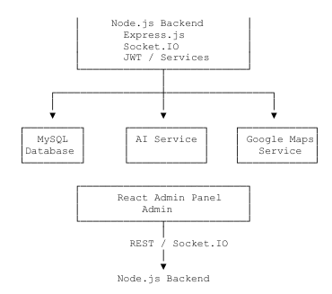
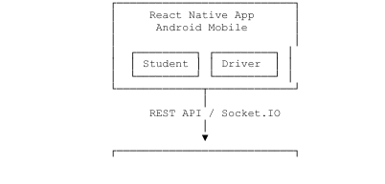

Fig. 3.5.1 : System Architecture
3.5.2 GPS Tracking Architecture
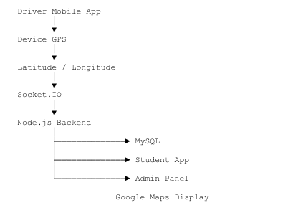

Fig. 3.5.2 : GPS Tracking Architecture
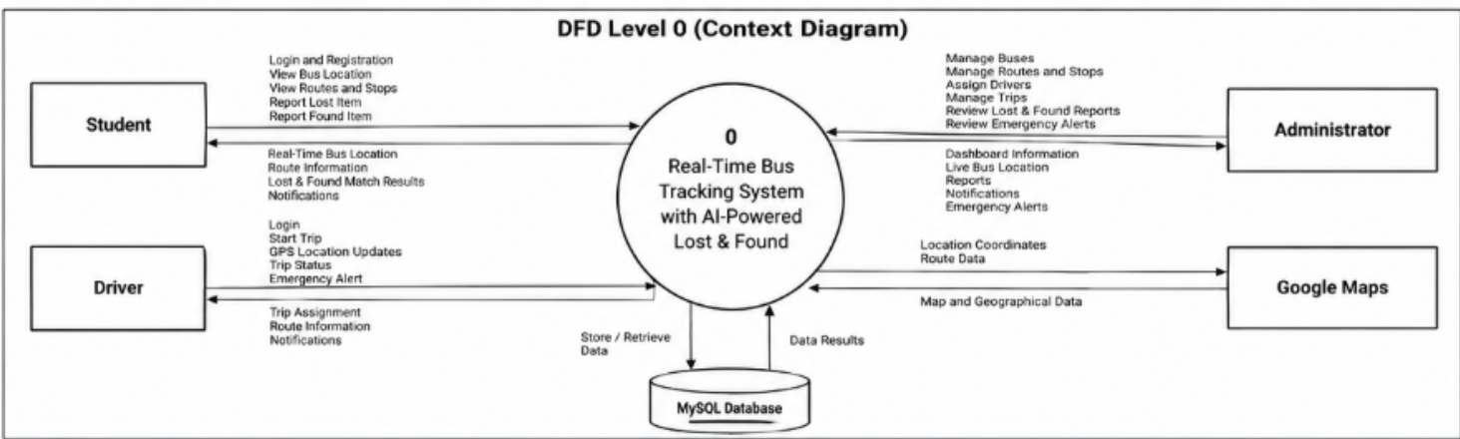
3.5.3 DFD Level 0,1,2 (Context Diagram)
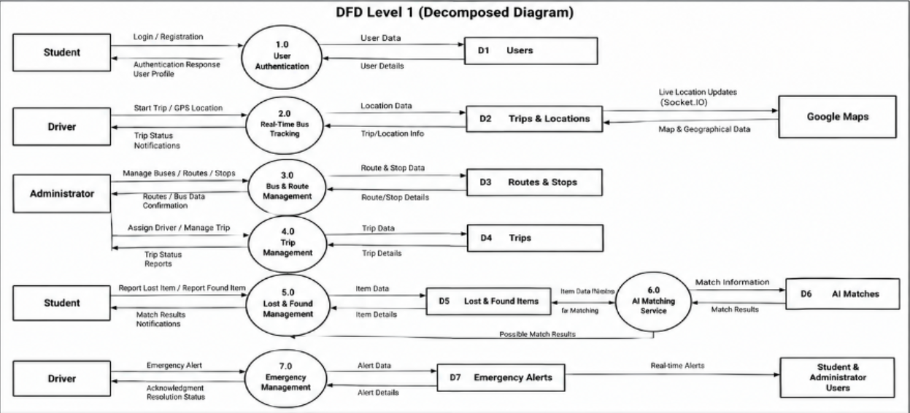

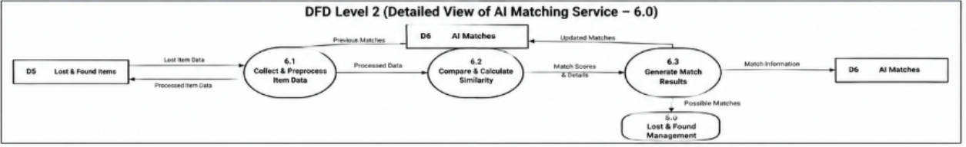
Fig. 3.5.3 : DFD Level 0,1,2 (Context Diagram)

3.5.4 ER Diagram (Entity-Relationship Schema)
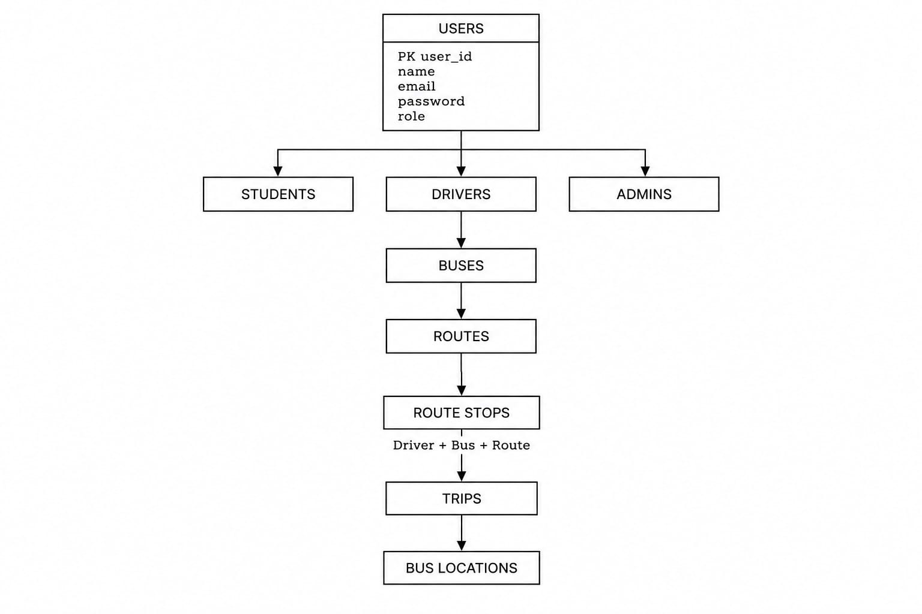

Fig. 3.5.4 : ER Diagram (Entity-Relationship Schema)

3.5.5 Use Case Diagram

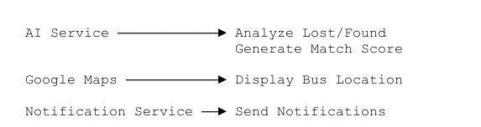
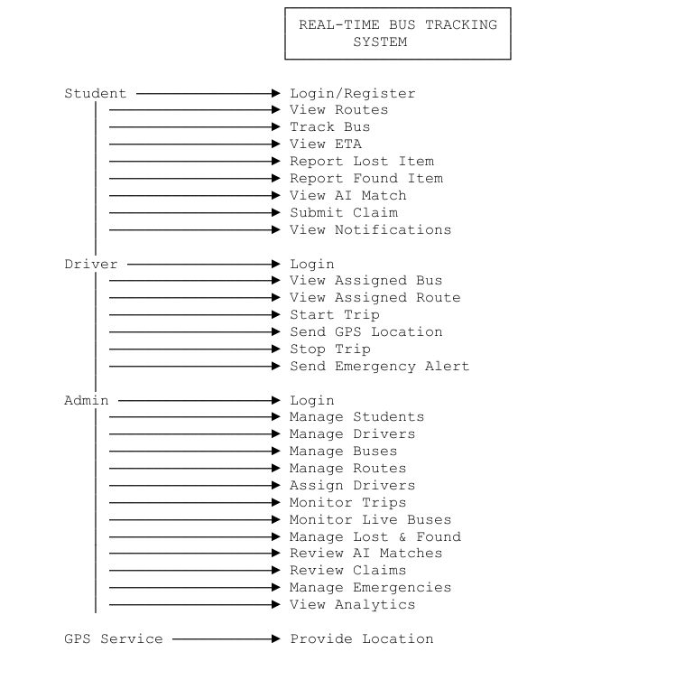

Fig. 3.5.5: Use Case Diagram

CHAPTER IV
Implementation / GUI
4.1 Module Description

The system is implemented using separate functional modules connected through a centralized backend.

The Authentication Module verifies users and provides role-based access to Student, Driver, and Administrator functionalities.

The Student Module allows students to view real-time bus locations, check routes and stops, and submit Lost or Found reports.

The Driver Module allows drivers to start and end trips. During an active trip, the application continuously obtains GPS coordinates and sends them to the backend.

The Real-Time Tracking Module processes GPS data and broadcasts updated bus locations to authorized users through Socket.IO.

The Administrator Module provides a centralized dashboard for managing buses, routes, stops, drivers, and trips. Administrators can also monitor active buses.

The Lost & Found Module allows users to submit detailed reports about lost or found belongings.

The AI-Assisted Matching Module analyzes Lost and Found reports and calculates possible match scores.

The system provides suggestions to the Administrator, who makes the final decision regarding ownership.

4.2 Pseudo Code of Module
MODULE: User Login
START
INPUT username and password
VERIFY username and password
IF user is valid THEN
IDENTIFY user role
OPEN appropriate dashboard
ELSE
DISPLAY login error
END IF
END
MODULE: Real-Time Bus Tracking
START
Driver logs in
Driver starts trip
WHILE trip is active DO
GET current GPS latitude
GET current GPS longitude
SEND location to backend using Socket.IO
Backend validates location
STORE latest location
BROADCAST location to Students and Administrators
END WHILE
Driver ends trip
STOP location tracking
END
MODULE: Lost and Found Report
START
User selects Lost or Found report
INPUT item name
INPUT description
INPUT category
INPUT image
INPUT bus information
INPUT route information
INPUT approximate time
INPUT location
INPUT seat number
SAVE report in database
SEND report for AI-assisted matching
END
MODULE: AI-Assisted Matching
START
GET Lost Item report
GET available Found Item reports
FOR each Found Item report DO
COMPARE item name
COMPARE description
COMPARE category
COMPARE image
COMPARE bus
COMPARE route
COMPARE time
COMPARE location
COMPARE seat number

CALCULATE match score
END FOR
DISPLAY possible matches
Administrator verifies match
IF Administrator approves THEN
UPDATE item status
NOTIFY relevant users
END IF
END
4.3 Screenshot of Module
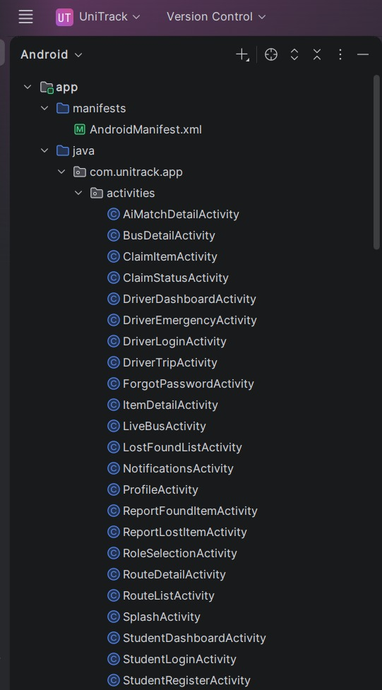
Fig. 4.3.1 Module 1
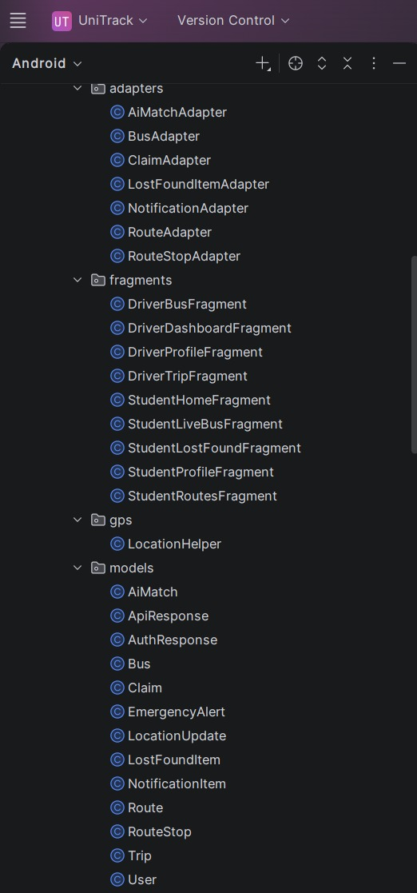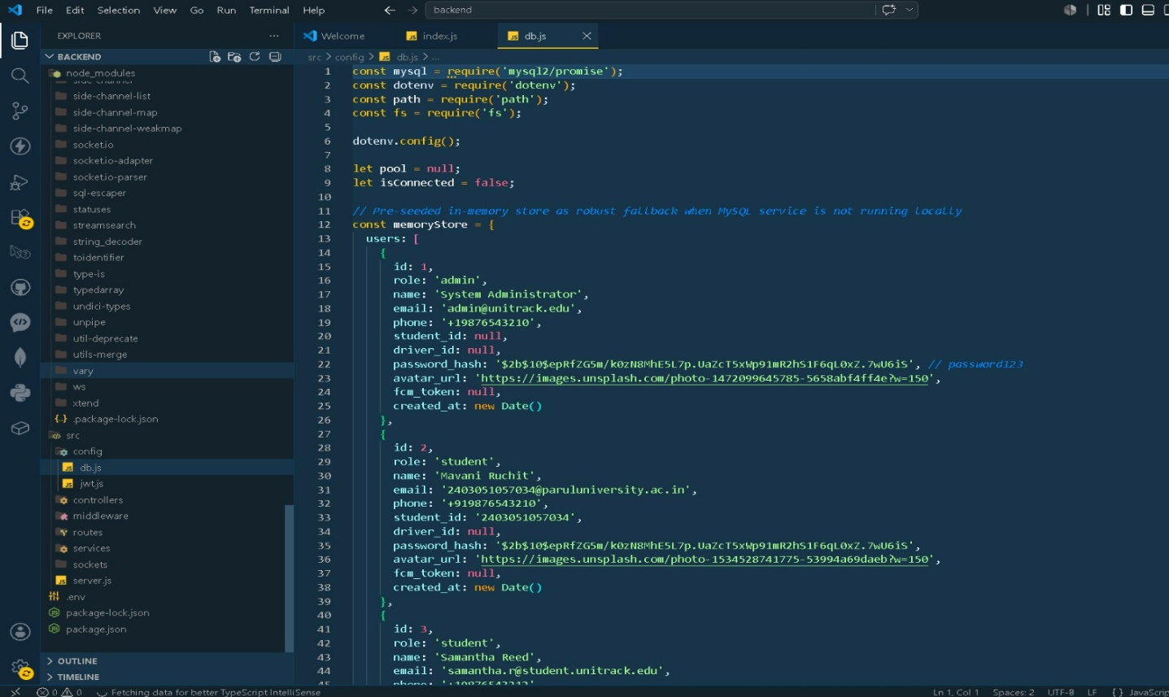
Fig. 4.3.2 Module 2

Fig. 4.3.3 Module 3

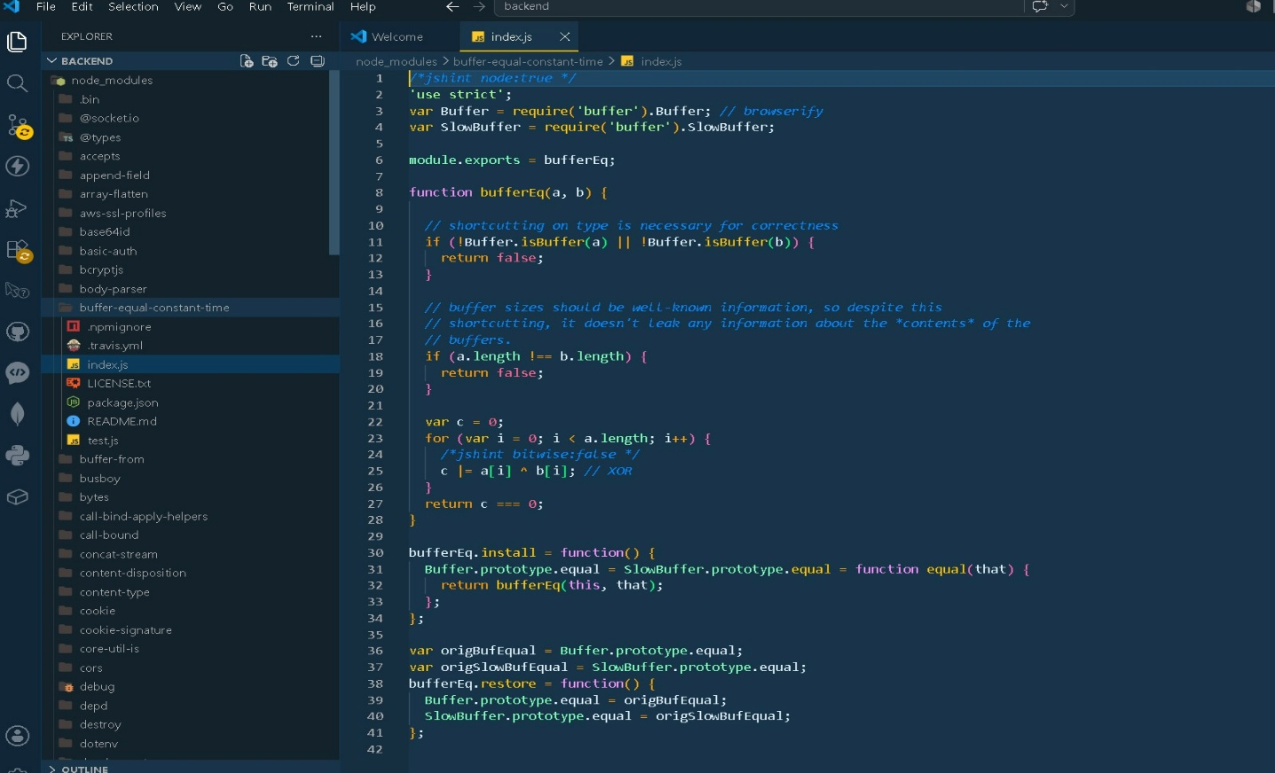

Fig. 4.3.4 Module 4

CHAPTER V
Results
The proposed Real-Time Bus Tracking System with AI-Powered Lost & Found successfully provides a centralized solution for managing university transportation services.
The real-time bus tracking functionality allows the Driver application to collect GPS coordinates during an active trip and transmit the information to the backend. The updated location is then distributed to authorized Students and Administrators through real-time communication. Students can view the current location of the bus on Google Maps, reducing uncertainty and unnecessary waiting time.
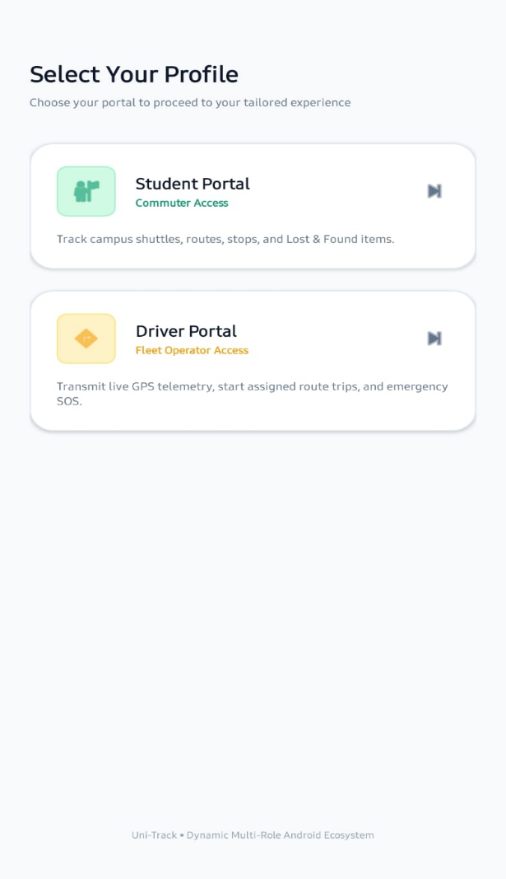
Fig. 5.1
The Administrator Dashboard provides centralized management of buses, routes, stops, drivers, and trips. Administrators can monitor active buses and maintain transportation information efficiently.
The Student and Driver functionalities are successfully integrated into the same React Native Android application through role-based access. This reduces the requirement for separate mobile applications and simplifies application management.
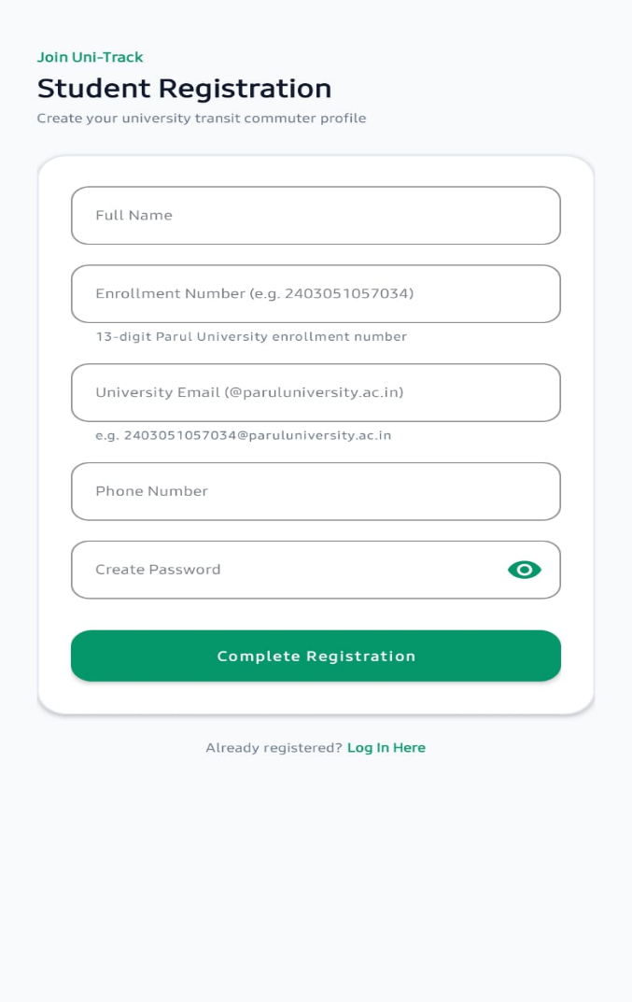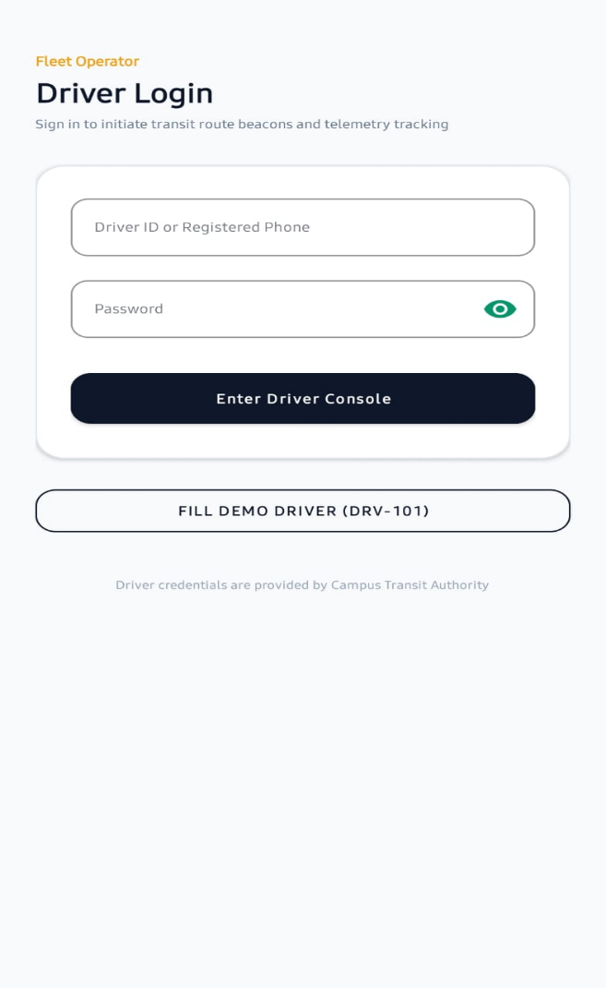

The Lost & Found module provides a digital method for reporting lost and found belongings. Users can submit detailed information related to an item, including its name, description, category, image, bus, route, approximate time, location, and seat number.
The AI-assisted matching functionality improves the process of identifying possible matches between Lost and Found reports. The system compares multiple contextual factors and generates a match score to assist administrators. The final ownership decision remains under administrative control, ensuring that AI-generated suggestions do not automatically determine ownership.

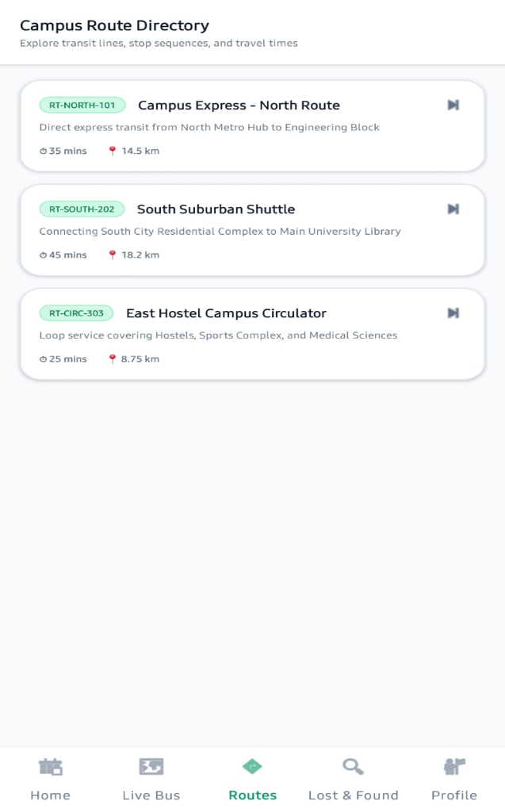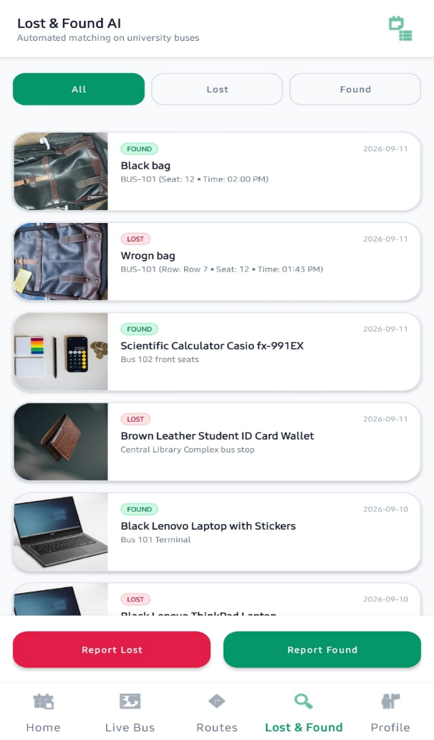
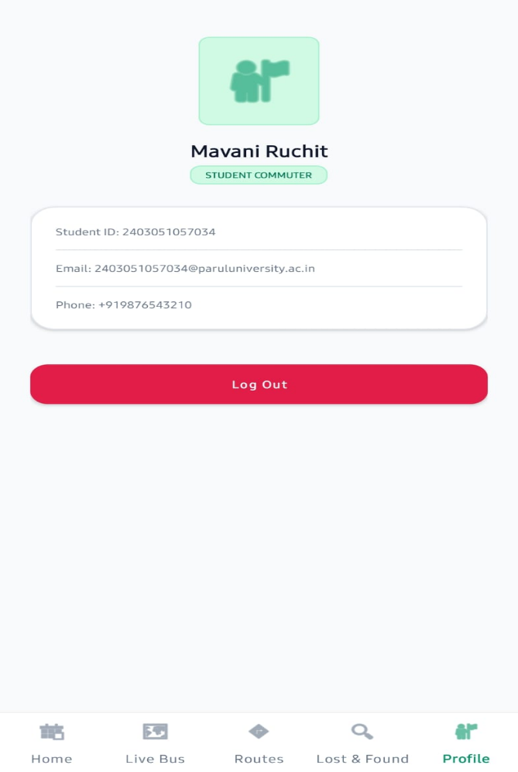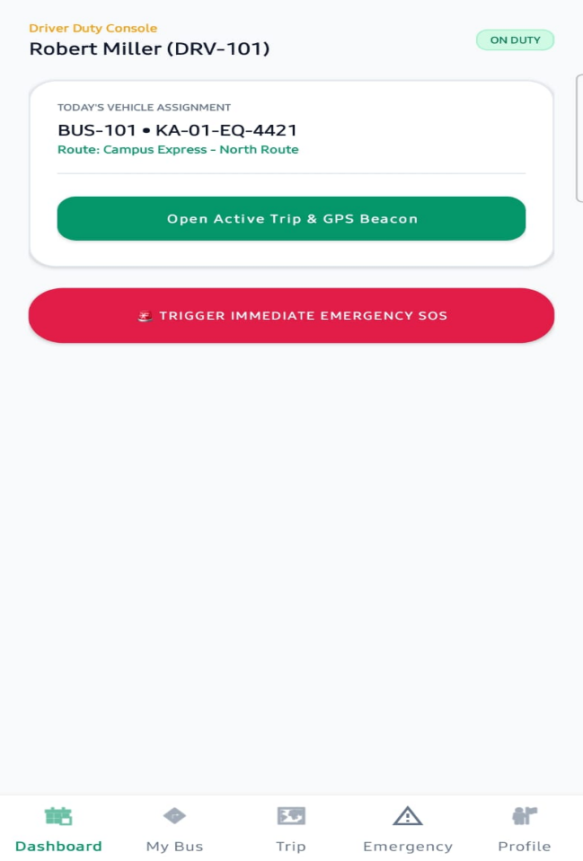
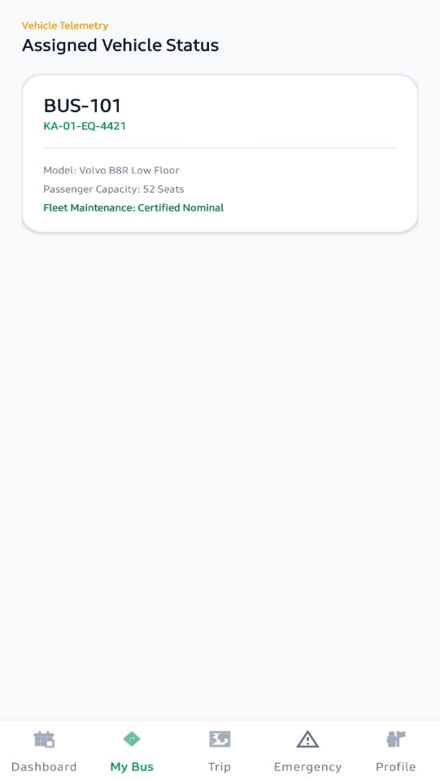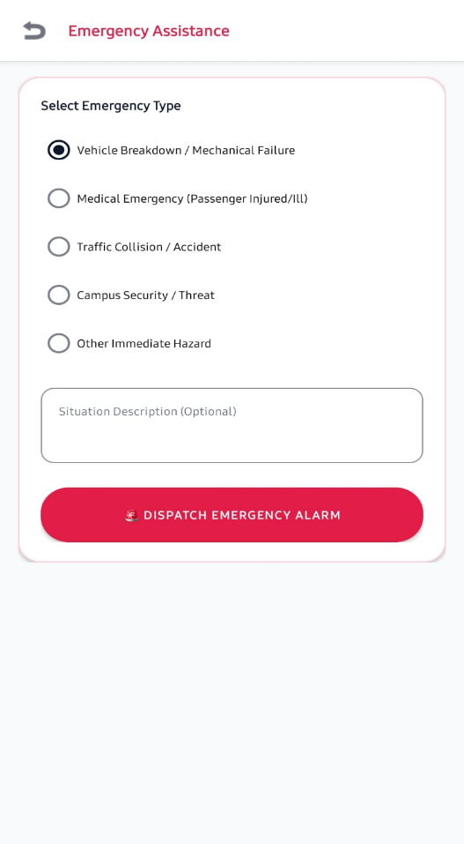
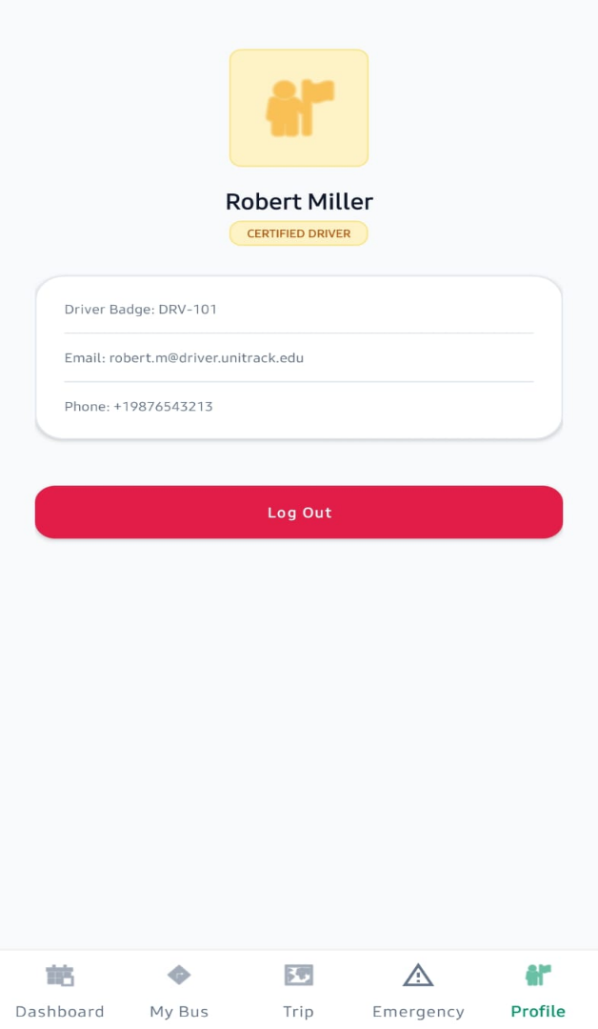
CHAPTER VI
CONCLUSION & FUTURE SCOPE
6.1 Conclusion
The Real-Time Bus Tracking System with AI-Powered Lost & Found provides a centralized and intelligent solution for improving university transportation management. The system addresses the limitations of traditional transportation methods, such as fixed schedules, manual communication, telephone-based coordination, and physical notice boards.
The proposed system enables real-time tracking of university buses using GPS technology. When a driver starts a trip, the mobile application collects GPS coordinates and sends location updates to the backend through real-time communication. Students and administrators can then access updated bus location information, helping students reduce unnecessary waiting time and improve their travel planning.
The system also provides an administrator dashboard for managing buses, drivers, routes, stops, and trips. Administrators can monitor active buses and efficiently manage transportation-related information from a centralized platform.
Another important feature of the project is the AI-Powered Lost & Found system. Students can report lost or found items by providing information such as item name, description, category, image, bus, route, approximate time, location, and seat number. The AI-assisted system compares available reports using multiple contextual factors and generates possible match scores. However, the final ownership verification and decision remain under the control of the administrator.
The integration of Student and Driver functionality within a single mobile application also reduces the need to maintain separate applications. Overall, the project combines GPS technology, mobile applications, web technology, real-time communication, database management, mapping services, notifications, and AI-assisted matching into one integrated university transportation ecosystem.
Therefore, the proposed system can improve the efficiency, transparency, convenience, and management of university transportation services.

6.2 Future Work
The proposed system can be further improved and extended with additional advanced features in the future.
Some possible future enhancements are:
- Estimated Time of Arrival (ETA) Prediction
Artificial intelligence and historical trip data can be used to predict more accurate bus arrival times.
- Traffic and Route Analysis
Real-time traffic information can be integrated to identify traffic congestion and suggest better routes.
- Push Notifications
Students can receive automatic notifications regarding bus arrival, route changes, trip delays, emergency situations, and Lost & Found matches.
- Bus Occupancy Monitoring
Sensors or manual input can be used to monitor the number of passengers inside a bus.
- QR Code-Based Bus Boarding
Students can scan a QR code while boarding the bus for attendance and transportation monitoring.
- Emergency Response Enhancement
Future versions can provide automatic emergency notifications to university authorities and emergency contacts.
- Advanced AI Image Matching
More advanced image recognition and machine learning techniques can improve the accuracy of Lost & Found item matching.
- Multilingual Support
The application can support multiple languages to make the system more accessible to different users.
- Predictive Bus Maintenance
Historical vehicle data can be analyzed to predict maintenance requirements and reduce unexpected bus failures.
- Integration with Smart Campus Services
The system can be integrated with other university services such as student attendance, campus security, hostel management, and smart parking.

CHAPTER VII
REFERENCES
- Google Maps Platform, Google Maps APIs and location services.
Google Maps Platform

- Node.js Documentation, Backend development and server-side JavaScript.
Node.js Documentation

- Socket.IO Documentation, Real-time communication between client and server.
Socket.IO Documentation

- MySQL Documentation, Database management and relational database services.
MySQL Documentation

- Android Developers, GPS location services and Android application development.
Android Developers

- Google Play Services Location API, Location and GPS services for Android applications.
Google Play Services Location

- React Documentation, Web and user interface development concepts.
React Documentation

- Artificial Intelligence for Lost and Found Matching, AI-based comparison using item descriptions, categories, images, and contextual information.

