Description

Intended User

Features

User Interface Mocks

Screen 1

Screen 2

Key Considerations

How will your app handle data persistence?

Describe any corner cases in the UX.

Describe any libraries you’ll be using and share your reasoning for including them.

Describe how you will implement Google Play Services.

Next Steps: Required Tasks

Task 1: Project Setup

Task 2: Implement UI for Each Activity and Fragment

Task 3: Your Next Task

Task 4: Your Next Task

Task 5: Your Next Task

**GitHub Username**: ruchiverma6@gmail.com

# App Name:

News Bot

# 

# Description

**Summary:**

This app is a chat bot app which helps user to browse news from different categories at one place.

User just have to chat with news bot in a way like I want news from sports category or I want news from any other category politics then News bot will present list of news from sports section or from any other asked category.

Solution: User don't need to browse news headlines for different news categories.

Now user can surf news for different news categories at one place through chat interaction.

This app provides news for following categories: Sports, Entertainment, General, Politics, Gaming, Music, Business, Science and nature

# Intended User

Almost for anyone interested in news

# Features

Chatbot interaction to browse news for different categories

Saves NEWS information in database

# 

# User Interface Mocks

## Screen 1

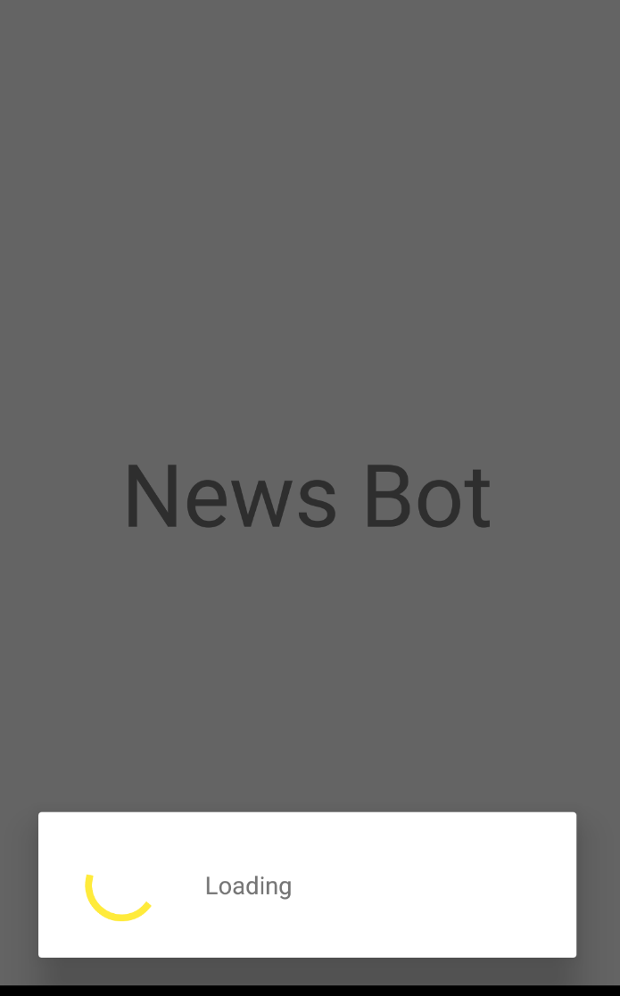

News Bot app loading screen

## Screen 2

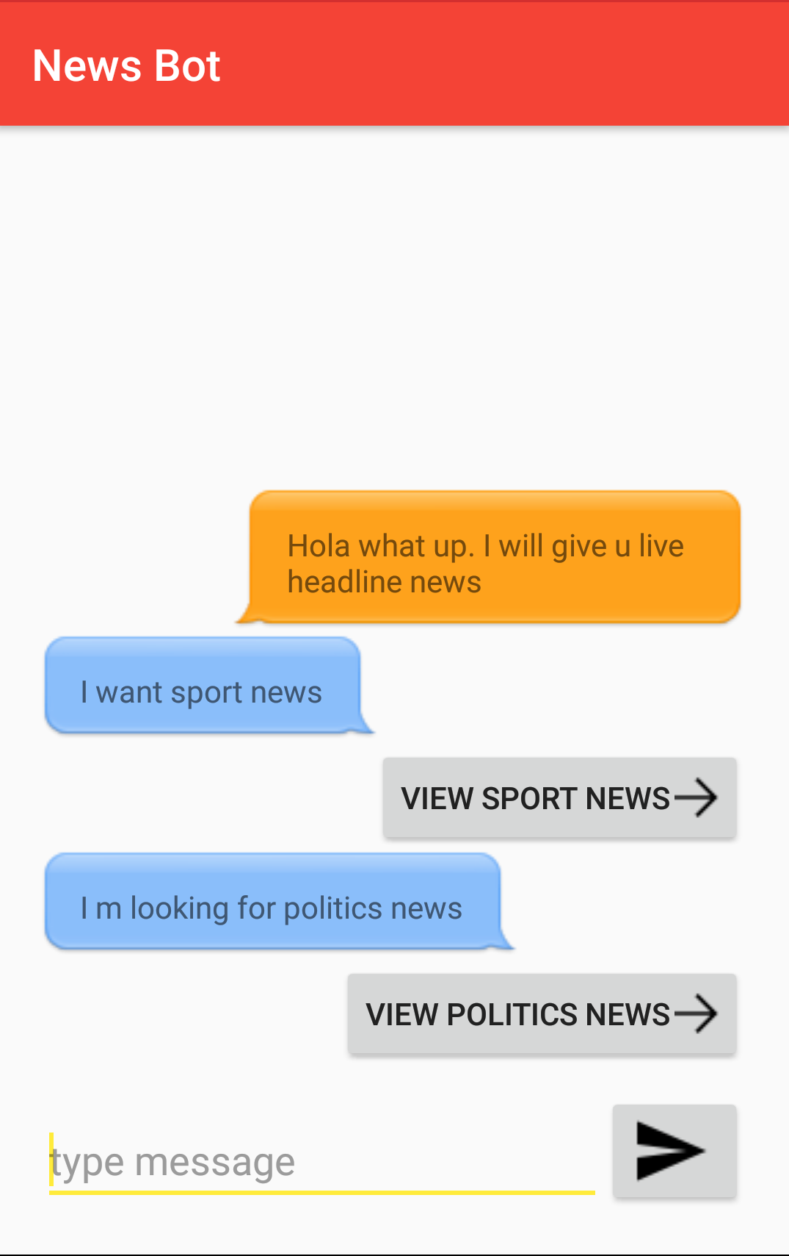

Chat Screen for asking news for different categories.

## Screen 3

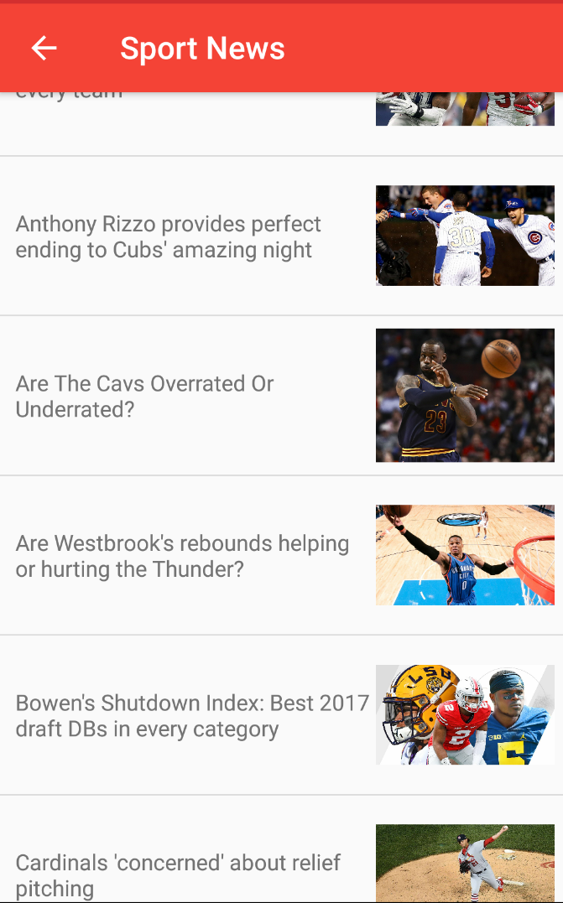

News list screen for sports category.

## Screen 4

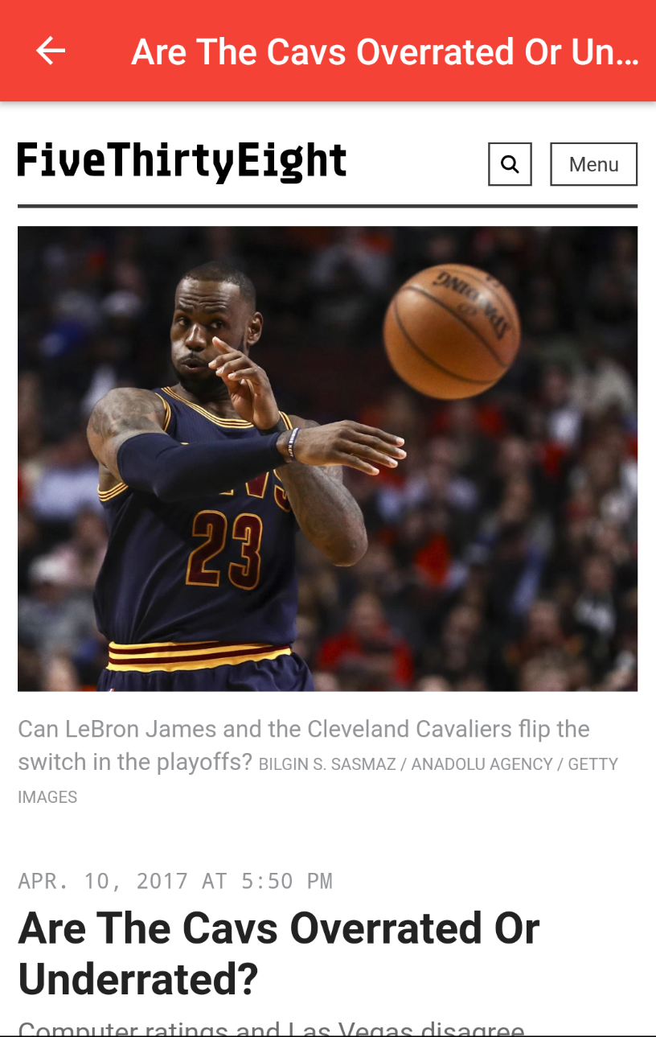

News detail screen.

# 

# Key Considerations

### How will your app handle data persistence?

I will use content provider and sqlite db

### Describe any corner cases in the UX.

For example, how does the user return to a Now Playing screen in a media player if they hit the back button?

On first time launch of app, loading screen would be visible to user and after that Test Ad screen will be visible. But from second time of app launch, user will be landed to chat window screen instead of going to loading and test add screen.

### Describe any libraries you’ll be using and share your reasoning for including them.

1) Picasso library:

to handle the loading and caching of images.

2) LUIS Client library:

LUIS stands for Language Understanding Intelligent Service. This is designed to provide you with an easy way to create models, which allow applications to understand user command.

LUIS Client library is getting used for language understanding that provides intent classification and entity extraction for human interaction in chat bot.

3) Retrofit:

Networking library for making network calls

### 

### Describe how you will implement Google Play Services.

Google Analytics: I will implement google analytics to track how many times user landed to chat screen, News list screen and News detail screen and how many times user sent messages, and also will track how many times user saw news result.

ADMOB: I will implement admob to show test InterstitialAd

at first launch of app.

# Next Steps: Required Tasks

This is the section where you can take the main features of your app (declared above) and decompose them into tangible technical tasks that you can complete incrementally until you have a finished app.

## Task 1: Project Setup

* Download android studio
* Import android project for News Bot app
* Create API key for accessing News open API at following site: https://newsapi.org/
* Configure following libraries:

Picasso

Retrofit

LuisClient

* Configure Google Analytics

## Task 2: Implement UI for Each Activity and Fragment

List the subtasks.

* Build UI for MainActivity
* Build UI for ChatActivity
* Build UI for NewsListActivity
* Build UI for NewsListFragment
* Build UI for NewsDetailActivity
* Build UI for NewsDetailFragment

## Task 3: Creating Layouts and Data Binding to UI

Subtasks:

* Create layouts for Loading screen, Chat screen, News list screen, News detail screen for phone and tablet both
* Bind data from database to UI using cursor loader

## 

## Task 4: Integrate Retrofit library

Subtasks:

* Create endpoint for fetching news API
* Create common client class for accessing retrofit instance
* Execute retrofit calls for different api

## Task 5: Implement Sqlite DB implementation

Subtasks:

* Write SQLiteOpenHelper class to manage sqlitedatabase instance
* Create Columns and tables
* Write code for insert/update/query of data from database

## Task 6: Implement Google Analytics

## Task 7: Implement AdMob to show test ad