Product and Category Management System
Week 3 - ER Diagram and Relational Schema
The steps followed for this task are given below one by one.
Step 1: List out the Entities
From the requirement of the system, two entities were finalised:
Category
Product
Category holds the different groups a product can belong to, and Product holds the actual item details. These are the same entities used in Week 2 also.
Step 2: List the Attributes of each Entity
Category:
Attribute | Data Type | Key | Description
category_id | INT | PK | Unique id for each category.
category_name | VARCHAR(50) | - | Name of the category.

Product:
Attribute | Data Type | Key | Description
product_id | INT | PK | Unique id for each product.
product_name | VARCHAR(100) | - | Name of the product.
category_id | INT | FK | Links back to the Category entity.
price | DECIMAL(10,2) | - | Price of the product.
stock | INT | - | Available quantity of the product.
Step 3: Decide the Primary Keys
category_id is taken as the primary key for Category, and product_id is taken as the primary key for Product, because both of these values are unique for every record and will never repeat.
Step 4: Find the Relationship and its Cardinality
Next step is to see how these two entities are connected. Looking at the requirement, one category can have many products in it (like Electronics has both Laptop and Mobile Phone), but one product will only ever belong to one category. So the relationship between Category and Product is one-to-many (1:M).
In ER diagrams this is usually shown as Category having a 1 on its side and Product having an M (or N) on its side, connected through a relationship called "has".
Step 5: Draw the ER Diagram
Using the entities, attributes, keys and cardinality decided in the steps above, the ER diagram was drawn as shown below. The primary key of each entity is marked as PK and the foreign key is marked as FK.
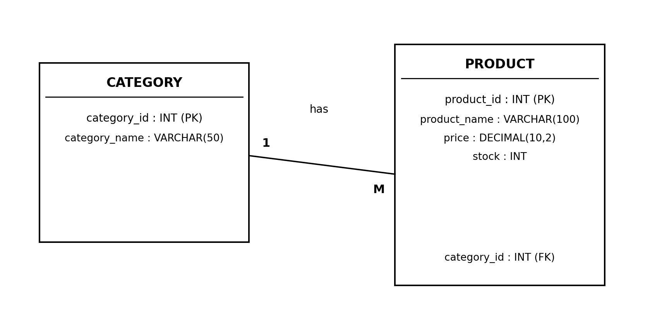
Fig 1: ER Diagram of the system - Category (1) has Product (M)
Step 6: Convert the ER Diagram into a Relational Schema
Once the ER diagram is ready, the next step is to convert it into a relational schema. The rule that is normally followed is simple: every entity becomes a table, every attribute becomes a column, and for a one-to-many relationship the primary key of the "1" side entity is added as a foreign key inside the table on the "many" side.
Following this rule, the ER diagram above converts into the below relational schema:
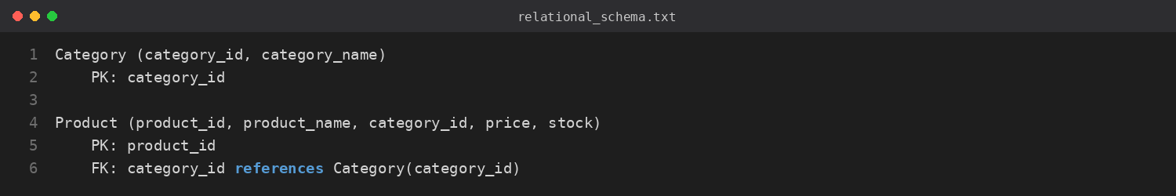
Here category_id appears in both tables - once as the primary key inside Category, and once again inside Product as a foreign key, which is exactly how the one-to-many relationship gets represented in a relational schema.
Step 7: Map the Schema to actual MySQL Tables
The last step is just to write this relational schema as actual SQL so it can be run in MySQL Workbench. This is the same table structure that was already created and used in Week 1:
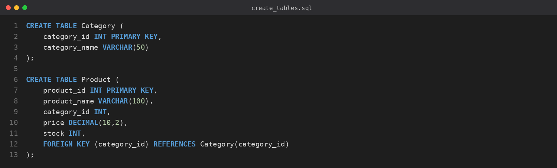
Code
Below is the complete code that can be run directly in MySQL Workbench, starting from creating the database up to inserting sample data and checking the output. This is basically the schema from Step 6 turned into a working database.
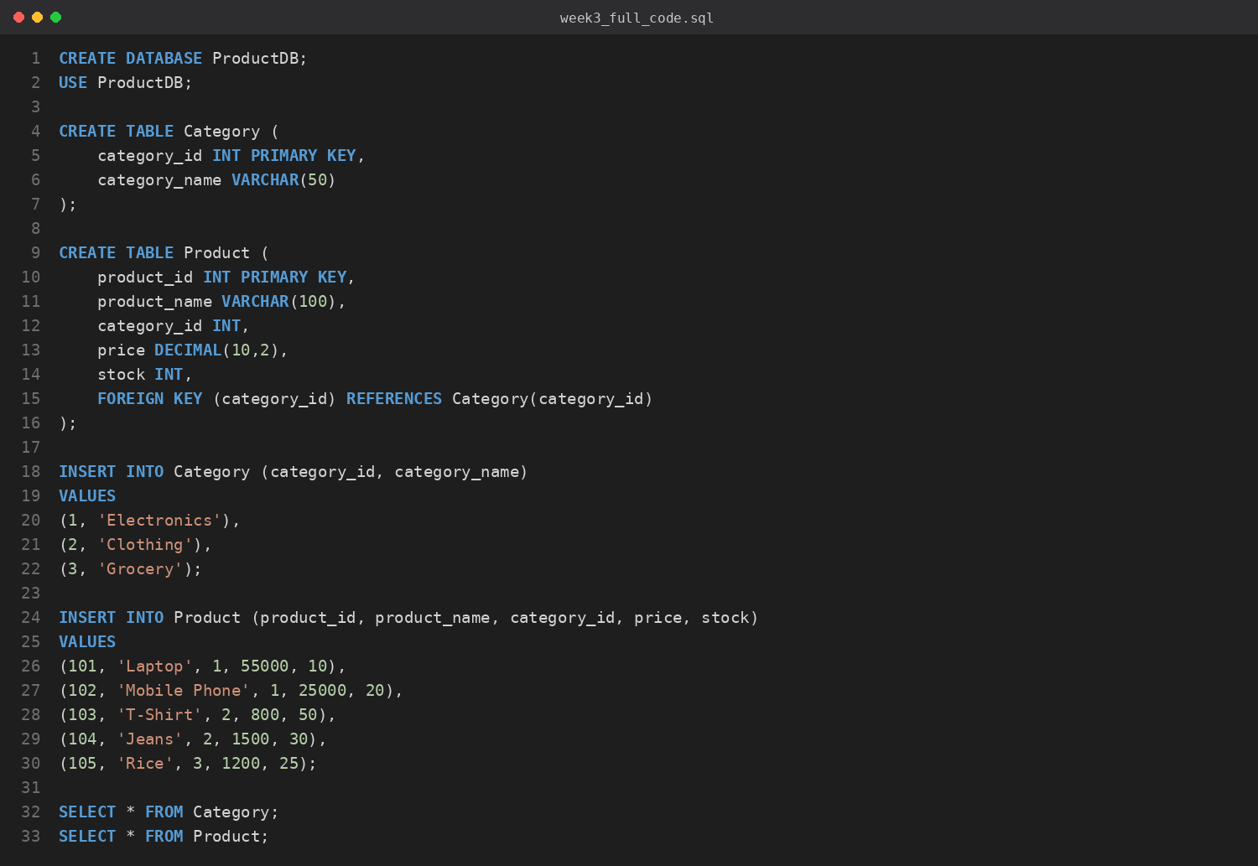
Running this code creates the database, creates both tables with the primary key and foreign key exactly as shown in the ER diagram and relational schema, and then fills them with sample data so the design can be verified with real output.
Conclusion
So in this week, the ER diagram was drawn first with Category and Product as entities, category_id and product_id as their primary keys, and a one-to-many relationship between them. This ER diagram was then converted step by step into a relational schema, and finally that schema was matched with the actual MySQL tables. This shows that the design (ER diagram) and the implementation (SQL tables) are consistent with each other.

