Product and Category Management System
Week 2 - Entities, Attributes, Primary Keys and Relationships
Aim of this Week
In week 1 we had already created the database and tables in MySQL Workbench for the Product and Category system. This week the task was to go back and properly identify what are the entities in this system, what attributes each entity has, which attribute is the primary key, and how the two entities are related to each other. Basically this is the design part that should normally come before writing the actual SQL code.
Entities Identified
After going through the requirement (storing products, storing categories, and linking each product to a category), two entities were identified for this system:
- Category - this entity keeps the list of categories like Electronics, Clothing, Grocery etc.
- Product - this entity keeps the details of each product like its name, price, stock and which category it belongs to.
These are the same two entities that were used to make the Category and Product tables in Week 1, so this week is basically the design reasoning behind that.
Attributes and Primary Key of each Entity
Category entity:
Attribute | Data Type | Key | Description
category_id | INT | PK | This is the primary key, every category has a unique id.
category_name | VARCHAR(50) | - | Name of the category, for example Electronics or Grocery.

Product entity:
Attribute | Data Type | Key | Description
product_id | INT | PK | Primary key of the product table, unique for every product.
product_name | VARCHAR(100) | - | Name of the product, like Laptop, T-Shirt, Rice etc.
category_id | INT | FK | This is a foreign key, it comes from the Category entity and tells which category the product belongs to.
price | DECIMAL(10,2) | - | Price of the product.
stock | INT | - | How many units of that product are available.
Relationship between Category and Product
There is a one-to-many relationship between Category and Product. This means one category can have many products under it, but one product will always belong to only one category. For example, the Electronics category has both Laptop and Mobile Phone under it, but Laptop itself can not belong to two categories at the same time.
This relationship is shown using the category_id column, which is the primary key in Category and is used again as a foreign key inside Product.
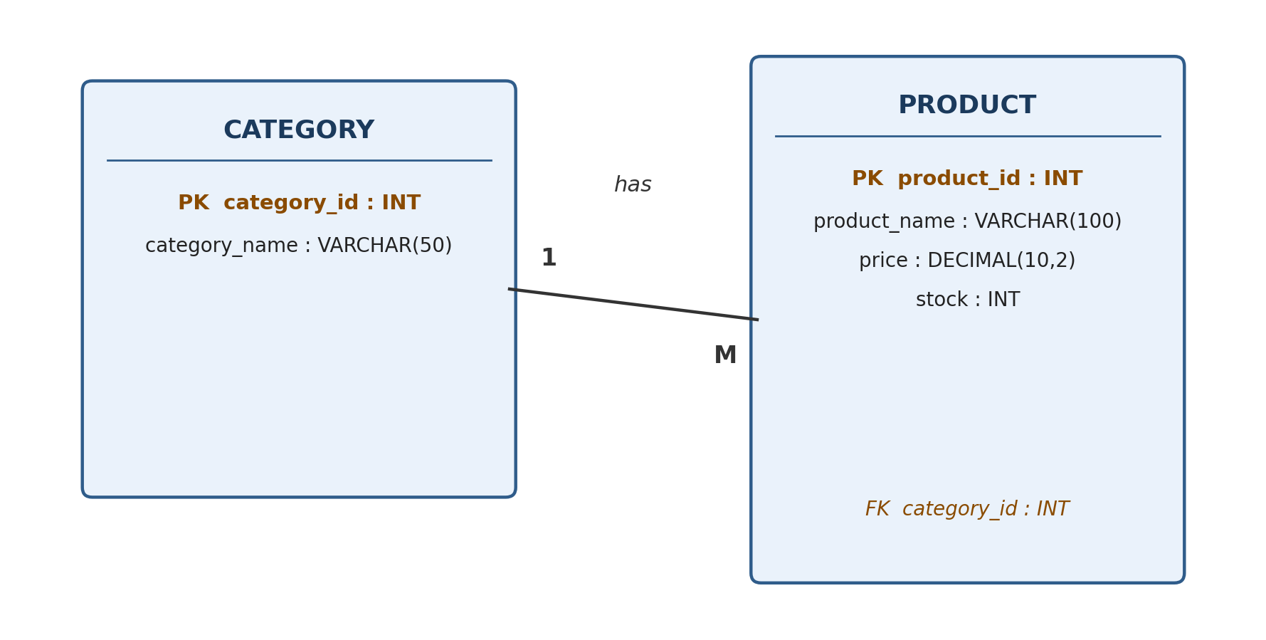
Category and Product entities with their keys, showing the one-to-many relationship
How this looks in MySQL
Since this design was already implemented in Week 1, the same entities and attributes appear as tables in MySQL like this:
CREATE TABLE Category (
category_id INT PRIMARY KEY,
category_name VARCHAR(50)
);

CREATE TABLE Product (
product_id INT PRIMARY KEY,
product_name VARCHAR(100),
category_id INT,
price DECIMAL(10,2),
stock INT,
FOREIGN KEY (category_id) REFERENCES Category(category_id)
);
Here category_id is PRIMARY KEY inside Category table, and the same column is added inside Product table as a FOREIGN KEY pointing back to Category. This way MySQL will not allow adding a product with a category_id that does not actually exist in the Category table.
Conclusion
So for this week, the entities identified were Category and Product, with category_id and product_id as their primary keys, and category_id also working as a foreign key to connect the two. This whole design matches with the tables that were already created and used in Week 1, which shows that the database structure is correct and properly normalized.

