What is a Database ?

* Database is a collection of Data.
* Relational databases store data in the form of tables that can be easily retrived, managed and updated.
* Data is organized into tables, rows, columns and indexes to find the relevant data easier.

Some Popular Databases are :

* MySQL

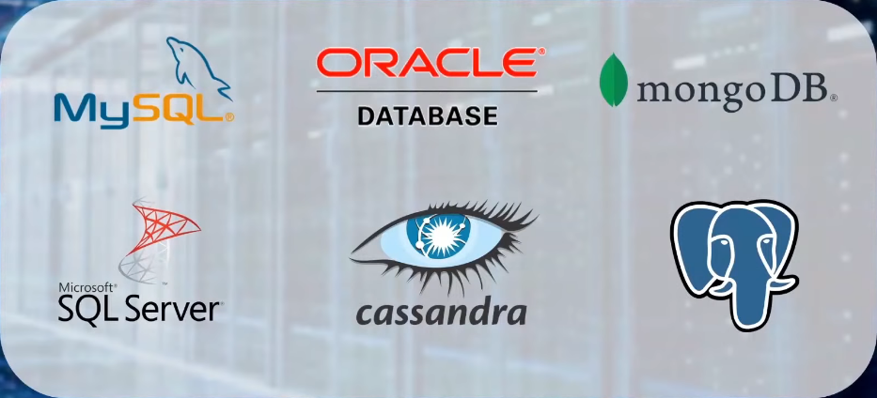

* Oracle
* MongoDB
* SQL Server
* Apache Cassandra
* Postgre SQL

What is SQL ?

* SQL is a language to communicate with the database.
* SQL commands help to process, store, analyze and manipulate databases.
* SQL is developed by IBM.

What is a Table?

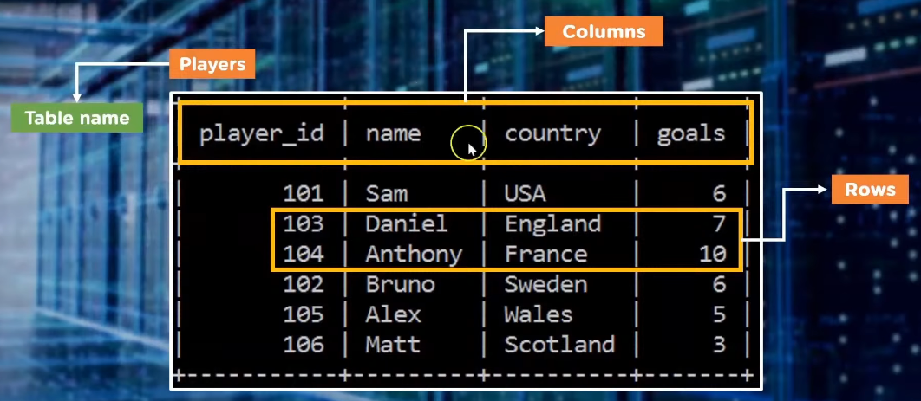

A Table has :

* Table Name
* Columns / Fields
* Rows / Record / Tuple

Features Of SQL :

* SQL lets us access any data within the relational database
* SQL is very fast in retrieving large amounts of data very efficiently
* SQL is versatile as it works with data systems from Oracle, IBM, Microsoft etc.
* SQL helps managing database without knowing a lot of coding

Applications Of SQL :

* SQL is used to create a database , define its structure, implement it and lets you perform many functions.
* SQL is also used for maintaining an already existing database.
* SQL is intensely used as a client server language to connect front end with back end thus supporting the client server architecture.
* SQL when deployed as DCL ( Data Control Language ) it helps protect the database from unauthorized access.

ER Diagram ( Entity – Relationship Diagram )

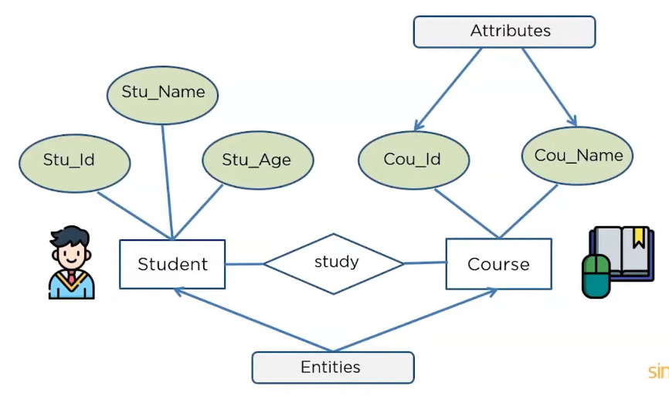

* ER Diagram describes the relationships of entities that need to be stored in a database.
* ER Diagram is mainly a structural design ( Framework ) for the database.
* Components of ER diagram are : Entities, Attributes and Relationships.

Need Of ER Diagram :

* Help us conceptualize the database , and help us know which fields need to be embedded for a particular entity
* Gives better understanding of information stored in the database.
* Reduces complexity and saves time creating dtabases
* Helps describe elements using ER model

Symbols used in ER Diagram :

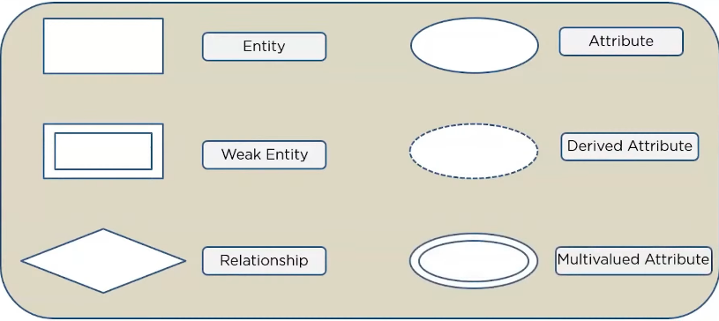

Components Of ER Diagram :

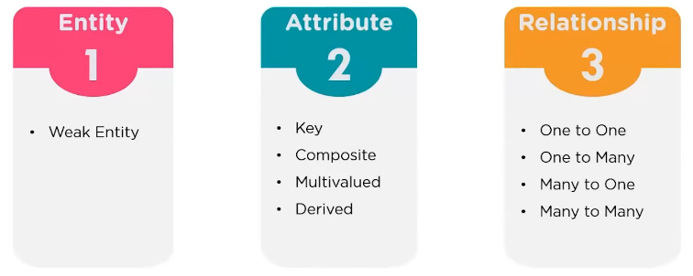

**Entity :**

* An Entity can either be a living or non living component
* An Entity is represented as a Rectangle in ER Diagram
* Below Student and Courses are entities related to one another by relation ‘Study’

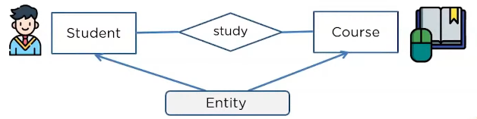

* An Entity which relies over another entity is called weak entity.
* In Below Example, School is a Strong Entity because it has a Primary Key “School Number”, But Classroom is a Weak Entity as it has no Primary Key. The Room Number is not unique to any school, all school can have same room number, so to distinguish each classroom of a school from another school we may depend on ‘School Number’ which is an attribute of School Entity.

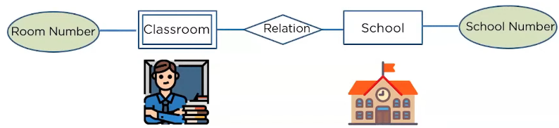

**Attribute :**

* An attribute is describes the property of an Entity.
* An attribute is represented as Oval in an ER diagram.

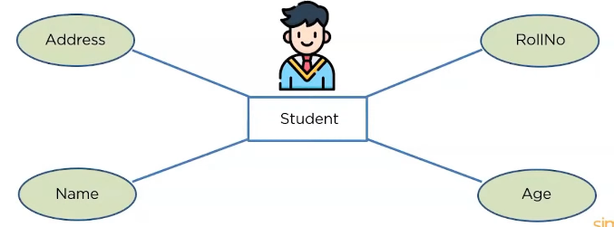

*Key Attribute:*

* Attribute that uniquely identifies an Entity
* Below Roll Number can uniquely identify Student entity so it is a Key Attribute

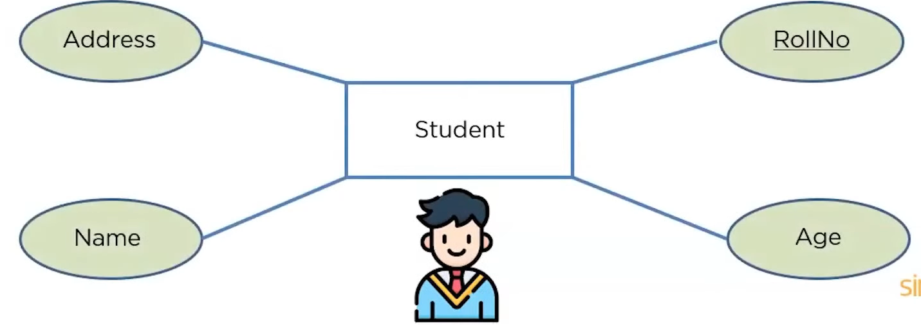

*Composite Attribute:*

* A Composite attribute is an attribute that is composed of Other Attributes
* Below Name is composed of three different attributes

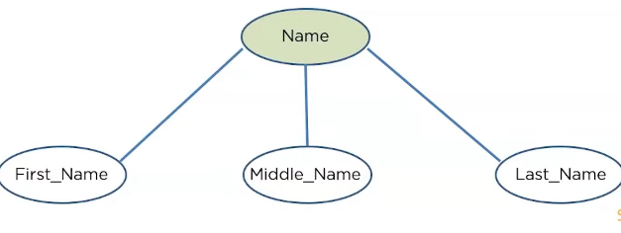

*Derived Attribute:*

* A Derived attribute can be extracted from other attributes of the entity
* Below the Age attribute can be derived from Date Of Birth Attribute

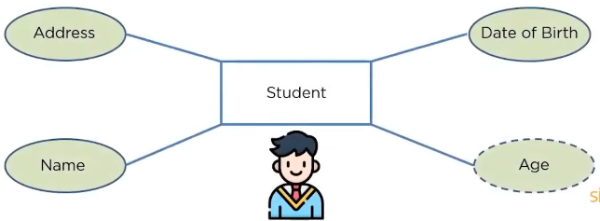

*Multivalued Attribute:*

* An attribute that can contain multiple values for same Record / Tuple is known as multivalued attribute
* Below each Student may have more than one phone number which makes Phone Number a Multivalued attribute

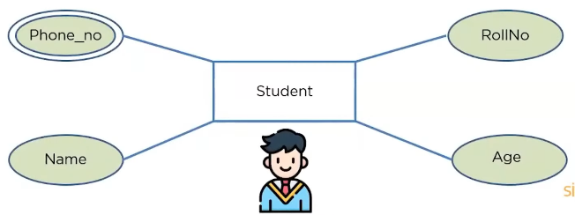

**Relationship**

* Relationships among Entities are shown in diamond shape

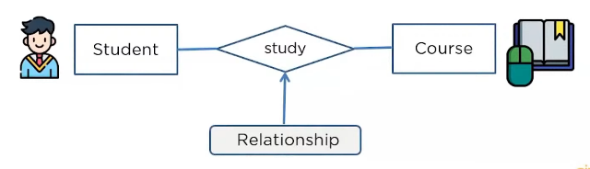

*One to One Relationship:*

* When single element of an entity is related to a single element of another entity
* Like a Student only has one Id card and vice versa

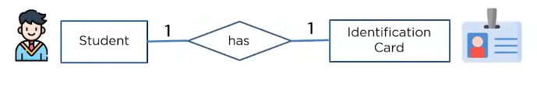

*One To Many Relationship :*

* When single element of an entity is related to more than one element of another entity
* Like a Customer can order many orders, but the same order cannot be ordered by many Customers.

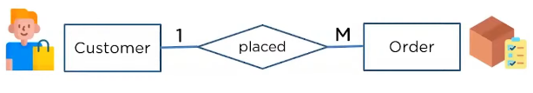

*Many To One Relationship:*

* When more than one element of an entity is related to single element of another entity
* Like Many students can opt for a single course, but one student cannot opt for many course



*Many to Many Relationship:*

* When more than one element of an entity is related to more than one element of another entity
* Many employees can be assigned to a single project, and vice versa

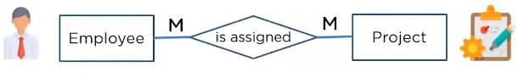

Types of SQL Commands

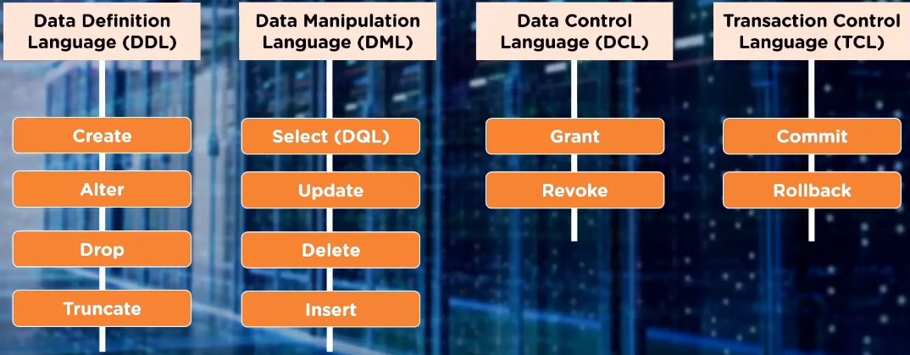

* DDL ( Data Definition Language ) :
  + Used to create structure of the table
  + All DDL commands are auto commited i.e, it permanently saves all the changes in the database.
* DML ( Data Manipulation Language ) :
  + DML commands are used to modify the database
  + It is responsible for all forms of changes in the database
  + DML commands are not auto commited
  + Select command is also known as DQL (Data Query Language)
* DCL ( Data Control Language ):
  + Allow us o control access to data within the database
  + Used to create objects related to user access and control the distribution of privilages among the users
* TCL (Transaction Control Language):
  + Allow users to manage database transactions

Basic Structure Of a SQl command:

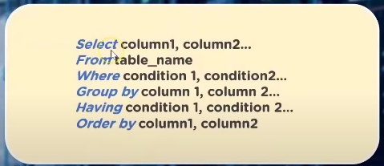

* *Select* : we specify various column names we want to fetch from the table
* *From* : we specify the table name
* *Where* : we specify the conditions on basis of which we want to filter out
* *Group* *By* : takes column names to group by its distribution
* *Having* : we use it to filter out tables based on groups
* *Order* *By* : we use it to filter out the result in either ascending or descending order of a particular column

SQL Datatypes

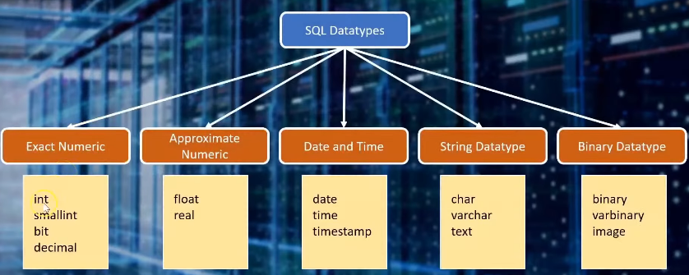

SQL Operators

