Screen 1:

Where user gets to ennter the user name:
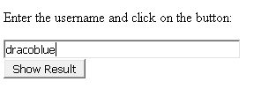

Screen 2:

Where when user clicks on show result, gets to see data related to user.
