from __future__ import print_function

import rospy

import random

import numpy as np

import robot_global

import human

import motor

import laser

import time_step

import math

import tf

import sys

from time import gmtime, strftime

import copy

import time

from ShortestPathFindAlgorithm import spfa

from ShortestPathFindAlgorithm import unit

from std_srvs.srv import Empty

from sensor_msgs.msg import LaserScan

from std_msgs.msg import String

from std_msgs.msg import String

from geometry_msgs.msg import Twist

from std_msgs.msg import Bool

from geometry_msgs.msg import Quaternion

from geometry_msgs.msg import Vector3

#ACTION_LOG_FILE = open("my_net18/actionLog_" + strftime("%Y-%m-%d-%H-%M-%S", gmtime()) + ".txt", 'a+')

actionoutPath = "my_net22/actionLog_" + strftime("%Y-%m-%d-%H-%M-%S", gmtime()) + ".txt"

PI=3.1415926

RSTATEDIS = 10

RSTATEANGLE = 10

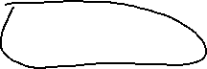

RSTATEFACINGANGLE = 10

RREWARDDIS = 20*5

RREWARDANGLE = 20

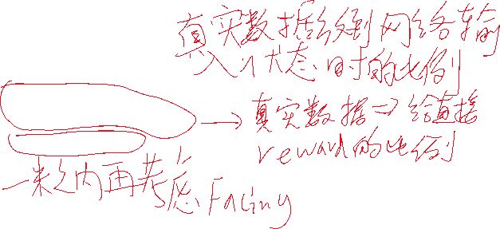

RREWARDFACINGANGLE = 20*4

FACINGDIS_RANGE = 1

MAX_LASER_RANGE = 3

MIN_LASER_RANGE = 0

MINNUM = 0.1

FAILREWARD = -300

WINREWARD = 500

ARRIVEDIS = 0.8

ARRIVEANGLE = 0.5

POSITIVEDIS = 0.8

DISFROMSTARTTOEND = 4

MINDISFROMSTARTTOEND = 0.5

my_case_robotx = [3, 1, 3, 2, 2, 1]

my_case_roboty = [0.1, 0.1, 0.1, 0.1, 0.1, 0.1]

my_case_robotz = [2, 2, 2.5, 2.5, 2.5, 7]

my_case_robot_rotat_x = [0, 0, 0, 0, 0, 0]

my_case_robot_rotat_y = [1, 1, 1, 1, 1, 1]

my_case_robot_rotat_z = [0, 0, 0, 0, 0, 0]

my_case_robot_rotat_w = [PI, 0, -PI, -PI / 4, -PI * 3 / 4, -PI / 4]

my_case_humanx = [3, 3, 3, 2, 2, 3]

my_case_humany = [1.27, 1.27, 1.27, 1.27, 1.27, 1.27]

my_case_humanz = [8, 8, 6, 7, 7, 3.5]

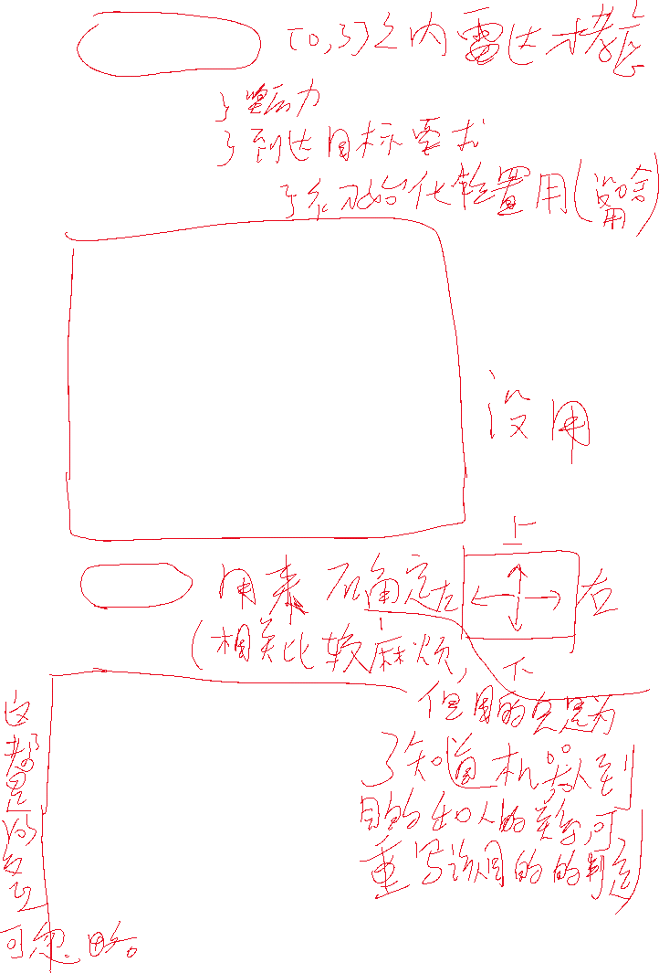

opposite_x = [0, 0, 0, 2, 2, 0]

opposite_z = [-1.5, -1.5, 1.5, 0, 0, -1.5]

tmp_out_pos = 0

global_rn = 0

def get_human_position_res_callback(position_value):

human.position = position_value

human.get_position_res_flag = True

def pub_get_human_position_req():

value = Bool()

value.data = True

human.PubGetPositionReq.publish(value)

human.get_position_res_flag = False

def get_human_rotation_res_callback(rotation_value):

human.rotation = rotation_value

human.get_rotation_res_flag = True

def pub_get_human_rotation_req():

value = Bool()

value.data = True

human.PubGetRotationReq.publish(value)

human.get_rotation_res_flag = False

def get_position_res_callback(position_value):

robot_global.position = position_value

robot_global.get_position_res_flag = True

def pub_get_position_req():

value = Bool()

value.data = True

robot_global.PubGetPositionReq.publish(value)

robot_global.get_position_res_flag = False

def set_position_res_callback(value):

robot_global.set_position_res_flag = value.data

## new add for human

def set_human_pose_res_callback(value):

human.set_human_pose_res_flag = value.data

def pub_set_human_pose_req(position_value):

human.PubSetPositionReq.publish(position_value)

human.set_human_pose_res_flag = False

def pub_set_position_req(position_value):

robot_global.PubSetPositionReq.publish(position_value)

robot_global.set_position_res_flag = False

def set_rotation_res_callback(value):

robot_global.set_rotation_res_flag = value.data

def pub_set_rotation_req(rotation_value):

robot_global.PubSetRotationReq.publish(rotation_value)

robot_global.set_rotation_res_flag = False

def get_rotation_res_callback(rotation_value):

robot_global.rotation = rotation_value

robot_global.get_rotation_res_flag = True

def pub_get_rotation_req():

value = Bool()

value.data = True

robot_global.PubGetRotationReq.publish(value)

robot_global.get_rotation_res_flag = False

def reset_node_physics_res_callback(value):

robot_global.reset_node_physics_res_flag = value.data

def pub_reset_node_physics_req():

value = Bool()

value.data = True

robot_global.PubResetNodePhsicsReq.publish(value)

robot_global.reset_node_physics_res_flag = False

def human_connect():

rospy.Subscriber("/human_name", String)

# connect

model_name = None

while model_name is None:

try:

model_name = rospy.wait_for_message('/human_name', String, timeout=5)

except:

pass

print("human %s connect success" % model_name.data)

return model_name.data

def robot_connect():

rospy.Subscriber("/model_name", String)

# connect

model_name = None

while model_name is None:

try:

model_name = rospy.wait_for_message('/model_name', String, timeout=5)

except:

pass

print("robot %s connect success" % model_name.data)

return model_name.data

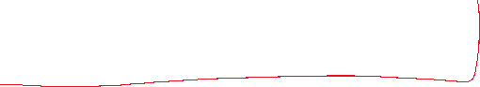

#change webots laser and dist to our focus data

def discretize_observation(laser_data, laser_dim, collision_threshold):



sum = 0.0

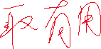

new_laser_data = []



for i, item in enumerate(laser_data.ranges):

sum += laser_data.ranges[i]

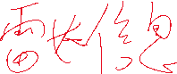

if ((i + 1) % 3 == 0):

new_laser_data.append(sum / 3.0)

sum = 0

collision = False

mod = len(new_laser_data) / laser_dim

discretized_ranges = []

###just for habit..

HJKINF = 1000000

tmp_cnt = 0

min_val = HJKINF

for i, item in enumerate(new_laser_data):

####add

if (i % mod == mod - 1 and tmp_cnt + 1 <= laser_dim):

min_val = min(min_val, new_laser_data[i])

tmp_cnt = tmp_cnt + 1

if min_val > MAX_LASER_RANGE:

discretized_ranges.append(MAX_LASER_RANGE)

elif min_val < MIN_LASER_RANGE:

discretized_ranges.append(MIN_LASER_RANGE)

else:

discretized_ranges.append(min_val)

####init

if (i % mod == 0):

min_val = HJKINF

min_val = new_laser_data[i]

#####update

min_val = min(min_val, new_laser_data[i])

if (new_laser_data[i] < collision_threshold):

collision = True

print("hjk--- check dim of laser: ", len(discretized_ranges))

#for x in enumerate(discretized_ranges):

# print("***check**: ", x)

return discretized_ranges, collision

#get angle from point 1 to point 2

#angle is rotate y-axis(+) to vector<1=>2>, reverse clock is +(0, PI), clock is -(0, PI)

def getangle(x1, y1, x2, y2):

if y1 > y2 + MINNUM:

rtang = math.atan((x1-x2)/(y1-y2))

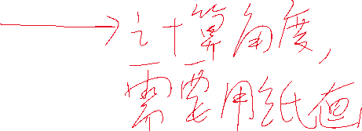

elif math.fabs(y1-y2) < MINNUM:

if x1 > x2+MINNUM:

rtang = PI/2



elif x1 < x2-MINNUM:

rtang = -PI/2

else:



rtang = 0

else:

if x1 > x2:

rtang = PI+math.atan((x1-x2)/(y1-y2))

else:

rtang = -PI+math.atan((x1-x2)/(y1-y2))

return rtang

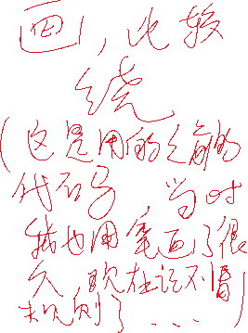

#get feature between point 1 and point 2: angle from point 1 to interleave angle, angle from interleave angle to point 2

def getanglefea(x1, y1, w1, x2, y2, w2):

rtang = getangle(x1, y1, x2, y2)

ang1 = rtang - w1

if ang1 > PI:

ang1 = ang1-2*PI

elif ang1 <= -PI:

ang1 = ang1 + 2*PI

ang2 = w2 - w1

if ang2 > PI:

ang2 = ang2 - 2*PI

elif ang2 <= -PI:

ang2 = ang2 + 2*PI

return rtang, ang1, ang2

#now for hjk, just calcu dist.

def getDisXZ(robotpos_x, robotpos_z, robotrot_w, rightpos_x, rightpos_z, rightrot_w):

distx = robotpos_x - rightpos_x

distz = robotpos_z - rightpos_z

dist1 = math.sqrt(distx * distx + distz * distz)

return dist1

def getopposite(position, rotation, my_case = -1):

rpos = Vector3()

rpos.x = position.x

rpos.y = position.y

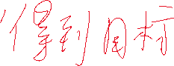

rpos.z = position.z #- 0.5

global tmp_out_pos

tmp_out_pos = 0

global global_rn

if my_case == -1:

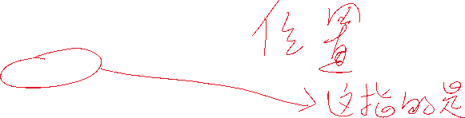

print("hjktest---- getopposit this")

#rn = random.random()

if global_rn < 0.25:

rpos.x = position.x - POSITIVEDIS

tmp_out_pos = 1

elif global_rn < 0.5:

rpos.x = position.x + POSITIVEDIS

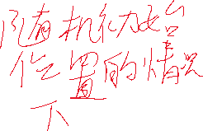

tmp_out_pos = 3

elif global_rn < 0.75:

rpos.z = position.z + POSITIVEDIS

tmp_out_pos = 2

else:

rpos.z = position.z - POSITIVEDIS

tmp_out_pos = 4

else:

rpos.x = rpos.x + opposite_x[my_case]



rpos.z = rpos.z + opposite_z[my_case]



if opposite_x[my_case] > 0.01:

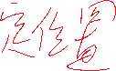

tmp_out_pos = 3



if opposite_x[my_case] < -0.01:

tmp_out_pos = 1

if opposite_z[my_case] > 0.01:

tmp_out_pos = 2

if opposite_z[my_case] < -0.01:

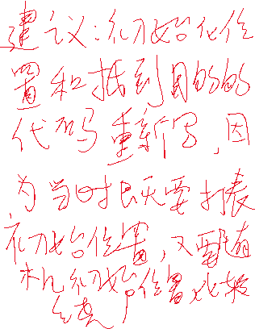

tmp_out_pos = 4

print("GGGGGGGGGg************************* goal is : ", tmp_out_pos)

#rpos.z = position.z + 3 # - 0.5

rrot = Quaternion()

rrot.x = rotation.x

rrot.y = rotation.y

rrot.z = rotation.z

rrot.w = PI

if tmp_out_pos == 1:

rrot.w = -PI/ 2

elif tmp_out_pos == 2:

rrot.w = 0

elif tmp_out_pos == 3:

rrot.w = PI / 2

elif tmp_out_pos == 4:

rrot.w = PI

# if rrot.w > PI:

# rrot.w = rrot.w - PI*2

return rpos, rrot

def changeStateFromEnvToNetwork(laser_state, dist1, rot1, rot2, action):

print("hjk--- rot1 is : ", rot1)

print("hjk--- dist1 is : ", dist1)



# no need to add do something to laser_state. Becuase laser_state has its limit !!!!!!!!!!!!!!!!!!!

limitLaser_state = laser_state

state = limitLaser_state + [dist1 * RSTATEDIS, rot1 * RSTATEANGLE, rot2 * RSTATEFACINGANGLE, action]

return state

class WebotsLidarNnEnv(): #why not object?? hjk

def __init__(self, laser_dim, collision_threshold):



self.my_case = -1

global global_rn



global_rn = random.random()



self.laser_dim = laser_dim

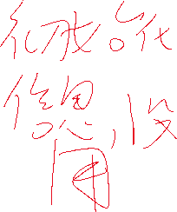

self.collision_threshold = collision_threshold

rospy.init_node('webots_env', anonymous=True)

robot_global.robot_name = robot_connect()

human.human_name = human_connect()

robot_global.PubSetPositionReq = rospy.Publisher('/simulation_set_position_req', Vector3, queue_size=1)

robot_global.SubSetPositionRes = rospy.Subscriber('/simulation_set_position_res', Bool,

set_position_res_callback)

###new add for human_pose

human.PubSetPositionReq = rospy.Publisher('/simulation_set_human_pose_req', Vector3, queue_size=1)

human.SubSetPositionRes = rospy.Subscriber('/simulation_set_human_pose_res', Bool,

set_human_pose_res_callback)

# human.PubSetRotationReq = rospy.Publisher('/simulation_set_rotation_req', Quaternion, queue_size=1)

#human.SubSetRotationRes = rospy.Subscriber('/simulation_set_rotation_res', Bool,

# set_rotation_res_callback)

robot_global.PubSetRotationReq = rospy.Publisher('/simulation_set_rotation_req', Quaternion, queue_size=1)

robot_global.SubSetRotationRes = rospy.Subscriber('/simulation_set_rotation_res', Bool,

set_rotation_res_callback)

robot_global.PubResetNodePhsicsReq = rospy.Publisher('/simulation_reset_node_physics_req', Bool, queue_size=1)

robot_global.SubResetNodePhsicsRes = rospy.Subscriber('/simulation_reset_node_physics_res', Bool,

reset_node_physics_res_callback)

robot_global.PubGetPositionReq = rospy.Publisher('/simulation_get_position_req', Bool, queue_size=1)

robot_global.SubGetPositionRes = rospy.Subscriber('/simulation_get_position_res', Vector3,

get_position_res_callback)

robot_global.PubGetRotationReq = rospy.Publisher('/simulation_get_rotation_req', Bool, queue_size=1)

robot_global.SubGetRotationRes = rospy.Subscriber('/simulation_get_rotation_res', Quaternion,

get_rotation_res_callback)

human.PubGetPositionReq = rospy.Publisher('/simulation_get_human_position_req', Bool, queue_size=1)

human.SubGetPositionRes = rospy.Subscriber('/simulation_get_human_position_res', Vector3,

get_human_position_res_callback)

human.PubGetRotationReq = rospy.Publisher('/simulation_get_human_rotation_req', Bool, queue_size=1)

human.SubGetRotationRes = rospy.Subscriber('/simulation_get_human_rotation_res', Quaternion,

get_human_rotation_res_callback)

for i in range(0, 5):

time_step.time_step_call() #zuoyong? hjk

motor.init()

motor.set_velocity(0, 0, 0, 0)

time_step.time_step_call()

time_step.time_step_call()

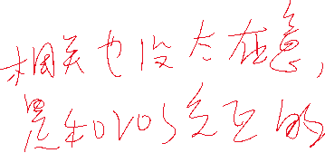

time_step.time_step_call()

laser.init()

#laser.get_laser_scan_data()

self.reward_range = (-np.inf, np.inf)

self.action_history1 = 0

self.action_history2 = 0

self.action_history3 = 0

for i in range(0, 5):

time_step.time_step_call()

#get robot pose

pub_get_position_req()

while robot_global.get_position_res_flag is False:

time_step.time_step_call()

pub_get_rotation_req()

while robot_global.get_rotation_res_flag is False:

time_step.time_step_call()

#get human pose

pub_get_human_position_req()

while human.get_position_res_flag is False:

time_step.time_step_call()

pub_get_human_rotation_req()

while human.get_rotation_res_flag is False:

time_step.time_step_call()

rpos, rrot = getopposite(human.position, human.rotation, self.my_case)

dist1 = getDisXZ(robot_global.position.x, robot_global.position.z, robot_global.rotation.w, rpos.x, rpos.z, rrot.w)

rtang, rot1, rot2 = getanglefea(robot_global.position.x, robot_global.position.z, robot_global.rotation.w,

rpos.x, rpos.z, rrot.w)

self.distp = dist1 #past distance

self.rot1p =rot1

self.rot2p = rot2

self.init_dist_pos = 0

self.wintimes_dist_key = 10

self.wintimes_all = [0, 0, 0, 0, 0, 0, 0, 0, 0, 0, 0]

self.wintimes_win = [0, 0, 0, 0, 0, 0, 0, 0, 0, 0, 0]

self.wintimes = 0

self.collisiontimes = 0

self.N = int(6.6 * unit + 10)

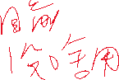

self.M = int(9.9 * unit + 10)

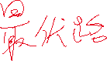

self.mp = self.init_map_hjktest()



self.lenp = 0

self.old_robot_postion = copy.deepcopy(robot_global.position)

self.old_robot_rotation = copy.deepcopy(robot_global.rotation)

def init_map_hjktest(self):

mp = np.zeros((self.N, self.M))

for i in range(int(4.5 * unit), int(6.60 * unit + 1)):

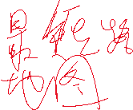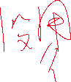

for j in range(int(0 * unit), int(1.90 * unit + 1)):



mp[i][j] = 1



for i in range(int(6.00 * unit), int(6.60 * unit + 1)):

for j in range(int(2.80 * unit), int(5.00 * unit + 1)):

mp[i][j] = 1

for i in range(int(2.30 * unit), int(3.70 * unit + 1)):

for j in range(int(3.15 * unit), int(3.45 * unit + 1)):

mp[i][j] = 1

for i in range(int(3.70 * unit), int(4.10 * unit + 1)):

for j in range(int(9.10 * unit), int(9.90 * unit + 1)):

mp[i][j] = 1

for i in range(int(1.60 * unit), int(3.40 * unit + 1)):

for j in range(int(8.50 * unit), int(9.90 * unit + 1)):

mp[i][j] = 1

for i in range(int(0 * unit), int(1.00 * unit + 1)):

for j in range(int(0 * unit), int(3.30 * unit + 1)):

mp[i][j] = 1

for i in range(int(0 * unit), int(1.00 * unit + 1)):

for j in range(int(4.40 * unit), int(5.80 * unit + 1)):

mp[i][j] = 1

for i in range(int(0 * unit), int(1.40 * unit + 1)):

for j in range(int(6.10 * unit), int(7.90 * unit + 1)):

mp[i][j] = 1

return mp

def distance(self, p1, p2):

dist = math.sqrt((p1.x-p2.x)*(p1.x-p2.x)+(p1.y-p2.y)*(p1.y-p2.y)+(p1.z-p2.z)*(p1.z-p2.z))

return dist

def step(self, action):

if action == 0: # FORWARD

if self.action_history1 != 0:

motor.set_velocity(0, 0, 0, 0)

pub_reset_node_physics_req()

while robot_global.reset_node_physics_res_flag is False:

time_step.time_step_call()

motor.set_velocity(5.0, 5.0, 5.0, 5.0)

elif action == 1: # LEFT forward

if self.action_history1 != 3:

motor.set_velocity(0, 0, 0, 0)

pub_reset_node_physics_req()

while robot_global.reset_node_physics_res_flag is False:

time_step.time_step_call()

motor.set_velocity(4.0, 4.0, 7.0, 7.0)

elif action == 2: # RIGHT forward

if self.action_history1 != 4:

motor.set_velocity(0, 0, 0, 0)

pub_reset_node_physics_req()

while robot_global.reset_node_physics_res_flag is False:

time_step.time_step_call()

motor.set_velocity(7.0, 7.0, 4.0, 4.0)

elif action == 3: # TURN LEFT

if self.action_history1 != 1:

motor.set_velocity(0, 0, 0, 0)

pub_reset_node_physics_req()

while robot_global.reset_node_physics_res_flag is False:

time_step.time_step_call()

motor.set_velocity(-3.0, -3.0, 3.0, 3.0)

elif action == 4: # TURN RIGHT

if self.action_history1 != 2:

motor.set_velocity(0, 0, 0, 0)

pub_reset_node_physics_req()

while robot_global.reset_node_physics_res_flag is False:

time_step.time_step_call()

motor.set_velocity(3.0, 3.0, -3.0, -3.0)

self.action_history3 = self.action_history2

self.action_history2 = self.action_history1

self.action_history1 = action

for i in range(0, 4):

time_step.time_step_call()

laser_data, done = laser.get_laser_scan_data()

while done is False:

laser_data, done = laser.get_laser_scan_data()

time_step.time_step_call()

laser_state, is_collision = discretize_observation(laser_data, self.laser_dim, self.collision_threshold)

# get robot pose

pub_get_position_req()

while robot_global.get_position_res_flag is False:

time_step.time_step_call()

pub_get_rotation_req()

while robot_global.get_rotation_res_flag is False:

time_step.time_step_call()

# get human pose

pub_get_human_position_req()

while human.get_position_res_flag is False:

time_step.time_step_call()

pub_get_human_rotation_req()

while human.get_rotation_res_flag is False:

time_step.time_step_call()

# get right opposite pose to human

rpos, rrot = getopposite(human.position, human.rotation, self.my_case)

rtang, rot1, rot2 = getanglefea(robot_global.position.x, robot_global.position.z, robot_global.rotation.w, rpos.x, rpos.z, rrot.w)

dist1 = getDisXZ(robot_global.position.x, robot_global.position.z, robot_global.rotation.w, rpos.x, rpos.z,

rrot.w)

# state = laser_state + [dist1, rot1, rot2] + action_history

#print ("from robot to person: ", robot_global.position.x, robot_global.position.z, robot_global.rotation.w,

# human.position.x, human.position.z, human.rotation.w, dist1, rot1)

# print ("State : " + str(state) + " Action : " + str(action))

state = changeStateFromEnvToNetwork(laser_state, dist1, rot1, rot2, action)

'''

distance = getDisXZ(robot_global.position.x, robot_global.position.z, robot_global.rotation.w, self.old_robot.position.x, self.old_robot.position.z, self.old_robot.rotation.w)

#distance = getDisXZ(robot_global.position.x, robot_global.position.z, self.old_robot.position.x, self.old_robot.position.z, self.old_robot.rotation.w)

ACTION_LOG_FILE = open("my_net18/actionLog_" + strftime("%Y-%m-%d-%H-%M-%S", gmtime()) + ".txt", 'a+')

#print("???", file = ACTION_LOG_FILE)

print("postion change : ", distance, file=ACTION_LOG_FILE)

doubletmp = 1.0 * (robot_global.rotation.w - self.old_robot.rotation.w)

if doubletmp >= 2.0 * PI - 0.000001:

doubletmp = 0

if doubletmp <= -2.0 * PI + 0.000001:

doubletmp = 0

print("rotation value change : ", doubletmp, file=ACTION_LOG_FILE)

sys.stdout.flush()

self.old_robot_x = copy.deepcopy(robot_global)

'''

done = is_collision

if done is True :

reward = FAILREWARD

self.collisiontimes += 1

print("------------------------------------------------------------------------------")

print("------------------------------------------------------------------------------")

print("------------------------------------------------------------------------------")

print("------------------------------------------------------------------------------")

print("------------------------------------------------------------------------------")

print("------------------------------------------------------------------------------")

print("----------------------------------")

print("----------------------------------")

print ("-----NO! You collide it!------------")

print("----------------------------------")

print("----------------------------------")

print("----------------------------------")

print("------------------------------------------------------------------------------")

print("------------------------------------------------------------------------------")

print("------------------------------------------------------------------------------")

print("------------------------------------------------------------------------------")

print("------------------------------------------------------------------------------")

else :

reward = 0

tmp_par = dist1

if tmp_par > FACINGDIS_RANGE:

tmp_par = FACINGDIS_RANGE

print("hjk--- robot: ", robot_global.rotation.w, rrot.w)

print("hjk--- delta dis last - now : ", self.distp - dist1)

print("hjk--- delta angle last - now : ", math.fabs(self.rot1p), math.fabs(rot1), math.fabs(self.rot1p) - math.fabs(rot1))



print("hjk--- 2222222 delta angle last - now : ", math.fabs(self.rot2p), math.fabs(rot2), math.fabs(self.rot2p) - math.fabs(rot2))

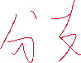

if dist1 < 2.00:



reward = tmp_par * ((self.distp - dist1) * RREWARDDIS + (math.fabs(self.rot1p) - math.fabs(rot1)) * RREWARDANGLE) + (FACINGDIS_RANGE - tmp_par) * RREWARDFACINGANGLE * (math.fabs(self.rot2p) - math.fabs(rot2)) # 0 + (self.difap - difa1)*10

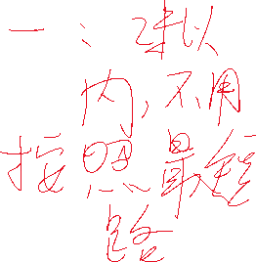

print ("hjk--reward: ", tmp_par * ((self.distp - dist1) * RREWARDDIS + (math.fabs(self.rot1p) - math.fabs(rot1)) * RREWARDANGLE), (FACINGDIS_RANGE - tmp_par) * RREWARDFACINGANGLE * (math.fabs(self.rot2p) - math.fabs(rot2)))

# print ("distance of past and this frame: " + str(self.distp) + " " + str(dist1))

# print ("angle difference of past and this frame: " + str(self.difap) + " " + str(difa1))

print ("Rewards: " + str(reward))

self.lenp = dist1

else:

myspfa = spfa(self.mp, self.N, self.M, robot_global.position.x, robot_global.position.z, rpos.x, rpos.z)



now_l, now_g_x, now_g_z = myspfa.getKey()

ang, _, _ = getanglefea(robot_global.position.x, robot_global.position.z, robot_global.rotation.w, now_g_x, now_g_z, 0)

reward = (self.lenp - now_l) * RREWARDDIS + (PI / 2.0 - math.fabs(ang)) * RREWARDANGLE

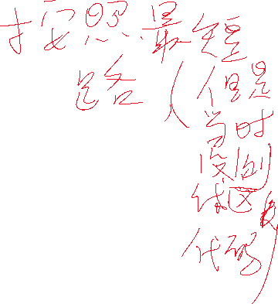

print("hjk--reward: ", (self.lenp - now_l) * RREWARDDIS, (PI / 2.0 - math.fabs(ang)) * RREWARDANGLE, reward)

self.lenp = now_l

# time.sleep(10000000)

actionout = open(actionoutPath, 'a+')

print("action", action, "postionchange:", getDisXZ(robot_global.position.x, robot_global.position.z, 0, self.old_robot_postion.x, self.old_robot_postion.z, 0), "rotationchange:", np.fabs(robot_global.rotation.w - self.old_robot_rotation.w), file=actionout)

sys.stdout.flush()

actionout.close()

self.old_robot_postion = copy.deepcopy(robot_global.position)

self.old_robot_rotation = copy.deepcopy(robot_global.rotation)

self.distp = dist1

self.rot1p = rot1

self.rot2p = rot2

if dist1 < ARRIVEDIS and math.fabs(rot2) < ARRIVEANGLE:

reward = WINREWARD

print (dist1)

print("******************************************************************************")

print("******************************************************************************")

print("******************************************************************************")

print("******************************************************************************")

print("******************************************************************************")

print("******************************************************************************")

print("**********************************")

print("**********************************")

print ("*****OK! You shoot it!************")

print("**********************************")

print("**********************************")

print("**********************************")

print("******************************************************************************")

print("******************************************************************************")

print("******************************************************************************")

print("******************************************************************************")

print("******************************************************************************")

self.wintimes_win[self.init_dist_pos] = self.wintimes_win[self.init_dist_pos] + 1

self.wintimes = self.wintimes + 1

done = True

#exit()

print("*********** hjk-- already shot win for all episode: ", self.wintimes, "collision: ", self.collisiontimes, self.wintimes_all, self.wintimes_win)

return np.asarray(state), reward, done, {}

def reset(self, testxml = 0, xml_human_x = -1, xml_human_y = -1, xml_human_rotation_z = -1, xml_robot_x = -1, xml_robot_y = -1, xml_robot_rotation_z = -1):

if testxml == 0:

for random_iter in range(20):

if self.my_case == -1:

print("hjktest---- reset this", random_iter)

randomrobotINT = random.randint(0, 9)

if randomrobotINT == 0:

robotx = 1.5

roboty = 0.1

robotz = 1.5

elif randomrobotINT == 1:

robotx = 2

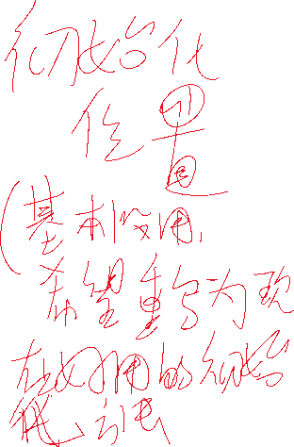

roboty = 0.1

robotz = 1.5

elif randomrobotINT == 2:

robotx = 3

roboty = 0.1

robotz = 1.5

else:

robotx = random.random() * (5.5 - 2) + 2

roboty = 0.1

robotz = random.random() * (8 - 4) + 4

#robotx = random.random() * (5 - 1.5) + 1.5

#roboty = 0.1

#robotz = random.random() * (8 - 1.5) + 1.5

'''

robotx = random.random() * (5.5 - 3.8) + 3.8

roboty = 0.1

robotz = random.random() * (4.5 - 2.7) + 2.7

'''

robot_rotat_x = 0

robot_rotat_y = 1

robot_rotat_z = 0

robot_rotat_w = random.uniform(-PI, PI)#-3.14, 3.14) #-PI*4/5

randomINT =random.randint(0, 4)

if randomINT == 0:

humanx = 3

humany = 1.27

humanz = 6

elif randomINT == 1:

humanx = 4.5

humany = 1.27

humanz = 7.5

elif randomINT >= 2 and randomINT <= 4:

humanx = 2.5

humany = 1.27

humanz = 2

else:

humanx = random.random()*(4 - 2.5) + 2.5

humany = 1.27

humanz = random.random()*(7.5 - 2.5) + 2.5

else:

robotx = my_case_robotx[self.my_case]

roboty = my_case_roboty[self.my_case]

robotz = my_case_robotz[self.my_case]

robot_rotat_x = my_case_robot_rotat_x[self.my_case]

robot_rotat_y = my_case_robot_rotat_y[self.my_case]

robot_rotat_z = my_case_robot_rotat_z[self.my_case]

robot_rotat_w = my_case_robot_rotat_w[self.my_case]

humanx = my_case_humanx[self.my_case]

humany = my_case_humany[self.my_case]

humanz = my_case_humanz[self.my_case]

###important!!!!!

global global_rn

global_rn = random.random()

### room

position = Vector3()

position.x = robotx

position.y = roboty

position.z = robotz

rotation = Quaternion()

rotation.x = robot_rotat_x

#rotation.y = random.uniform(-3.14, 3.14)

rotation.y = robot_rotat_y

rotation.z = robot_rotat_z

rotation.w = robot_rotat_w

human_pose = Vector3()

human_pose.x = humanx

human_pose.y = humany

human_pose.z = humanz

rpos, rrot = getopposite(human_pose, human.rotation, self.my_case)

dist1 = getDisXZ(position.x, position.z, rotation.w, rpos.x, rpos.z,

rrot.w)

distRtoH = getDisXZ(position.x, position.z, rotation.w, human_pose.x, human_pose.z, 0)

if self.my_case != -1 or (dist1 < DISFROMSTARTTOEND and distRtoH > MINDISFROMSTARTTOEND):

break

elif testxml == 1:

position = Vector3()

position.x = xml_robot_x

position.y = 0.1

position.z = xml_robot_y

rotation = Quaternion()

rotation.x = 0

# rotation.y = random.uniform(-3.14, 3.14)

rotation.y = 1

rotation.z = 0

rotation.w = xml_robot_rotation_z

human_pose = Vector3()

human_pose.x = xml_human_x

human_pose.y = 1.27

human_pose.z = xml_human_y

global global_rn

if xml_human_rotation_z == 1:

global_rn = 0

elif xml_human_rotation_z == 2:

global_rn = 0.6

elif xml_human_rotation_z == 3:

global_rn = 0.2

elif xml_human_rotation_z == 4:

global_rn = 0.9

done = motor.set_velocity(0, 0, 0, 0)

while done is False:

time_step.time_step_call()

done = motor.set_velocity(0, 0, 0, 0)

pub_reset_node_physics_req()

while robot_global.reset_node_physics_res_flag is False:

time_step.time_step_call()

pub_set_position_req(position)

while robot_global.set_position_res_flag is False:

time_step.time_step_call()

pub_set_rotation_req(rotation)

while robot_global.set_rotation_res_flag is False:

time_step.time_step_call()

pub_get_human_position_req()

while human.get_position_res_flag is False:

time_step.time_step_call()

pub_get_human_rotation_req()

while human.get_rotation_res_flag is False:

time_step.time_step_call()

#print('hjk--- not set random :', human.position.x, human.position.y, human.position.z, human.rotation.x, human.rotation.y, human.rotation.z, human.rotation.w)

pub_set_human_pose_req(human_pose)

print("hjk--lll :", human.set_human_pose_res_flag)

while human.set_human_pose_res_flag is False:

time_step.time_step_call()

pub_get_human_position_req()

while human.get_position_res_flag is False:

time_step.time_step_call()

pub_get_human_rotation_req()

while human.get_rotation_res_flag is False:

time_step.time_step_call()

print('hjk--- have set random :', human.position.x, human.position.y, human.position.z)

laser_data, done = laser.get_laser_scan_data()

while done is False:

laser_data, done = laser.get_laser_scan_data()

time_step.time_step_call()

laser_state, is_collision = discretize_observation(laser_data, self.laser_dim, self.collision_threshold)

for i in range(0, 10):

time_step.time_step_call()

###############

self.action_history1 = 0

self.action_history2 = 0

self.action_history3 = 0

#get human pose

pub_get_human_position_req()

while human.get_position_res_flag is False:

time_step.time_step_call()

pub_get_human_rotation_req()

while human.get_rotation_res_flag is False:

time_step.time_step_call()

# self.mp = np.zeros((self.N,self.M))

rpos, rrot = getopposite(human.position, human.rotation, self.my_case)

dist1 = getDisXZ(robot_global.position.x, robot_global.position.z, robot_global.rotation.w, rpos.x, rpos.z, rrot.w)

rtang, rot1, rot2 = getanglefea(position.x, position.z, rotation.w, rpos.x, rpos.z, rrot.w)

print("11111 state dis : ", dist1 * 10)

state = changeStateFromEnvToNetwork(laser_state, dist1, rot1, rot2, -1)

self.distp = dist1

self.lenp = dist1

self.rot1p = rot1

self.rot2p = rot2

# self.old_robot = robot_global

self.old_robot_postion = copy.deepcopy(robot_global.position)

self.old_robot_rotation = copy.deepcopy(robot_global.rotation)

self.init_dist_pos = int(self.distp / 0.5)

#self.init_dist_pos = self.init_dist / 0.5

if self.init_dist_pos > self.wintimes_dist_key:

self.init_dist_pos = self.wintimes_dist_key

print("wwwww????? : ", self.init_dist_pos, self.distp)

self.wintimes_all[self.init_dist_pos] = self.wintimes_all[self.init_dist_pos] + 1

return np.asarray(state)