from __future__ import print_function

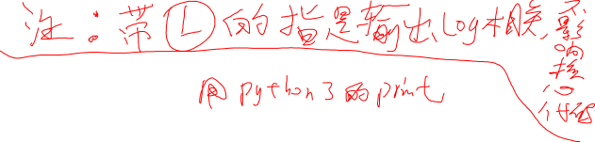

from collections import deque

from hjk_real_facing_people_webots_env_obstacle import WebotsLidarNnEnv

from hjk_saved_neural_qlearning import NeuralQLearner

from hjk_real_facing_people_webots_env_obstacle import actionoutPath

import tensorflow as tf



import numpy as np

import sys

import rospy

import random

import copy



import xml.dom.minidom

import gc

from time import gmtime, strftime

out_wintimes_path = "my_net22/wintimes_" + strftime("%Y-%m-%d-%H-%M-%S", gmtime()) + ".txt"



out_test_wintimes_path = "my_net22/test_wintimes_" + strftime("%Y-%m-%d-%H-%M-%S", gmtime()) + ".txt"



laser_dim = 16

dst_dim = 2

facing_dim = 1

history_dim = 1



state_dim = laser_dim + dst_dim + facing_dim + history_dim



num_actions = 5

MAX_STEPS = 150

COLLISION_THRESHOLD = 0.3

episode_history = deque(maxlen=100)

# 0 means to train; 1 means to test for my case ;

py_function = 0

MAX_EPISODES = 100000

JUSTTEST = 0

# now when justtest, it will make use. And should use right limit_sta_dis_value and limit_sta_dis_pos

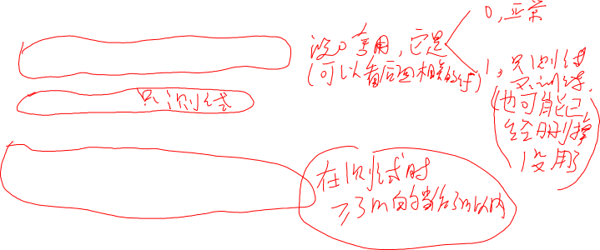

USELIMITSTADIS = 0

LIMITSTADISVALUE = 3 * 10

LIMITSTADISPOS = laser_dim # 0~15is laser, 16 is dist

## four layers

num_layers = 4

num_neural = [state_dim, 18, 18, num_actions]

human_x = []

human_y = []

human_rotation_z = []

robot_x = []

robot_y = []

robot_rotation_z = []



def loadxml():



dom = xml.dom.minidom.parse('src/env/test.xml')

root = dom.documentElement

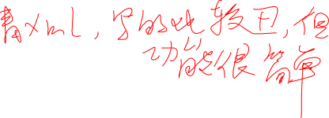

bb = root.getElementsByTagName('episode')

for i, var in enumerate(bb):

human_x.append(float(var.getElementsByTagName('human_x')[0].firstChild.data))

human_y.append(float(var.getElementsByTagName('human_y')[0].firstChild.data))

human_rotation_z.append(int(var.getElementsByTagName('human_rotation_z')[0].firstChild.data))

robot_x.append(float(var.getElementsByTagName('robot_x')[0].firstChild.data))

robot_y.append(float(var.getElementsByTagName('robot_y')[0].firstChild.data))

robot_rotation_z.append(float(var.getElementsByTagName('robot_rotation_z')[0].firstChild.data))

def add_layer(inputs, in_size, out_size, w_name, b_name, activation_function=None):

Weights = tf.get_variable(w_name, [in_size, out_size],

initializer=tf.random_normal_initializer(mean=0.0, stddev=0.2))

biases = tf.get_variable(b_name, out_size,

initializer=tf.constant_initializer(0))

Wx_plus_b = tf.matmul(inputs, Weights) + biases

if activation_function is None:

outputs = Wx_plus_b

else:

outputs = activation_function(Wx_plus_b)

return outputs

def init_q_net(states):



h1 = add_layer(states, num_neural[0], num_neural[1], 'W1', 'b1', activation_function=tf.nn.relu)

h2 = add_layer(h1, num_neural[1], num_neural[2], 'W2', 'b2', activation_function=tf.nn.relu)

q = add_layer(h2, num_neural[2], num_neural[3], 'W3', 'b3', activation_function=None)

return q



def complex_init_q_net(states):

laser = tf.slice(states, [0, 0], [-1, laser_dim])

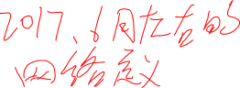

goal = tf.slice(states, [0, laser_dim], [-1, dst_dim + facing_dim])

his_a = tf.slice(states, [0, laser_dim + dst_dim + facing_dim], [-1, history_dim])



# print(laser)



# print(goal)



# print(his_a)

laser_8 = add_layer(laser, laser_dim, 8, 'W1', 'b1', activation_function=tf.nn.relu)

cat_laser_8_his_a = tf.concat([laser_8, his_a], 1)



# print(cat_laser_8_his_a)

laser_5 = add_layer(cat_laser_8_his_a, 9, 5, 'W2', 'b2', activation_function=tf.nn.relu)

cat_laser_5_goal = tf.concat([laser_5, goal], 1)

cat_r8 = add_layer(cat_laser_5_goal, 8, 8, 'W3', 'b3', activation_function=tf.nn.relu)

cat_5 = add_layer(cat_r8, 8, 5, 'W4', 'b4', activation_function=None)

# h_8_and_1 = tf.concat(1, h_)

# h2 = add_layer(h1, num_neural[1], num_neural[2], 'W2', 'b2', activation_function=tf.nn.relu)

# q = add_layer(h2, num_neural[2], num_neural[3], 'W3', 'b3', activation_function=None)

return cat_5

def testtest(path):

env.collision_threshold = 0.25

xml_test_cnt = 0

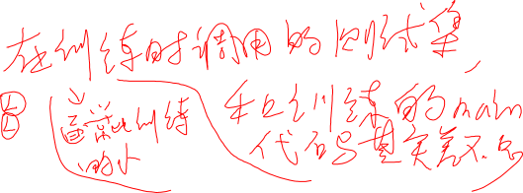

sum_steps = 0

l = len(human_x)

#print('---- ', l)

for i_episode in xrange(l):

env.my_case = -1

state = env.reset(1, human_x[i_episode], human_y[i_episode], human_rotation_z[i_episode], robot_x[i_episode],

robot_y[i_episode], robot_rotation_z[i_episode])

last_action = -1

wrongActionTimes = 0

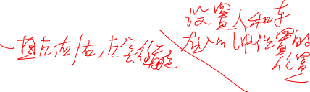

record_t = -1

for t in xrange(MAX_STEPS):

record_t = t

#print("In episode ", i_episode, ":")

#print('step ' + str(t))

# print("new change : ", state, "sure: ", state[-1])

# print("333333 --- state: ", state[LIMITSTADISPOS], state)

limit_state = copy.deepcopy(state)

if limit_state[LIMITSTADISPOS] > LIMITSTADISVALUE:

limit_state[LIMITSTADISPOS] = LIMITSTADISVALUE - random.random() * 10



# print("www i don't konw: ", state)

print('tttttttttttttttttttttttttttttttttttttttttttt: ', i_episode, 'wintimes: ', xml_test_cnt)

action = q_learner.eGreedyAction(limit_state[np.newaxis, :], False)

if (last_action == 3 and action == 4) or (last_action == 4 and action == 3):

wrongActionTimes = wrongActionTimes + 1

if wrongActionTimes == 2:

wrongActionTimes = 0



print('hjk--- ffffff :', action)

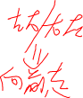

action = 0

#print('hjk--action: ', action, 'lastaction', last_action)

actionout = open(actionoutPath, 'a+')

# print("??????????????????????????????????????????????????????????????????????????????????????")

print('action: ', action, 'lastaction: ', last_action, file = actionout)

sys.stdout.flush()



actionout.close()

next_state, reward, done, _ = env.step(action)

last_action = action

state = next_state

if done:

if reward >= 500 - 1:

xml_test_cnt += 1

sum_steps += t

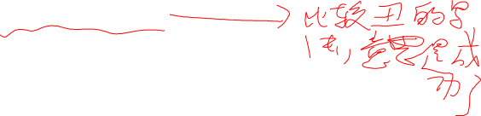

out_test_wintimes = open(out_test_wintimes_path, 'a+')

print('testround: ', i_episode, "win!! use steps: ", t, file=out_test_wintimes)

out_test_wintimes.close()

break

if xml_test_cnt == 0:

mean_steps = 0

else:

mean_steps = sum_steps * 1.0 / xml_test_cnt

out_test_wintimes = open(out_test_wintimes_path, 'a+')

print('test ', path, "wintimes: ", xml_test_cnt, "mean_steps: ", mean_steps, file=out_test_wintimes)

sys.stdout.flush()

out_test_wintimes.close()

env.collision_threshold = COLLISION_THRESHOLD

if __name__ == '__main__':

len_args = len(sys.argv)

path = None

if (len_args > 1):

path = str(sys.argv[1])

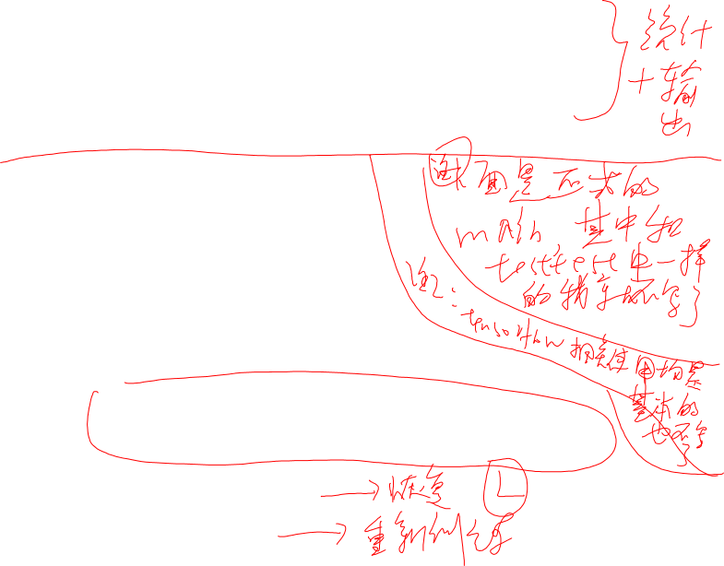

loadxml()

env_name = 'facing_people_webots_env_obstacle'

sess = tf.Session()

#### hjk change the learning_rate to 0.001. nnn.....

optimizer = tf.train.RMSPropOptimizer(learning_rate=0.004, decay=0.9)

# writer = tf.train.SummaryWriter("/tmp/{}-experiment-1".format(env_name), graph=sess.graph)

writer = tf.summary.FileWriter("my_net20/{}-experiment-1".format(env_name), graph=sess.graph)

if path is not None:

print('resotre net path: ' + path)

else:

print("init")

# restore_net(sess, path)



q_learner = NeuralQLearner(sess,



optimizer,

complex_init_q_net,

path,

state_dim,

num_actions,

512, # batch_size=32,

0.5, # init_exp=0.3, # 0.5, # initial exploration prob

0.1, # final_exp=0.001, # final exploration prob

# anneal_steps=10000, # N steps for annealing exploration

200000, # anneal_steps=2000, # N steps for annealing exploration

10000, # replay_buffer_size=10000,

3, # store_replay_every=3, # how frequent to store experience

0.9, # discount_factor=0.9, # discount future rewards

0.01, # target_update_rate=0.01,

0.01, # reg_param=0.01, # regularization constants

5, # max_gradient=5, # max gradient norms

False, # double_q_learning=False,

None, # summary=None,

100 # summary_every=100

)

# print(sess.run(tf.get_default_graph().get_tensor_by_name("q_network/b3:0")))

# print(sess.run(tf.get_default_graph().get_tensor_by_name("target_network/b3:0")))

env = WebotsLidarNnEnv(laser_dim, COLLISION_THRESHOLD)

wintimes = 0

for i_episode in xrange(MAX_EPISODES):

# initialize

if py_function == 1:

env.my_case = i_episode



else:

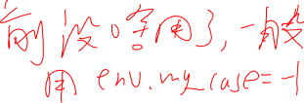

env.my_case = -1

state = env.reset()

# print("2222222 --- state: ", state[LIMITSTADISPOS])

total_rewards = 0

last_action = -1

wrongActionTimes = 0

record_t = -1

for t in xrange(MAX_STEPS):

gc.collect()



record_t = t

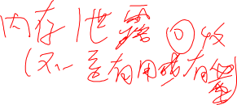

print("In episode ", i_episode, ":")

print('step ' + str(t))

# print("new change : ", state, "sure: ", state[-1])

if JUSTTEST == 0:

action = q_learner.eGreedyAction(state[np.newaxis, :])

else:

if USELIMITSTADIS == 0:

action = q_learner.eGreedyAction(state[np.newaxis, :], False)

else:



# print("333333 --- state: ", state[LIMITSTADISPOS], state)

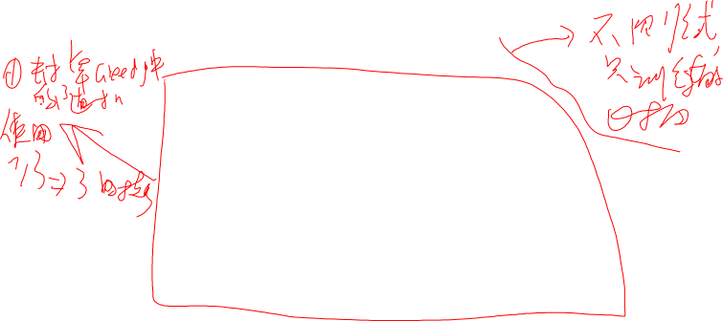

limit_state = copy.deepcopy(state)

if limit_state[LIMITSTADISPOS] > LIMITSTADISVALUE:

limit_state[LIMITSTADISPOS] = LIMITSTADISVALUE - random.random() * 10

# print("www i don't konw: ", state)

print('hjk--- limit_state: ', state, limit_state)

action = q_learner.eGreedyAction(limit_state[np.newaxis, :], False)

if (last_action == 3 and action == 4) or (last_action == 4 and action == 3):

wrongActionTimes = wrongActionTimes + 1

if wrongActionTimes == 2:

wrongActionTimes = 0

print('hjk--- ffffff :', action)

action = 0

print('hjk--action: ', action, 'lastaction', last_action)

actionout = open(actionoutPath, 'a+')

# print("??????????????????????????????????????????????????????????????????????????????????????")

print('action: ', action, 'lastaction: ', last_action, file=actionout)

sys.stdout.flush()

actionout.close()

next_state, reward, done, _ = env.step(action)

last_action = action

total_rewards += reward

if JUSTTEST == 0:



if state[-1] != -1 and next_state[-1] != -1:

q_learner.storeExperience(state, action, reward, next_state, done)

q_learner.updateModel(i_episode)

state = next_state

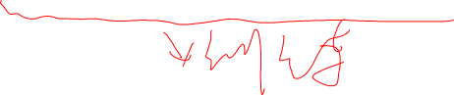

if done:

if reward >= 500 - 1:

wintimes += 1

else:

record_t = -1

break

episode_history.append(wintimes)

# mean_rewards = np.mean(episode_history)

print("Episode {}".format(i_episode))

#print("Finished after {} timesteps".format(t + 1))

print("Reward for this episode: {}".format(total_rewards))

# print("last 99 episodes wintimes: ", episode_history[-1][0] - episode_history[0][0])

out_wintimes = open(out_wintimes_path, "a+")

print("Episode: ", i_episode, " ", q_learner.exploration, " ", "last 99 episodes wintimes: ",

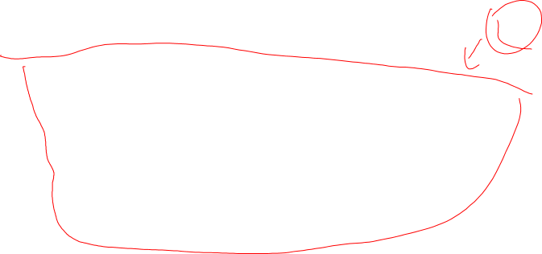

episode_history[-1] - episode_history[0], 'step: ', record_t,

file=out_wintimes)

sys.stdout.flush()

out_wintimes.close()

# print("Average reward for last 100 episodes: {}".format(mean_rewards))

if JUSTTEST == 0:

if i_episode >= 200 and i_episode % 200 == 0:

path = 'my_net22/' + env_name + '_' + str(num_layers) \

+ 'layers_' + str(i_episode + 1) + 'epsiode_' + \

strftime("%Y-%m-%d-%H-%M-%S", gmtime()) + 'restore_network_rerandom'

q_learner.save_net(path)



testtest(str(i_episode + 1))、

