MediCare Pharmacy
Management System
Full Project Report
Project Name | Pharmacy Management System
Project Type | Desktop pharmacy management application
Application Platform | C# Windows Forms
Framework | .NET Framework 4.7.2
Database | SQL Server LocalDB using ADO.NET
Core idea: Three roles. One pharmacy system. Complete workflow control.

Abstract
This report documents the MediCare Pharmacy Management System, a C# Windows Forms desktop application designed for pharmacy operations. The system provides role-based access for customers, pharmacists, and administrators. It supports user authentication, medicine browsing, cart management, order placement, prescription upload, inventory management, order processing, user administration, and basic reporting. The report follows the same high-level organization as the provided GitHub README sample while expanding it into a formal project report with architecture analysis, database design, module descriptions, testing strategy, limitations, and future improvement recommendations.

Table of Contents
- 1. Introduction
- 2. Project Overview
- 3. Objectives and Scope
- 4. Key Features
- 5. Technology Stack
- 6. System Architecture
- 7. Database Design
- 8. Project Structure
- 9. Module-Wise Implementation
- 10. Core Workflows
- 11. Installation and Setup Guide
- 12. Default Login Credentials
- 13. Testing and Validation
- 14. Security and Data Integrity Review
- 15. Limitations
- 16. Future Enhancements
- 17. Contributors
- 18. Conclusion
- 19. References
- Appendix A. Suggested Database Setup Script

1. Introduction
Modern pharmacies need a reliable system to manage medicines, customers, prescriptions, orders, and administrative decisions. Manual handling of these tasks can create delays, inventory mistakes, missing prescription records, and poor order tracking. The MediCare Pharmacy Management System addresses these problems through a structured desktop application that separates responsibilities among customers, pharmacists, and administrators.
The uploaded project is implemented as a Windows Forms application. Its forms are built programmatically using C# controls, panels, labels, buttons, grids, and custom drawing. The application connects to a SQL Server LocalDB database named PharmacyDB through ADO.NET and a shared DBHelper class.

2. Project Overview
MediCare is a role-based pharmacy desktop application designed to streamline the full pharmacy workflow from medicine browsing and order placement to pharmacist inventory handling and admin-level oversight.
Role | System Responsibility
Customer | Browse/search medicines, add to cart, place orders, track orders, upload prescriptions, manage profile.
Pharmacist | View inventory, restock medicines, process customer orders, review prescriptions, manage own profile.
Admin | Monitor dashboard statistics, manage users, medicines, orders, prescriptions, reports, and profile settings.

3. Objectives and Scope

3.1 Objectives
- Provide a single pharmacy management application for customers, pharmacists, and administrators.
- Improve medicine search, ordering, inventory tracking, and prescription handling.
- Use role-based navigation so that each user sees only the features relevant to their role.
- Store application data in SQL Server LocalDB and access it through ADO.NET.
- Create a maintainable project structure with separate forms for authentication and dashboards.

3.2 Scope
- Included: registration, login, password reset, medicine browsing, cart, order placement, prescription upload, inventory management, order status update, user management, and basic reporting.
- Not included: online payment gateway, cloud deployment, pharmacy barcode scanner integration, regulatory e-prescription verification, multi-branch stock synchronization, and production-level authentication hardening.

4. Key Features

4.1 Customer Features
- Register and log in with customer role.
- Browse and search medicine inventory by name or category.
- View medicine price, category, stock, and image information where available.
- Add medicines to cart with quantity validation and stock reduction logic.
- Remove items from cart and restore stock accordingly.
- Place an order from cart and generate order header/order item records.
- Track order history and view order item details.
- Upload prescriptions and check prescription status.
- Edit profile details and update password.

4.2 Pharmacist Features
- Dashboard cards for total medicines, low-stock medicines, pending orders, and pending prescriptions.
- Search and view medicine inventory.
- Restock medicines by adding quantity to existing stock.
- View customer orders and update order status.
- Approve or reject uploaded prescriptions.
- Edit pharmacist profile details and password.

4.3 Admin Features
- Dashboard statistics for users, medicines, orders, low stock, and delivered-order revenue.
- Add, update, delete, and view medicines.
- Upload or update medicine image paths.
- View and update all orders.
- Approve, reject, and delete prescriptions.
- View and delete users.
- Display basic reports such as revenue, delivered orders, pending orders, and inventory count.
- Edit admin profile and update password.

5. Technology Stack
Technology | Usage in Project
C# | Primary programming language used for application logic and event handling.
.NET Framework 4.7.2 | Target framework defined in the project file and application configuration.
Windows Forms | Desktop user interface technology used for login, registration, dashboards, grids, and forms.
SQL Server LocalDB | Local relational database engine used for PharmacyDB.
ADO.NET | Database access layer using SqlConnection, SqlCommand, SqlDataAdapter, and DataTable.
System.Drawing | Custom UI rendering, colors, cards, icons, and panel drawing.
Visual Studio | Recommended IDE for building and running the solution.

6. System Architecture
The application follows a simple layered desktop architecture. The presentation layer is made of Windows Forms screens, the data access layer is centralized in DBHelper.cs, and persistent data is stored in SQL Server LocalDB. LoginForm routes users to the correct dashboard based on the Role field stored in the Users table.
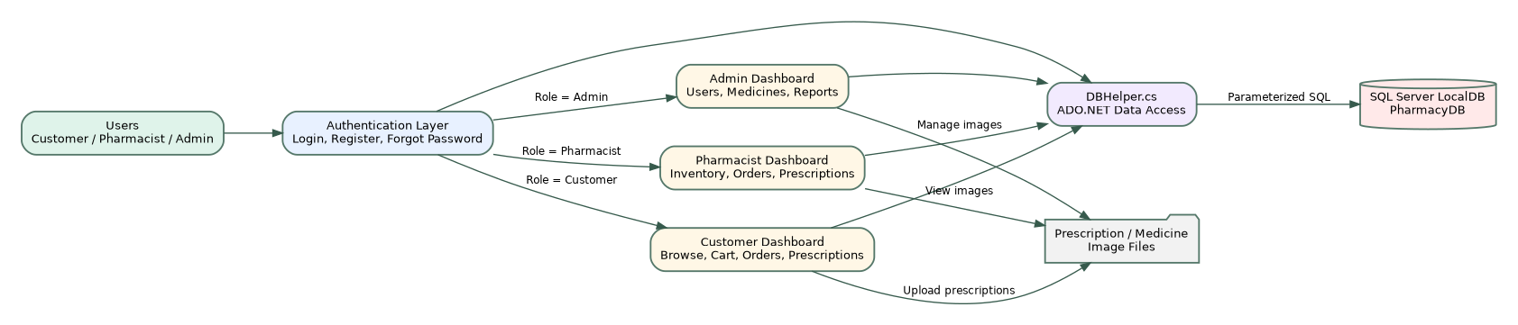
Figure 1: High-level architecture of the MediCare Pharmacy Management System

6.1 Architectural Components
Layer / Component | Description
Presentation Layer | LoginForm, RegisterForm, ForgotPasswordForm, CustomerDashboard, PharmacistDashboard, and AdminDashboard.
Business Workflow Layer | Event handlers and dashboard methods that validate user input, calculate totals, manage stock, and control role-specific flows.
Data Access Layer | DBHelper.cs provides reusable database methods such as RegisterUser, LoginUser, GetMedicines, AddToCart, PlaceOrder, UploadPrescription, and UpdatePassword.
Database Layer | PharmacyDB stores users, medicines, cart records, order headers, order items, and prescriptions.
File Layer | Prescription uploads and medicine images are represented using file names and file paths in the database.

7. Database Design
The source code uses multiple tables to separate user accounts, medicines, cart items, order summaries, order line items, and prescriptions. Compared with a single Orders table, the OrderHeaders and OrderItems design is more normalized because one order can contain multiple medicines.
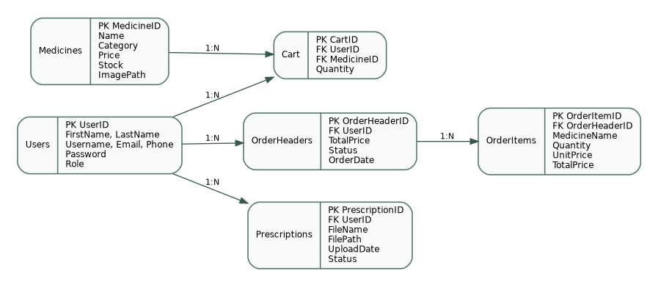
Figure 2: Entity relationship overview based on the uploaded project source

7.1 Table Summary
Table | Purpose
Users | Stores registered users, login identity, contact details, password, and role.
Medicines | Stores medicine catalog details including name, category, price, stock, and optional image path.
Cart | Temporary basket that links a user to medicines and selected quantities.
OrderHeaders | Stores one summary row per placed order, including user, total price, status, and date.
OrderItems | Stores individual medicines inside each order, including quantity, unit price, and total price.
Prescriptions | Stores uploaded prescription file metadata and review status.

7.2 Main Entities and Fields
Entity | Important Fields
Users | UserID (PK), FirstName, LastName, Username, Email, Phone, Password, Role
Medicines | MedicineID (PK), Name, Category, Price, Stock, ImagePath
Cart | CartID (PK), UserID (FK), MedicineID (FK), Quantity
OrderHeaders | OrderHeaderID (PK), UserID (FK), TotalPrice, Status, OrderDate
OrderItems | OrderItemID (PK), OrderHeaderID (FK), MedicineName, Quantity, UnitPrice, TotalPrice
Prescriptions | PrescriptionID (PK), UserID (FK), FileName, FilePath, UploadDate, Status

8. Project Structure
The project is organized as a Visual Studio solution with one Windows Forms project named PharmacyUser.
PharmacyUser/
├── PharmacyUser.sln
└── PharmacyUser/
├── Program.cs
├── App.config
├── DBHelper.cs
├── LoginForm.cs
├── LoginForm.Designer.cs
├── RegisterForm.cs
├── RegisterForm.Designer.cs
├── ForgotPasswordForm.cs
├── CustomerDashboard.cs
├── PharmacistDashboard.cs
├── AdminDashboard.cs
└── Properties/
├── AssemblyInfo.cs
├── Resources.resx
└── Settings.settings
File | Responsibility
Program.cs | Application entry point. Starts the Windows Forms application and opens LoginForm.
App.config | Stores the LocalDB connection string named PharmacyDB.
DBHelper.cs | Central database helper class for user, medicine, cart, order, prescription, and password operations.
LoginForm.cs | Authenticates users and opens the correct dashboard according to user role.
RegisterForm.cs | Creates new user accounts and records role information.
ForgotPasswordForm.cs | Allows username-based password reset.
CustomerDashboard.cs | Implements customer browsing, cart, order, prescription, invoice, and profile features.
PharmacistDashboard.cs | Implements inventory restocking, order processing, prescription review, and profile features.
AdminDashboard.cs | Implements system statistics, medicine/user/order/prescription management, reporting, and profile features.

9. Module-Wise Implementation

9.1 Authentication Module
The authentication module includes login, registration, and password reset. Login checks the Users table using username and password, then uses the Role column to decide whether the user should enter the customer dashboard, pharmacist dashboard, or admin dashboard.
- RegisterUser inserts new user information into the Users table.
- LoginUser reads a matching user row from the Users table.
- ResetPassword updates the stored password for a username.
- Role-based redirection is the main access-control mechanism.

9.2 Customer Dashboard Module
The customer dashboard focuses on medicine discovery and order placement. It shows medicine cards/grid data, accepts quantity input, validates stock, updates cart records, and allows customers to place orders. Prescription upload functionality stores file name and path information in the Prescriptions table.

9.3 Pharmacist Dashboard Module
The pharmacist dashboard focuses on operational pharmacy tasks. It displays stock and pending workload metrics, allows restocking of medicines, updates order statuses, and approves or rejects prescriptions. This module is important because it bridges customer orders and fulfillment.

9.4 Admin Dashboard Module
The admin dashboard provides the highest level of control. It can manage users, medicines, orders, and prescriptions. It also calculates system metrics such as total users, total medicines, total orders, low-stock count, and revenue from delivered orders.

9.5 Database Helper Module
DBHelper.cs centralizes the most reusable database operations. It improves maintainability because common data operations are not duplicated across every form. However, some direct SQL statements still exist inside dashboard files, so further refactoring could move all database access into the helper layer or a repository/service layer.

10. Core Workflows
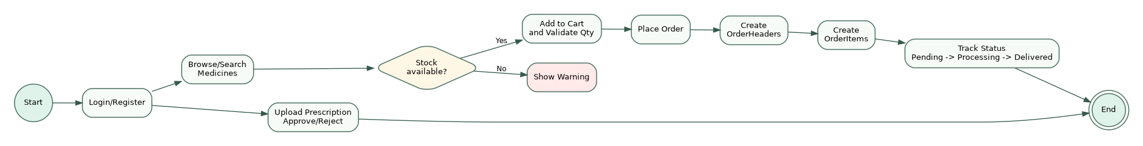
Figure 3: Customer order and prescription workflow

10.1 Customer Ordering Workflow
- Customer logs in or registers a new account.
- Customer searches or browses medicines by name/category.
- Customer chooses quantity and adds medicine to cart.
- System validates available stock and updates cart quantity.
- Customer places order from cart.
- System creates one OrderHeaders record and related OrderItems records.
- System clears the cart after successful order placement.
- Customer tracks order status until it is processed and delivered.

10.2 Prescription Workflow
- Customer uploads prescription file information.
- The uploaded file name/path and default status are stored in Prescriptions.
- Pharmacist or admin reviews the prescription.
- Prescription status is updated to Approved or Rejected.
- Customer can view the prescription status from their dashboard.

10.3 Inventory Workflow
- Admin creates or updates medicine records.
- Customer orders reduce available stock when items are added or quantity changes.
- Removing cart items restores stock.
- Pharmacist can restock medicines by adding quantity.
- Low-stock indicators help staff identify items that require restocking.

11. Installation and Setup Guide

11.1 Prerequisites
- Windows operating system with Visual Studio 2019 or later.
- .NET Framework 4.7.2 developer targeting pack.
- SQL Server Express LocalDB or a compatible SQL Server instance.
- SQL Server Management Studio or another SQL client for creating the database.

11.2 Setup Steps
- Extract the uploaded PharmacyUser source package.
- Open PharmacyUser.sln in Visual Studio.
- Create the PharmacyDB database in SQL Server LocalDB.
- Run the database creation script from Appendix A or an equivalent schema script.
- Confirm the App.config connection string points to the correct database instance.
- Build the solution using Ctrl + Shift + B.
- Run the application using F5 and log in with a seeded admin account or a newly registered user.

11.3 Connection String
<connectionStrings>
<add name="PharmacyDB"
connectionString="Data Source=(localdb)\MSSQLLocalDB;Initial Catalog=PharmacyDB;Integrated Security=True"
providerName="System.Data.SqlClient" />
</connectionStrings>

12. Default Login Credentials
The uploaded source package does not include a complete database seed file. The provided README sample uses the following default admin account. If the database is created manually, this account can be inserted as the initial administrator.
Role | Username | Password | Purpose
Admin | arnob | 1 | Initial access to admin dashboard after database setup.

13. Testing and Validation
The following manual test cases are recommended to validate the major system flows.
ID | Test Area | Input / Action | Expected Result
TC-01 | Register user | Enter valid name, username, email, phone, password, and role. | User is inserted and can log in.
TC-02 | Login routing | Log in using Customer, Pharmacist, and Admin accounts. | Correct dashboard opens for each role.
TC-03 | Medicine search | Search by medicine name/category. | Matching medicines are displayed.
TC-04 | Add to cart | Add an in-stock medicine with valid quantity. | Cart updates and stock is reduced.
TC-05 | Remove from cart | Remove a cart item. | Cart row is deleted and stock is restored.
TC-06 | Place order | Place order with non-empty cart. | OrderHeaders and OrderItems are created; cart is cleared.
TC-07 | Prescription upload | Upload a prescription file path. | Prescription appears with pending status.
TC-08 | Prescription review | Approve or reject prescription as pharmacist/admin. | Status changes correctly.
TC-09 | Restock medicine | Add stock quantity as pharmacist. | Medicine stock increases.
TC-10 | Admin medicine management | Add, update, and delete medicines. | Inventory records change correctly.

14. Security and Data Integrity Review

14.1 Strengths
- Most DBHelper database operations use parameterized SQL commands, which helps reduce SQL injection risk.
- Role-based dashboard routing separates customer, pharmacist, and admin screens.
- Foreign-key-style relationships are logically present in cart, orders, and prescriptions.
- Stock validation prevents users from ordering more than available quantity in the intended workflow.

14.2 Issues and Risks
- Passwords are stored and compared as plain text; this is not safe for production use.
- Some dashboard operations build SQL statements with inline values; these should be converted to parameterized commands everywhere.
- The password reset flow appears username-based and does not include email verification or token expiry.
- File upload paths should be validated to prevent unsafe file access or unsupported file types.
- No transaction wrapper is visible around the multi-step ordering process; order creation and stock updates should be atomic.

14.3 Recommended Fixes
- Use salted password hashing such as PBKDF2, bcrypt, or Argon2 instead of storing plain text passwords.
- Move all SQL into a repository/service layer and enforce parameterized commands consistently.
- Use SQL transactions for cart checkout, stock changes, order header creation, order item creation, and cart cleanup.
- Add input validation for email, phone number, price, stock quantity, and uploaded file type.
- Introduce audit fields such as CreatedAt, UpdatedAt, CreatedBy, and UpdatedBy for important tables.

15. Limitations
- The application is desktop-only and not designed for browser/mobile access.
- The database script is not packaged as a dedicated migration file in the uploaded source.
- Authentication is functional but not production-grade because password storage and reset mechanisms need hardening.
- The UI is manually built in C# code, which gives full control but can make future UI maintenance harder.
- The application does not currently support advanced pharmacy features such as barcode scanning, supplier purchase orders, batch expiry tracking, or insurance/payment integration.

16. Future Enhancements
Area | Recommended Enhancement
Security | Add hashed passwords, reset tokens, validation, and stronger role authorization checks.
Database | Add migrations, constraints, transactions, indexes, and proper delete rules.
Inventory | Track batch number, expiry date, supplier, reorder level, and purchase history.
Reporting | Add date-range reports, medicine sales charts, export to PDF/Excel, and revenue analytics.
User Experience | Add better error messages, empty-state screens, keyboard shortcuts, and responsive layout improvements.
Deployment | Package installer, database setup wizard, and configuration screen for database connection.
Architecture | Refactor into layered architecture using Models, Repositories, Services, and Forms.

17. Contributors
The following contribution mapping follows the contributor information provided in the sample README link supplied by the user.
Name | Contribution
Arnob Das | Admin Dashboard
Istiauque Hossain Akib | Customer Dashboard, Forgot Password
Adreta Mallick | Pharmacist Dashboard
Snahasish Paul Tonmoy | Database Connection, Register, Login, README

18. Conclusion
The MediCare Pharmacy Management System is a practical academic desktop application that covers the main operational needs of a small pharmacy. It supports customer ordering, prescription handling, pharmacist workflow, and admin management within one Windows Forms solution. The project demonstrates solid use of C#, Windows Forms, ADO.NET, and SQL Server LocalDB. Its main strengths are the role-based workflow, centralized DBHelper class, and broad feature coverage. For production use, the most important improvements would be stronger password security, full SQL parameterization, transaction-based checkout, a packaged database migration script, and deeper reporting features.

19. References
1. Provided sample README: Pharmacy-Management-System README on GitHub
2. Uploaded source package: PharmacyUser 1.zip, analyzed in this report.

Appendix A. Suggested Database Setup Script
The following script is aligned with the uploaded source code. It includes OrderHeaders and OrderItems because the source code uses a header/detail order model.
CREATE DATABASE PharmacyDB;
GO
USE PharmacyDB;
GO
CREATE TABLE Users (
UserID INT IDENTITY(1,1) PRIMARY KEY,
FirstName NVARCHAR(50) NOT NULL,
LastName NVARCHAR(50) NOT NULL,
Username NVARCHAR(50) NOT NULL UNIQUE,
Email NVARCHAR(100) NOT NULL,
Phone NVARCHAR(20),
Password NVARCHAR(255) NOT NULL,
Role NVARCHAR(20) NOT NULL DEFAULT 'Customer'
);
CREATE TABLE Medicines (
MedicineID INT IDENTITY(1,1) PRIMARY KEY,
Name NVARCHAR(100) NOT NULL,
Category NVARCHAR(50),
Price DECIMAL(10,2) NOT NULL,
Stock INT NOT NULL DEFAULT 0,
ImagePath NVARCHAR(500) NULL
);
CREATE TABLE Cart (
CartID INT IDENTITY(1,1) PRIMARY KEY,
UserID INT NOT NULL,
MedicineID INT NOT NULL,
Quantity INT NOT NULL DEFAULT 1,
FOREIGN KEY (UserID) REFERENCES Users(UserID),
FOREIGN KEY (MedicineID) REFERENCES Medicines(MedicineID)
);
CREATE TABLE OrderHeaders (
OrderHeaderID INT IDENTITY(1,1) PRIMARY KEY,
UserID INT NOT NULL,
TotalPrice DECIMAL(10,2) NOT NULL,
Status NVARCHAR(20) NOT NULL DEFAULT 'Pending',
OrderDate DATETIME NOT NULL DEFAULT GETDATE(),
FOREIGN KEY (UserID) REFERENCES Users(UserID)
);
CREATE TABLE OrderItems (
OrderItemID INT IDENTITY(1,1) PRIMARY KEY,
OrderHeaderID INT NOT NULL,
MedicineName NVARCHAR(100) NOT NULL,
Quantity INT NOT NULL,
UnitPrice DECIMAL(10,2) NOT NULL,
TotalPrice DECIMAL(10,2) NOT NULL,
FOREIGN KEY (OrderHeaderID) REFERENCES OrderHeaders(OrderHeaderID)
);
CREATE TABLE Prescriptions (
PrescriptionID INT IDENTITY(1,1) PRIMARY KEY,
UserID INT NOT NULL,
FileName NVARCHAR(255) NOT NULL,
FilePath NVARCHAR(500),
UploadDate DATETIME NOT NULL DEFAULT GETDATE(),
Status NVARCHAR(20) NOT NULL DEFAULT 'Pending',
FOREIGN KEY (UserID) REFERENCES Users(UserID)
);
INSERT INTO Users (FirstName, LastName, Username, Email, Phone, Password, Role)
VALUES ('Admin', 'User', 'arnob', 'admin@medicare.com', '01700000000', '1', 'Admin');
INSERT INTO Medicines (Name, Category, Price, Stock) VALUES
('Paracetamol', 'Pain Relief', 60.00, 100),
('Vitamin D3', 'Supplements', 150.00, 80),
('Zinc Tablets', 'Supplements', 95.00, 60),
('Omeprazole', 'Gastric', 75.00, 90),
('Amoxicillin', 'Antibiotic', 120.00, 50),
('Metformin', 'Diabetes', 85.00, 70),
('Aspirin', 'Pain Relief', 45.00, 110),
('Cetirizine', 'Allergy', 55.00, 65);

