MINI PROJECT REPORT

TOPIC:- Online Shopping App

Name:-Manish L Rude

* INTRODUCTION

I am working on project which deals with user in there shopping and assist them by giving a easy and user freindly system for shopping which is based on c programming.in this project i used function,array,switch cases and pionter.My system gives complete list of products to the customer and made world more advance.

* Functionality Provided

1. Different brands of computer accessories,shoes,mobile phone etc are available for user.

2. user are able to add multiple items at the same time.

3. With the help of my system user will able to cancel any item and readd any item at any time.

4. user campare prizes of another product and add variety of product.

5. user are able to see total items they select.

6. user are able to see total amount of all items they selects and it seen in the cart.

* STRUCTURE
* At first user have to enter there name for fufther shopping and there convenience.
* Main menu will apear on the screen it gives the perfect menu of different categories of shopping.
* User have to select one of them category for further shopping.
* All available list is displayed on the sceen for user they need to select products as there wish and add it to cart.
* User has wish to move on further shopping or simply see there total amount and leave there shopping.all items add by user,total amount,quantity,cost will be displays at last.
* Implementation of project

Below link leads you though my project:

https://github.com/rudemanish/M1_Project-/blob/main/SHOPING.C

* OUTPUT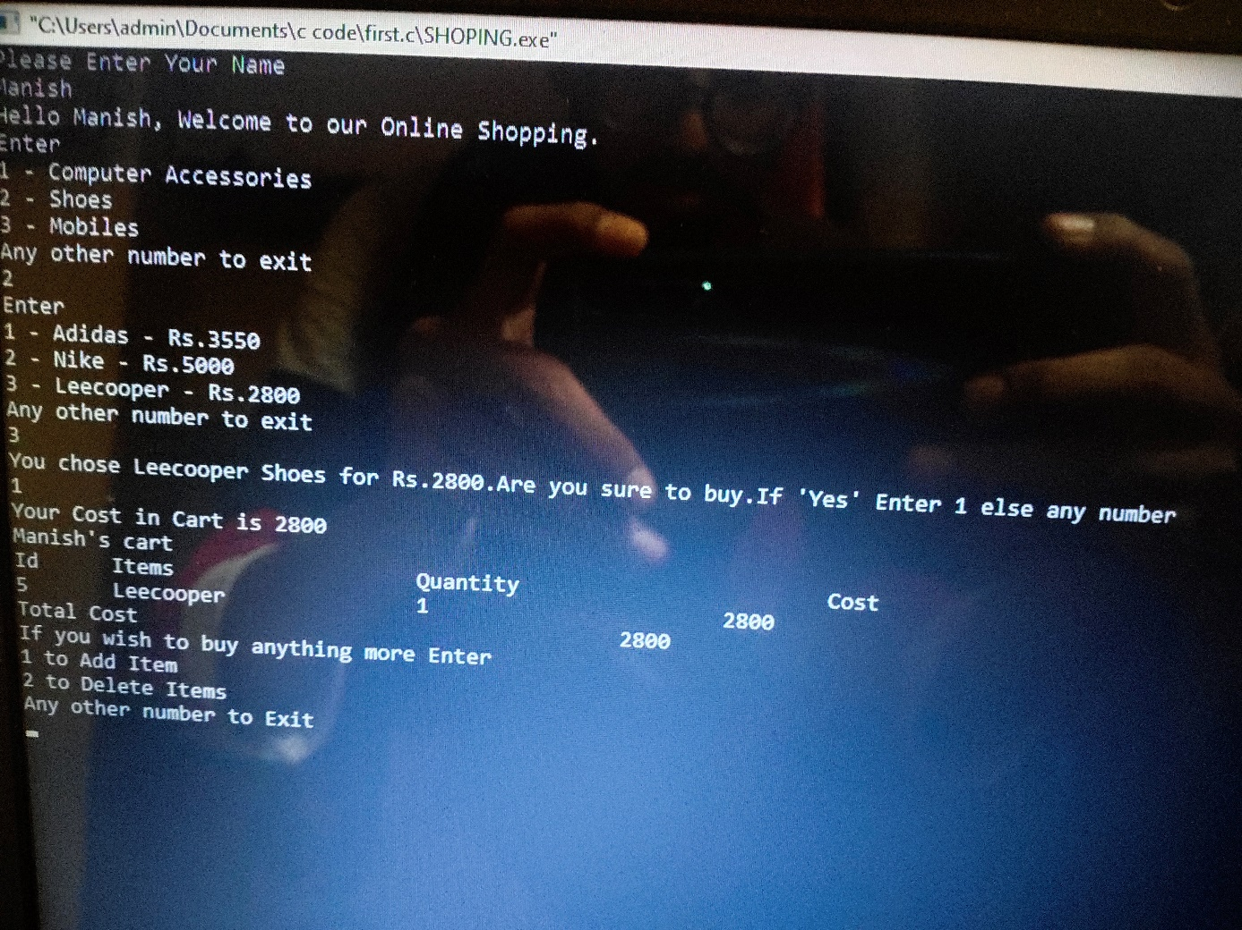
* EXPLANATION OF CODE
* STEP 1

Firstly ,(char items[]) is constructed,which store the product details i.e. brands name,cost,and variety

* STEP 2

Ask for detail of user for example-"Please enter your name".in my code get(str) and printf use for welcoming the user.

* STEP 3

Implemenation of LOOP and SWITCH fuctions in the code for user freindly system.

* STEP 4

At last, if user want to delete any product they have to enter there id and select the product,whenever the item is deleted amount is deducted from total amount.the service will end with the message "Thanks for choosing us and visit again

THANKING YOU!