# FL8. Lesson 7. Control flow.

# Homework

1. The result of your work should be packed to **folder** with html and js files (separate html and js files for each task). Inner folder structure should be exactly as follows:

*|__ homework_07 /  
 |__ js /*

*|__ task1.js*

*|__ task2.js*

*|__ task1.html`*

*|__ task2.html*

1. Code has to be readable, tested and well-formatted.
2. The folder must be loaded into the GitHub repository '**front-end-lab-8**' in the **master** branch

## Task #1. Pyramid

Write a program due to the following requirements:

* Ask user to enter natural number **N** (0<**N**<=20) // use prompt()
* If number **N** is not natural or doesn`t match required range, output error message in console // For example: console.error(‘Incorrect!’);
* If **N** match all requirements you should build and output in console pyramid with **N** floors

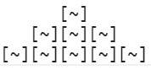

*Pyramid with 3 floors (N = 3)*

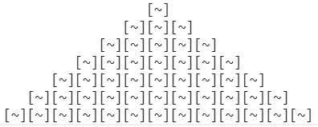

*Pyramid with 7 floors (N = 7)*

* To build pyramid use spaces, square brackets, tilde and **\n** (new line) characters.

## Task #2. Guessing game

Your task is to write a game. Requirements:

* Show a message ‘Do you want to play a game?’ *// use confirm()*
* If user clicked ‘Cancel’ – output in console message `You did not become a millionaire`, if clicked ‘Ok’ – start a game: randomly /* Math.random() */ choose a number in range [0; 5], and ask user to enter a number
* User has 3 attempts to guess a number
* If user guessed number on 1-st attempt prize is 10$ (maximum prize for current numbers range), 2-nd attempt – 5$, 3-rd attempt – 2$
* If user did not guess a number, output in console message ‘Thank you for a game. Your prize is: …’, and ask if he wants to play again.
* If user did guess - ask if he wants to continue a game *// use confirm().*
* If user does not want to continue – output in console message ‘Thank you for a game. Your prize is: …’, and ask if he wants to play again.
* If user does want to continue, make number range twice as big as the previous one /* for example [0; 5] -> [0; 10] */, and three times bigger maximum prize /* for example on 1-st attempt prize will be 30$, 2-nd attempt – 15$, 3-rd attempt – 7$ */. Prize must be added to the previous one and number of attempts should be set to 3 (user should has 3 attempts to guess a number for each numbers range)
* Each time you ask user to enter a number */* using prompt() */* you should show him a range of numbers, how much attempts he has left, his total prize and possible prize on current attempt. See example below:

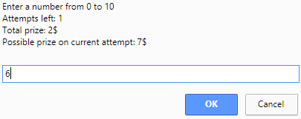

* All these stuff should be repeated until user lose or decide to quit