**AI PROJECT**

**Rudhika Kawar**

**Rrk324**

**INTRODUCTION**

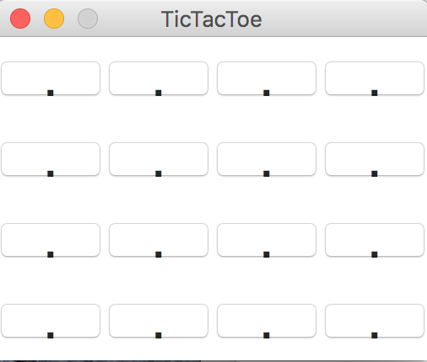

An interactive 4×4 Tic-Tac-Toe game for a person to play against a computer. The game consists of a 4×4 grid. To win, a player must place 4 of his/her symbols on 4 squares that line up vertically, horizontally or diagonally (45 or 135 degrees.)

**IMPLEMENTAION**

1. The implementation of the game is done in python 2.
2. The implementation consists of a python file AI_Project.py
3. This file contains two classes. One for the game logic and one for the gui.

Class Board – Game Logic ( Contains the alpha beta pruning algorithm

Class GUI – Uses Tkinter -  Python's de-facto standard GUI (Graphical User Interface) package

1. The code contains inline comments for the explanation of the code.

**STEPS TO PLAY**

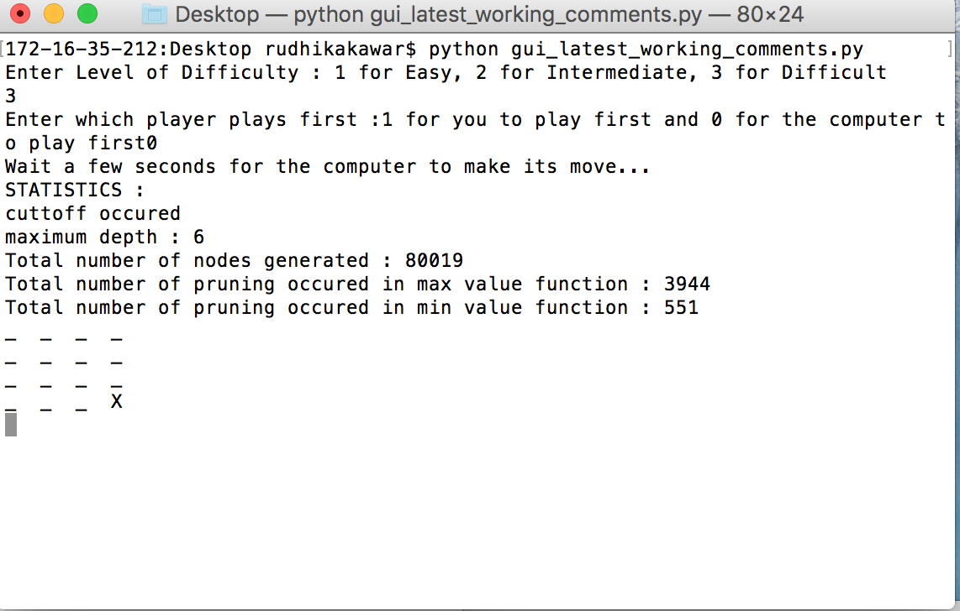

The user is first needed to select which level of difficulty the user wants to play.

1 – Easy

2 – Intermediate

3 – Difficult

The user then selects whether he wants to play the game first or the computer

1 – User to play first

2 – Computer to play first

After every move STATISTICS regarding the game are displayed that contain :

(1) whether cutoff occurred

(2) maximum depth reached

(3) total number of nodes generated (including root node)

(4) number of times pruning occurred within the MAX-VALUE function

(5) number of times pruning occurred within the MIN-VALUE function.

**DETAILS OF EACH LEVEL**

LEVEL 1 – EASY :

A random function is used that creates a random move on the board

LEVEL 2 – INTERMEDIATE :

The evaluation function used in this level is :

Number of remaining ways (rows, columns or diagonals which can still be filled to winning state) to win for x - Number of remaining ways to win for 0

LEVEL 3 – DIFFICULT :

The evaluation function used in this level is :

Eval(s)=6X3 +3X2(s)+X1(s)−(6O3 +3O2(s)+O1(s))

Max Depth Cut off limit : 6 Max time for a move allowed: 10 seconds

**INSTRUCTIONS**

1. Open the terminal and type python filename.csv

( python gui_latest_working_comments.py)

1. The python version is Python 2 and will not Python 3 as certain imported libraries used are specifically for Python 2
2. The terminal will prompt with:

Enter Level of Difficulty : 1 for Easy, 2 for Intermediate, 3 for Difficult

Type in 1,2 or 3 for the difficulty level you want to play on

1. Then the terminal will prompt with:

Enter which player plays first :1 for you to play first and 0 for the computer to play first

Type in 1 or 2 to select which player plays first

1. A gui screen will open next

The gui screen has clickable squares. Once you select a square you want to play on wait for a few seconds for the computer to play a move.

1. Keep playing until either you or computer wins or the game draws.
2. Close the game by selecting the cross button on the top left corner.
3. Only when this is done will the game stop
4. To play again follow the same procedure.