Preparing the development tool

Before running the project, Android application development environment needs to be setup. There is a detailed instruction in the Android website on how to do this. Go to <http://developer.android.com/training/index.html>. Basically, there are three steps.

1. Download the Android SDK.

Link: <http://developer.android.com/sdk/index.html>

1. Download the latest SDK tools and platforms using the SDK Manager.

Link: <http://developer.android.com/sdk/installing/adding-packages.html>

1. Install the ADT plugin for Eclipse.

Link: <http://developer.android.com/sdk/installing/installing-adt.html>

Running the project

1. Import project into eclipse
   1. Click File->Import->Existing Projects into workspace
   2. Add the path of project into “Select root directory”. This the path where you have downloaded the project sources from the mail.
   3. Uncheck “Copy projects into workspace” and “Add project to working sets”
   4. Click Finish.
2. Go to the project just imported and right click the package below “src” folder. See Figure 1.
3. Click Run As->Android Application

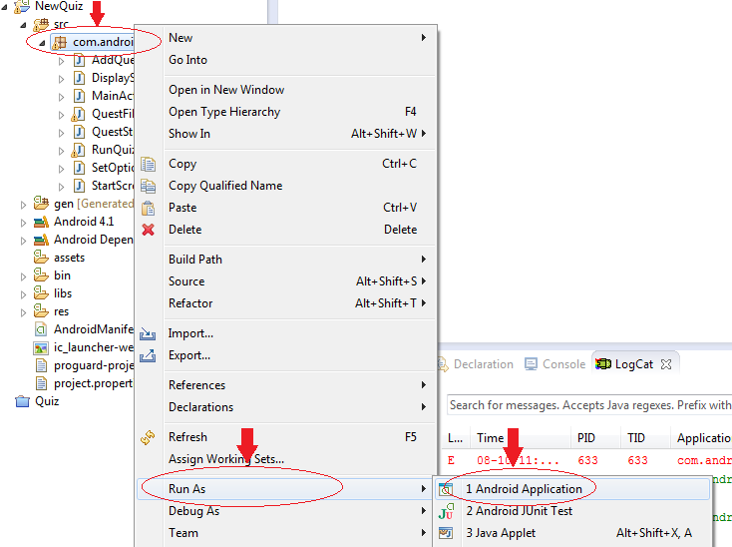

Figure 1

1. You should see the quiz project being loaded into the emulator. There is extensive help on the Android website about how to launch the emulator.

Link <http://developer.android.com/training/basics/firstapp/running-app.html>

1. You should see an emulator with the Quiz application as shown in Figure 2.
2. Once the Quiz is loaded, you have to put the Question.txt file before starting the quiz. Else the Quiz will throw exception and will not start.

Figure 1: How to run android application in emulator

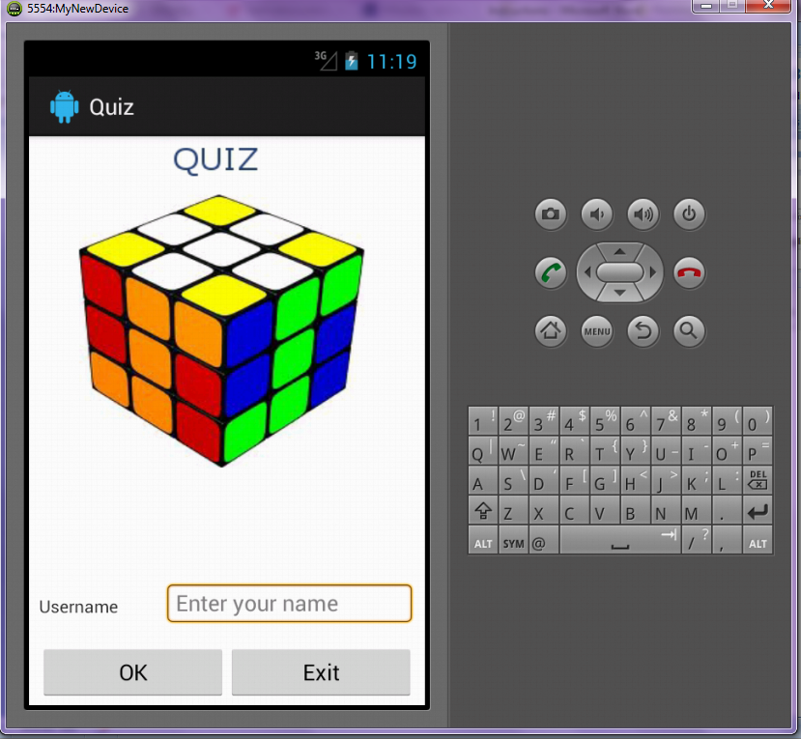

Figure 2: Quiz application started on emulator

Inserting Question.txt into the emulator

1. In the eclipse, click the DDMS tab on the top right corner as shown in Figure 3, Step 1.
2. Then click “File Explorer” tab shown in Figure3, Step 2.
3. Click “/mnt/sdcard” folder.
4. Then click the icon on the same tool bar as “File Explorer” which says “Push a file into the device”. It is shown in Figure 4.
5. Choose the file path and select OK.
6. You are done. Now you can start the quiz.

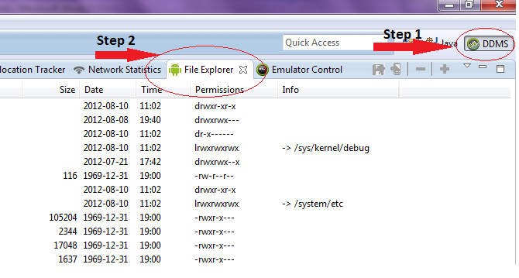

Figure 3: DDMS and File Explorer

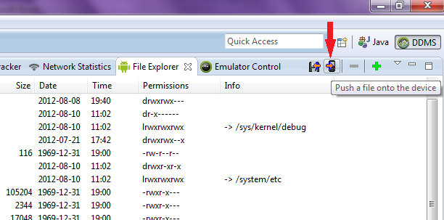

Figure 4: Put files into the device