Java Program for CRUD Operations MongoDB

import com.mongodb.client.*;
import com.mongodb.client.model.Filters;
import com.mongodb.client.model.Updates;
import org.bson.Document;
public class MongoDBConnection {
public static void main(String[] args) {
// Connect to MongoDB
MongoClient mongoClient = MongoClients.create("mongodb://localhost:27017");
// Access database
MongoDatabase database = mongoClient.getDatabase("collegedb");
// Access collection
MongoCollection<Document> collection =
database.getCollection("Students");
//
// CREATE (Insert)
//
Document student = new Document("id", 101)
.append("name", "Josh")
.append("department", "CSE")
.append("cgpa", 9.1);
collection.insertOne(student);
System.out.println("Document Inserted Successfully");
//
// READ (Find)
//
System.out.println("\nStudent Records:");
FindIterable<Document> students = collection.find();
for (Document doc : students) {
System.out.println(doc.toJson());
}
//
// UPDATE
//
collection.updateOne(
Filters.eq("id", 101),
Updates.set("cgpa", 9.2)
);
System.out.println("\nDocument Updated Successfully");
//
// READ Updated Record
//
Document updatedStudent =
collection.find(Filters.eq("id", 101)).first();
System.out.println("\nUpdated Record:");
System.out.println(updatedStudent.toJson());
//
// DELETE
//
collection.deleteOne(Filters.eq("id", 101));
System.out.println("\nDocument Deleted Successfully");
// Close connection
mongoClient.close();
}
}

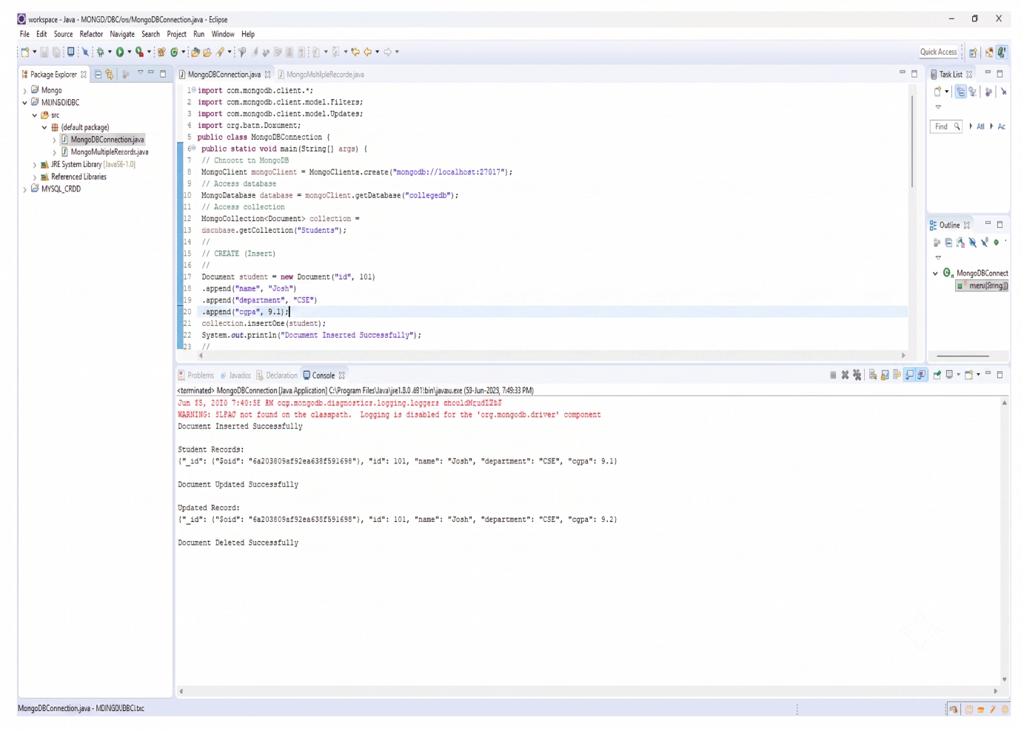

CRUD OPERATIONS FOR MULTIPLE RECORDS

import com.mongodb.client.*;
import com.mongodb.client.model.Filters;
import com.mongodb.client.model.Updates;
import org.bson.Document;
import java.util.Arrays;

public class MongoMultipleRecords {

public static void main(String[] args) {

// Connect to MongoDB
MongoClient mongoClient =
MongoClients.create("mongodb://localhost:27017");

// Access Database
MongoDatabase database =
mongoClient.getDatabase("collegedb");

// Access Collection
MongoCollection<Document> collection =
database.getCollection("students");

// Optional: Clear old data
collection.deleteMany(new Document());

//
// INSERT MANY DOCUMENTS
//
collection.insertMany(Arrays.asList(
new Document("id", 1).append("name", "Alice"),
new Document("id", 2).append("name", "Bob"),
new Document("id", 3).append("name", "Charlie")
));

System.out.println("Documents Inserted Successfully");

//
// DISPLAY ALL DOCUMENTS
//
System.out.println("\nAll Documents:");

for (Document doc : collection.find()) {
System.out.println(doc.toJson());
}

//
// FIND DOCUMENT WITH ID = 2
//
Document foundDoc =
collection.find(Filters.eq("id", 2)).first();

System.out.println("\nFound Document:");
System.out.println(foundDoc.toJson());

//
// UPDATE DOCUMENT
//
collection.updateOne(
Filters.eq("id", 2),
Updates.set("name", "Bobby")
);

System.out.println("\nDocument Updated Successfully");

//
// DISPLAY UPDATED DOCUMENT
//
Document updatedDoc =
collection.find(Filters.eq("id", 2)).first();

System.out.println("\nUpdated Document:");
System.out.println(updatedDoc.toJson());

//
// DELETE DOCUMENT
//
collection.deleteOne(Filters.eq("id", 2));

System.out.println("\nDocument Deleted Successfully");

//
// DISPLAY REMAINING DOCUMENTS
//
System.out.println("\nRemaining Documents:");

for (Document doc : collection.find()) {
System.out.println(doc.toJson());
}

// Close Connection
mongoClient.close();
}
}

