CampusCore API
Project Documentation & Report
Rudrakumar Dadhalwala
Registration Number: 24BCE10547
Vellore Institute of Technology (VIT), Bhopal

1. Project Title & Overview
Title: CampusCore API - Project Dashboard
Outcome: The successful design, development, and deployment of a scalable RESTful backend application aimed at streamlining university campus management. The API efficiently handles core institutional entities, primarily focusing on Departments and Students, enabling robust Create, Read, Update, and Delete (CRUD) operations alongside relational data linking.

2. Tools & Technologies Used
- Python (3.10+): Core programming language used for backend logic and data structure handling.
- FastAPI (v0.100+): High-performance web framework used for building the asynchronous API routing and endpoint architecture.
- Uvicorn: ASGI web server implementation used to run the FastAPI application.
- OpenAPI (OAS 3.1) / Swagger UI: Automated interactive API documentation generated directly from the codebase.
- Pydantic: Utilized for strict data validation, enforcing payload schemas for DepartmentModel and StudentModel.

3. System Outputs & Explanations

3.1 Initial Project Dashboard Overview
The interactive Swagger UI dashboard provides a centralized view of all available endpoints. The initial default interface includes standard GET operations to fetch lists of records and POST operations to append new entities to the system, properly segregated by resource type (Departments vs. Students).

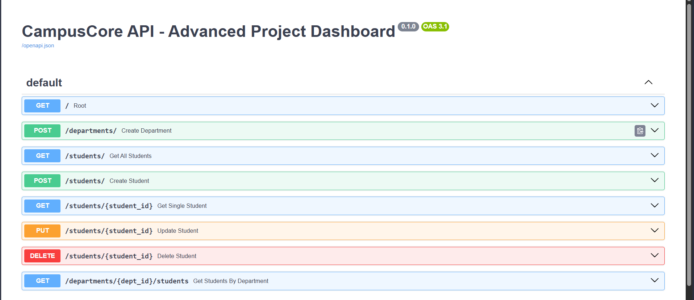

3.2 Department Creation & Server Response
To establish the foundational infrastructure of the campus, a department must be registered. A JSON payload containing the department's name ("Computer Science Engineering") and room_number is transmitted via a POST request to the /departments/ route.
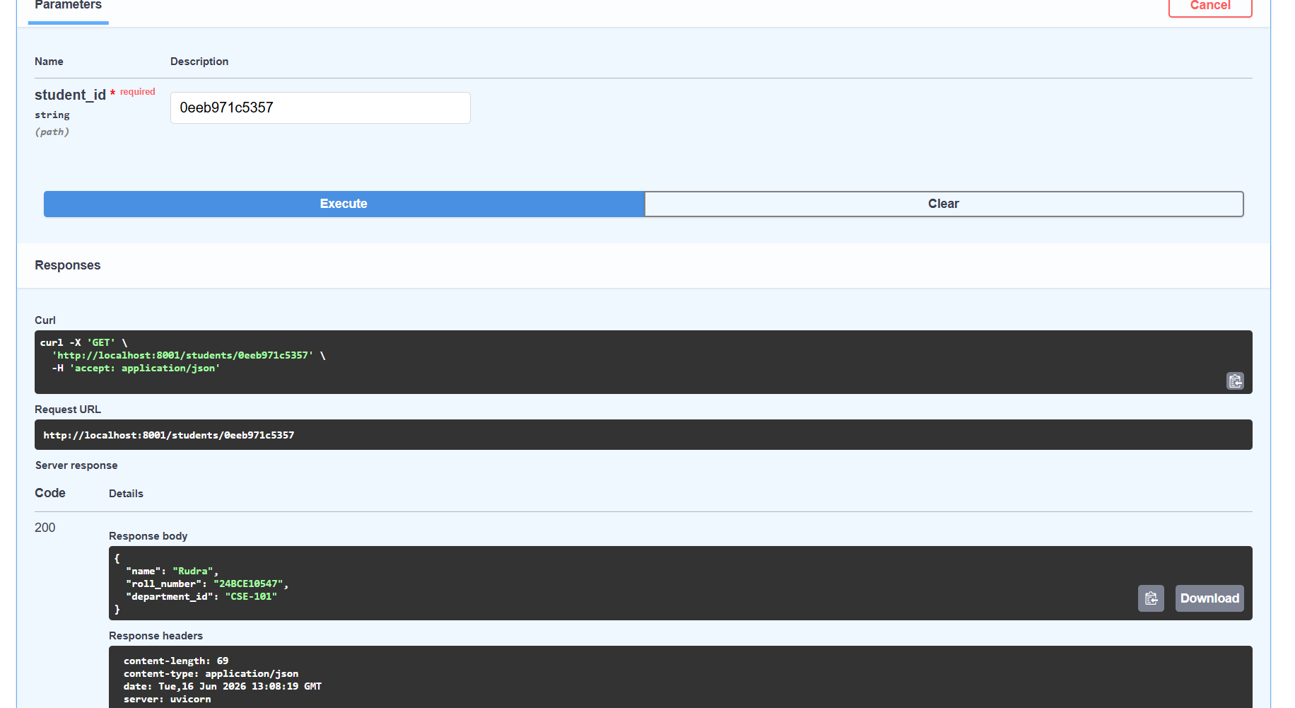
The Uvicorn server processes the payload, performs data validation, and responds with a 200 OK status. The server returns a confirmation message alongside a unique alphanumeric id (e.g., 2392c41d9ee5477b9b28fe45) which acts as the primary key for relational linking in subsequent operations.

3.3 Student Registration & Relational Linking
With a department established, a student profile is created. The POST /students/ endpoint accepts a payload encompassing the student's name, registration number, and the previously generated department_id. This demonstrates a successful one-to-many relationship mapping between departments and students.

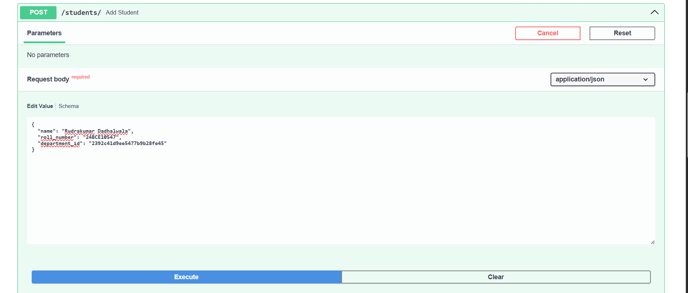

3.4 Advanced Project Dashboard
The API evolves into an "Advanced Project Dashboard," expanding the capability matrix. Beyond basic additions, the system supports dynamic routing parameters ({student_id}, {dept_id}), facilitating precise data mutations via PUT requests and record removals via DELETE requests. Nested routes like /departments/{dept_id}/students allow for targeted aggregations.


3.5 Targeted Data Retrieval
The system excels at precise queries. By passing a specific unique identifier (e.g., 0eeb971c5357) to the GET /students/{student_id} endpoint, the server efficiently retrieves and formats the requested individual's data, verifying correct database associations.
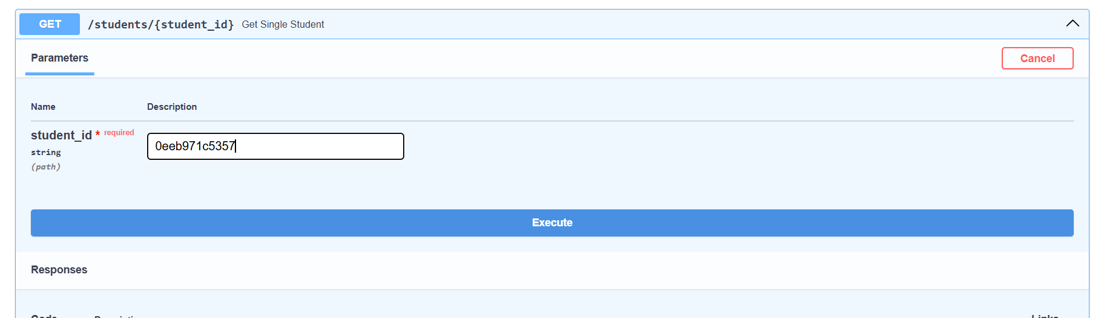

3.6 Complex Payload Handling
The API is engineered to accept complex, nested JSON objects. In advanced student creation flows, the request body accepts arrays of structured objects. For instance, registering course modules like Data Structures and Algorithms and Software Engineering involves passing a list of dictionaries with specific subject codes, alongside float values for gpa and string states for exam_schedule.
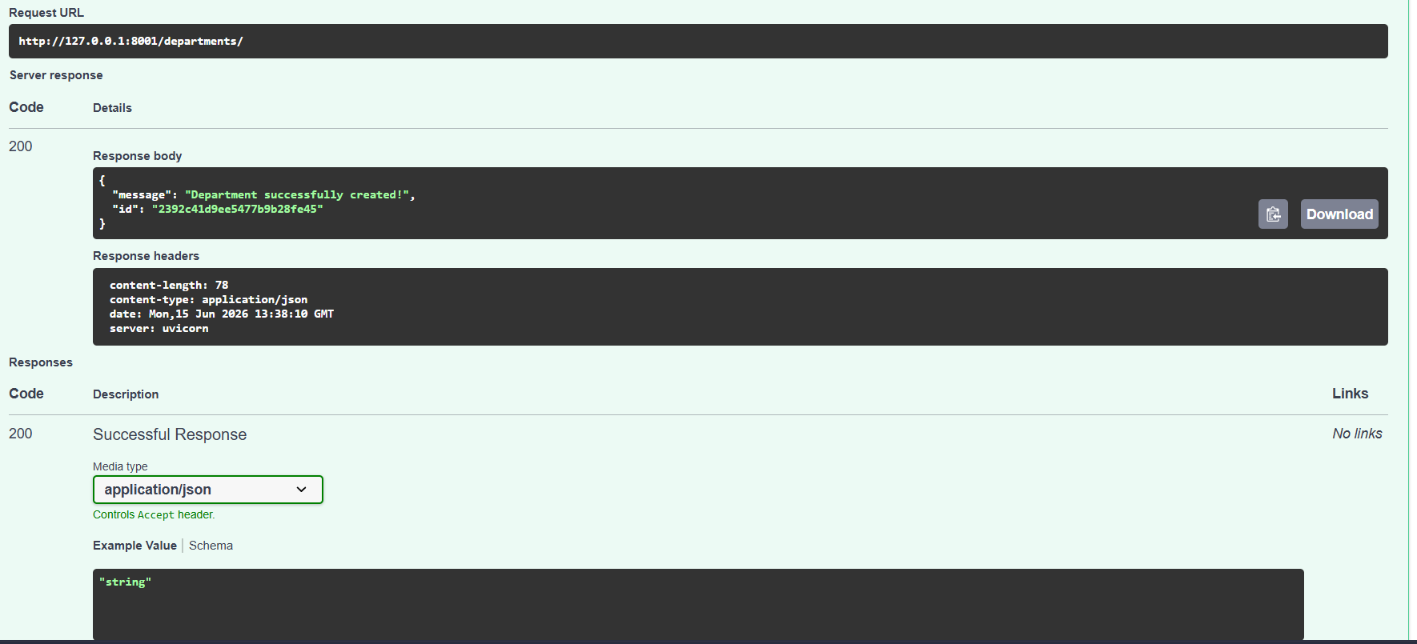

4. Summary
The CampusCore API is a comprehensive backend service structured around REST conventions. By leveraging modern asynchronous Python frameworks, the system guarantees high throughput and low-latency responses. It successfully models the hierarchical nature of a university—ensuring that students are properly mapped to their respective academic departments. Furthermore, the integration of automated OpenAPI documentation provides a seamless interface for frontend developers and testing mechanisms to interact with the backend logic.

5. Conclusion
This project proves the efficacy of utilizing modern tooling to build foundational software architectures. The implementation of robust data models, strict payload validation, and relational endpoints results in a stable and highly extendable campus management system. The CampusCore API establishes a solid groundwork that can easily scale to incorporate more complex features such as authentication, faculty management, and real-time event logging in the future.

