SignalReach
SAMPLE / DEMONSTRATION REPORT
Complete Website QA Report
Northstar Creative Studio — Demo Website

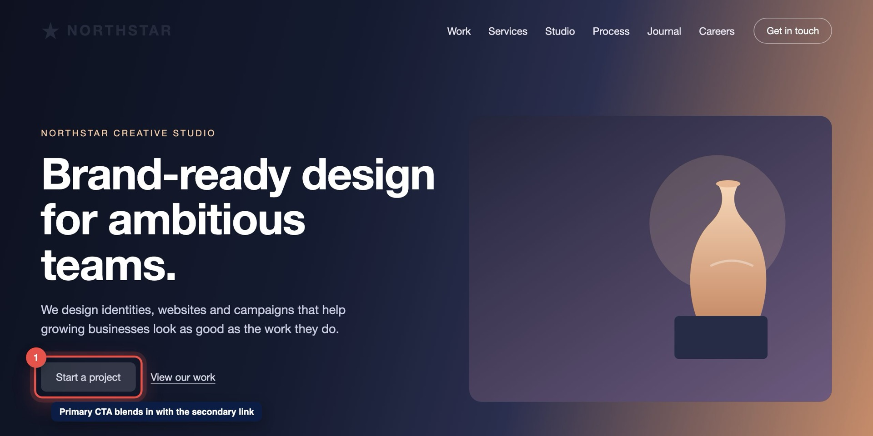
Demo website screenshot used throughout this sample report.
Website | Northstar Creative Studio — Demo Website
Report type | Full Website QA
Status | Sample Report
Reviewed at | Desktop 1280px · Tablet 820px · Mobile 390px
Prepared by | SignalReach

This is a sample report created for demonstration purposes. Actual findings and report length vary depending on the website.

Contents
Executive Summary
Homepage — Design & Visual QA
Finding 01 — Primary call-to-action lacks visual emphasis. High
Finding 02 — Logo loses contrast against the hero background. Medium
Responsive QA
Finding 03 — Navigation becomes cramped at tablet widths. Medium
Finding 04 — Hero heading wraps awkwardly on smaller screens. High
Finding 05 — Important subject matter is cropped on mobile. Medium
Finding 06 — Cards become uneven at intermediate widths. Low
UX, Usability & Conversion
Finding 07 — Important CTA appears too late in the page journey. High
Finding 08 — Some text/background combinations have weak contrast. Medium
Functional QA
Finding 09 — Form submission gives no confirmation. Critical
Finding 10 — Interactive control lacks feedback after activation. Medium
Content Presentation
Finding 11 — Heading and supporting copy don’t communicate priority. Low
Basic Performance & Technical
Finding 12 — Large media can be optimized to improve loading. Quick Win
Prioritized Recommendations & Next Steps
About This Sample Report

Executive Summary
This sample review demonstrates how SignalReach documents visual, usability, responsive and functional issues across a website. Each finding includes context, impact and a recommended next step.
The demo website has a strong visual direction, but the main call to action is easy to miss, several layouts break at tablet and mobile widths, and the contact form gives visitors no confirmation. Fixing the critical and high-priority items first will have the biggest effect on clarity and enquiries.
FINDINGS BY PRIORITY — DEMO DATA
Priority | Findings | What it means
CRITICAL | 1 | Blocks a key task or loses enquiries — fix first.
HIGH | 3 | Noticeably hurts clarity, trust or conversions.
MEDIUM | 5 | Visible quality issue worth scheduling soon.
LOW | 2 | Polish item — improves consistency.
QUICK WIN | 1 | Small effort, clear benefit.
Total | 12 | Sample counts for demonstration — not measured client results.

AREAS COVERED IN A SIGNALREACH REVIEW
Design & Visual QA  Typography · Spacing · Color consistency · Image presentation · Hierarchy | Responsive QA  Desktop · Tablet · Mobile · Overflow · Wrapping · Spacing
UX & Usability  Navigation · CTA clarity · Forms · User flow · Interaction feedback | Functional QA  Buttons · Links · Forms · Dropdowns · Interactive elements
Content Presentation  Headings · Readability · Messaging hierarchy · Calls to action | Conversion Review  CTA placement · Clarity · Trust elements · User journey
Basic Performance & Technical  Image weight · Obvious loading issues · Layout stability | Search / AI Readiness (supporting)  Content structure · Heading hierarchy · Understandable page content

SECTION · HOMEPAGE

Homepage — Design & Visual QA
First impressions: hero, branding and the primary call to action at desktop width.
Finding | Issue | Priority
01 | Primary call-to-action lacks visual emphasis. | HIGH
02 | Logo loses contrast against the hero background. | MEDIUM

FINDING 01 · HOMEPAGE · HERO / CTA

Primary call-to-action lacks visual emphasis.
Homepage — Hero | Desktop
Screenshot — Homepage, Hero (Desktop). Marker 1 highlights the issue.
Issue | The “Start a project” button uses a pale fill that blends into the hero background and looks almost identical to the secondary “View our work” link beside it.
Why It Matters | Visitors may not immediately see the main action the page wants them to take, which reduces enquiries from the most visited page.
Priority | HIGH
Recommended Improvement | Give the primary CTA a solid, high-contrast fill, add more space around it and style “View our work” clearly as a secondary text link.

FINDING 02 · HOMEPAGE · LOGO / BRANDING

Logo loses contrast against the hero background.
Homepage — Header | Desktop
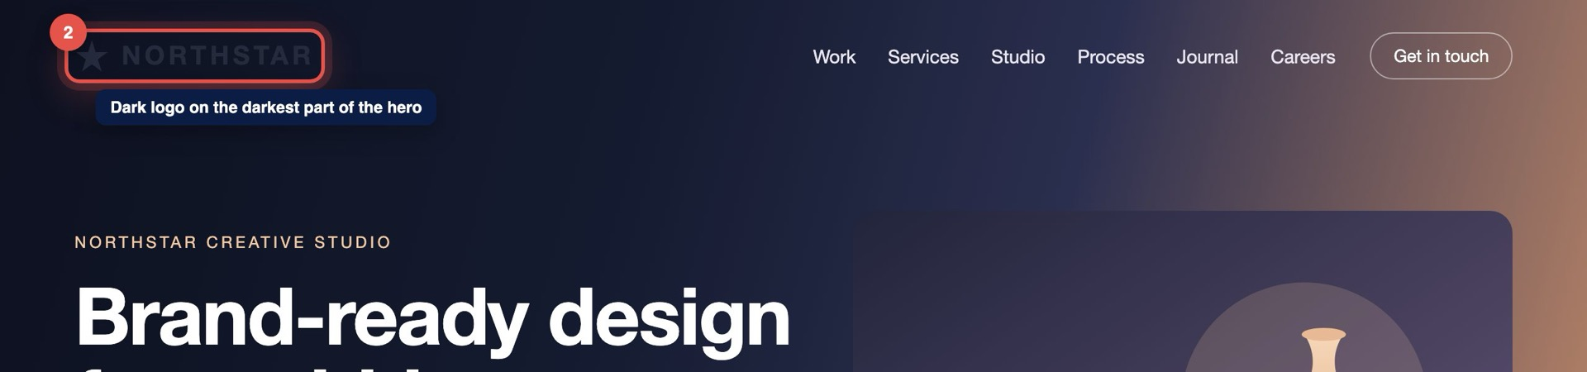
Screenshot — Homepage, Header (Desktop). Marker 2 highlights the issue.
Issue | The dark logo sits on top of the darkest part of the hero gradient, so the wordmark is hard to read at a glance.
Why It Matters | The brand is the first thing visitors use to orient themselves; a faint logo makes the site feel less polished and less trustworthy.
Priority | MEDIUM
Recommended Improvement | Use a light version of the logo over the hero (or add a subtle header background) so it keeps at least 4.5:1 contrast.

SECTION · RESPONSIVE QA

Responsive QA
How layouts, navigation and media behave across tablet and mobile widths.
Finding | Issue | Priority
03 | Navigation becomes cramped at tablet widths. | MEDIUM
04 | Hero heading wraps awkwardly on smaller screens. | HIGH
05 | Important subject matter is cropped on mobile. | MEDIUM
06 | Cards become uneven at intermediate widths. | LOW

FINDING 03 · RESPONSIVE QA · NAVIGATION

Navigation becomes cramped at tablet widths.
All pages — Header navigation | Tablet · 820px
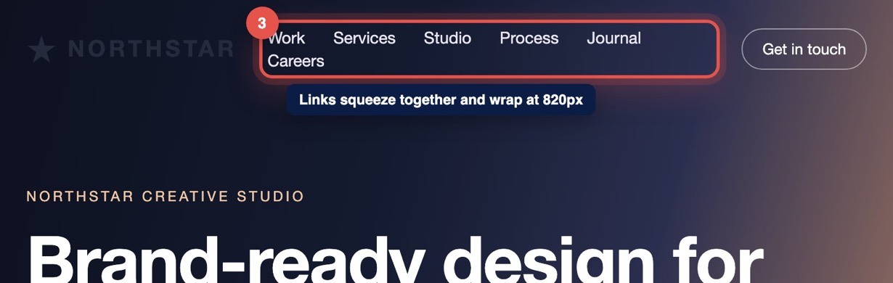
Screenshot — All pages, Header navigation (Tablet · 820px). Marker 3 highlights the issue.
Issue | Between roughly 780px and 1000px the six menu links and the header button squeeze together, and two items wrap onto a second line under the logo.
Why It Matters | Cramped, wrapping navigation is hard to tap accurately and makes the header look broken on common tablet sizes.
Priority | MEDIUM
Recommended Improvement | Switch to the mobile menu earlier (around 1000px) or reduce the number of top-level links and tighten their spacing rules.

FINDING 04 · RESPONSIVE QA · MOBILE RESPONSIVENESS

Hero heading wraps awkwardly on smaller screens.
Homepage — Hero heading | Mobile · 390px
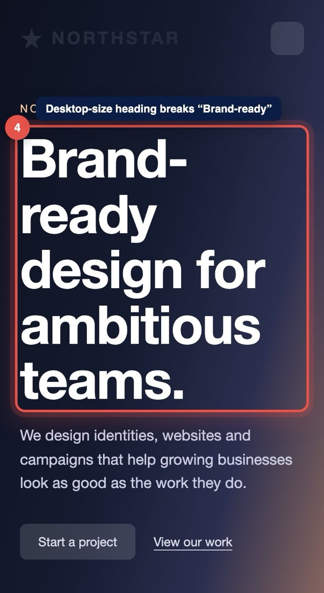
Screenshot — Homepage, Hero heading (Mobile · 390px). Marker 4 highlights the issue.
Issue | The hero heading keeps its desktop size on mobile, so “Brand-ready” splits across lines and the heading pushes the CTA below the first screen.
Why It Matters | The key message becomes harder to read and visitors must scroll before they see any action to take.
Priority | HIGH
Recommended Improvement | Scale the heading down fluidly on small screens (for example with clamp()), prevent the hyphenated word from breaking and keep the CTA visible in the first view.

FINDING 05 · RESPONSIVE QA · IMAGE / MEDIA

Important subject matter is cropped on mobile.
Homepage — Hero image | Mobile · 390px
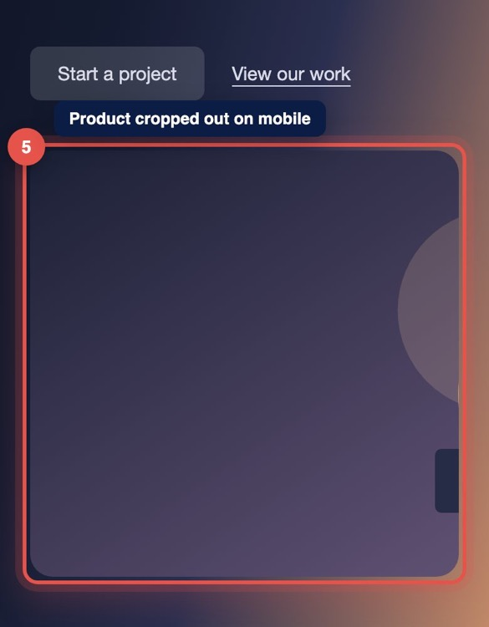
Screenshot — Homepage, Hero image (Mobile · 390px). Marker 5 highlights the issue.
Issue | On narrow screens the hero artwork is cropped from the left edge, cutting off the featured product so only empty background remains.
Why It Matters | The image no longer communicates what the studio does, so the hero loses its visual message on the devices most visitors use.
Priority | MEDIUM
Recommended Improvement | Set the image focal point (object-position) to keep the subject in frame, or provide a mobile-specific crop of the artwork.

FINDING 06 · RESPONSIVE QA · RESPONSIVE LAYOUT

Cards become uneven at intermediate widths.
Services — Service cards | Tablet · 900px
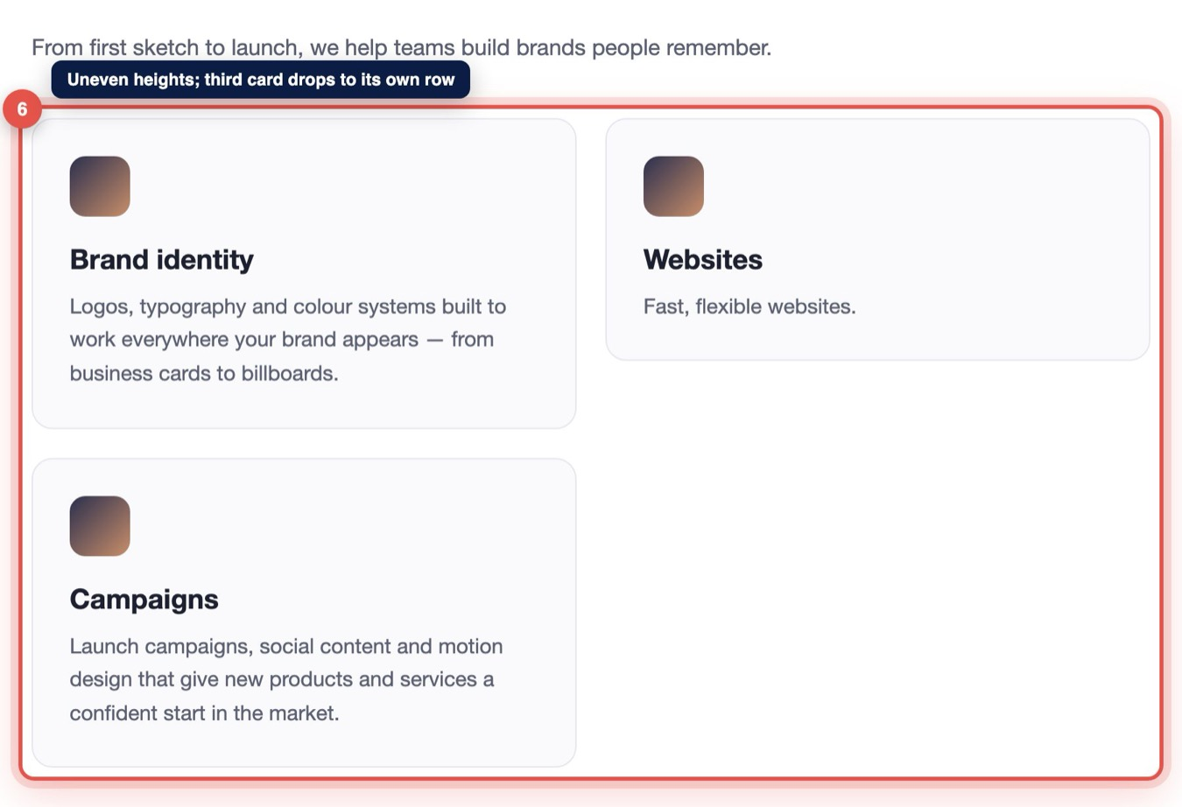
Screenshot — Services, Service cards (Tablet · 900px). Marker 6 highlights the issue.
Issue | At around 900px the service cards have different heights and the third card drops onto its own row, leaving an unbalanced gap.
Why It Matters | Uneven cards make the section look unfinished and make the services harder to compare side by side.
Priority | LOW
Recommended Improvement | Use equal-height cards (stretch alignment) and a two-column layout at this width so the cards wrap in balanced rows.

SECTION · UX & USABILITY

UX, Usability & Conversion
How easily visitors can understand the page and reach the next step.
Finding | Issue | Priority
07 | Important CTA appears too late in the page journey. | HIGH
08 | Some text/background combinations have weak contrast. | MEDIUM

FINDING 07 · UX & USABILITY · CONVERSION FLOW

Important CTA appears too late in the page journey.
Homepage — Full page | Desktop
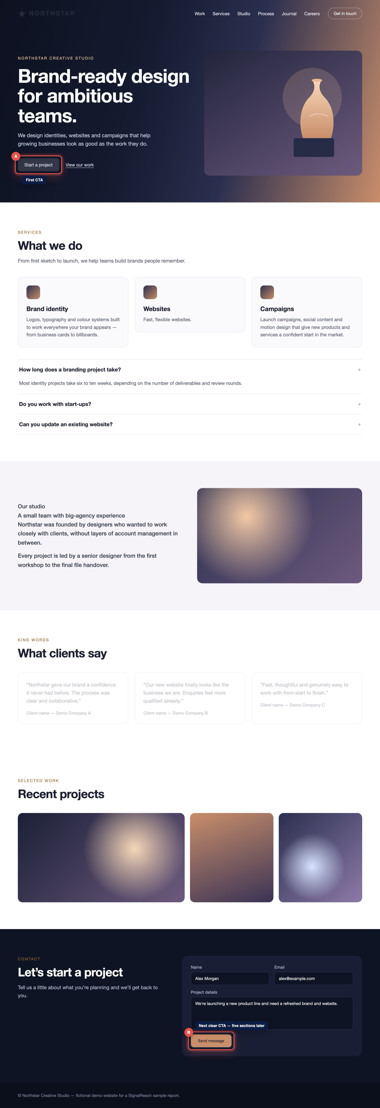
Screenshot — Homepage, Full page (Desktop). Marker A/B highlights the issue.
Issue | After the hero, the next clear invitation to get in touch only appears in the footer area, after five full sections of content.
Why It Matters | Visitors who are convinced halfway down the page have no obvious next step, so interested visitors may leave without enquiring.
Priority | HIGH
Recommended Improvement | Repeat a clear “Start a project” CTA after the services and case-study sections, and add a short contact prompt before the footer.

FINDING 08 · UX & USABILITY · ACCESSIBILITY / USABILITY

Some text/background combinations have weak contrast.
Homepage — Testimonials | Desktop
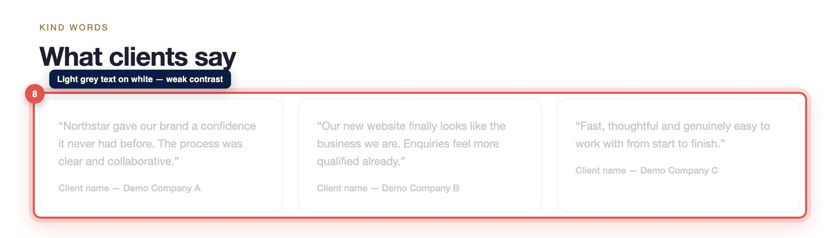
Screenshot — Homepage, Testimonials (Desktop). Marker 8 highlights the issue.
Issue | Testimonial quotes and client names use very light grey text on a white background, making them difficult to read.
Why It Matters | Low-contrast text is harder for everyone to read — especially on mobile, in bright light or for visitors with low vision — and weakens a key trust section.
Priority | MEDIUM
Recommended Improvement | Darken the testimonial text to meet WCAG AA contrast (4.5:1 for body text) and give client names a stronger weight.

SECTION · FUNCTIONALITY

Functional QA
Forms, buttons and interactive elements — does each one respond clearly?
Finding | Issue | Priority
09 | Form submission gives no confirmation. | CRITICAL
10 | Interactive control lacks feedback after activation. | MEDIUM

FINDING 09 · FUNCTIONALITY · FORM UX

Form submission gives no confirmation.
Contact — Contact form | Desktop
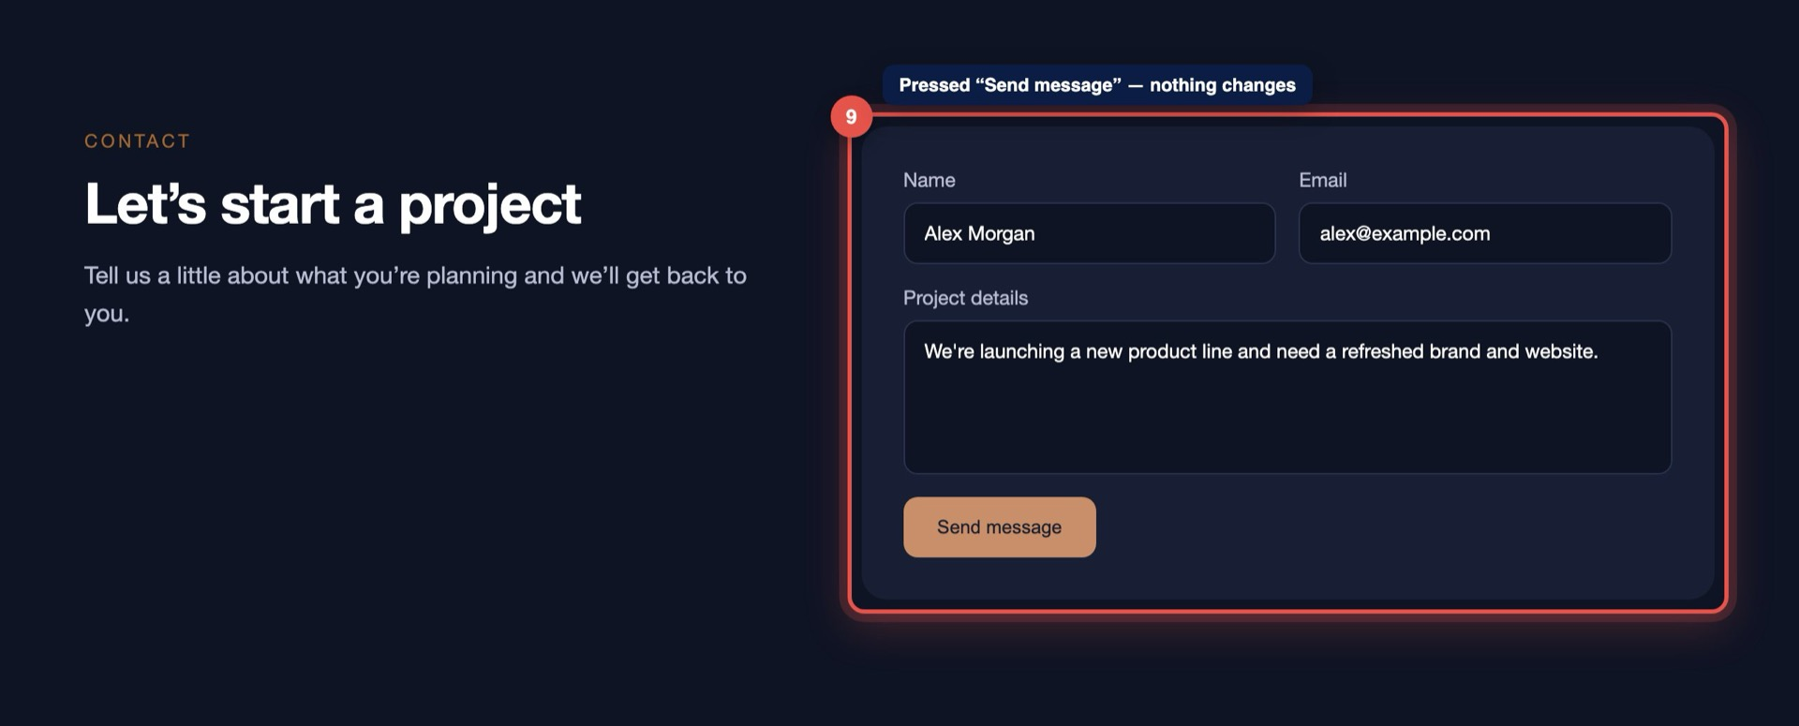
Screenshot — Contact, Contact form (Desktop). Marker 9 highlights the issue.
Issue | After the contact form is filled in and “Send message” is pressed, nothing visibly changes — no success message, no loading state and the fields stay filled.
Why It Matters | Visitors can’t tell if their enquiry was sent, so they may submit repeatedly or leave assuming it failed — directly risking lost leads.
Priority | CRITICAL
Recommended Improvement | Show a clear success message (and clear the fields) after a successful submit, show a loading state on the button and display a helpful error if sending fails.

FINDING 10 · FUNCTIONALITY · FUNCTIONALITY

Interactive control lacks feedback after activation.
Services — FAQ accordion | Desktop
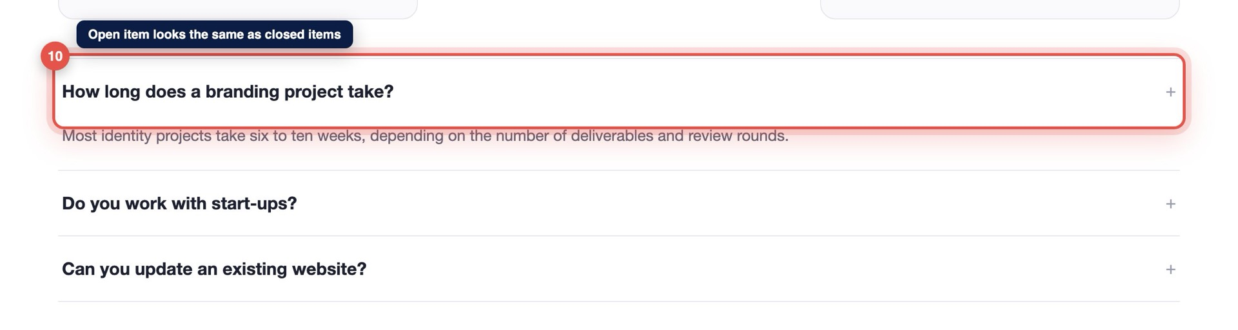
Screenshot — Services, FAQ accordion (Desktop). Marker 10 highlights the issue.
Issue | FAQ items open when clicked, but there is no change to the icon, colour or state — open and closed items look identical.
Why It Matters | Without feedback, visitors aren’t sure whether their click worked or which answer belongs to which question.
Priority | MEDIUM
Recommended Improvement | Rotate or swap the icon when an item is open, highlight the open item and set aria-expanded so the state is also announced to assistive technology.

SECTION · CONTENT

Content Presentation
Headings, readability and messaging hierarchy.
Finding | Issue | Priority
11 | Heading and supporting copy don’t communicate priority. | LOW

FINDING 11 · CONTENT · CONTENT HIERARCHY

Heading and supporting copy don’t communicate priority.
About — Studio story | Desktop
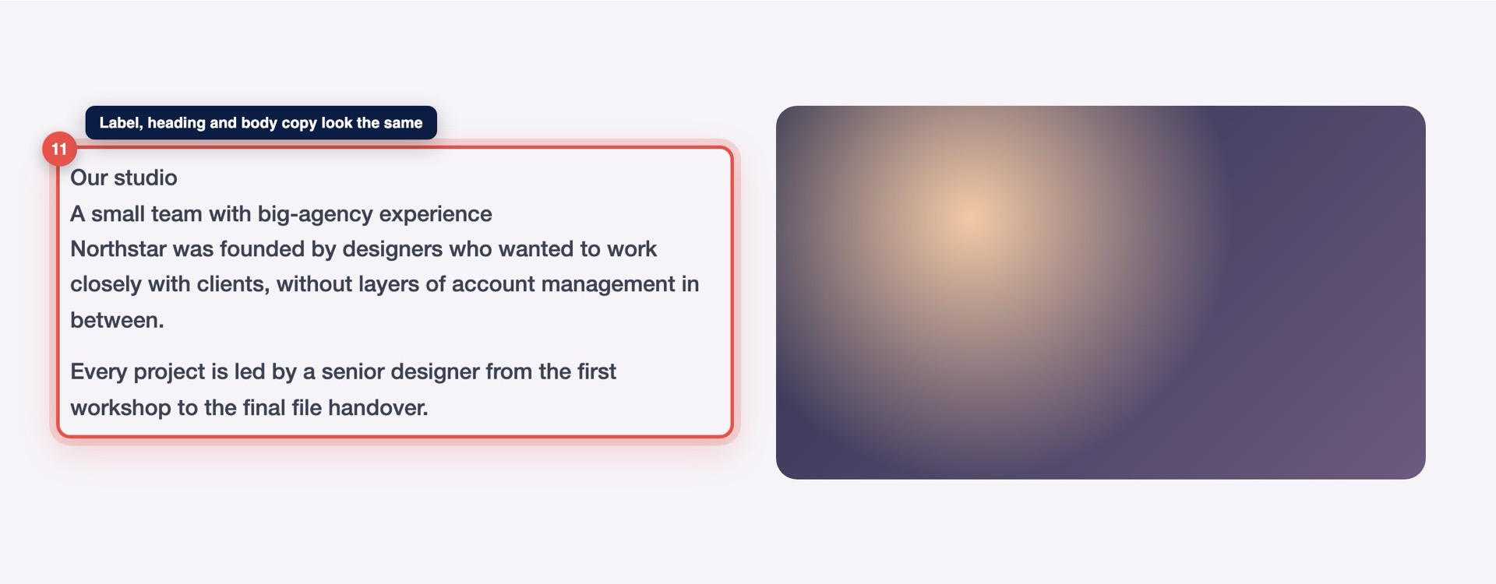
Screenshot — About, Studio story (Desktop). Marker 11 highlights the issue.
Issue | The section label, heading and body copy are almost the same size and weight, so there is no clear entry point into the content.
Why It Matters | Visitors scan before they read; without a clear hierarchy the section’s main message is easy to skip. A clear heading structure also helps search engines and AI tools understand the page.
Priority | LOW
Recommended Improvement | Make the section heading clearly larger and bolder, keep the label small and use one main heading level per section.

SECTION · PERFORMANCE

Basic Performance & Technical
Obvious loading and media-weight observations (not a full technical audit).
Finding | Issue | Priority
12 | Large media can be optimized to improve loading. | QUICK WIN

FINDING 12 · PERFORMANCE · PERFORMANCE / TECHNICAL

Large media can be optimized to improve loading.
Homepage — Gallery | Desktop
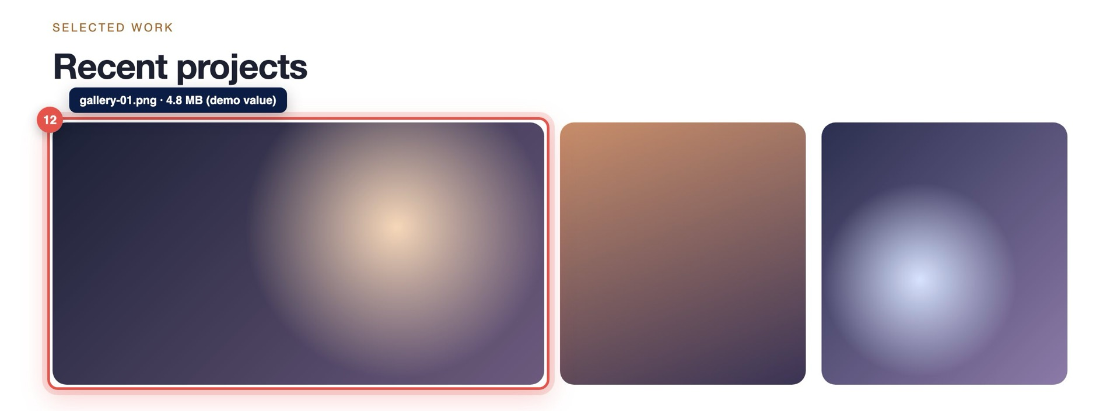
Screenshot — Homepage, Gallery (Desktop). Marker 12 highlights the issue.
Issue | The gallery uses very large, uncompressed images that are scaled down in the browser (demo value: 4.8 MB for the first image).
Why It Matters | Heavy images slow down the first view, especially on mobile connections, and can cause visible layout shifts while loading.
Priority | QUICK WIN
Recommended Improvement | Export images at the size they’re displayed, use a modern format such as WebP, add width/height attributes and lazy-load images below the fold.

Prioritized Recommendations
All findings in recommended order of work, from the most to the least urgent.
# | Priority | Recommended improvement
09 | CRITICAL | Form submission gives no confirmation.  Show a clear success message (and clear the fields) after a successful submit, show a loading state on the button and display a helpful error if sending fails.
01 | HIGH | Primary call-to-action lacks visual emphasis.  Give the primary CTA a solid, high-contrast fill, add more space around it and style “View our work” clearly as a secondary text link.
04 | HIGH | Hero heading wraps awkwardly on smaller screens.  Scale the heading down fluidly on small screens (for example with clamp()), prevent the hyphenated word from breaking and keep the CTA visible in the first view.
07 | HIGH | Important CTA appears too late in the page journey.  Repeat a clear “Start a project” CTA after the services and case-study sections, and add a short contact prompt before the footer.
02 | MEDIUM | Logo loses contrast against the hero background.  Use a light version of the logo over the hero (or add a subtle header background) so it keeps at least 4.5:1 contrast.
03 | MEDIUM | Navigation becomes cramped at tablet widths.  Switch to the mobile menu earlier (around 1000px) or reduce the number of top-level links and tighten their spacing rules.
05 | MEDIUM | Important subject matter is cropped on mobile.  Set the image focal point (object-position) to keep the subject in frame, or provide a mobile-specific crop of the artwork.
08 | MEDIUM | Some text/background combinations have weak contrast.  Darken the testimonial text to meet WCAG AA contrast (4.5:1 for body text) and give client names a stronger weight.
10 | MEDIUM | Interactive control lacks feedback after activation.  Rotate or swap the icon when an item is open, highlight the open item and set aria-expanded so the state is also announced to assistive technology.
06 | LOW | Cards become uneven at intermediate widths.  Use equal-height cards (stretch alignment) and a two-column layout at this width so the cards wrap in balanced rows.
11 | LOW | Heading and supporting copy don’t communicate priority.  Make the section heading clearly larger and bolder, keep the label small and use one main heading level per section.
12 | QUICK WIN | Large media can be optimized to improve loading.  Export images at the size they’re displayed, use a modern format such as WebP, add width/height attributes and lazy-load images below the fold.

Suggested Next Steps
- Fix the critical form confirmation issue first so no enquiries are lost.
- Address the high-priority CTA and mobile hero issues to improve first impressions and conversions.
- Schedule the medium-priority responsive and contrast fixes in the next design/development pass.
- Batch the low-priority and quick-win items into a polish sprint.
- Re-test the key pages on desktop, tablet and mobile after changes are made.

About This Sample Report
This is a sample report created for demonstration purposes. Actual findings and report length vary depending on the website.
Northstar Creative Studio is a fictional business created for this demonstration. The screenshots come from a demo website built for this purpose, and all findings, counts and values are sample data.
Every real SignalReach report is created by a person reviewing your actual website — page by page, section by section, across desktop, tablet and mobile — with screenshots, clear explanations, priorities and practical recommendations like the ones in this example.
Ready to see what your website is missing?
Submit your website and we’ll manually review the experience page by page, then send you a practical QA report like this example.
Get Your Free QA Report → SignalReach website › Get Your Free QA Report

