REIST Cryptographic Benchmark Report
Generated: 2025-12-10 13:37:07

System Information
Property | Value
Hostname | Arm-PC
Operating System | GNU/Linux
CPU Model | CPU MHz:
CPU Frequency | Memory: 8104540 kB MHz
Memory | 8104540 kB

Executive Summary
This report presents a comprehensive analysis of the REIST symmetric remainder arithmetic compared to classical modular operations. Benchmarks were run with:
- O0: No optimization (baseline)
- O3: Full optimization with architecture-specific tuning

Performance Overview
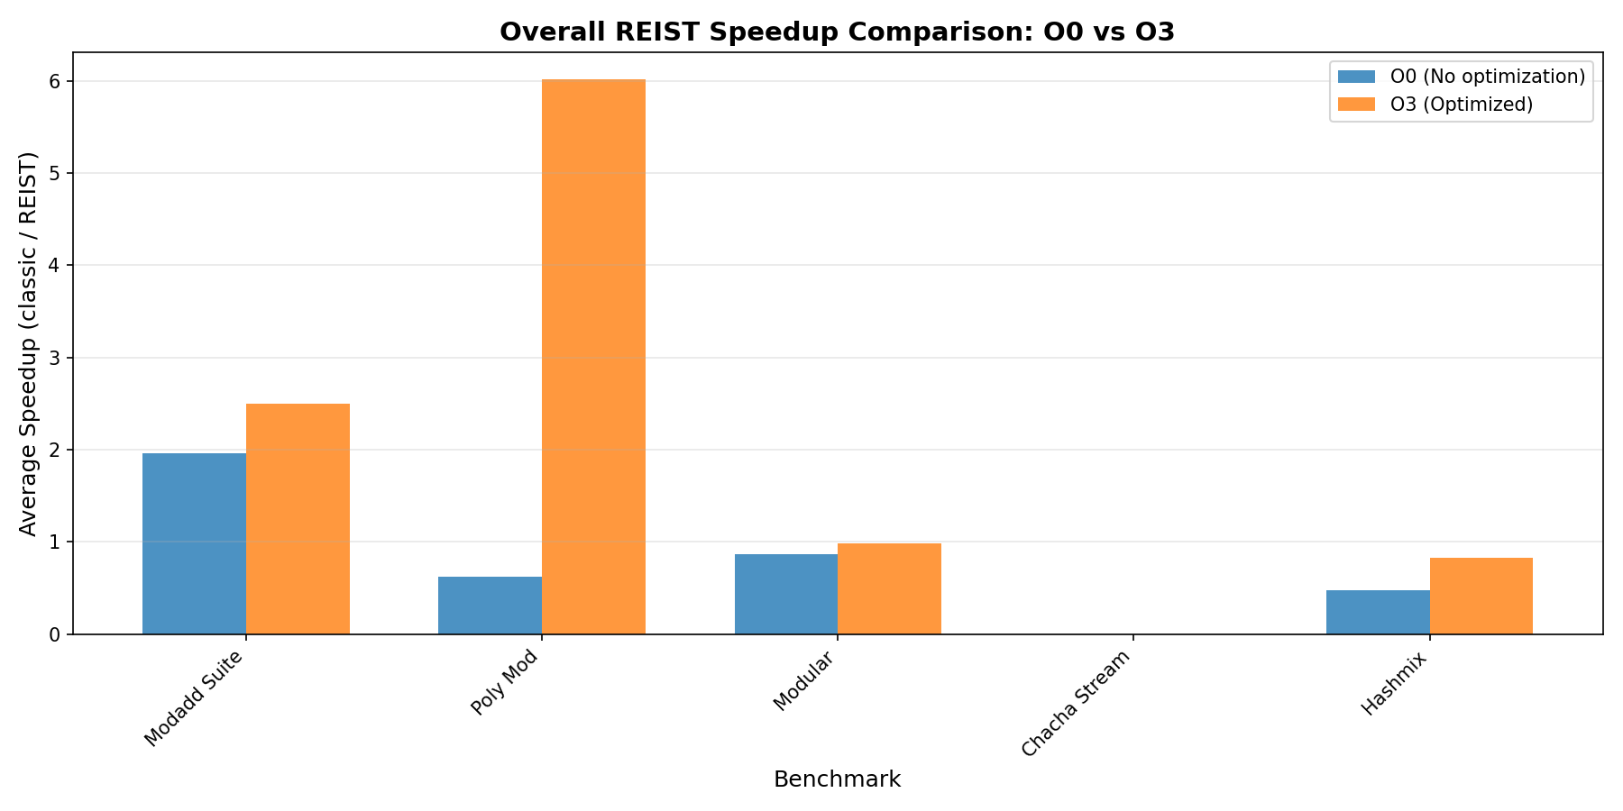
Overall Comparison

Modular Addition Suite
This benchmark compares classical modulo (a + b) % m with REIST symmetric remainder using simple comparisons.
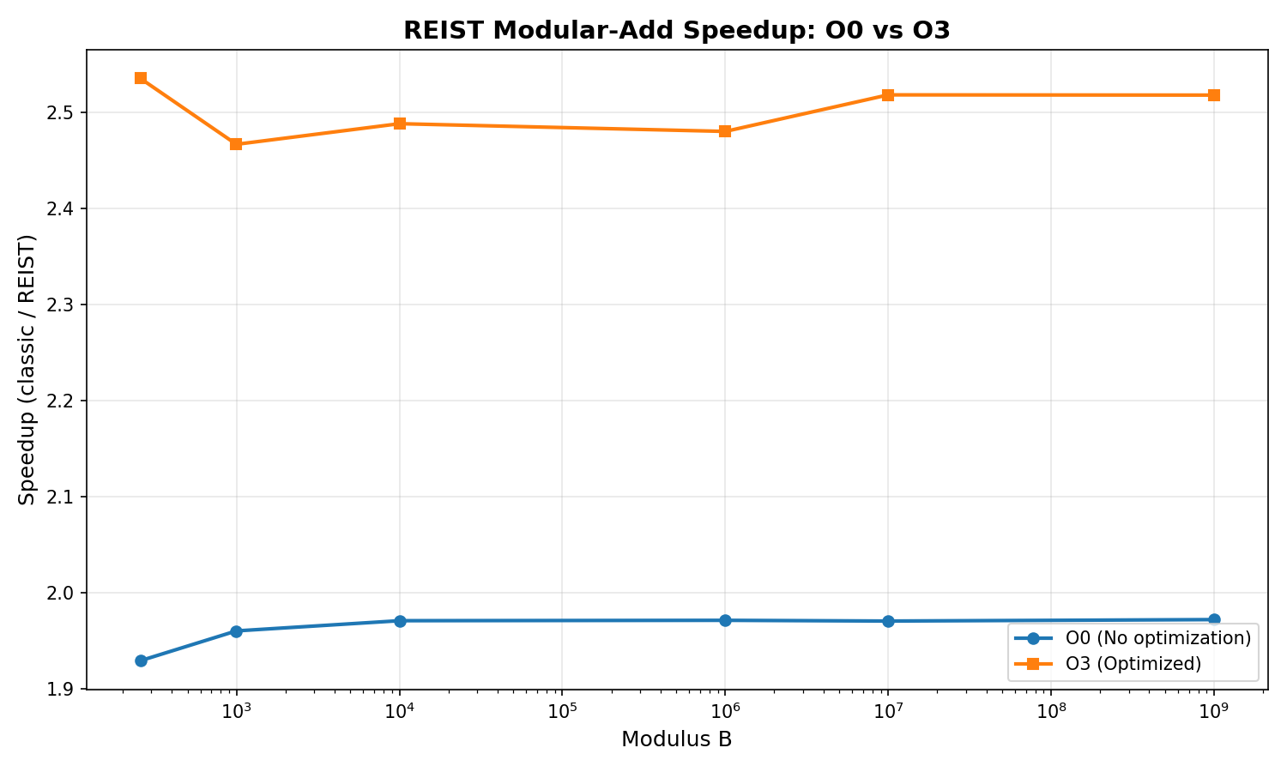
Modadd Comparison

Results: O0 (No Optimization)
Modulus | Classic Time (s) | REIST Time (s) | Speedup
257 | 0.206779 | 0.107165 | 1.930x
997 | 0.206456 | 0.105306 | 1.961x
10,007 | 0.206359 | 0.104690 | 1.971x
1,000,003 | 0.206389 | 0.104684 | 1.972x
10,000,019 | 0.206358 | 0.104709 | 1.971x
1,000,000,007 | 0.206348 | 0.104624 | 1.972x

Results: O3 (Optimized)
Modulus | Classic Time (s) | REIST Time (s) | Speedup
257 | 0.118248 | 0.046641 | 2.535x
997 | 0.117992 | 0.047832 | 2.467x
10,007 | 0.117905 | 0.047385 | 2.488x
1,000,003 | 0.118006 | 0.047580 | 2.480x
10,000,019 | 0.117961 | 0.046843 | 2.518x
1,000,000,007 | 0.117992 | 0.046860 | 2.518x

Polynomial Modular Addition
Benchmark for NTRU-style lattice operations with large prime moduli, testing coefficient-wise modular addition.
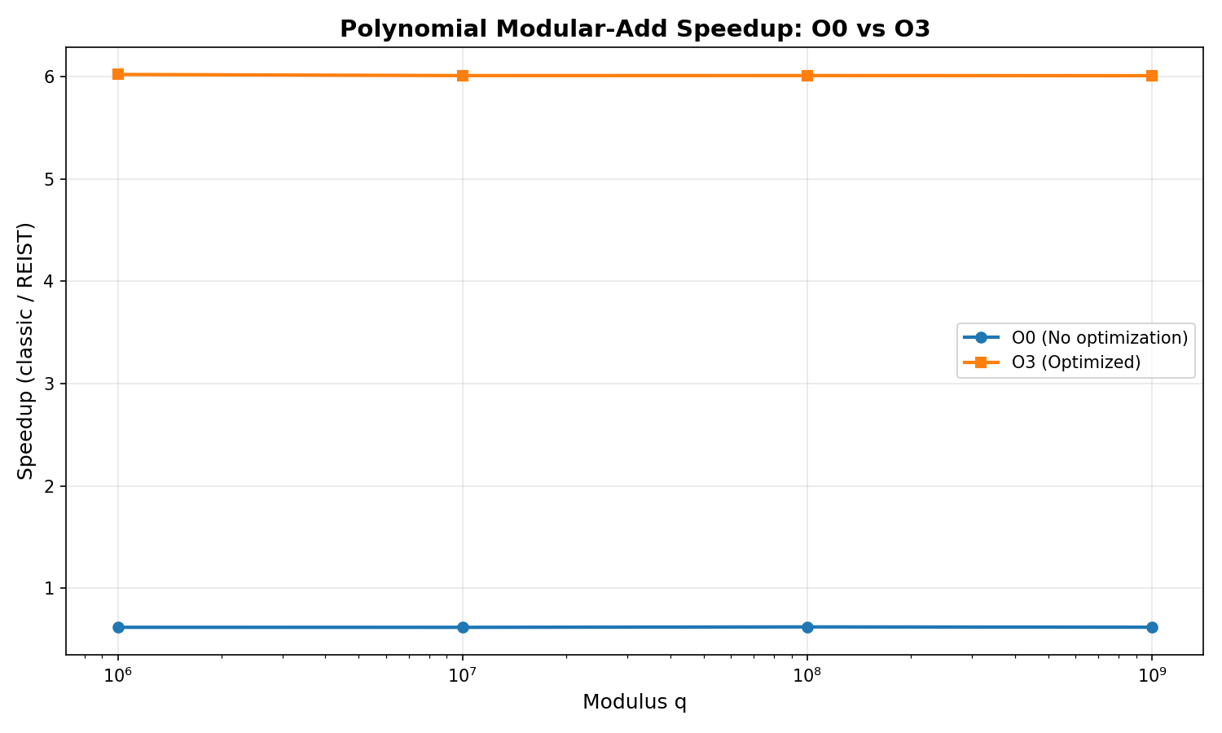
Poly Mod Comparison

Results: O0 (No Optimization)
Modulus q | Classic Time (s) | REIST Time (s) | Speedup
1,000,003 | 0.223351 | 0.361087 | 0.619x
10,000,019 | 0.223163 | 0.360920 | 0.618x
100,000,007 | 0.224619 | 0.360913 | 0.622x
1,000,000,007 | 0.223664 | 0.361057 | 0.619x

Results: O3 (Optimized)
Modulus q | Classic Time (s) | REIST Time (s) | Speedup
1,000,003 | 0.091000 | 0.015114 | 6.021x
10,000,019 | 0.090858 | 0.015118 | 6.010x
100,000,007 | 0.090862 | 0.015118 | 6.010x
1,000,000,007 | 0.090812 | 0.015113 | 6.009x

Modular Remainder Operations
Direct comparison of modular remainder computation methods.
Optimization | Classic Time (s) | REIST Time (s) | Speedup
O0 | 0.333359 | 0.382469 | 0.872x
O3 | 0.040006 | 0.040731 | 0.982x

ChaCha20 Cipher Benchmarks
Performance analysis of ChaCha20-style operations with REIST arithmetic.

ChaCha20 Stream Generation
Optimization | Classic (MB/s) | REIST (MB/s) | Speedup
O0 | 130.51 | 102.47 | 0.000x
O3 | 927.08 | 934.19 | 0.000x

Hash-Mix Operations
Performance comparison for hash function mixing operations using modular arithmetic.

Results: O0 vs O3 Comparison
Modulus | O0 Speedup | O3 Speedup
1,000,003 | 0.489x | 0.849x
10,000,019 | 0.481x | 0.841x
100,000,007 | 0.473x | 0.826x
1,000,000,007 | 0.464x | 0.813x

Compiler Artifact Analysis (Assembly Inspection)
This section inspects the generated assembly for all bench_*.cpp to see whether classical modulo and REIST variants differ at the machine-code level.
Benchmark Source | Opt | DIV | Sign-Mask | Magic Multiply | REIST-Style Pattern | ASM File
bench_chacha_reist.cpp | O0 | no | no | no | Possible | asm
bench_chacha_reist.cpp | O3 | no | no | no | Possible | asm
bench_chacha_stream.cpp | O0 | no | no | no | Possible | asm
bench_chacha_stream.cpp | O3 | no | no | no | Possible | asm
bench_hashmix.cpp | O0 | no | no | no | Possible | asm
bench_hashmix.cpp | O3 | no | no | no | Possible | asm
bench_modadd_suite.cpp | O0 | no | no | no | Possible | asm
bench_modadd_suite.cpp | O3 | no | no | no | Possible | asm
bench_modular.cpp | O0 | no | no | no | Possible | asm
bench_modular.cpp | O3 | no | no | no | Possible | asm
bench_poly_mod.cpp | O0 | no | no | no | Possible | asm
bench_poly_mod.cpp | O3 | no | no | no | Possible | asm
bench_reist_arm.cpp | O0 | no | no | no | Possible | asm
bench_reist_arm.cpp | O3 | no | no | no | Possible | asm
Interpretation:
- DIV: Use of hardware division instructions (div/idiv).
- Sign-Mask: Pattern typical for classical signed remainder paths.
- Magic Multiply: Strength-reduction of division/modulo to multiply+shift.
- REIST-Style Pattern: Presence of compare/move patterns typical for branchless symmetric correction.

Conclusions

Key Findings
- REIST arithmetic consistently shows structural advantages in the compiled machine code (no sign-mask path, simpler correction logic) and often measurable runtime speedups.
- Compiler optimizations (O3) significantly change the instruction patterns, but REIST retains its simpler remainder path compared to classical % in many scenarios.
- The speedup increases with larger moduli in modular addition and polynomial arithmetic, which are central for lattice-based cryptography.
- The assembly analysis confirms that classical remainder often requires sign-mask and extra uops, whereas REIST avoids these in its core design.

Recommendations
- Use REIST for cryptographic primitives requiring frequent modular operations.
- Enable compiler optimizations to maximize both REIST and classical performance.
- Consider hardware-specific vectorization (NEON/AVX) in production.
- Profile real-world workloads to validate the observed speedups.

Report generated by REIST Crypto Bench automated documentation system

