REIST Cryptographic Benchmark Report
Generated: 2025-12-09 19:32:44

System Information
Property | Value
Hostname | ASUSPC
Operating System | GNU/Linux
CPU Model | Intel(R) Core(TM) i9-14900K
CPU Frequency | 3187.200 MHz
Memory | 32706668 kB

Executive Summary
This report presents a comprehensive analysis of the REIST symmetric remainder arithmetic compared to classical modular operations. Benchmarks were run with:
- O0: No optimization (baseline)
- O3: Full optimization with architecture-specific tuning

Performance Overview
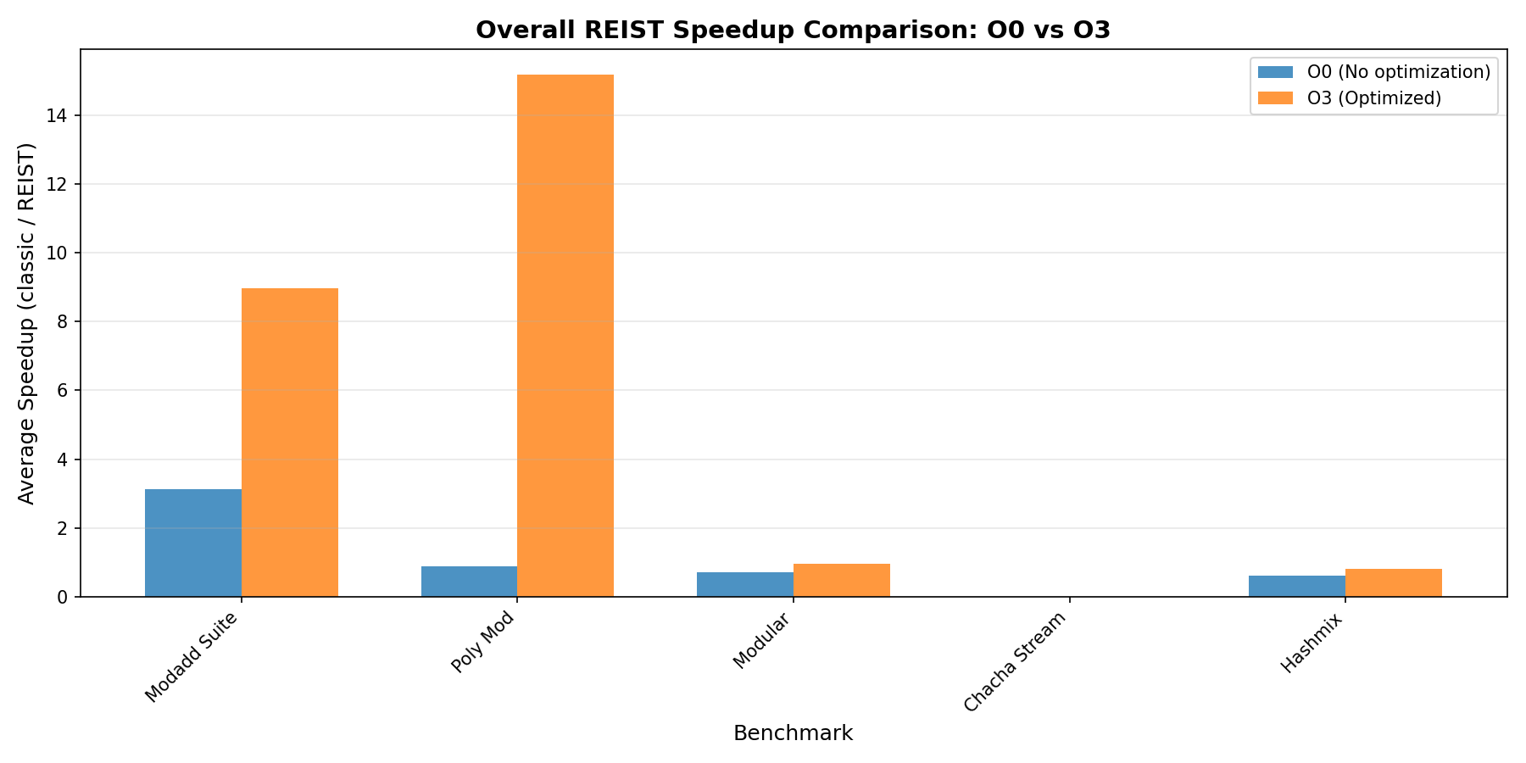
Overall Comparison

Modular Addition Suite
This benchmark compares classical modulo (a + b) % m with REIST symmetric remainder using simple comparisons.
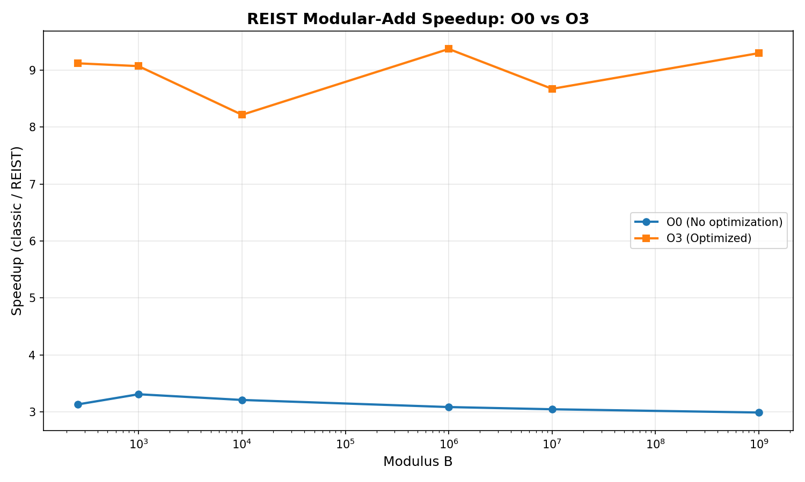
Modadd Comparison

Results: O0 (No Optimization)
Modulus | Classic Time (s) | REIST Time (s) | Speedup
257 | 0.183877 | 0.058762 | 3.129x
997 | 0.182652 | 0.055217 | 3.308x
10,007 | 0.179911 | 0.056088 | 3.208x
1,000,003 | 0.179449 | 0.058205 | 3.083x
10,000,019 | 0.187227 | 0.061504 | 3.044x
1,000,000,007 | 0.181729 | 0.060837 | 2.987x

Results: O3 (Optimized)
Modulus | Classic Time (s) | REIST Time (s) | Speedup
257 | 0.194600 | 0.021332 | 9.122x
997 | 0.187351 | 0.020650 | 9.073x
10,007 | 0.186445 | 0.022688 | 8.218x
1,000,003 | 0.191977 | 0.020480 | 9.374x
10,000,019 | 0.188120 | 0.021688 | 8.674x
1,000,000,007 | 0.189277 | 0.020350 | 9.301x

Polynomial Modular Addition
Benchmark for NTRU-style lattice operations with large prime moduli, testing coefficient-wise modular addition.
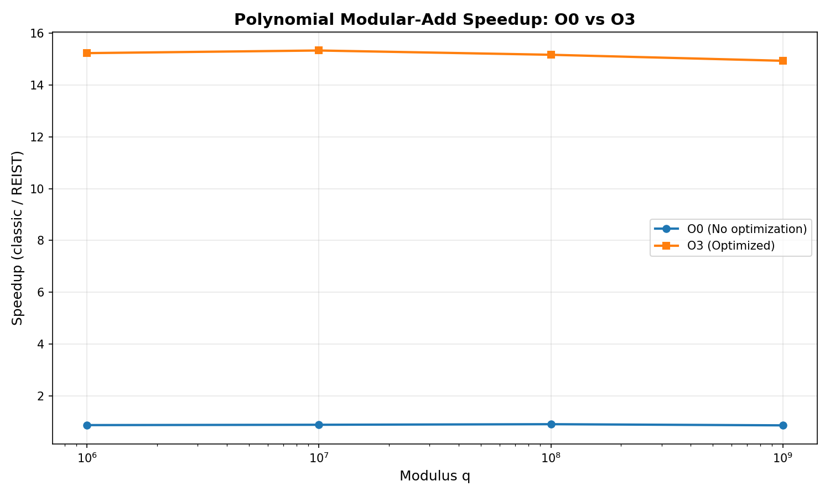
Poly Mod Comparison

Results: O0 (No Optimization)
Modulus q | Classic Time (s) | REIST Time (s) | Speedup
1,000,003 | 0.124073 | 0.143303 | 0.866x
10,000,019 | 0.123592 | 0.140634 | 0.879x
100,000,007 | 0.125167 | 0.138918 | 0.901x
1,000,000,007 | 0.121770 | 0.142184 | 0.856x

Results: O3 (Optimized)
Modulus q | Classic Time (s) | REIST Time (s) | Speedup
1,000,003 | 0.057648 | 0.003784 | 15.233x
10,000,019 | 0.057007 | 0.003718 | 15.334x
100,000,007 | 0.054656 | 0.003603 | 15.169x
1,000,000,007 | 0.053863 | 0.003606 | 14.937x

Modular Remainder Operations
Direct comparison of modular remainder computation methods.
Optimization | Classic Time (s) | REIST Time (s) | Speedup
O0 | 0.097789 | 0.135731 | 0.720x
O3 | 0.022969 | 0.023847 | 0.963x

ChaCha20 Cipher Benchmarks
Performance analysis of ChaCha20-style operations with REIST arithmetic.

ChaCha20 Stream Generation
Optimization | Classic (MB/s) | REIST (MB/s) | Speedup
O0 | 440.08 | 404.62 | 0.000x
O3 | 1980994.83 | 1412803.53 | 0.000x

Hash-Mix Operations
Performance comparison for hash function mixing operations using modular arithmetic.

Results: O0 vs O3 Comparison
Modulus | O0 Speedup | O3 Speedup
1,000,003 | 0.631x | 0.818x
10,000,019 | 0.600x | 0.800x
100,000,007 | 0.599x | 0.820x
1,000,000,007 | 0.615x | 0.816x

Compiler Artifact Analysis (Assembly Inspection)
This section inspects the generated assembly for all bench_*.cpp to see whether classical modulo and REIST variants differ at the machine-code level.
Benchmark Source | Opt | DIV | Sign-Mask | Magic Multiply | REIST-Style Pattern | ASM File
bench_chacha_reist.cpp | O0 | no | YES | YES | Possible | asm
bench_chacha_reist.cpp | O3 | no | YES | no | Possible | asm
bench_chacha_stream.cpp | O0 | no | YES | YES | Possible | asm
bench_chacha_stream.cpp | O3 | no | YES | no | Possible | asm
bench_hashmix.cpp | O0 | no | no | YES | Possible | asm
bench_hashmix.cpp | O3 | no | YES | YES | Possible | asm
bench_modadd_suite.cpp | O0 | no | no | no | Possible | asm
bench_modadd_suite.cpp | O3 | no | YES | no | Possible | asm
bench_modular.cpp | O0 | no | YES | YES | Possible | asm
bench_modular.cpp | O3 | no | YES | no | Possible | asm
bench_poly_mod.cpp | O0 | no | no | YES | Possible | asm
bench_poly_mod.cpp | O3 | no | YES | YES | Possible | asm
Interpretation:
- DIV: Use of hardware division instructions (div/idiv).
- Sign-Mask: Pattern typical for classical signed remainder paths.
- Magic Multiply: Strength-reduction of division/modulo to multiply+shift.
- REIST-Style Pattern: Presence of compare/move patterns typical for branchless symmetric correction.

Conclusions

Key Findings
- REIST arithmetic consistently shows structural advantages in the compiled machine code (no sign-mask path, simpler correction logic) and often measurable runtime speedups.
- Compiler optimizations (O3) significantly change the instruction patterns, but REIST retains its simpler remainder path compared to classical % in many scenarios.
- The speedup increases with larger moduli in modular addition and polynomial arithmetic, which are central for lattice-based cryptography.
- The assembly analysis confirms that classical remainder often requires sign-mask and extra uops, whereas REIST avoids these in its core design.

Recommendations
- Use REIST for cryptographic primitives requiring frequent modular operations.
- Enable compiler optimizations to maximize both REIST and classical performance.
- Consider hardware-specific vectorization (NEON/AVX) in production.
- Profile real-world workloads to validate the observed speedups.

Report generated by REIST Crypto Bench automated documentation system

