Student Name: Click to insert your name here. Use the convention LASTNAME_Firstname

Year Level: Click to insert the Year level you are in. E.g. 7, 8 or 9



Introduce Application 3

Usability Principles 3

Prescribed and Self Determined Criteria 4

Mind Map 5

Create a mind map showing your ideas – Refer to Qlearn for template 5

DFD 6

Data Dictionary 6

Algorithms 7

Wireframes 8

Mock Ups 9

Code 10

User Feedback 13

Evaluation 14

Impacts Evaluation 15

References 16

# Introduce Application

Provide context to the application

Identify the User Problem it is solving that is guided by the User Persona Stimulus on the Task Sheet

# Usability Principles

Recognise and Describe the Usability Principles

|  |  |
| --- | --- |
| **Usability Principles** | **Explanation with reference** |
| **Utility** |  |
| **Safety** |  |
| **Effectiveness** |  |
| **Learnability** |  |
| **Accessibility** |  |

# Mind Map

# Create a mind map showing your ideas – Refer to Qlearn for template

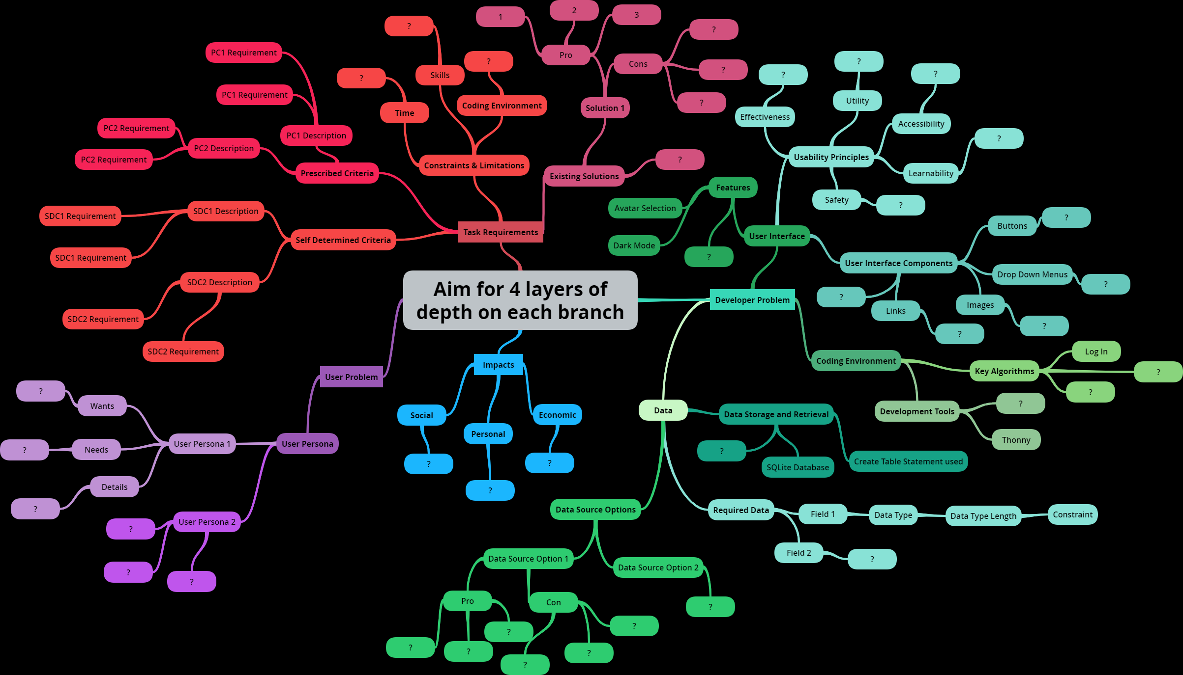

# DFD

Develop a DFD that shows the Entities, Processes and Data Stores for your application

# Data Dictionary

Generate a data dictionary for the data stores in your DFD

Include data type, column name, data type length, constraints, etc

|  |  |  |  |
| --- | --- | --- | --- |
| **Column Name** | **Data Type** | **Data Type Length** | **Sample Data** |
|  |  |  |  |
|  |  |  |  |
|  |  |  |  |
|  |  |  |  |
|  |  |  |  |
|  |  |  |  |
|  |  |  |  |

# Algorithms

Develop algorithms for each DFD Process in your application

Present them in an IPO Chart

|  |  |  |
| --- | --- | --- |
| **Inputs** | **Processes** | **Outputs** |
|  |  |  |

# Wireframes

development of wire frames

annotations of elements and principles of communication for the proposed wire frames

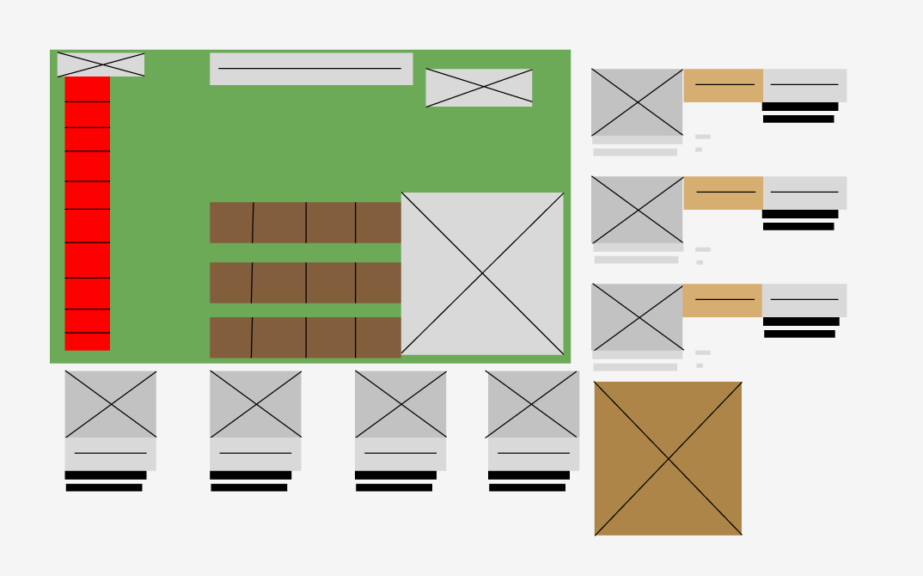

# Mock Ups

symbolisation of a mockup of a graphical user interface

annotations of usability principles for the proposed mockups

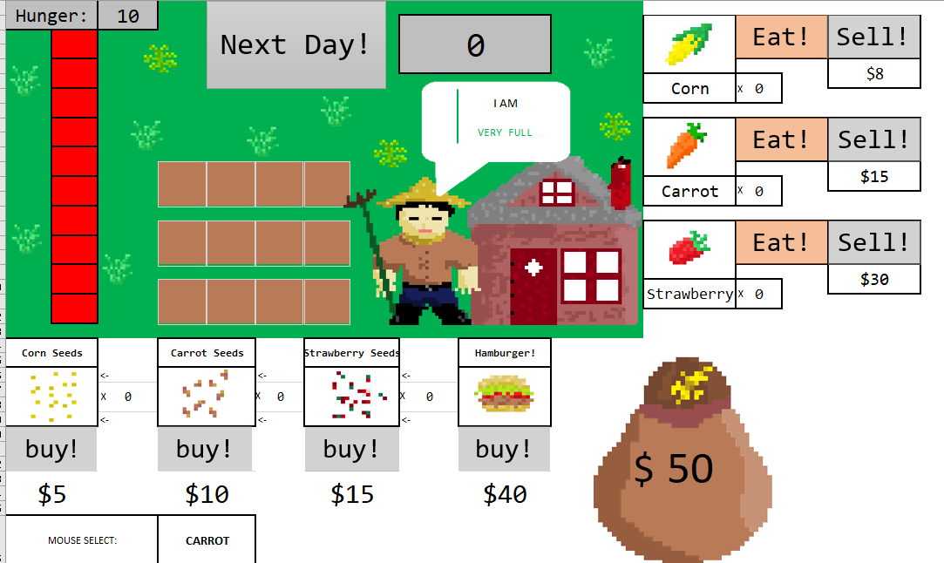

# Code

Insert screen captures of your commented code

# User Feedback

Create user feedback surveys that gather data on all PC and SDC

|  |  |  |
| --- | --- | --- |
| **Prescribed Criteria 1** | | |
| **Questions (These are created from your requirements of your PC and SDC)** | **User Feedback 1** | **User Feedback 2** |
|  |  |  |
|  |  |  |
|  |  |  |
|  |  |  |
|  |  |  |
|  |  |  |

# Evaluation

Evaluate components and solution against the prescribed and self-determined criteria. Use the evaluation template

|  |  |  |  |  |  |
| --- | --- | --- | --- | --- | --- |
| **Criteria** | **Description** | **Requirements** | **Y/N** | **Justification** | **Recommendation** |
| Prescribed Criteria 1 | Copy and Paste the description in from the Task Sheet Stimulus Section  E.g. Wear your Mansfield State High School Uniform Correctly | Create evaluative components of the larger Criteria.  E.g. Tuck your shirt in | Did you meet this? Yes or No | Communicate how the requirement has been met | Make recommendations about what you would do different next time/how could you improve this further/is there anything you would change in hindsight |
| E.g. Wear Black Leather Shoes |  |  |  |
| E.g. Correct Hat and always worn |  |  |  |
|  |  |  |  |
| Prescribed Criteria 2 | Copy and Paste the description in from the Task Sheet Stimulus Section |  |  |  |  |
|  |  |  |  |
|  |  |  |  |
|  |  |  |  |
|  |  |  |  |
| Self-Determined Criteria 1 | Create a criteria that links to the user problem developed in the User Persona Table |  |  |  |  |
|  |  |  |  |
|  |  |  |  |
| **Evaluation Summary** | | | | | |
| My website was successful because...(use specific criteria)  My website did / did not meet the user requirements because...  One way my website could be improved is...  Overall, the project was a success / could have been better. | | | | | |

# Impacts Evaluation

|  |  |  |
| --- | --- | --- |
| **Personal** | **Social** | **Economic** |
|  |  |  |

# References

**There are no sources in the current document.**