ATELIER — LOCAL PRODUCT GENERATION QUALITY AUDIT
Product: P01187465 · Test date: 19 August 2026 · Audit: human carrying the referenced handbag

Executive verdict
REJECTED — no local generation engine is currently approved to produce a publishable human-with-product image for this product.
The strongest supplied lifestyle reference passed the local validator. The latest SDXL CPU output was generated, inspected, and correctly rejected. It contains a person and a large tote-like object, but the object is not detected as the referenced handbag and visibly loses distinctive product construction. The system now blocks this output instead of presenting it as successful.

What was tested
Item | Result | Details
Product references | 4 supplied | Front/detail references plus two model/lifestyle views were available.
Reference quality check | PASS for b2 | Person, bag, contact, scale and identity proxy all passed.
Generated output | FAIL | Person detected; handbag not detected; contact/scale/identity proxy failed.
Publish decision | BLOCKED | No verified engine is selectable in Rudras.

Reference used for the successful baseline check
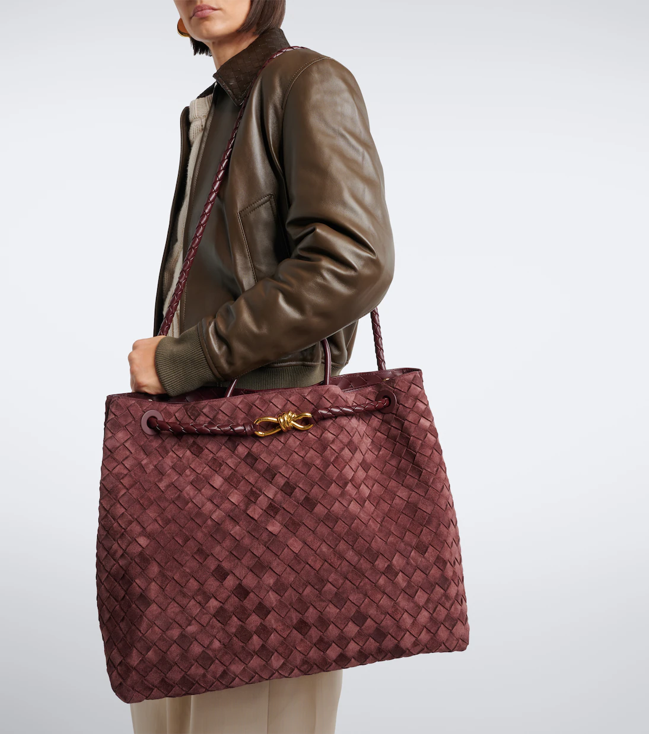
The b2 lifestyle reference is the control image that demonstrates the validator can recognize a real model carrying this product. Scores: person 0.865, handbag 0.9914, identity proxy 0.8228, bag/person area ratio 0.7331.

Latest generated output and quality result
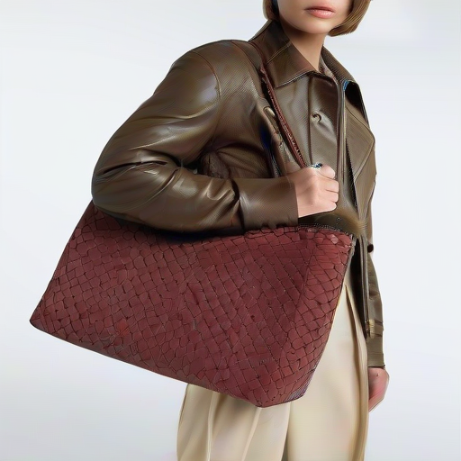
Output file: .local/generation-validation/outputs/sdxl-human-with-bag.png
Generation time: 152.4 seconds · Resolution: 512 × 512 · Engine: local SDXL CPU fast human path · Status: failed / not publishable
Check | Result | Observed
Real person | PASS | Person score 0.9923
Handbag/backpack/suitcase detected | FAIL | No supported bag detected at the required confidence
Physical contact | FAIL | No validated person-to-bag contact pair
Believable scale | FAIL | No valid bag/person geometry pair
Reference identity proxy | FAIL | Not evaluated as passing because the product detection gate failed
Overall | FAIL | No handbag, backpack, or suitcase was detected with the person

Why the output is not good enough
- The CPU SDXL image-to-image fallback changed the product into a generic burgundy tote-like shape instead of preserving the supplied handbag.
- Distinctive construction visible in the references — the gold clasp, cord/eyelet details, handle geometry, and silhouette — is not preserved reliably in the generated frame.
- Prompting alone cannot force exact product identity in plain SDXL image-to-image conditioning, especially at the current fast CPU profile.
- The output visually suggests a person holding a large bag, but commercial quality requires the actual uploaded product, not merely a similar category object.
- The system therefore does not auto-repair this frame by publishing it. It fails closed and keeps the frame out of the result set.

Full local engine matrix
Engine | Runtime/model status | Smoke result | Why it is not selectable
Qwen Image Edit 2511 | Repository + runner present; weights/runtime/CUDA missing | BLOCKED | Requires local weights, isolated runtime, and NVIDIA CUDA
FLUX.1 Schnell | Repository + runner present; weights/runtime/CUDA missing | BLOCKED | Requires local weights, isolated runtime, and NVIDIA CUDA
Fooocus | Official source/runtime present | BLOCKED | No non-interactive Atelier runner; no CUDA worker
HiDream-O1 Image | Repository, runner, and weights present | BLOCKED | No NVIDIA GPU detected
FLUX.2 Dev | Repository present; checkpoint and autoencoder missing | BLOCKED | Missing FLUX.2 Dev checkpoint/ae.safetensors and no CUDA
FLUX.2 Klein 4B NVFP4 | Checkpoint present | BLOCKED | Needs compatible NVFP4 runner and NVIDIA CUDA
Stable Diffusion XL | Local CPU model/runtime available | FAILED | Generated a person but failed handbag detection and identity checks in 152.4s

How the current safety and quality gate works
- A backend is not considered ready because files merely exist. It must pass a current human-with-product smoke test.
- The local validator uses the open-source Faster R-CNN COCO checkpoint. It checks person detection, handbag/backpack/suitcase detection, physical proximity, relative scale, and a conservative reference identity proxy.
- Verification is stored with an expiry and a runtime fingerprint covering model artifacts, nested files, runner/Python dependencies, package metadata, Torch/runtime data, validator checkpoint, thresholds, and generation profile.
- The shoot route rechecks verification at queue start, before each frame, and immediately before dispatch. A changed or expired runtime is rejected.
- The report uses exact states: verified, failed, unverified, or unavailable. No hosted or paid image-generation fallback is used.

What is fixed now
- Unverified engines can no longer be routed through Rudras for human-with-product generation.
- The rejected SDXL output is recorded with its output path, latency, validation details, and failure reason.
- The UI shows backend audit state and disables the start action when no verified engine is available.
- Source-preserved fallback remains explicitly labeled and is only allowed when the supplied model-carrying reference itself passes local person+product validation.
- Runtime changes cannot silently reuse an old smoke-test pass.

What must be done to make generation work reliably
- Attach a real NVIDIA CUDA worker with enough VRAM for the selected local model and validator.
- Install and verify the required local weights and isolated runtimes for Qwen, FLUX.1 Schnell, HiDream, FLUX.2 Dev, and FLUX.2 Klein.
- Implement and test a non-interactive Fooocus Atelier runner; source/runtime presence alone is not enough.
- Run the audit from backend/ so the audit process uses the same Python environment as the API: python scripts/audit_human_product_generation.py --engine all --references <2-6 references>.
- Do not enable an engine until it produces at least one real model-carrying handbag result that passes the local validator and a visual product-identity review.
- Improve the identity verifier with stronger local multi-reference shape/hardware matching so clasp, handle, eyelet, cord, silhouette, and material drift are caught automatically.

Final status
The application is behaving safely: it is not pretending that an altered or unverified handbag image is correct. The current blocker is infrastructure and model capability, not a hidden UI failure. With the present CPU-only environment, there is no engine that can honestly be marked verified for this handbag human-with-product use case.
Audit report source: .local/generation-validation/human-product-report.json · Live health snapshot captured after API restart · Validator checkpoint is local and checksum-pinned.

