- TASK 1 – LOGO REDESIGN
Objective: Redesign the existing logo to give it a fresh, modern look. Key Focus Areas
- Maintain brand identity while enhancing visual appeal.
- Apply modern design trends and techniques.
- Create multiple variations and explain the design logic.
Tools: Adobe Illustrator, CorelDRAW, Figma, Canva.
Existing Logo:
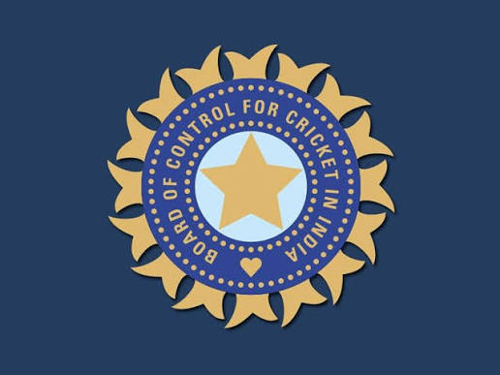
New Redesign Logo:
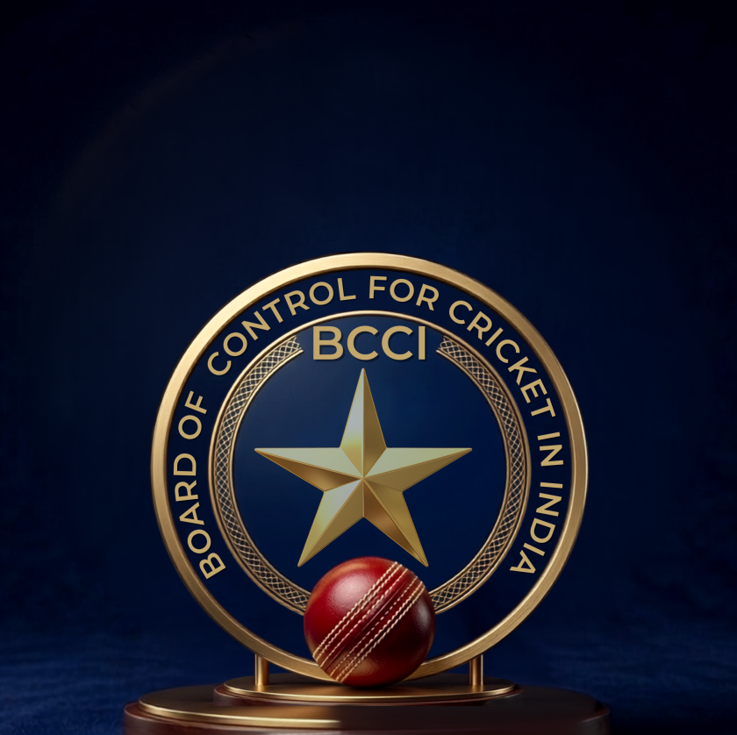
- TASK 3 – TYPOGRAPHY PRACTICE
Objective: Master the art of typography to enhance visual communication.
Skills to Develop:
● Experiment with font pairing, hierarchy, spacing and alignment
● Create impactful text-based designs.
● Understand the psychological effect of different type styles.
Tools: Adobe illustrator, Photoshop, Canva.
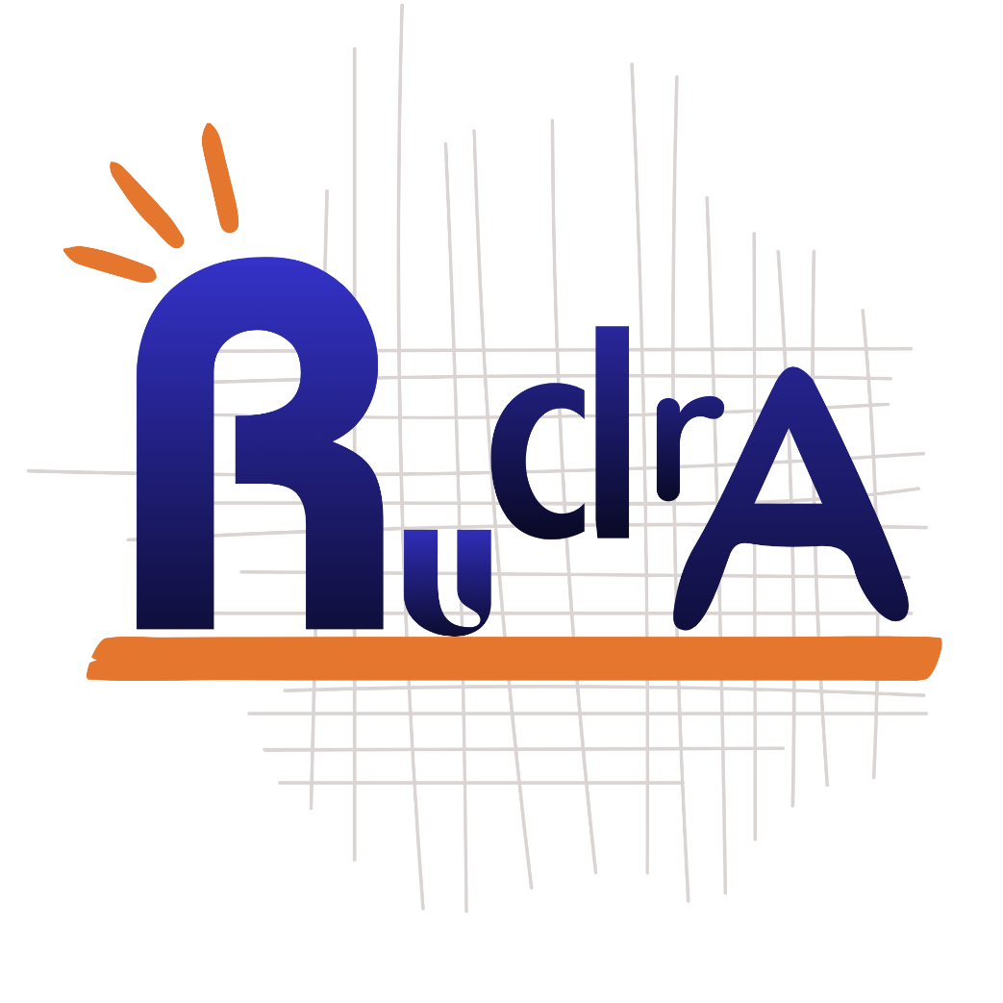

- TASK 4 – STORYBOARDING DESIGN
Objective: Design storyboards to visualize narratives and user journeys.
Key Deliverables:
● Breakdown concepts into visual scenes or frames.
● Develop compelling sequences for videos, animations or user flows.
● Collaborate with content creators and animation for execution.
Tools: Storyboard That, Adobe illustrator, Photoshop, Procreate.
