JAYPEE UNIVERSITY OF ENGINEERING & TECHNOLOGY, GUNA
DEPARTMENT OF Computer science & engineering

A PRACTICAL WORK BOOK
of
COMPUTER ORGANIZATION & Architecture LAB
(COURSE CODE: CS208)

SUBMITTED
TO
Type FaCulTy Name

Name of student__________________ ____________ENRL NO.________

Class____________________ BATCH_______________________________

BRANCH___________________SESSION______________________________

INDEX

S. No. | Aim of the experiment | Date of submission | signature | remarks

EXPERIMENT#1
Aim: Designing of basic digital circuits using logic gates.
Exercise#1: Design two inputs and five outputs All-in-One logic gate circuit shown in Fig.1 using Logisim simulator with (i) data width 1 (ii) data width 4.
Boolean Expressions | Logic Diagram
C = not A  D = A.B  E = A+B  F = ~(A.B)  G = A$⊕$B | 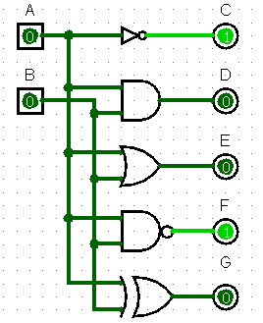
Truth Table or Karnaugh (K) Map
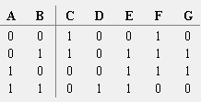

- Use above format to prepare your lab record.
- Use given cover page in your file and write your information (name, enrl. etc) by pen.
- Use given index format in the file and write the information after the completion of each experiment by pen.
- Use minimum number of pages for the text of each experiment.
- Don’t leave space in the pages unnecessarily.
- Edit the contents carefully for better appearance of the file..
- Use optimal size of figures. Text in figures should be visible clearly but figure should not be unnecessarily too big.
- Each page of file must have your name and enrolment number at the bottom of page (can be used footer). File must not be a copy and paste.
- Save all files at your personnel space, preferably in N-drive, by creating a folder named as ‘COA Lab’.

