Machine Learning–Based Soft Sensor for
Distillation Column Product Purity Prediction
Consolidated Project Report
RUDRA PRATAP KESHRI
Dept.Of Chemical Engineering
IIT GUWAHATI, ASSAM
August 2026

Executive Summary
This project builds and validates a machine learning soft sensor that predicts the ethanol (top-product) mole fraction of a distillation column in real time from tray temperatures and flow rates — the same kind of application refineries use to reduce dependence on slow lab composition analysis. Five algorithms were trained and compared: Linear Regression, Random Forest, XGBoost, Support Vector Regression (SVR), and an Artificial Neural Network (ANN).
Two findings anchor this report. First, an initial random train/test split produced suspiciously high accuracy (R² ≈ 0.999 across several models) — investigation revealed this was inflated by data leakage: the dataset contains only 13 unique operating points, and a naive row-wise split let samples from the same operating condition appear in both training and test data. Correcting this with a group-aware split (holding out entire operating points) gave an honest evaluation. Second, under that honest evaluation, the five models split sharply into two groups:
- Random Forest and XGBoost remained highly accurate and stable (Test R² ≈ 0.999, train-test gap < 0.001).
- Linear Regression, SVR, and especially the ANN (Test R² = −3.30) showed real overfitting once forced to generalize to a genuinely unseen operating regime.
Based on this evidence, Random Forest and XGBoost are the models recommended for deployment. A working prediction dashboard built on these two models accompanies this report.

Contents
1. Introduction & Motivation
2. Dataset Description
3. Exploratory Data Analysis
4. Feature Engineering & Data Preparation
5. Headline Finding #1 — The Data Leakage Fix
6. Model Training & Comparison
7. Headline Finding #2 — Tree-Based vs. Linear/PCA Generalization Gap
8. Conclusion & Deployment Recommendation
9. Limitations & Future Work
10. Appendix — Deliverables

1. Introduction & Motivation
In a distillation column, product composition is the variable operators care about most, but it is also the hardest to measure directly and continuously — lab analysis (gas chromatography) can take anywhere from several minutes to hours, creating a lag between when a process upset occurs and when it is detected. Refineries and petrochemical plants (e.g. BPCL, Reliance) address this with 'soft sensors': models that infer product composition in real time from fast, cheap, continuously-available measurements such as tray temperatures, pressures, and flow rates.
This project builds such a soft sensor for a binary distillation column, predicting the ethanol mole fraction of the overhead (top) product. The objective is not only to produce an accurate model, but to demonstrate a rigorous ML methodology: proper exploratory analysis, defensible data-cleaning decisions, principled feature engineering, and — critically — an honest evaluation methodology that doesn't overstate how well the model will perform on genuinely new operating conditions.

2. Dataset Description
The dataset (dataset_distill.csv) contains 4,408 time-sampled observations across 21 process variables:
Variable(s) | Description
Pressure | Column pressure (found to be constant across all rows)
T1 – T14 | Tray temperatures (K), tray 1 = top (near condenser) to tray 14 = bottom (near reboiler)
L, V | Reflux flow and vapor flow rates (kg/h)
D, B, F | Distillate, bottoms, and feed flow rates (kg/h)
Ethanol concentration | Target variable — ethanol mole fraction in the top product
No missing values or duplicate rows were present. The dataset turned out to represent 13 distinct simulated operating points (fixed combinations of L, V, D, B), each run as a transient simulation with 258–586 time-samples — a structural fact that becomes central to the modeling methodology in Section 5.

3. Exploratory Data Analysis
Key findings from the initial data audit:
- Pressure is constant (1.01 atm, zero variance) across every row — no predictive value.
- Ethanol concentration ranges from 0.538 to 0.892 (mean ≈ 0.792) and is left-skewed (skewness ≈ −1.71).
- Tray temperatures show a clear, physically sensible profile rising from top to bottom of the column.
- Top-tray temperature (T1) correlates most strongly with the target (r ≈ 0.98) — consistent with vapor-liquid equilibrium theory at fixed pressure.
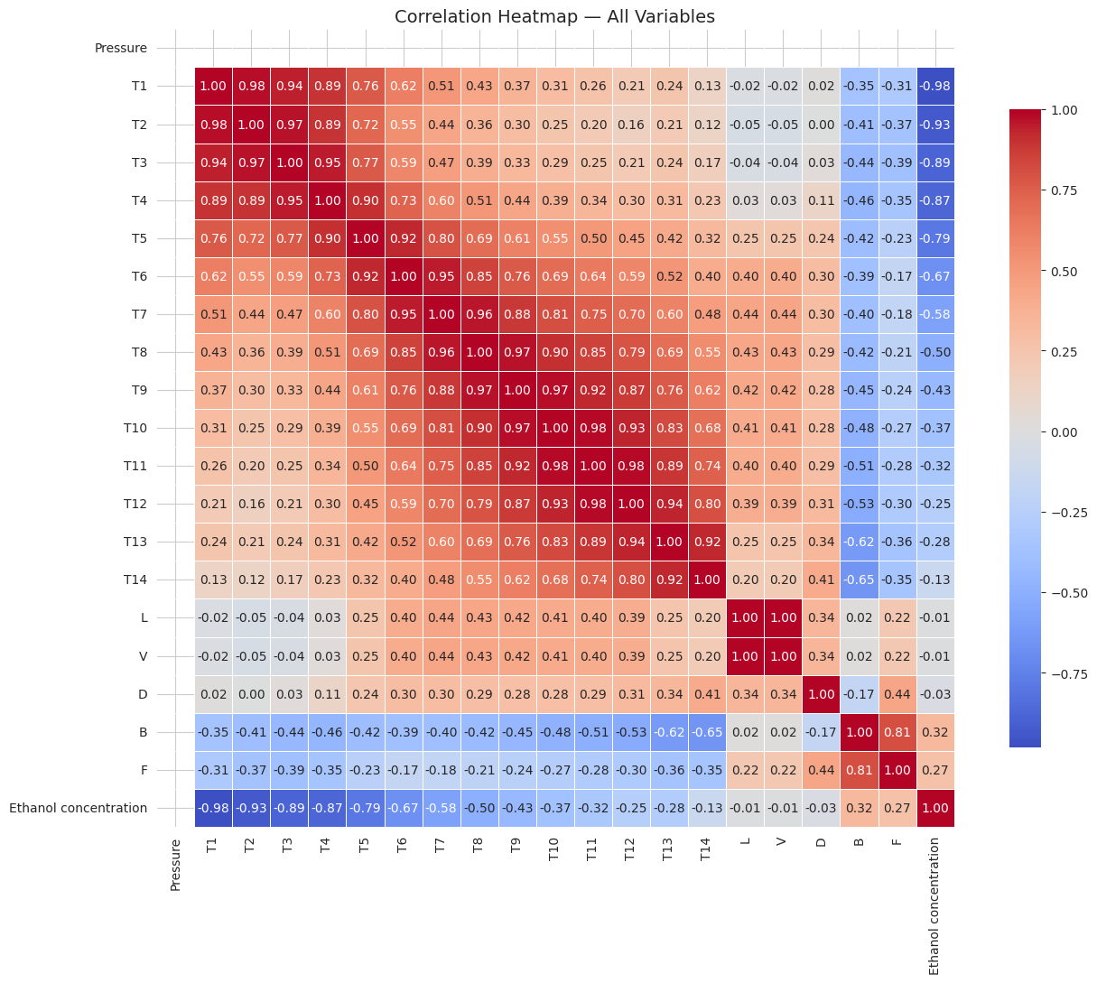
Figure 1. Correlation heatmap of all process variables.
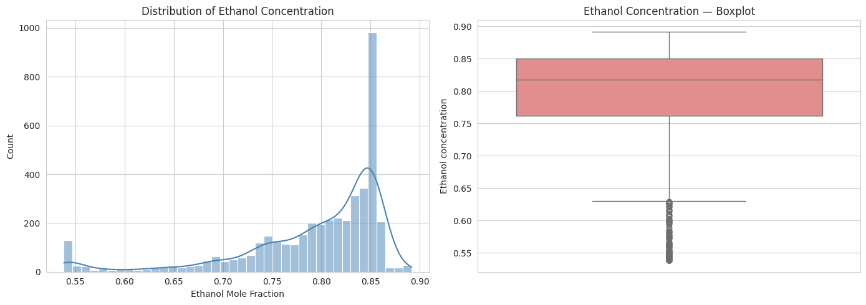
Figure 2. Distribution of the target variable, showing left skew.
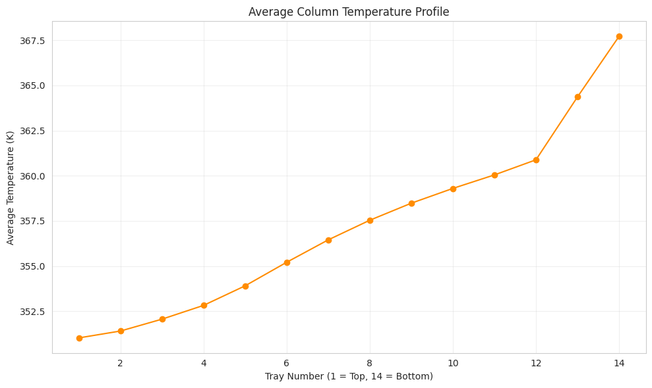
Figure 3. Average column temperature profile — rises smoothly from top to bottom, as physically expected.

4. Feature Engineering & Data Preparation

4.1 Target Skew
Square and cube transforms were tested against Box-Cox and Yeo-Johnson. Box-Cox (λ ≈ 8.0) reduced skewness from −1.71 to −0.39, but its valid numerical range on this data proved to be only ~0.05 wide — small prediction errors invert to NaN. All models were ultimately trained on the original (untransformed) target scale, which Linear Regression already handled adequately (R² ≈ 0.95 under a naive split).
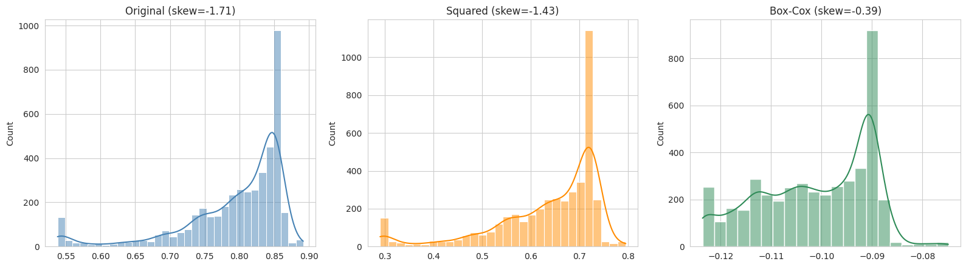
Figure 4. Target skewness before and after candidate transforms.

4.2 Data Quality: Recovering Corrupted Flow Readings
551 rows (12.5%) had physically impossible L/V values (up to hundreds of millions) traced to a comma-decimal / scientific-notation export error. Rather than deleting these rows, D, B, and F (unaffected columns) were used as a lookup key: since this is fixed-setpoint simulation data, each corrupted operating point matched exactly one valid (L, V) pair elsewhere in the data. All 551 rows were recovered by lookup — zero rows were dropped.
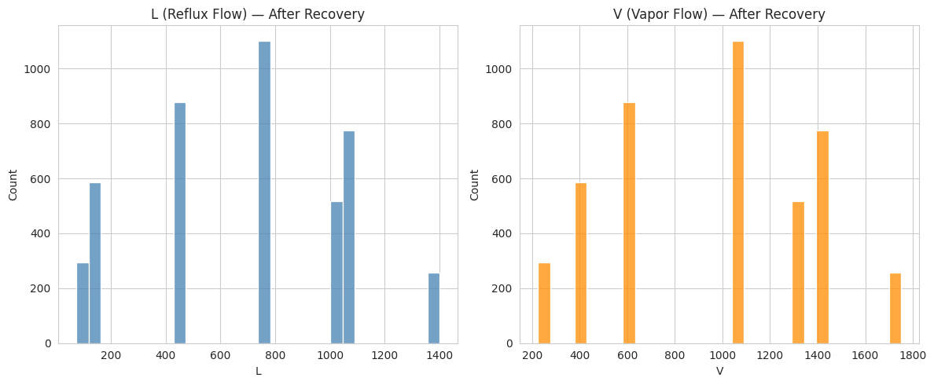
Figure 5. L and V distributions after recovering the corrupted values.

4.3 Redundant & Collinear Features
A mass-balance check confirmed F = D + B exactly for every row — F is fully redundant and was dropped. Variance Inflation Factor (VIF) analysis showed raw L, V, D, B, F were severely multicollinear (infinite VIF), a direct consequence of only 13 unique operating points existing in the data. Replacing raw L/V with engineered Reflux Ratio (L/D) and Boil-up Ratio (V/B) resolved this for the flow variables.

4.4 Dimensionality Reduction: PCA on Tray Temperatures
The 14 tray temperatures remained severely collinear with each other (VIF up to ~480) even after fixing the flow variables — expected, since a temperature profile up a column is smooth and adjacent trays are nearly redundant. PCA was applied to the standardized temperatures, retaining components up to a 98% cumulative-variance threshold, which required 5 components (up from 3 at a 95% threshold).
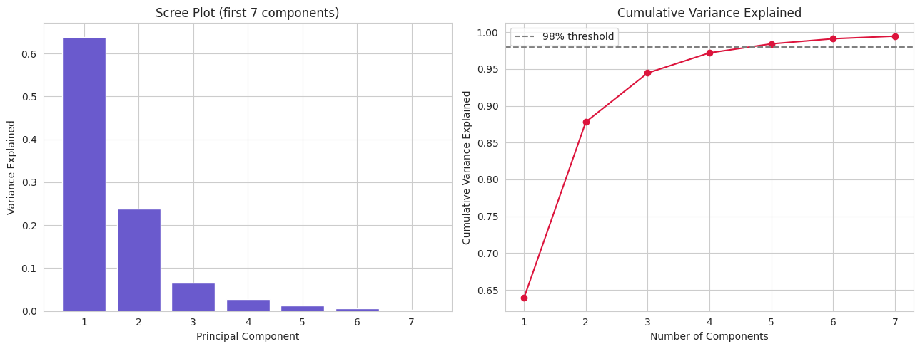
Figure 6. PCA scree plot and cumulative variance explained — 5 components needed for 98%.

4.5 Two Final Feature Sets
- Tree-based set (20 features): raw T1–T14, L, V, D, B, Reflux Ratio, Boil-up Ratio — kept raw since tree ensembles are insensitive to multicollinearity and this preserves interpretability.
- Linear/PCA set (7 features): PC1–PC5, Reflux Ratio, Boil-up Ratio, D, B — decorrelated (all VIF < 10) for Linear Regression, SVR, and the ANN.

5. Headline Finding #1 — The Data Leakage Fix
An initial model trained with a standard random 80:20 row-wise split reported Test R² ≈ 0.999 for several models — suspiciously high for a real-world-style prediction task. Investigation traced this to the dataset's structure: only 13 unique operating points, each a transient run of hundreds of time-samples. A random row split allows samples from the same run to land in both training and test sets, so a model can partly interpolate within a trajectory it has already seen extensively rather than genuinely generalizing to new conditions.
This was verified directly: the same Random Forest configuration was evaluated two ways — a naive random split, and 5-fold GroupKFold cross-validation where entire operating points are held out per fold.
Evaluation Method | Test R²
Naive random 80:20 split | 0.9999
Group-aware CV — fold 1 | 0.9954
Group-aware CV — fold 2 | 0.9998
Group-aware CV — fold 3 | 0.9996
Group-aware CV — fold 4 | 0.8994
Group-aware CV — fold 5 | 0.9996
Group-aware CV — mean (± std) | 0.9787 (± 0.0397)
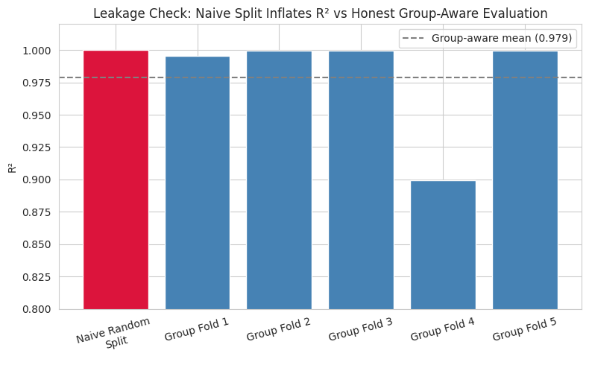
Figure 7. Naive split R² sits above the group-aware mean; one held-out operating point (fold 4) proved genuinely harder.
The fix: every train/test split and every cross-validation fold used from this point onward holds out entire operating points via GroupShuffleSplit / GroupKFold on an OperatingPoint identifier, so no model is ever evaluated on a condition it has partially seen during training.

6. Model Training & Comparison
Five models were trained on the group-aware 80:20 split (3,341 training rows across 10 operating points; 1,067 test rows across 3 held-out operating points). Random Forest, XGBoost, and SVR were tuned via RandomizedSearchCV using group-aware 5-fold cross-validation; the ANN used early stopping.
Model | Test RMSE | Test MAE | Test R² | Train–Test R² Gap | Verdict
Random Forest | 0.00136 | 0.00107 | 0.9994 | 0.0004 | OK
XGBoost | 0.00181 | 0.00110 | 0.9990 | 0.0009 | OK
SVR | 0.01906 | 0.01104 | 0.8887 | 0.1055 | Overfitting
Linear Regression | 0.02502 | 0.02086 | 0.8081 | 0.1576 | Overfitting
ANN (MLP) | 0.11847 | 0.09714 | −3.303 | 4.300 | Severe overfitting
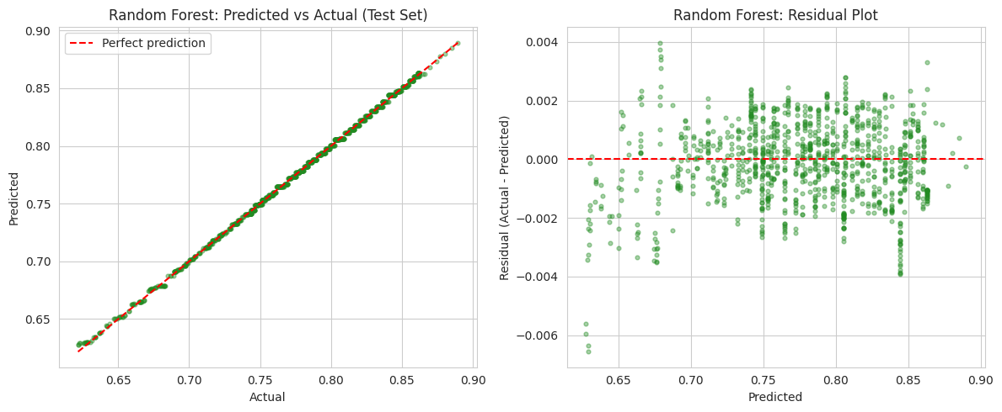
Figure 8. Random Forest — predicted vs. actual and residuals (test set).
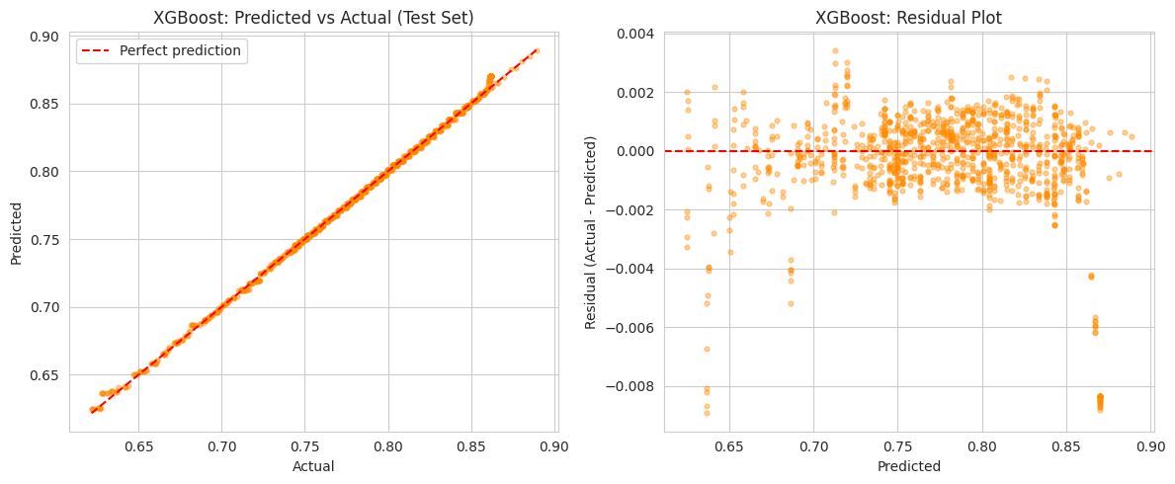
Figure 9. XGBoost — predicted vs. actual and residuals (test set).
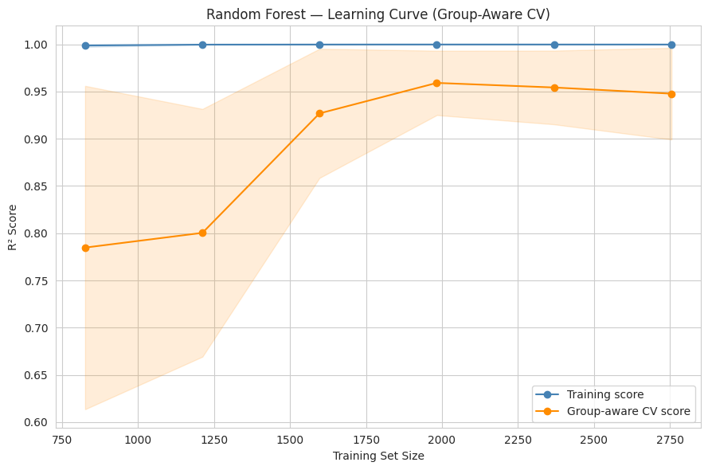
Figure 10. Random Forest learning curve under group-aware cross-validation — training and validation scores converge, confirming neither over- nor under-fitting.
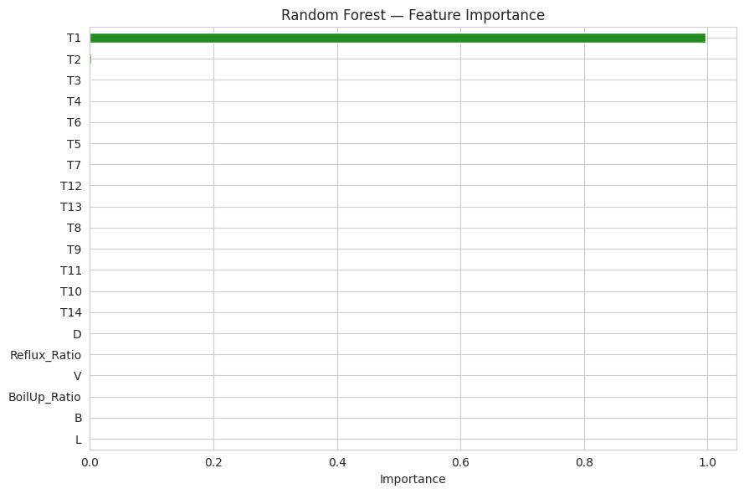
Figure 11. Random Forest feature importance — T1 (top-tray temperature) alone accounts for 99.8% of total importance.
This is a notable practical finding, not just a modeling detail: because T1 sits nearest the condenser, its temperature is almost a direct proxy for top-product composition via vapor-liquid equilibrium at fixed pressure — every other variable's contribution is negligible by comparison. For a real deployment, this suggests a single reliable thermocouple near the top tray, rather than a full 14-point profile, may capture nearly all of the predictive signal — worth validating against plant data before acting on it.

7. Headline Finding #2 — Tree-Based vs. Linear/PCA Generalization Gap
The group-aware evaluation didn't just lower the reported accuracy — it split the five models into two clear groups. Random Forest and XGBoost stayed accurate and stable. Linear Regression, SVR, and the ANN — all trained on the PCA-compressed feature set — showed real overfitting once genuinely forced to predict an unseen operating regime. The ANN's Test R² of −3.30 means its predictions were worse than simply guessing the training mean for every test row.
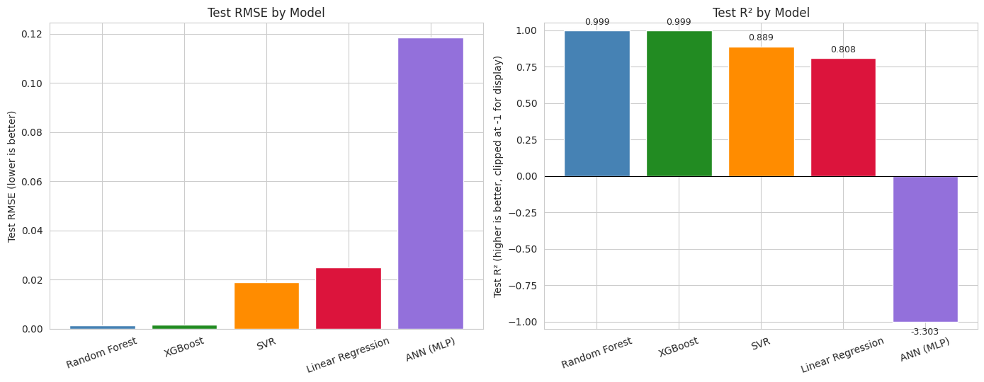
Figure 12. Final Test RMSE and R² by model — the ANN's catastrophic failure is visible even after clipping the axis.
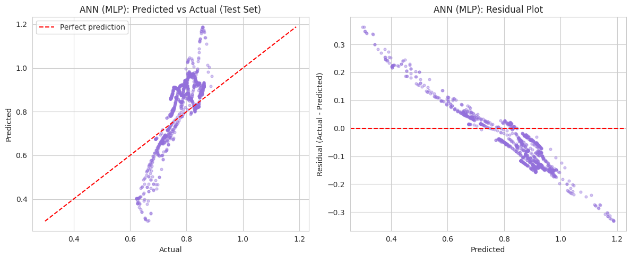
Figure 13. ANN — predicted vs. actual (test set). Predictions cluster far from the actual values for the held-out operating regime.
Why this happened: under the naive split, PCA components for test rows were close to ones the model had already trained on from the same run. Under the group-aware split, the held-out operating point produces PC1–PC5 and ratio values the model has never seen — and linear, kernel (SVR), and neural network models extrapolate far worse outside their training data's range than tree ensembles, which instead fall back on the nearest training example rather than producing unbounded predictions. This is a direct illustration of why the evaluation methodology matters as much as model choice: the same features and target looked fine under leaked evaluation and failed once leakage was removed.

Supplementary: Spec-Compliance Classification (F1 / Precision / Recall / ROC-AUC)
As a secondary demonstration (these are classification metrics; RMSE/MAE/R² above remain the primary evaluation for this regression task), each model's predictions were thresholded against the training-set median to flag 'On-Spec' vs. 'Off-Spec' batches:
Model | F1 | Precision | Recall | ROC-AUC
Random Forest | 0.981 | 1.000 | 0.963 | 0.9998
XGBoost | 0.981 | 1.000 | 0.963 | 1.0000
SVR | 0.934 | 0.924 | 0.945 | 0.9961
Linear Regression | 0.589 | 1.000 | 0.417 | 0.9863
ANN (MLP) | 0.425 | 0.282 | 0.862 | 0.7427
These track the regression results closely, as expected — a model with poor continuous-prediction accuracy under distribution shift also struggles at a threshold built on top of those same predictions.

8. Conclusion & Deployment Recommendation
Random Forest and XGBoost are the models recommended for deployment. This is not merely because they scored highest — it is because they were the only models that remained accurate and stable (train-test R² gap under 0.001) under an evaluation methodology specifically designed to be hard to game: entire operating points withheld from training. Both also offer feature-importance rankings, giving an operator or engineer a defensible answer to 'why did the model predict this?' — a meaningful advantage over compressed-feature models for a plant deployment context.
Linear Regression, SVR, and the ANN are not recommended in their current form. Their failure is likely addressable — fewer PCA components, stronger regularization, or a larger, more operationally diverse training set — but as evaluated here, they should not be trusted to extrapolate to a new operating regime.
For a refinery context (BPCL, Reliance, and similar PSUs), this kind of tree-based soft sensor could plausibly reduce dependence on lab turnaround time for composition monitoring, flagging off-spec product in real time rather than after a lab analysis delay. A working prediction dashboard built on both recommended models accompanies this report (see Appendix).

9. Limitations & Future Work
- Only 13 operating points exist in this dataset; which specific points land in any given test split noticeably affects the reported R² (see the fold-4 result in Section 5). The group-aware cross-validated mean is a more statistically honest estimate of expected performance than any single split.
- This is clean, noise-free simulation data. Real plant sensor data would include measurement noise and drift — a natural and recommended next stress test is injecting synthetic noise into tray temperatures and re-checking the group-aware R².
- The ANN's internal early-stopping validation slice (scikit-learn's MLPRegressor) is not group-aware — a library limitation. This does not affect the final reported test metric, which still uses the group-aware held-out set.
- Root-causing and fixing the Linear Regression / SVR / ANN generalization failure (fewer PCA components, stronger regularization, more diverse training operating points) is a natural next step if a lighter-weight or more interpretable-by-coefficient model is ever preferred over the tree ensembles.

10. Appendix — Project Deliverables
This report consolidates the following notebooks and files, delivered alongside it:
- 01_EDA_Distillation.ipynb — exploratory data analysis
- 02_Feature_Engineering.ipynb — data cleaning, feature engineering, VIF/PCA analysis
- 03_Model_Training_Comparison.ipynb — group-aware model training, tuning, and evaluation
- distillation_features_tree_based.csv, distillation_features_linear_pca.csv — final model-ready feature sets
- Streamlit dashboard (app.py + trained Random Forest / XGBoost models) — interactive prediction demo

