**HEURISTIC EVALUATION REPORT OF CANON EOS 600D DSLR CAMERA**

**Product: Digital Single-lens Reflex Camera (Canon EOS 600D)**

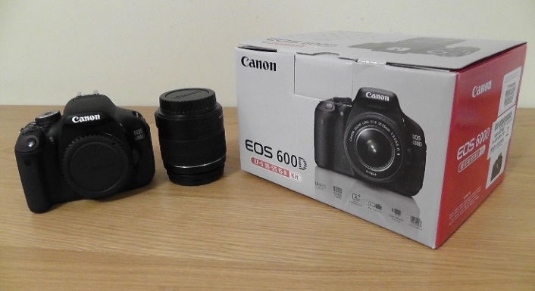

Figure : Canon EOS 600D DSLR Camera

1. **Visibility of system status**:

All the icons and buttons are designed in such a way so that it is visible to the users and also it is ease of users to use the camera. The users already know beforehand where they are and what they are doing because of the mode wheel, it directs the users on what mode he/she is currently.

2. **Match between system and the real world**:

The language used for the interface between user and the device is pretty much consistent with the real world language about which the users were already familiar with. The language used in the camera are like the on, off, manual, auto, delete, play, info, menu, settings and mode etc.

3. **User control and freedom**:

There is no back button feature in Canon EOS 600D DSLR Camera to undo the performed action. When user click into the camera settings, the way to get back to the main screen of the camera was not easy at all.

4. **Consistency and standards**:

The interface maintained consistency by using red light when the camera was not ready to take the picture as well as green light indicating that the camera is ready so that user can click the picture.

5. **Error prevention**:

There is always a confirmation box popping up every time whenever user wants to delete any picture or video from the camera. Additionally, there is also confirmation box popping up in the camera screen when user wants to switch off the camera which makes users to remain prevented from unwanted actions performed by mistake.

6. **Recognition rather than recall**:

Few icons used in the camera like the flash icon present on the mode wheel which is familiar to the user but few icons like the sports mode and portrait mode are not very familiar to the user. User has to google for the first time and then remember what the mode indicates for the next time.

7. **Flexibility and efficiency of use**:

One of the shortcut to zoom in or zoom out, and click a picture is the +/- button on the camera which has a set of predefined dimensions to choose from. Users were able to use the zoom dimensions manually by rotating the lens rather than using the user settings present in the camera’s main screen.

8. **Aesthetic and minimalist design**:

The design of the camera interface is aesthetic and minimalistic because of the many reasons. The wheels are used in order to minimize the use of a lot of buttons and prevent the interface from looking like a visual clutter. Also, the fonts and colors used in the camera are visible to users of any age group. Additionally, minimalist camera design makes easier for users to use and perform actions or else tasks given to them.

9. **Help users recognize, diagnose, and recover from errors**:

Canon EOS 600D Camera has built and designed in such a way that it shows few indications whenever the wrong mode is used by the user. Also, a weird sound comes from the lens when the camera does not click the picture. But these indications can be recognized only by an expert and also there is no feedback on how to recover from it.

10. **Help and Documentation**:

There is a button called guide which has few sample pictures and helps the user how to use the camera and click pictures, what modes can be used if the user wants a picture of the desired resolution and also there is a button called info which has all the camera related information that can be used by the user to get the relevant information he/she wants to know.