**USER AUTHENTICATION, FORM CREATION AND FORM VALIDATION**

**PROJECT**

**RUDRA NARAYAN BANJARA**

**[narayan.rudra28@gmail.com](mailto:narayan.rudra28@gmail.com)**

**Project Description**

This project is given to check the basic knowledge of PHP programming language. The main aim of the project is to create two PHP web pages i.e. index.php as a landing page and form.php to create a simple form that contain dynamic data, processing user data input through web forms and process GET and POST data. Dynamic data is displayed on the webpage using a programming language PHP.

This project has been developed using HTML, PHP and CSS. HTML has been used for front-end application development whereas PHP has been used to get dynamic data. Meanwhile styling is done to present webpages in more clear way through CSS.

**Development Environment**

* WAMP Server 3.0.0 - Windows web development environment.
* Operating System: Windows 10 Home, 64 Bit operating system, x64-based processor.
* Processor: Intel(R) Core(TM) i7
* Computer Environment: HP ENVY x360 laptop
* Scripting Languages: HTML5, PHP-5.6.16 and CSS3.
* Tools: Sublime Text Editor 3.

**Installation Instructions**

* Download the zipped project file (rbanjara_A20361827_p1.zip) from the blackboard and extract the zipped project file.
* If WAMP is not installed locally on your system, please install WAMP server from <http://www.wampserver.com/en/> . After installing WAMP server, start the WAMP server (start all services).
* Now, Move the extracted folder to the www folder of the WAMP system present in the C Drive. Run the web application locally (localhost) from the web browser, preferably Google. The URL in the browser should appear like this:

<http://localhost:8080/rbanjara_A20361827_p1/src/index.php>

* Parameter used for the index page GET request to see the dynamic name is name parameter i.e. $_GET['name'].
* The URL in the browser should appear like this to see the dynamic name:

<http://localhost:8080/rbanjara_A20361827_p1/src/index.php?name=rudra>

**Insights and Results**

* The main reason behind choosing this course is my love and passion for website design and development though I don’t like coding much.
* Creating the index.php didn’t took much time as the demo was already given by the professor in class lecture.
* Index page appears with a name when a GET parameter has been passed in the URL of the browser.



* When the page is loaded with no GET parameter in the URL:

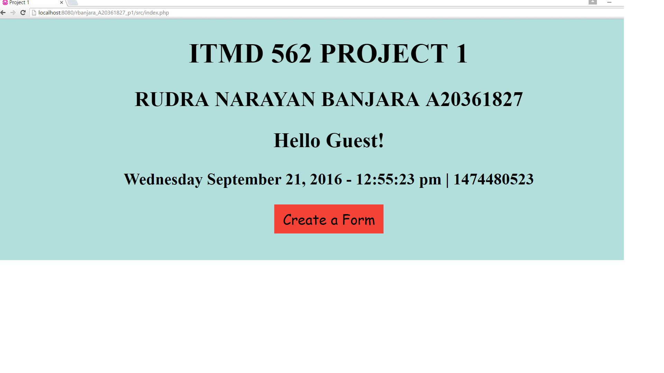

* The link to form.php webpage has been given as “Create a Form”, after clicking on the link it will redirected to form.php webpage.

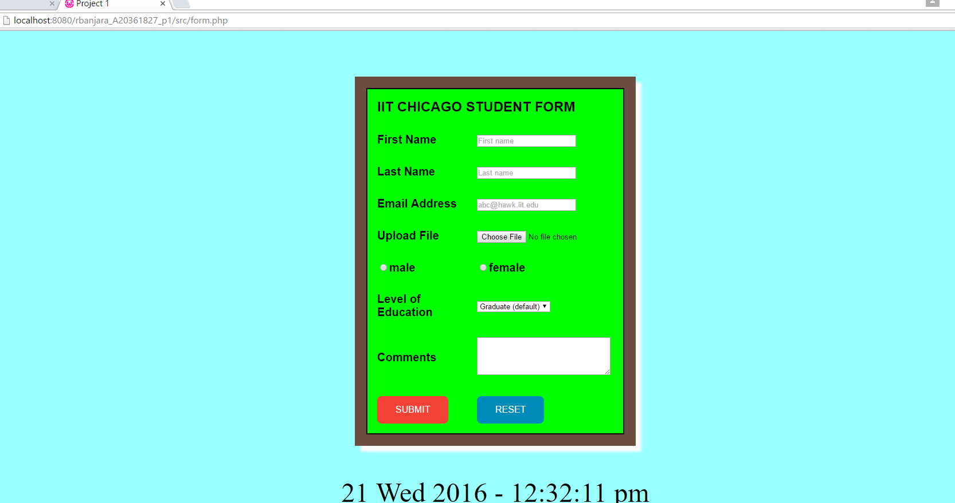

* Input validation has been done on first three input fields using PHP.

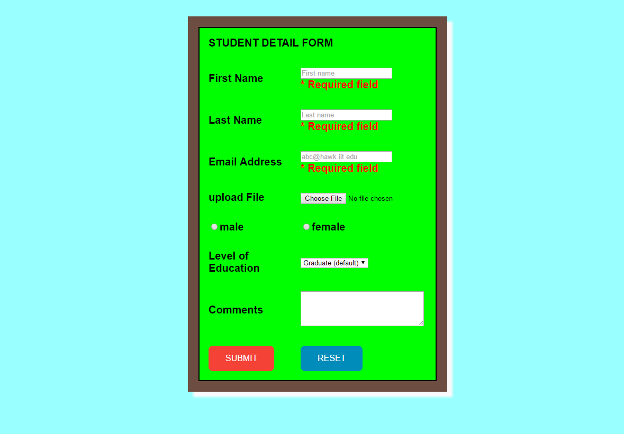

* During the development of the project, the most difficult task for me was to give a control structure to the PHP logic for the input validation. I went through couple of websites to figure out the problem.
* At the successful submission of the form, the dynamic data entered by the user has been displayed in the form of table.

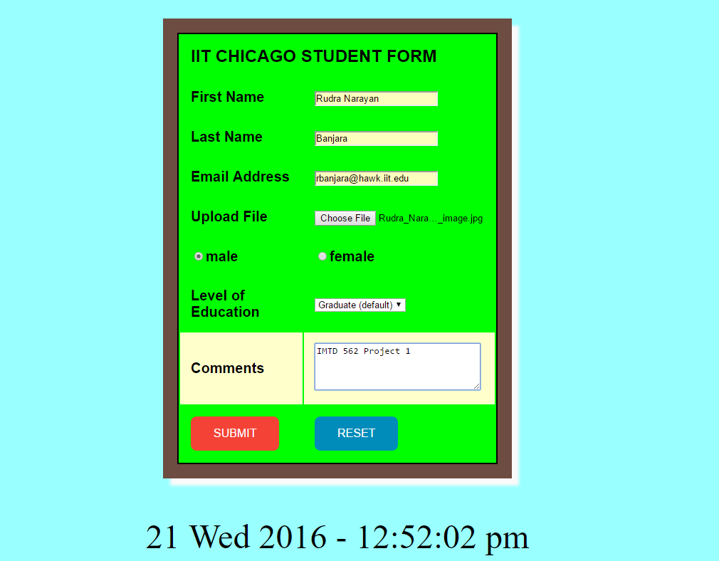

* Dynamic data display:

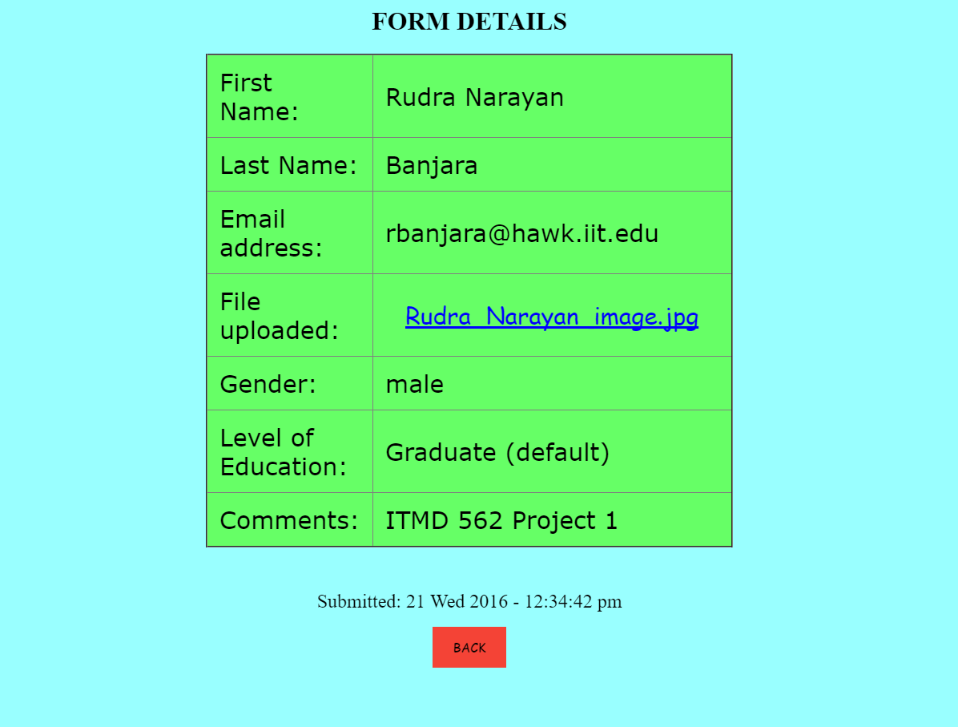

* Additionally, I faced problem during the completion of additional graduate requirement, file uploading and downloading. As, I didn’t try it earlier so this was something new experience for me. I went through couple of websites to check how to do file uploading and downloading in PHP, and managed to do it successfully.

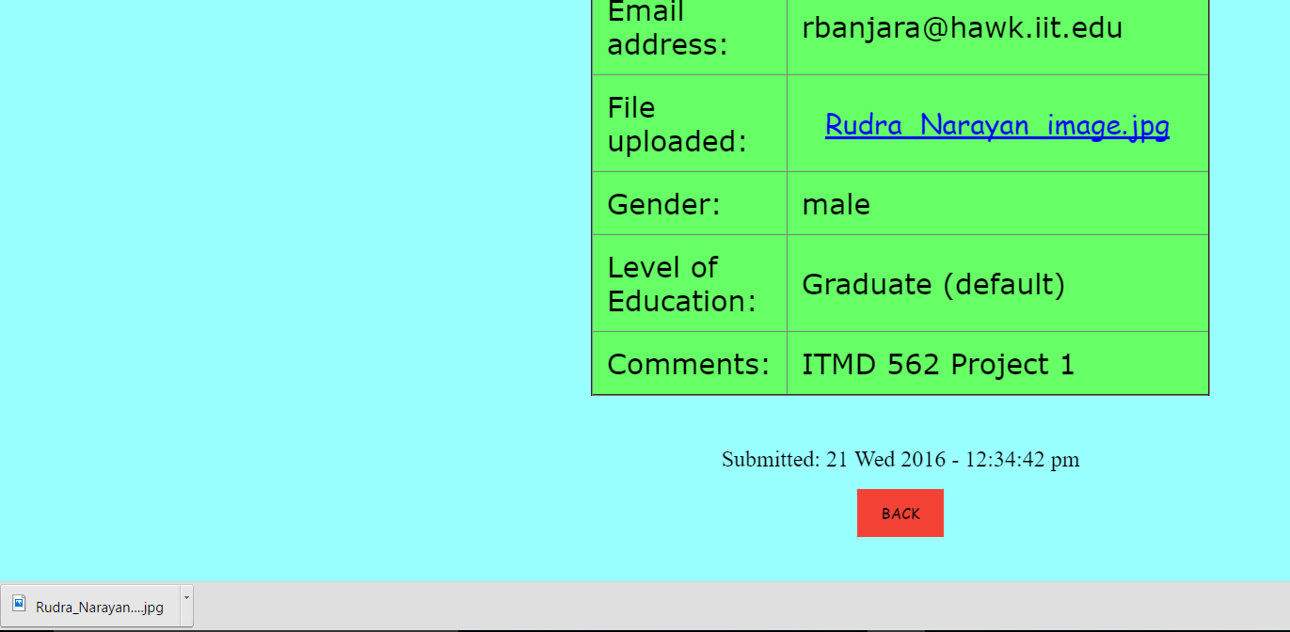

* The another difficult task for me was to figure out the problem for undefined index. Whenever I kept the input field blank, the form gets submitted but gives an error as undefined index.

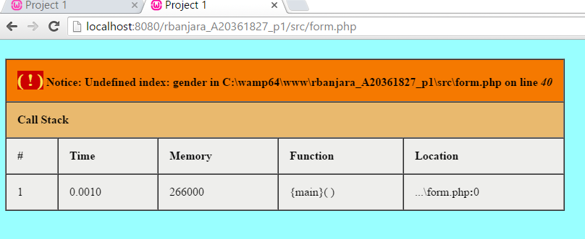

I looked in the discussion form, went through the suggestions and figured out the problem’s solution.

* Lastly, it was a great learning experience for me, my interest in the field of website design and development has been grown day by day and still I want to learn more.

**References**

* ITMD 562 Class lecture videos and demo given by the Prof. Brian Bailey.
* <http://www.w3schools.com/w3css/w3css_tables.asp>
* <http://www.w3schools.com/php/php_file_upload.asp>
* <http://www.w3schools.com/tags/att_a_download.asp>
* <http://webcheatsheet.com/php/file_upload.php>
* <http://stackoverflow.com/questions/10809937/undefined-index-with-post>

---------------------------------XXXXXXXXXXXXX--------------------------------------