Chittagong University of Engineering and Technology


Lab Report
Experiment No. 05: Analysis and Design of Micro-strip Patch Antenna.
Course: Body Sensor Network sessional (BME 422)
Prepared by:
Name: Rudra Chakraborty
ID: 2011026
Submitted to:
Ayesha Binth Humayun,
Lecturer
Department of Biomedical Engineering,CUET

Submission Date: March 29, 2026

Objectives:
Task 1:
In this task, the dimensions of the patch (length and width) were varied while keeping all other parameters constant as in the base case. Three cases were analyzed:
- Base Case: Original patch dimensions
- Increased Case: Patch dimensions increased by 100%
- Decreased Case: Patch dimensions reduced to 50% (since 100% decrease is not physically valid)
The ground plane size and feed position relation were kept consistent with the modified patch dimensions.
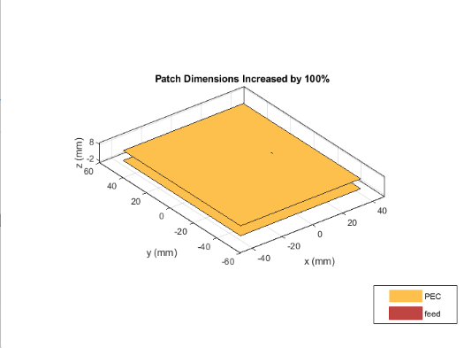
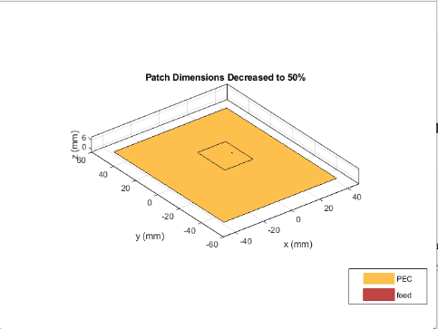
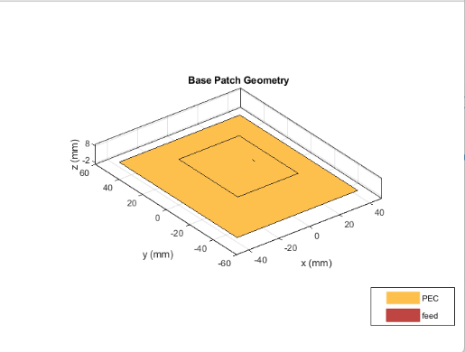

S-Parameter Analysis
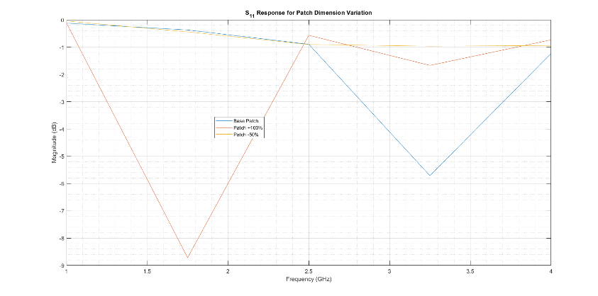
The reflection coefficient (S₁₁) was analyzed for all three cases over the frequency range of 1 GHz to 4 GHz using 5 frequency points.

Figure 4: S₁₁ Comparison for Patch Dimension Variation

Input Impedance Analysis
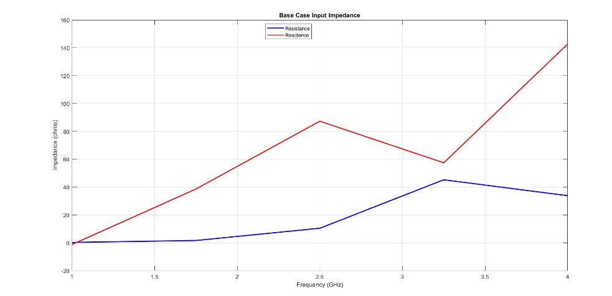
The input impedance of the base case antenna was also plotted to understand the matching characteristics.

Figure 5: Input Impedance of Base Case Antenna

1. Effect of Increasing Patch Dimensions
When the patch dimensions were increased:
- The resonant frequency shifted towards lower frequencies
- This happens because the effective electrical length of the antenna increases
- A larger patch behaves like a longer resonator → lower frequency resonance
From antenna theory:
$$f_{r}∝\frac{1}{L}$$
So increasing length results in decreasing resonant frequency

2. Effect of Decreasing Patch Dimensions
When the patch dimensions were reduced:
- The resonant frequency shifted towards higher frequencies
- Smaller patch → shorter electrical path → higher frequency resonance

3. Effect on S₁₁ (Reflection Coefficient)
- The matching condition changes significantly with patch size
- The minimum S₁₁ point (resonance) shifts:
  - Left (lower freq) for increased size
  - Right (higher freq) for decreased size
- Impedance mismatch may also increase if feed position is no longer optimal

4. Impedance Behavior
- The input impedance varies with patch size because:
  - The current distribution on the patch changes
  - The feed point relative to standing wave pattern changes
- Proper matching occurs only at specific dimensions
Conclusion
Changing the patch dimensions significantly affects the antenna’s resonant frequency and impedance chara -cteristics. Larger patches resonate at lower frequencies, while smaller patches resonate at higher frequencies. This demonstrates that patch size is a critical parameter in determining the operating frequency of a microstrip antenna.

Task 2: Ground Plane Variation
Observation
The variation in ground plane dimensions does not significantly shift the resonant frequency of the antenna. However, it has a noticeable impact on the reflection coefficient $S_{11}$, particularly on the depth of the curve, which reflects impedance matching quality.

Comparison of Cases
Increased Ground Plane (+100%)
The antenna with a larger ground plane exhibits a deeper $S_{11}$dip at lower frequencies. This indicates improved impedance matching due to a more stable and uniform current return path. The larger ground surface helps in better confinement of electromagnetic fields.
Decreased Ground Plane
When the ground plane size is reduced, the $S_{11}$magnitude becomes higher (closer to 0 dB), which indicates poorer matching. This occurs because the reduced ground plane disturbs the current distribution and increases edge effects, leading to higher reflections.

Analysis
The ground plane plays a crucial role in shaping the electromagnetic behavior of the antenna. While it does not directly control the resonant frequency like the patch dimensions, it strongly affects:
- impedance matching
- current return path
- fringing field distribution
A smaller ground plane leads to inefficient current flow and increased radiation losses, whereas a larger ground plane supports more stable antenna operation.

Conclusion
From the results, it can be concluded that the ground plane mainly influences the impedance matching and radiation efficiency rather than the resonant frequency. Increasing the ground plane size improves antenna performance by stabilizing current flow and reducing unwanted radiation effects, while decreasing it degrades overall performance.
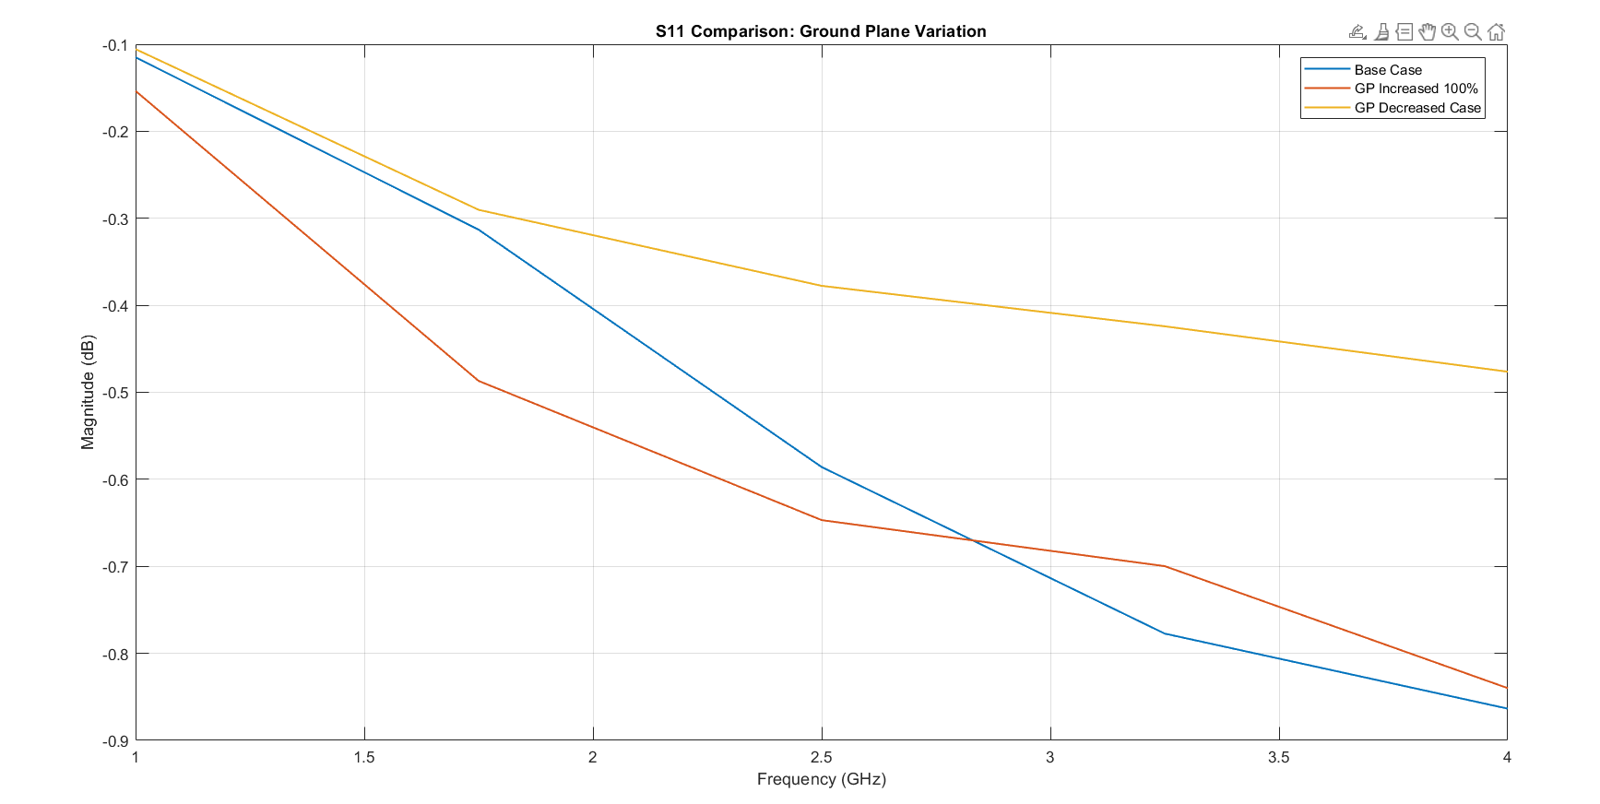

Task 3: Feed Offset Position Variation
In this task, the position of the feed point was varied while keeping all other antenna parameters unchanged from the base case. The objective was to observe how shifting the feed location affects the antenna performance.
Three cases were analyzed:
- Base Case: Feed located at the center of the patch
- Case 1: Feed moved towards the +X edge (near right edge)
- Case 2: Feed moved towards the −X edge (near left edge)
The feed was placed close to the edges (90% of half-length) instead of exactly at the edge to maintain a valid antenna structure.
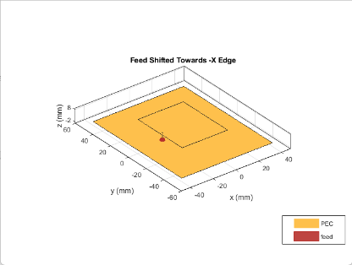
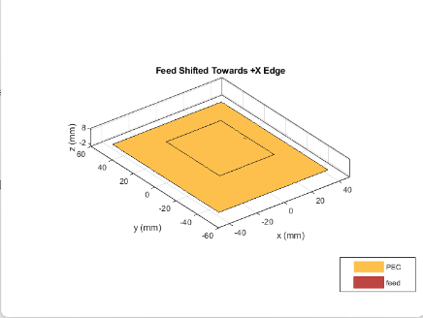
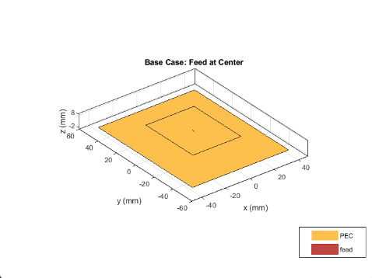

S-Parameter Analysis
The reflection coefficient $S_{11}$was evaluated for all three feed positions over the frequency range of 1 GHz to 4 GHz using 5 frequency points.
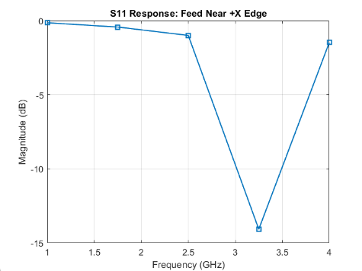
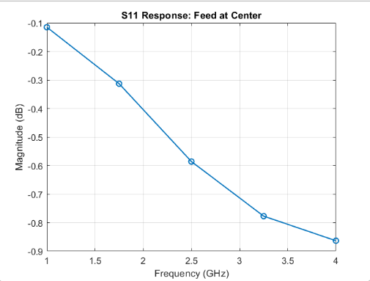
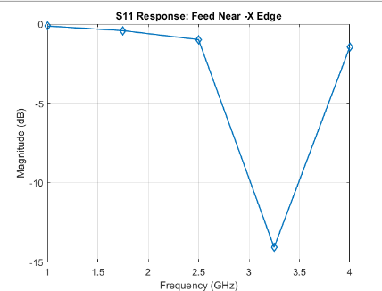

Explanation of Results

Effect of Feed Position on Antenna Performance
The feed position has a significant impact on the input impedance of the antenna, but it does not greatly affect the resonant frequency.
Base Case (Feed at Center)
- The feed at the center may not provide optimal impedance matching
- The current distribution at the center is not always suitable for efficient excitation
- As a result, the $S_{11}$may not reach a deep minimum
Feed Near Patch Edge (+X and −X)
When the feed is moved towards the edges:
- The impedance seen by the feed changes significantly
- The antenna may achieve better matching at certain positions
- The depth of the $S_{11}$curve changes, indicating improved or degraded matching
Both +X and −X shifts produce similar behavior because the patch is symmetric.

Antenna Theory Explanation
A microstrip patch antenna supports standing wave current distribution. The input impedance varies across the patch:
- Center → lower or mismatched impedance
- Edges → higher impedance
- Intermediate positions → optimal matching points
By moving the feed position, we effectively choose a different point on this impedance distribution.

Effect on S₁₁
From the plots:
- The resonant frequency remains nearly unchanged
- The depth of the S₁₁ curve changes, indicating variation in impedance matching
- Best performance occurs when feed position aligns with the antenna’s input impedance requirement (typically ~50 Ω)

Conclusion
The feed offset position plays a critical role in impedance matching of the microstrip patch antenna. While it does not significantly affect the resonant frequency, it strongly influences the reflection coefficient. Proper selection of the feed location ensures efficient power transfer and improved antenna performance.

Task 4: Feed Dimension Variation
In this task, the feed dimension of the patch microstrip antenna was changed while keeping all other antenna parameters fixed at the base-case values. Three cases were studied:
- Base case: original feed dimension
- Increased case: feed dimension increased by 50%
- Decreased case: feed dimension decreased by 50%
The goal was to examine how changing the feed size affects the impedance matching of the antenna.
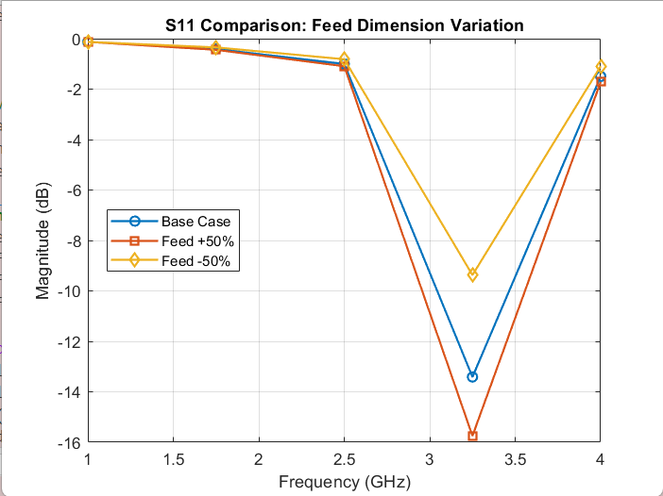

Observation
Changing the feed dimension mainly affects the depth of the S₁₁ curve, which indicates the quality of impedance matching. The resonant frequency does not change significantly, but the matching condition changes noticeably.
Increased feed dimension (+50%)
When the feed dimension is increased, the feed becomes wider. A wider feed line generally lowers the characteristic impedance and allows stronger coupling between the feed and the patch. Because of this:
- the matching condition may improve
- the reflection coefficient may become lower at resonance
- more power can be transferred from the source to the antenna
Decreased feed dimension (−50%)
When the feed dimension is decreased, the feed becomes narrower. A narrow feed line usually has a higher characteristic impedance, which can make impedance matching poorer. As a result:
- the reflection coefficient may increase
- less power is delivered efficiently to the patch
- mismatch losses become larger
Antenna perspective
The feed dimension controls how electromagnetic energy is coupled from the source into the radiating patch. Even though the patch size remains unchanged, modifying the feed width changes the input impedance seen at the port. Therefore, feed dimension is an important design parameter for proper impedance matching.
Conclusion
From this task, it can be concluded that changing the feed dimension affects the impedance matching of the antenna more than the resonant frequency. Increasing the feed dimension can improve coupling and matching, while decreasing it can lead to poorer matching and higher reflection. Hence, selecting an appropriate feed dimension is necessary for efficient antenna performance.

Task 5: Feed Model Variation
Observation
In this task, the feeding mechanism of the antenna was changed from a strip-type feed to a circular (coaxial) feed. This modification affects how energy is delivered from the source to the patch.

Comparison of Cases
Circular Feed:
The circular (coaxial) feed shows a deeper minimum in the $S_{11}$curve (approximately −7.2 dB). This indicates improved impedance matching and more efficient power transfer to the antenna.
Strip Feed:
The strip feed configuration produces a shallower dip in the $S_{11}$response (around −5.7 dB), which suggests comparatively weaker matching between the feed and the patch.

Analysis
The difference in performance arises due to the physical structure of the feed. Each feeding technique introduces different parasitic effects at the connection point:
- The circular feed provides a more localized and direct excitation
- The strip feed distributes the excitation along a transmission line
- These differences result in variations in inductive and capacitive effects
Because of this, the circular feed can sometimes provide a smoother transition of energy into the patch, leading to better impedance matching.

Conclusion
It can be concluded that the feed model significantly influences the antenna’s impedance characteristics. The circular feed in this case provides better matching compared to the strip feed, resulting in improved antenna efficiency. Therefore, selecting an appropriate feed structure is essential for optimizing antenna performance.
