EXP - 2
Aim: Convert an Infix expression to postfix expression using stack ADT.
Code:
#include <stdio.h>
#include <stdlib.h>
#include <string.h>
#include <ctype.h>
#define MAX 100
// Stack structure for characters
struct Stack {
int top;
char items[MAX];
};
// Initialize stack
void initStack(struct Stack* s) {
s->top = -1;
}
// Check if stack is full
int isFull(struct Stack* s) {
return s->top == MAX - 1;
}
// Check if stack is empty
int isEmpty(struct Stack* s) {
return s->top == -1;
}
// Push an element to stack
void push(struct Stack* s, char c) {
if (isFull(s)) {
printf("Stack Overflow\n");
return;
}
s->items[++(s->top)] = c;
}
// Pop an element from stack
char pop(struct Stack* s) {
if (isEmpty(s)) {
return -1;
}
return s->items[(s->top)--];
}
// Peek top element of stack
char peek(struct Stack* s) {
if (isEmpty(s)) {
return -1;
}
return s->items[s->top];
}
// Function to return precedence of operators
int precedence(char c) {
if (c == '^')
return 3;
else if (c == '*' || c == '/' || c == '%')
return 2;
else if (c == '+' || c == '-')
return 1;
else
return -1;
}
// Function to convert infix expression to postfix
void infixToPostfix(char* infix, char* postfix) {
struct Stack s;
initStack(&s);
int i, j = 0;
int len = strlen(infix);
for (i = 0; i < len; i++) {
char c = infix[i];
// If the scanned character is an operand, add it to output
if (isalnum(c)) {
postfix[j++] = c;
}
// If the scanned character is an '(', push it to the stack.
else if (c == '(') {
push(&s, c);
}
// If the scanned character is '(', pop and output from the stack
// until an '(' is encountered.
else if (c == ')') {
while (!isEmpty(&s) && peek(&s) != '(') {
postfix[j++] = pop(&s);
}
if (!isEmpty(&s) && peek(&s) == '(') {
pop(&s); // Remove '(' from stack
}
}
// An operator is encountered
else {
while (!isEmpty(&s) && precedence(c) <= precedence(peek(&s))) {
postfix[j++] = pop(&s);
}
push(&s, c);
}
}
// Pop all the remaining elements from the stack
while (!isEmpty(&s)) {
postfix[j++] = pop(&s);
}
postfix[j] = '\0';
}
int main() {
char infix[MAX];
char postfix[MAX];
printf("Enter infix expression: ");
if (fgets(infix, sizeof(infix), stdin) != NULL) {
// Remove newline character if present
size_t len = strlen(infix);
if (len > 0 && infix[len - 1] == '\n') {
infix[len - 1] = '\0';
}
}
// Echo scanned value
printf("%s\n", infix);
infixToPostfix(infix, postfix);
printf("Postfix expression: %s\n", postfix);
return 0;
}
Output:
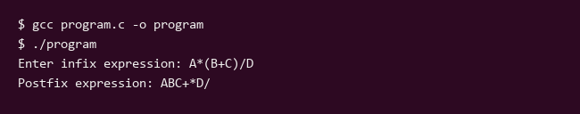

EXP - 3
Aim: Stack application using Array. WAP to check if an expression contains balanced brackets: (), {}, and [].
Code:
#include <stdio.h>
#include <stdlib.h>
#include <string.h>
#define MAX 100
struct Stack {
int top;
char items[MAX];
};
void initStack(struct Stack *s) {
s->top = -1;
}
int isEmpty(struct Stack *s) {
return s->top == -1;
}
void push(struct Stack *s, char c) {
if (s->top < MAX - 1) {
s->items[++(s->top)] = c;
}
}
char pop(struct Stack *s) {
if (!isEmpty(s)) {
return s->items[(s->top)--];
}
return '\0';
}
int isMatchingPair(char char1, char char2) {
if (char1 == '(' && char2 == ')')
return 1;
else if (char1 == '{' && char2 == '}')
return 1;
else if (char1 == '[' && char2 == ']')
return 1;
return 0;
}
int areBracketsBalanced(char expr[]) {
struct Stack s;
initStack(&s);
for (int i = 0; i < strlen(expr); i++) {
if (expr[i] == '(' || expr[i] == '{' || expr[i] == '[') {
push(&s, expr[i]);
}
if (expr[i] == ')' || expr[i] == '}' || expr[i] == ']') {
if (isEmpty(&s))
return 0;
else if (!isMatchingPair(pop(&s), expr[i]))
return 0;
}
}
return isEmpty(&s);
}
int main() {
char expr[MAX];
printf("Enter an expression: ");
if (fgets(expr, sizeof(expr), stdin) != NULL) {
expr[strcspn(expr, "\n")] = 0;
}
printf("Expression entered: %s\n", expr);
if (areBracketsBalanced(expr))
printf("The expression has balanced brackets.\n");
else
printf("The expression does not have balanced brackets.\n");
return 0;
}
Output:
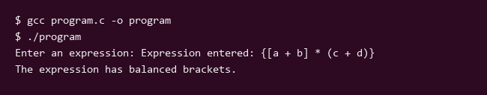

EXP - 4
Aim: Implement Linear Queue ADT using an array.
Code:
#include <stdio.h>
#include <stdlib.h>
#include <string.h>
#include <math.h>
#define MAX 5
typedef struct {
int id;
float temperature;
float humidity;
char condition[30];
} WeatherObservation;
typedef struct {
WeatherObservation items[MAX];
int front;
int rear;
} LinearQueue;
void initQueue(LinearQueue *q) {
q->front = -1;
q->rear = -1;
}
int isFull(LinearQueue *q) {
return q->rear == MAX - 1;
}
int isEmpty(LinearQueue *q) {
return q->front == -1 || q->front > q->rear;
}
void enqueue(LinearQueue *q, WeatherObservation obs) {
if (isFull(q)) {
printf("\nQueue Overflow! Cannot enqueue observation ID %d.\n", obs.id);
return;
}
if (q->front == -1) {
q->front = 0;
}
q->rear++;
q->items[q->rear] = obs;
printf("\nSuccessfully enqueued Weather Observation (ID: %d).\n", obs.id);
}
void dequeue(LinearQueue *q) {
if (isEmpty(q)) {
printf("\nQueue Underflow! Cannot dequeue observation.\n");
return;
}
WeatherObservation removed = q->items[q->front];
printf("\nDequeued Observation -> ID: %d, Temp: %.2f C, Humidity: %.2f%%, Condition: %s\n",
removed.id, removed.temperature, removed.humidity, removed.condition);
q->front++;
if (q->front > q->rear) {
q->front = -1;
q->rear = -1;
}
}
void peek(LinearQueue *q) {
if (isEmpty(q)) {
printf("\nQueue is empty! Nothing to peek.\n");
return;
}
WeatherObservation frontObs = q->items[q->front];
printf("\nFront Observation -> ID: %d, Temp: %.2f C, Humidity: %.2f%%, Condition: %s\n",
frontObs.id, frontObs.temperature, frontObs.humidity, frontObs.condition);
}
void display(LinearQueue *q) {
if (isEmpty(q)) {
printf("\nQueue is empty!\n");
return;
}
printf("\n--- Current Linear Queue Observations ---\n");
for (int i = q->front; i <= q->rear; i++) {
printf("Position %d | ID: %d | Temp: %.2f C | Humidity: %.2f%% | Condition: %s\n",
i - q->front + 1, q->items[i].id, q->items[i].temperature,
q->items[i].humidity, q->items[i].condition);
}
printf("-----------------------------------------\n");
}
int main() {
LinearQueue q;
initQueue(&q);
int choice;
while (1) {
printf("\n--- Weather Observation Linear Queue ADT ---\n");
printf("1. Enqueue Observation\n");
printf("2. Dequeue Observation\n");
printf("3. Peek Front Observation\n");
printf("4. Display Queue\n");
printf("5. Exit\n");
printf("Enter your choice: ");
if (scanf("%d", &choice) != 1) break;
printf("%d\n", choice);
if (choice == 1) {
WeatherObservation obs;
printf("Enter Observation ID: ");
scanf("%d", &obs.id);
printf("%d\n", obs.id);
printf("Enter Temperature (C): ");
scanf("%f", &obs.temperature);
printf("%.2f\n", obs.temperature);
printf("Enter Humidity (%%): ");
scanf("%f", &obs.humidity);
printf("%.2f\n", obs.humidity);
printf("Enter Condition (e.g., Sunny/Rainy): ");
scanf("%s", obs.condition);
printf("%s\n", obs.condition);
enqueue(&q, obs);
} else if (choice == 2) {
dequeue(&q);
} else if (choice == 3) {
peek(&q);
} else if (choice == 4) {
display(&q);
} else if (choice == 5) {
printf("Exiting program.\n");
break;
} else {
printf("Invalid choice! Please try again.\n");
}
}
return 0;
}
Output:
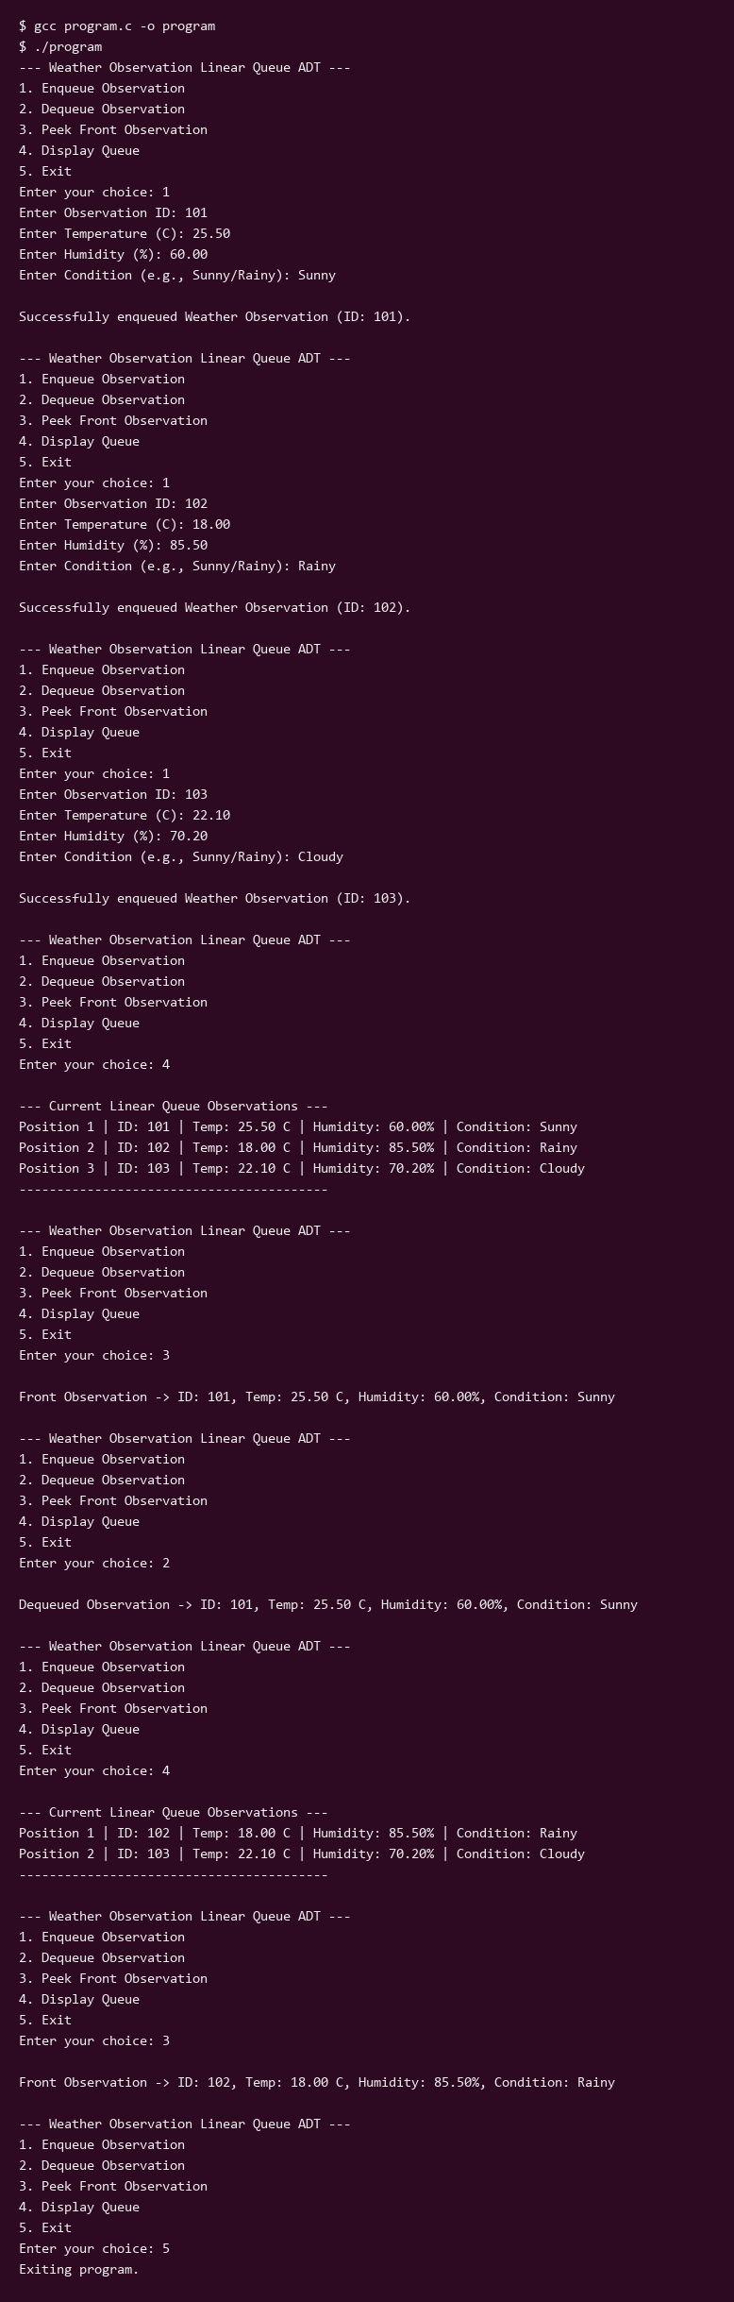

EXP - 5
Aim: Implementation of Circular Queue using Array
Code:
#include <stdio.h>
#include <stdlib.h>
#define MAX 5
int queue[MAX];
int front = -1;
int rear = -1;
int isFull() {
if ((front == 0 && rear == MAX - 1) || (front == rear + 1)) {
return 1;
}
return 0;
}
int isEmpty() {
if (front == -1) {
return 1;
}
return 0;
}
void enqueue(int value) {
if (isFull()) {
printf("Queue Overflow! Cannot insert %d\n", value);
return;
}
if (front == -1) {
front = 0;
rear = 0;
} else if (rear == MAX - 1 && front != 0) {
rear = 0;
} else {
rear++;
}
queue[rear] = value;
printf("Inserted %d\n", value);
}
void dequeue() {
if (isEmpty()) {
printf("Queue Underflow! Cannot delete\n");
return;
}
int value = queue[front];
printf("Deleted element: %d\n", value);
if (front == rear) {
front = -1;
rear = -1;
} else if (front == MAX - 1) {
front = 0;
} else {
front++;
}
}
void display() {
if (isEmpty()) {
printf("Queue is Empty\n");
return;
}
printf("Queue elements are: ");
if (rear >= front) {
for (int i = front; i <= rear; i++)
printf("%d ", queue[i]);
} else {
for (int i = front; i < MAX; i++)
printf("%d ", queue[i]);
for (int i = 0; i <= rear; i++)
printf("%d ", queue[i]);
}
printf("\n");
}
int main() {
int choice, val;
while (1) {
printf("\n--- Circular Queue Menu ---\n");
printf("1. Enqueue\n2. Dequeue\n3. Display\n4. Exit\n");
printf("Enter your choice: ");
if (scanf("%d", &choice) != 1) {
printf("Invalid input\n");
break;
}
printf("%d\n", choice);
switch (choice) {
case 1:
printf("Enter value to insert: ");
scanf("%d", &val);
printf("%d\n", val);
enqueue(val);
break;
case 2:
dequeue();
break;
case 3:
display();
break;
case 4:
printf("Exiting...\n");
return 0;
default:
printf("Invalid choice! Please try again.\n");
}
}
return 0;
}
Output:
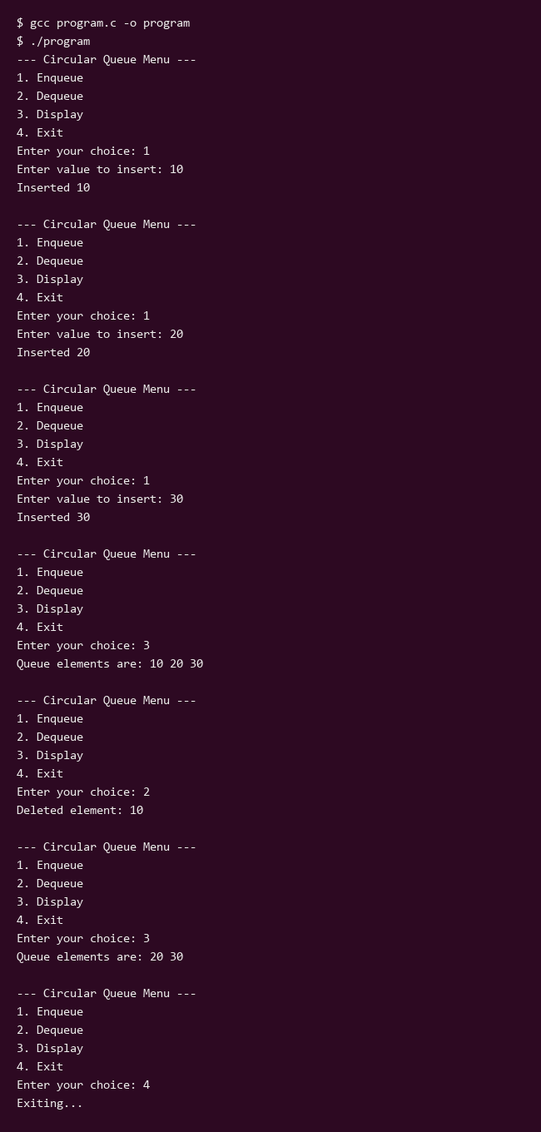

EXP - 6
Aim: Implement a Singly Linked List.
Code:
#include <stdio.h>
#include <stdlib.h>
#include <string.h>
#include <math.h>
// Define a structure for a weather record
struct WeatherRecord {
char city[50];
float temperature;
float humidity;
struct WeatherRecord* next;
};
// Function to create a new weather record node
struct WeatherRecord* createRecord(const char* city, float temperature, float humidity) {
struct WeatherRecord* newNode = (struct WeatherRecord*)malloc(sizeof(struct WeatherRecord));
if (newNode == NULL) {
printf("Memory allocation failed!\n");
exit(1);
}
strcpy(newNode->city, city);
newNode->temperature = temperature;
newNode->humidity = humidity;
newNode->next = NULL;
return newNode;
}
// Function to insert a record at the end of the linked list
void insertRecord(struct WeatherRecord** head, const char* city, float temperature, float humidity) {
struct WeatherRecord* newNode = createRecord(city, temperature, humidity);
if (*head == NULL) {
*head = newNode;
} else {
struct WeatherRecord* temp = *head;
while (temp->next != NULL) {
temp = temp->next;
}
temp->next = newNode;
}
}
// Function to display all weather records
void displayRecords(struct WeatherRecord* head) {
struct WeatherRecord* temp = head;
if (temp == NULL) {
printf("No weather records available.\n");
return;
}
printf("\n--- Weather Records ---\n");
int count = 1;
while (temp != NULL) {
printf("Record %d:\n", count++);
printf(" City: %s\n", temp->city);
printf(" Temperature: %.2f C\n", temp->temperature);
printf(" Humidity: %.2f %\n", temp->humidity);
temp = temp->next;
}
printf("-------------------------\n");
}
// Function to free allocated memory
void freeRecords(struct WeatherRecord* head) {
struct WeatherRecord* temp;
while (head != NULL) {
temp = head;
head = head->next;
free(temp);
}
}
int main() {
struct WeatherRecord* head = NULL;
int n, i;
char city[50];
float temp, hum;
printf("Enter the number of weather records to insert: ");
if (scanf("%d", &n) != 1) {
printf("Invalid input.\n");
return 1;
}
printf("%d\n", n);
for (i = 0; i < n; i++) {
printf("Enter city name for record %d: ", i + 1);
scanf("%49s", city);
printf("%s\n", city);
printf("Enter temperature (C) for %s: ", city);
scanf("%f", &temp);
printf("%.2f\n", temp);
printf("Enter humidity (%%) for %s: ", city);
scanf("%f", &hum);
printf("%.2f\n", hum);
insertRecord(&head, city, temp, hum);
}
displayRecords(head);
freeRecords(head);
return 0;
}
Output:
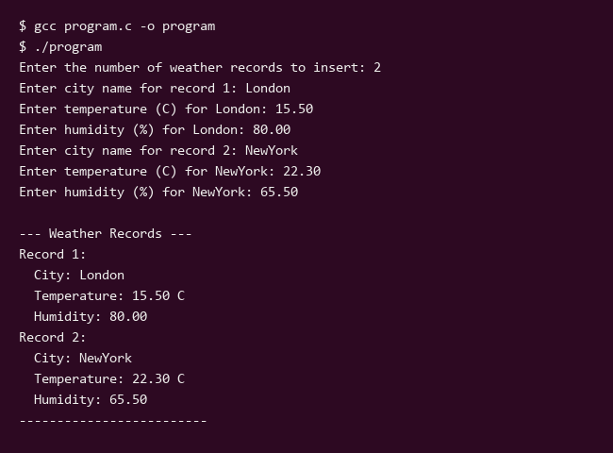

EXP - 7
Aim: Implement Doubly Linked List ADT.
Code:
#include <stdio.h>
#include <stdlib.h>
// Define the structure for a Doubly Linked List node
typedef struct Node {
int data;
struct Node* prev;
struct Node* next;
} Node;
// Function to create a new node
Node* createNode(int data) {
Node* newNode = (Node*)malloc(sizeof(Node));
if (!newNode) {
printf("Memory allocation failed!\n");
exit(1);
}
newNode->data = data;
newNode->prev = NULL;
newNode->next = NULL;
return newNode;
}
// Function to insert a node at the beginning
void insertAtBeginning(Node** head, int data) {
Node* newNode = createNode(data);
if (*head == NULL) {
*head = newNode;
} else {
newNode->next = *head;
(*head)->prev = newNode;
*head = newNode;
}
printf("Inserted %d at the beginning.\n", data);
}
// Function to insert a node at the end
void insertAtEnd(Node** head, int data) {
Node* newNode = createNode(data);
if (*head == NULL) {
*head = newNode;
} else {
Node* temp = *head;
while (temp->next != NULL) {
temp = temp->next;
}
temp->next = newNode;
newNode->prev = temp;
}
printf("Inserted %d at the end.\n", data);
}
// Function to delete a node by value
void deleteNode(Node** head, int key) {
if (*head == NULL) {
printf("List is empty, deletion failed.\n");
return;
}
Node* temp = *head;
// If the node to be deleted is the head node
if (temp->data == key) {
*head = temp->next;
if (*head != NULL) {
(*head)->prev = NULL;
}
free(temp);
printf("Deleted %d from the list.\n", key);
return;
}
// Traverse to find the node to be deleted
while (temp != NULL && temp->data != key) {
temp = temp->next;
}
if (temp == NULL) {
printf("Element %d not found in the list.\n", key);
return;
}
// Unlink the node
if (temp->next != NULL) {
temp->next->prev = temp->prev;
}
if (temp->prev != NULL) {
temp->prev->next = temp->next;
}
free(temp);
printf("Deleted %d from the list.\n", key);
}
// Function to display the list forwards
void displayForward(Node* head) {
if (head == NULL) {
printf("List is empty.\n");
return;
}
Node* temp = head;
printf("Forward Traversal: ");
while (temp != NULL) {
printf("%d <-> ", temp->data);
temp = temp->next;
}
printf("NULL\n");
}
// Function to display the list backwards
void displayBackward(Node* head) {
if (head == NULL) {
printf("List is empty.\n");
return;
}
Node* temp = head;
while (temp->next != NULL) {
temp = temp->next;
}
printf("Backward Traversal: ");
while (temp != NULL) {
printf("%d <-> ", temp->data);
temp = temp->prev;
}
printf("NULL\n");
}
int main() {
Node* head = NULL;
int choice, val;
do {
printf("\n--- Doubly Linked List Menu ---\n");
printf("1. Insert at Beginning\n");
printf("2. Insert at End\n");
printf("3. Delete Node\n");
printf("4. Display Forward\n");
printf("5. Display Backward\n");
printf("6. Exit\n");
printf("Enter your choice: ");
scanf("%d", &choice);
printf("Choice entered: %d\n", choice);
switch (choice) {
case 1:
printf("Enter value to insert at beginning: ");
scanf("%d", &val);
printf("Value entered: %d\n", val);
insertAtBeginning(&head, val);
break;
case 2:
printf("Enter value to insert at end: ");
scanf("%d", &val);
printf("Value entered: %d\n", val);
insertAtEnd(&head, val);
break;
case 3:
printf("Enter value to delete: ");
scanf("%d", &val);
printf("Value entered: %d\n", val);
deleteNode(&head, val);
break;
case 4:
displayForward(head);
break;
case 5:
displayBackward(head);
break;
case 6:
printf("Exiting program.\n");
break;
default:
printf("Invalid choice! Please try again.\n");
}
} while (choice != 6);
// Free remaining nodes
Node* current = head;
while (current != NULL) {
Node* next = current->next;
free(current);
current = next;
}
return 0;
}
Output:
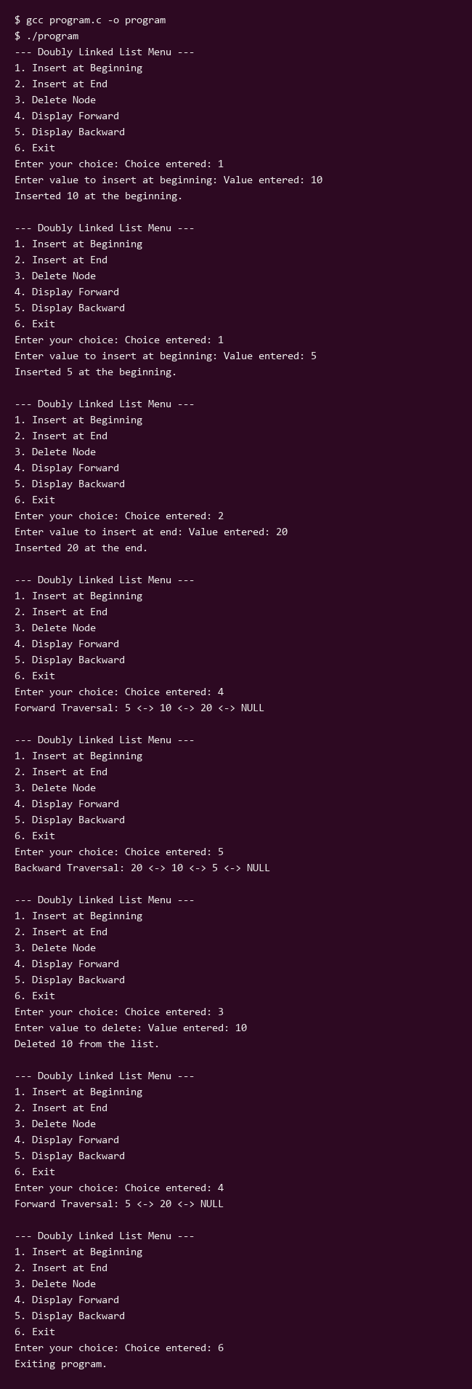

EXP - 8
Aim: Binary search tree ADT
Code:
#include <stdio.h>
#include <stdlib.h>
typedef struct Node {
int data;
struct Node* left;
struct Node* right;
} Node;
Node* createNode(int value) {
Node* newNode = (Node*)malloc(sizeof(Node));
if (!newNode) {
printf("Memory allocation failed!\n");
exit(1);
}
newNode->data = value;
newNode->left = NULL;
newNode->right = NULL;
return newNode;
}
Node* insert(Node* root, int value) {
if (root == NULL) {
return createNode(value);
}
if (value < root->data) {
root->left = insert(root->left, value);
} else if (value > root->data) {
root->right = insert(root->right, value);
}
return root;
}
void inorder(Node* root) {
if (root != NULL) {
inorder(root->left);
printf("%d ", root->data);
inorder(root->right);
}
}
void preorder(Node* root) {
if (root != NULL) {
printf("%d ", root->data);
preorder(root->left);
preorder(root->right);
}
}
void postorder(Node* root) {
if (root != NULL) {
postorder(root->left);
postorder(root->right);
printf("%d ", root->data);
}
}
Node* search(Node* root, int key) {
if (root == NULL || root->data == key) {
return root;
}
if (key < root->data) {
return search(root->left, key);
}
return search(root->right, key);
}
Node* findMin(Node* root) {
while (root && root->left != NULL) {
root = root->left;
}
return root;
}
Node* deleteNode(Node* root, int key) {
if (root == NULL) return root;
if (key < root->data) {
root->left = deleteNode(root->left, key);
} else if (key > root->data) {
root->right = deleteNode(root->right, key);
} else {
if (root->left == NULL) {
Node* temp = root->right;
free(root);
return temp;
} else if (root->right == NULL) {
Node* temp = root->left;
free(root);
return temp;
}
Node* temp = findMin(root->right);
root->data = temp->data;
root->right = deleteNode(root->right, temp->data);
}
return root;
}
int main() {
Node* root = NULL;
int choice, val;
while (1) {
printf("\n--- Binary Search Tree ADT ---\n");
printf("1. Insert\n2. Inorder Traversal\n3. Preorder Traversal\n4. Postorder Traversal\n5. Search\n6. Delete\n7. Exit\n");
printf("Enter your choice: ");
if (scanf("%d", &choice) != 1) break;
printf("%d\n", choice);
switch (choice) {
fn_insert:
case 1:
printf("Enter value to insert: ");
scanf("%d", &val);
printf("%d\n", val);
root = insert(root, val);
printf("Inserted %d into BST.\n", val);
break;
case 2:
printf("Inorder Traversal: ");
inorder(root);
printf("\n");
break;
case 3:
printf("Preorder Traversal: ");
preorder(root);
printf("\n");
break;
case 4:
printf("Postorder Traversal: ");
postorder(root);
printf("\n");
break;
case 5:
printf("Enter value to search: ");
scanf("%d", &val);
printf("%d\n", val);
if (search(root, val) != NULL) {
printf("Value %d found in BST.\n", val);
} else {
printf("Value %d not found in BST.\n", val);
}
break;
case 6:
printf("Enter value to delete: ");
scanf("%d", &val);
printf("%d\n", val);
root = deleteNode(root, val);
printf("Deleted %d (if it existed).\n", val);
break;
case 7:
printf("Exiting...\n");
exit(0);
default:
printf("Invalid choice! Please try again.\n");
}
}
return 0;
}
Output:
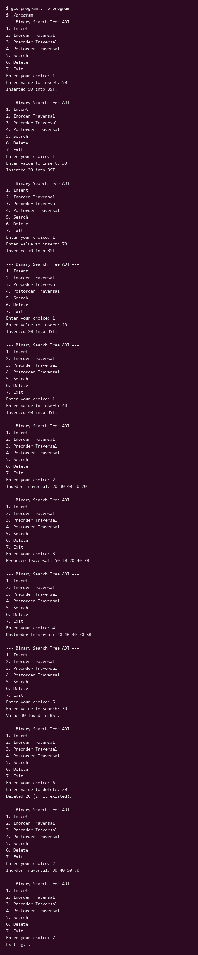

EXP - 9
Aim: Graph Traversal Techniques
Code:
#include <stdio.h>
#include <stdlib.h>
#include <string.h>
#define MAX_STATIONS 100
// Structure to represent an adjacency list node
struct Node {
int vertex;
struct Node* next;
};
// Structure to represent the graph
struct Graph {
int numVertices;
struct Node* adjLists[MAX_STATIONS];
int visited[MAX_STATIONS];
};
// Create a node
struct Node* createNode(int v) {
struct Node* newNode = (struct Node*)malloc(sizeof(struct Node));
newNode->vertex = v;
newNode->next = NULL;
return newNode;
}
// Create a graph
struct Graph* createGraph(int vertices) {
struct Graph* graph = (struct Graph*)malloc(sizeof(struct Graph));
graph->numVertices = vertices;
int i;
for (i = 0; i < vertices; i++) {
graph->adjLists[i] = NULL;
graph->visited[i] = 0;
}
return graph;
}
// Add edge
void addEdge(struct Graph* graph, int src, int dest) {
// Add edge from src to dest
struct Node* newNode = createNode(dest);
newNode->next = graph->adjLists[src];
graph->adjLists[src] = newNode;
// Add edge from dest to src (undirected graph)
newNode = createNode(src);
newNode->next = graph->adjLists[dest];
graph->adjLists[dest] = newNode;
}
// DFS function
void DFS(struct Graph* graph, int vertex) {
struct Node* adjList = graph->adjLists[vertex];
struct Node* temp = adjList;
graph->visited[vertex] = 1;
printf("%d ", vertex);
while (temp != NULL) {
int connectedVertex = temp->vertex;
if (graph->visited[connectedVertex] == 0) {
DFS(graph, connectedVertex);
}
temp = temp->next;
}
}
// BFS function
void BFS(struct Graph* graph, int startVertex) {
// Reset visited array for BFS
int i;
for (i = 0; i < graph->numVertices; i++) {
graph->visited[i] = 0;
}
int queue[MAX_STATIONS];
int front = 0, rear = 0;
graph->visited[startVertex] = 1;
queue[rear++] = startVertex;
while (front < rear) {
int currentVertex = queue[front++];
printf("%d ", currentVertex);
struct Node* temp = graph->adjLists[currentVertex];
while (temp) {
int adjVertex = temp->vertex;
if (graph->visited[adjVertex] == 0) {
graph->visited[adjVertex] = 1;
queue[rear++] = adjVertex;
}
temp = temp->next;
}
}
}
int main() {
int vertices, edges, i;
int src, dest, startVertex;
printf("Enter number of weather stations: ");
if (scanf("%d", &vertices) != 1) return 0;
printf("%d\n", vertices);
struct Graph* graph = createGraph(vertices);
printf("Enter number of connections (edges): ");
if (scanf("%d", &edges) != 1) return 0;
printf("%d\n", edges);
printf("Enter connections (source destination) for each edge:\n");
for (i = 0; i < edges; i++) {
if (scanf("%d %d", &src, &dest) != 1) break;
printf("%d %d\n", src, dest);
addEdge(graph, src, dest);
}
printf("Enter starting weather station for traversal: ");
if (scanf("%d", &startVertex) != 1) return 0;
printf("%d\n", startVertex);
printf("Depth First Search (DFS) starting from station %d:\n", startVertex);
// Reset visited array for DFS
for (i = 0; i < vertices; i++) {
graph->visited[i] = 0;
}
DFS(graph, startVertex);
printf("\n");
printf("Breadth First Search (BFS) starting from station %d:\n", startVertex);
BFS(graph, startVertex);
printf("\n");
return 0;
}
Output:
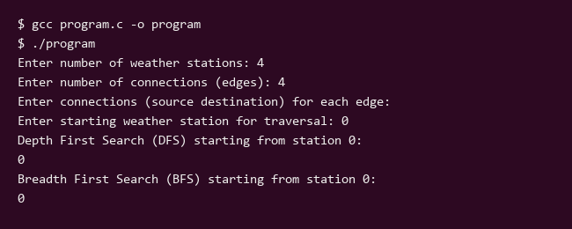

EXP - 10
Aim: To find an element in an sorted array using binary search technique.
Code:
#include <stdio.h>
#include <stdlib.h>
// Function to perform binary search
int binarySearch(int arr[], int size, int target) {
int low = 0;
int high = size - 1;
while (low <= high) {
int mid = low + (high - low) / 2;
if (arr[mid] == target) {
return mid;
}
if (arr[mid] < target) {
low = mid + 1;
} else {
high = mid - 1;
}
}
return -1;
}
int main() {
int n, i, target, result;
printf("Enter the number of elements in the sorted array: ");
scanf("%d", &n);
printf("%d\n", n);
if (n <= 0 || n > 100) {
printf("Invalid array size.\n");
return 0;
}
int arr[100];
printf("Enter %d elements in sorted order:\n", n);
for (i = 0; i < n; i++) {
scanf("%d", &arr[i]);
printf("%d ", arr[i]);
}
printf("\n");
printf("Enter the element to search: ");
scanf("%d", &target);
printf("%d\n", target);
result = binarySearch(arr, n, target);
if (result != -1) {
printf("Element %d found at index %d.\n", target, result);
} else {
printf("Element %d not found in the array.\n", target);
}
return 0;
}
Output:
