Practical - 1 | AIM: Linux System Administration and File Management for  Marketing Analytics Team
Problem Definition | Scenario: You have recently joined DataAnalytics Inc. as a Linux System Administrator. The company runs its analytics platform on Linux servers where project data, reports, scripts, and user accounts must be managed efficiently.  Your manager has assigned you the responsibility of setting up the project environment, managing files and directories, monitoring system resources, securing data, and creating backups for the Marketing Analytics team.  Tasks:  - Identify the current user.  - Find the current working directory.  - Display system information.  - Check system uptime and date.  - Create a directory named MarketingAnalytics.  - Create subdirectories: RawData, ProcessedData, Reports.  - Create data and report files.  - Add sample content.  - Display file contents.  - List all files and directories.  - Search for report files.  - Search specific content inside files.  - Copy report files to Backup directory.  - Rename files.  - Move files between directories.  - Delete a file.  - Delete an empty directory.
Implementation | Tasks:  - Identify the current user.  - whoami  2. Find the current working directory.  - pwd  3. Display system information.  - uname -a

- Check system uptime and date.
  - uptime
  - date

5. Create a directory named MarketingAnalytics.
- mkdir MarketingAnalytics

- Create subdirectories: RawData, ProcessedData, Reports.
  - mkdir MarketingAnalytics/RawData
  - mkdir MarketingAnalytics/ProcessedData
  - mkdir MarketingAnalytics/Reports

- Create data and report files.
  - touch MarketingAnalytics/RawData/sales_data.csv
  - touch MarketingAnalytics/RawData/sales_data.c
  - touch MarketingAnalytics/Reports/campaign_report.txt
  - touch MarketingAnalytics/Reports/monthly_report.txt
  - touch MarketingAnalytics/Reports/summary.txt

- Add sample content.
  - echo "Campaign Report for July 2026" > MarketingAnalytics/Reports/campaign_report.txt

  - echo "Monthly Marketing Report - July 2026 Total
Campaigns Run: 8 Total Leads Generated: 1450 Conversion Rate: 12.3%" > MarketingAnalytics/Reports/monthly_report.txt

  - echo "Raw Sales Data" >
MarketingAnalytics/RawData/sales_data.csv

  - echo "#include<stdio.h>" > MarketingAnalytics/RawData/sales_data.c

  - echo "Summary of Marketing Campaign" >
MarketingAnalytics/Reports/summary.txt

9. Display file contents.
- cat MarketingAnalytics/Reports/campaign_report.txt

10. List all files and directories.
- ls -R

11. Search for report files.
- find MarketingAnalytics -name "*.txt"

12. Search specific content inside files.
- grep "Marketing" -R MarketingAnalytics

- Copy report files to Backup directory.
  - mkdir MarketingAnalytics/Backup

  - cp
MarketingAnalytics/Reports/campaign_report.txt MarketingAnalytics/Backup/

  - cp
MarketingAnalytics/Reports/monthly_report.txt MarketingAnalytics/Backup/

14. Rename files.
- mv MarketingAnalytics/Backup/monthly_report.txt MarketingAnalytics/Backup/monthly_report_July2026.tx t

15. Move files between directories.
- mv MarketingAnalytics/RawData/sales_data.csv MarketingAnalytics/ProcessedData/

16. Delete a file.
- rm MarketingAnalytics/Reports/summary.txt

- Delete an empty directory.
  - mkdir MarketingAnalytics/Temp
  - rmdir MarketingAnalytics/Temp
Output | - Identify the current user  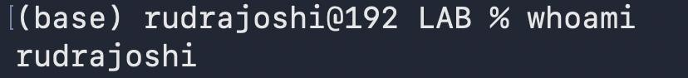  - Find the current working directory.

- Display system information.

- Check system uptime and date.
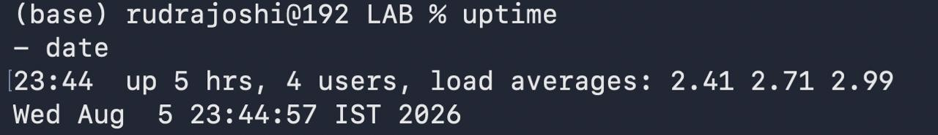

- Create a directory named MarketingAnalytics.

- Create subdirectories: RawData, ProcessedData, Reports.

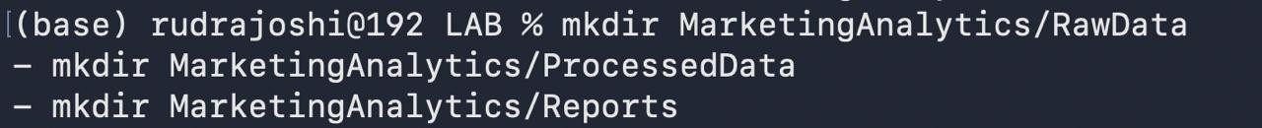

- Create data and report files.

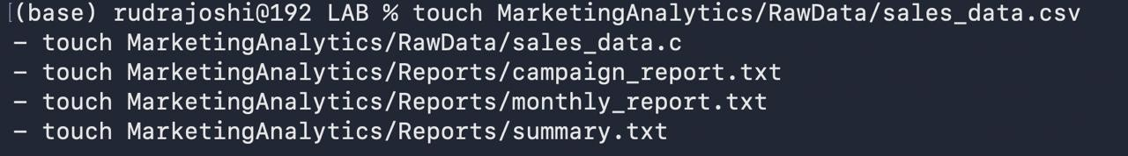

- Add sample content.
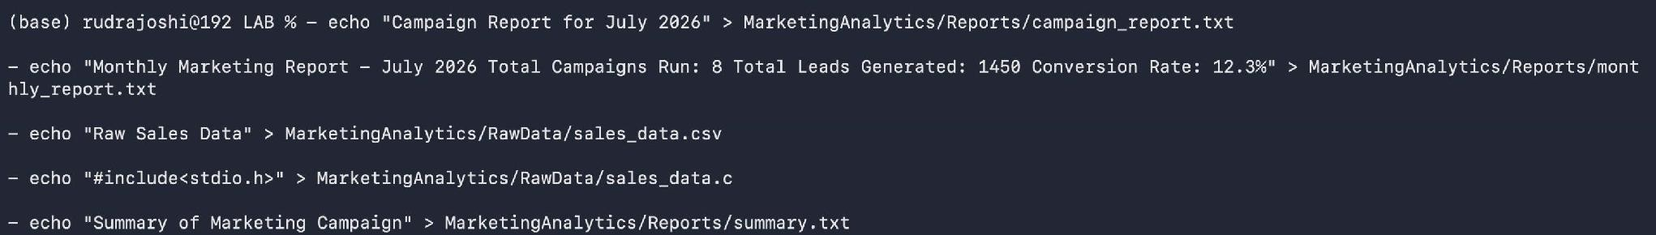

- Display file contents.

- List all files and directories.

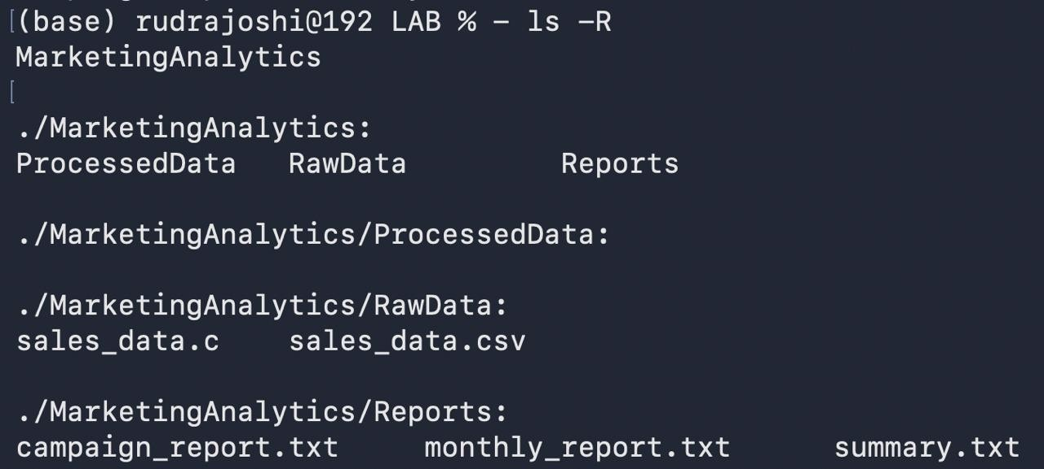

- Search for report files.

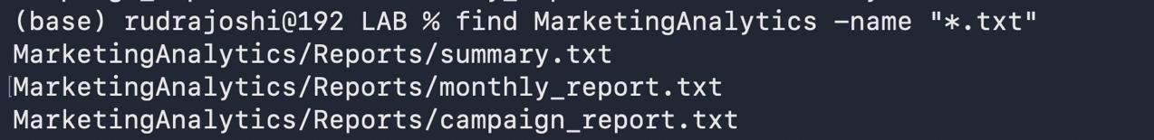

- Search specific content inside files.

- Copy report files to Backup directory.

- Rename files.

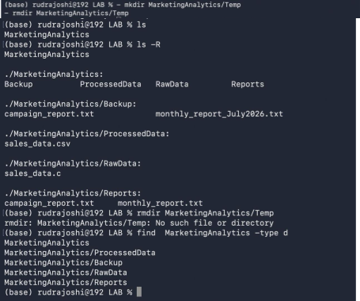

- Move files between directories.

- Delete a file.

- Delete an empty directory.

Key Questions / Analysis | Q1. What is the difference between absolute and relative paths? Answer:  An absolute path specifies the complete location of a file or directory starting from the root (/). A relative path specifies the location  relative to the current working directory.  Q2. Why are Linux permissions important for file security? Answer:  Linux permissions control who can read, write, or execute files and directories. They help protect data from unauthorized access, modification, or deletion.

Q3. What is the purpose of the grep command? Answer:
The grep command is used to search for specific text or patterns within one or more files. It helps quickly locate required information.

Q4. How does Linux support efficient file management? Answer:
Linux provides commands to create, copy, move, rename, search, and delete files and directories, making file management simple, organized, and efficient.

Q5. Why are backups important in enterprise environments? Answer:
Backups protect important data from accidental deletion, hardware failures, cyberattacks, or system crashes. They ensure data can be restored when needed, supporting business continuity.
Summary | This practical demonstrated the use of basic Linux system administration and file management commands for a Marketing Analytics project. It included identifying the current user, checking system information, creating directories and files, adding and viewing file contents, searching for files and text, copying, renaming, moving, and deleting files and directories, and organizing project data efficiently using Linux commands. The practical provided hands-on experience in managing files and directories in a Linux environment, which is essential for data analytics and system administration.

