CHAROTAR UNIVERSITY OF SCIENCE & TECHNOLOGY
Faculty of Technology & Engineering
Devang Patel Institute of Advance Technology and Research (DEPSTAR)
CSUE301 – Big Data Analytics
Practical File – ODD Semester 2026-27
Student ID: 24DIT025
Student Name: Rudra Joshi

Practical 10

1. Problem Definition
RetailEdge Analytics wants to segment a large number of customers according to their purchasing behaviour. Traditional single-node K-Means algorithms may face memory and scalability limitations when processing very large datasets.
In this practical, Apache Spark MLlib is used to implement Parallel K-Means clustering for customer segmentation.
Customer transaction data is processed to extract meaningful behavioural features such as:
- Total Spend
- Purchase Frequency
- Average Basket Size
- Recency
These features are normalized using StandardScaler and clustered using Spark MLlib K-Means with k = 5 clusters.
The clustering quality is evaluated using WSSSE, and the Elbow Method is used to compare different values of k. Customer segments are then interpreted based on their purchasing behaviour.

2. Part A — Practical Execution

Step 1: Creating Folder and Files
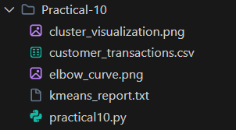

Step 2: Creating Spark Session
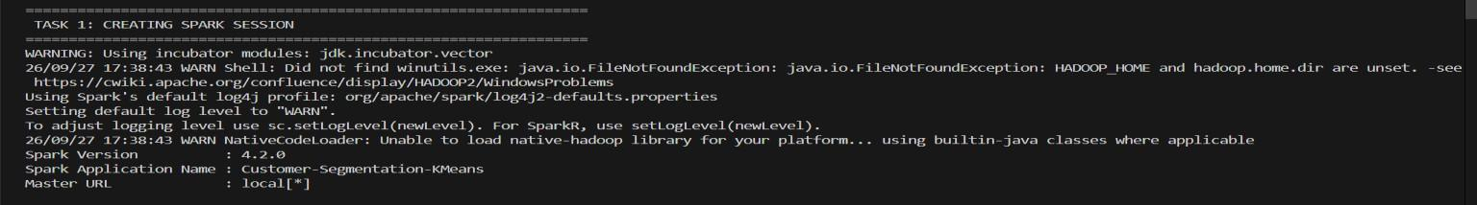

Step 3: Dataset Description
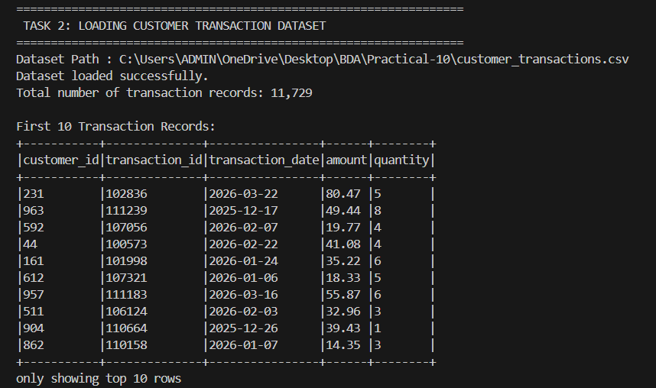

Step 4: Dataset Schema and Structure
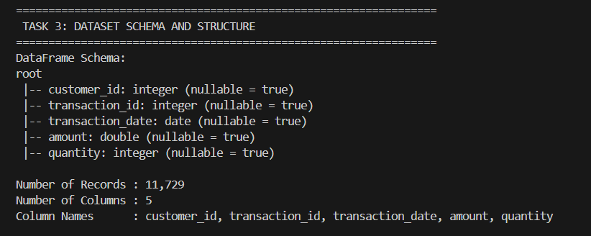

Step 5: Data Preprocessing
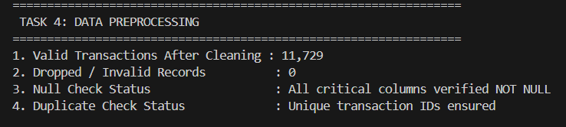

Step 6: Customer Feature Extraction
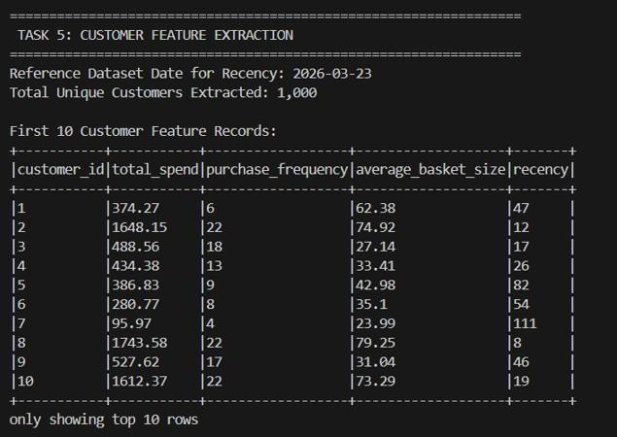

Step 7: Feature Vector Assembly
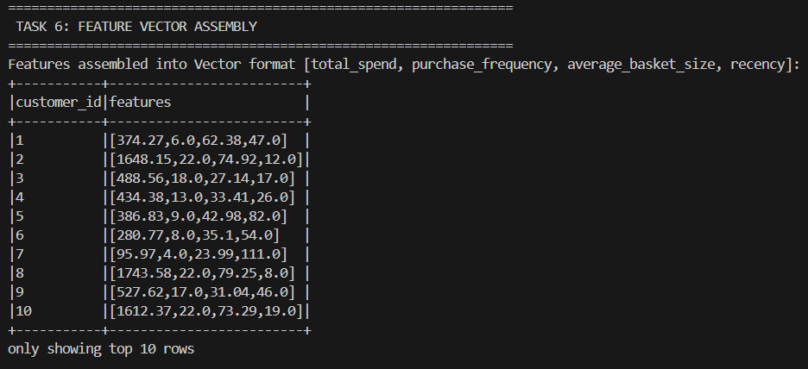

Step 8: Feature Scaling
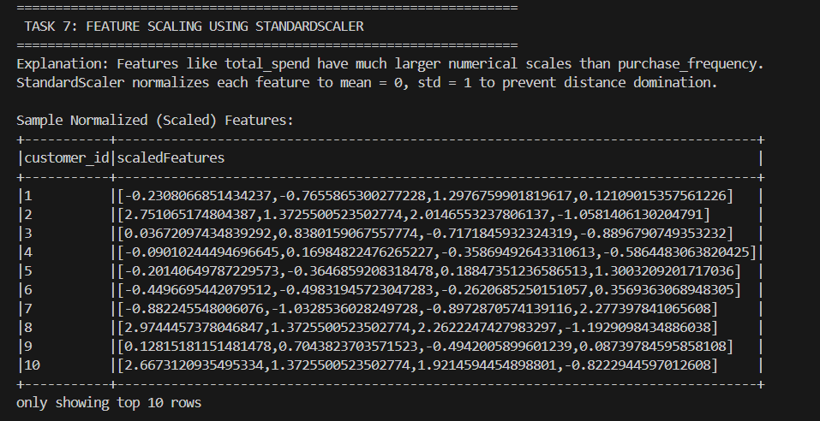

Step 9: Parallel K-Means
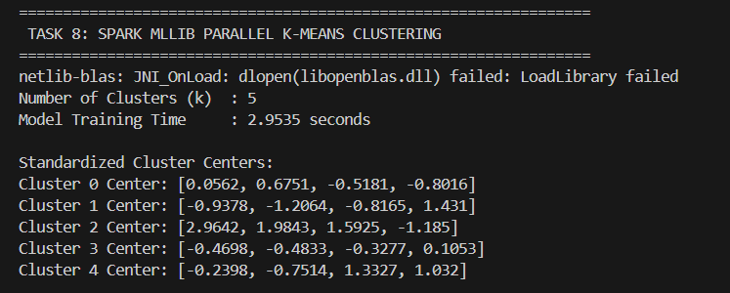

Step 10: WSSSE
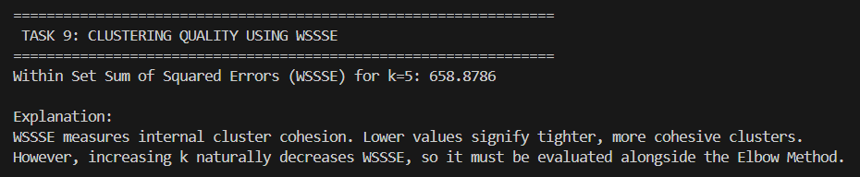

Step 11: Customer Cluster Assignment
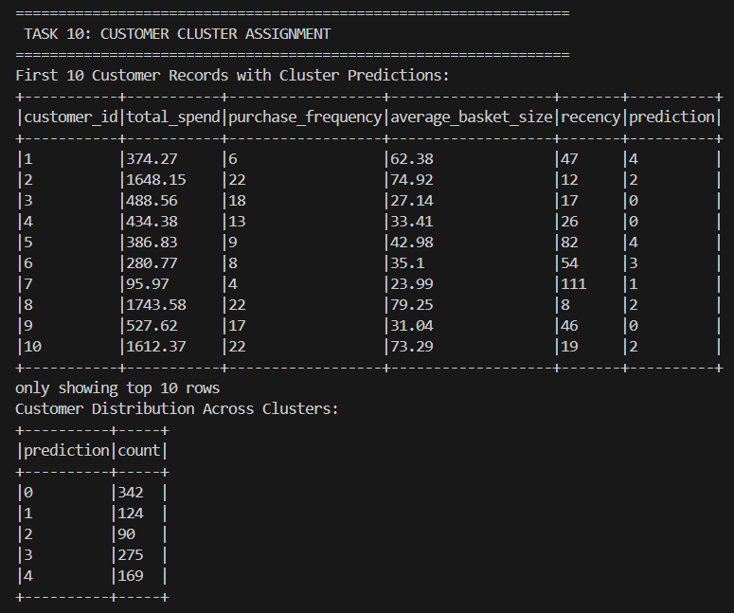

Step 12: Cluster Centers & Segment Summary
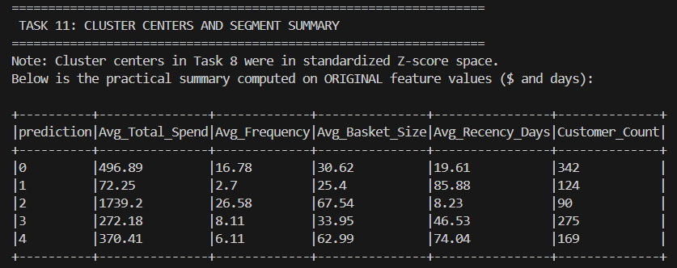

Step 13: Customer Segment Interpretation
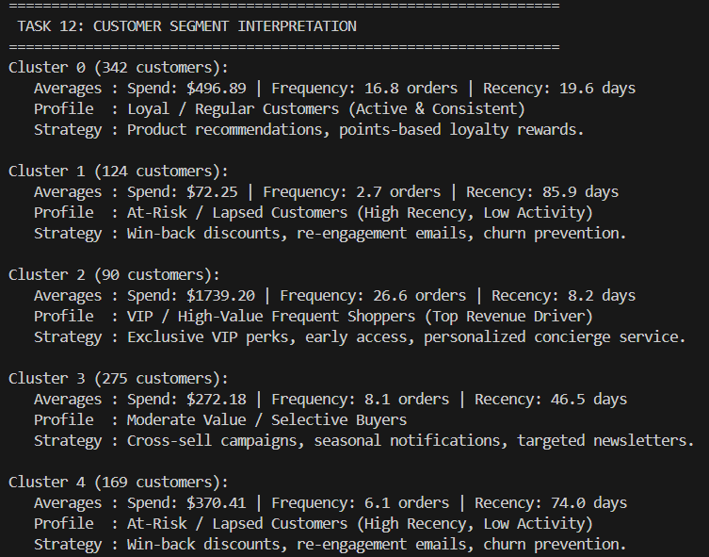

Step 14: Elbow Method
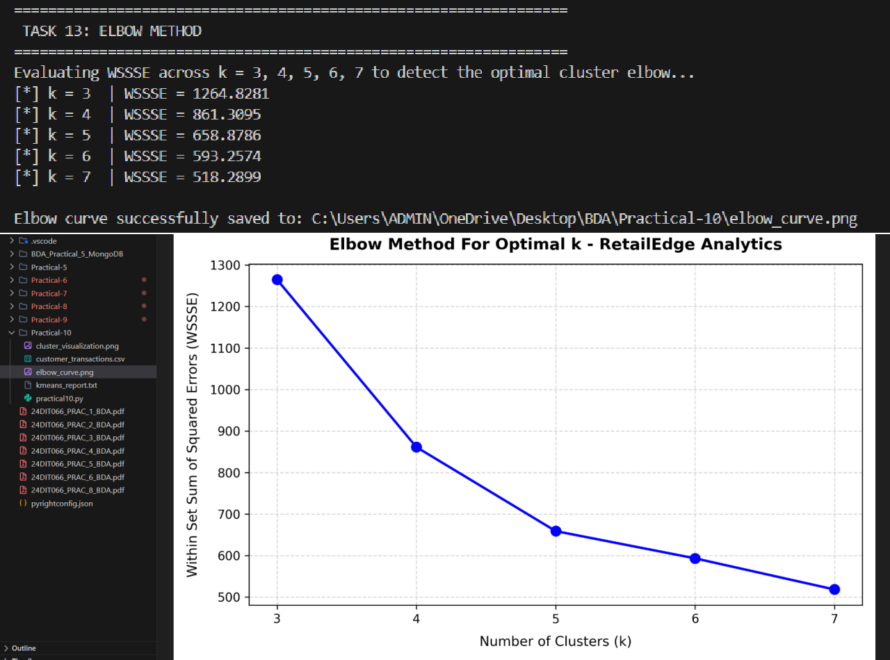

Step 15: K=3 vs K=5 vs K=7
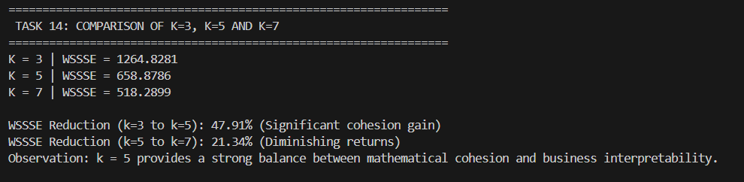

Step 16: Bisecting K-Means
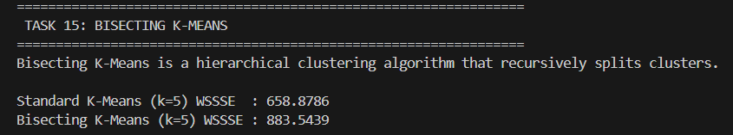

Step 17: Single Node vs Spark
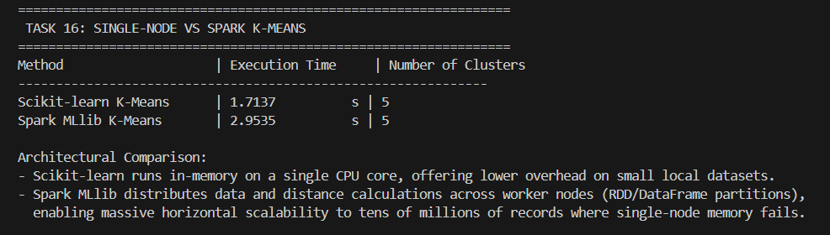

Step 18: Cluster Visualization
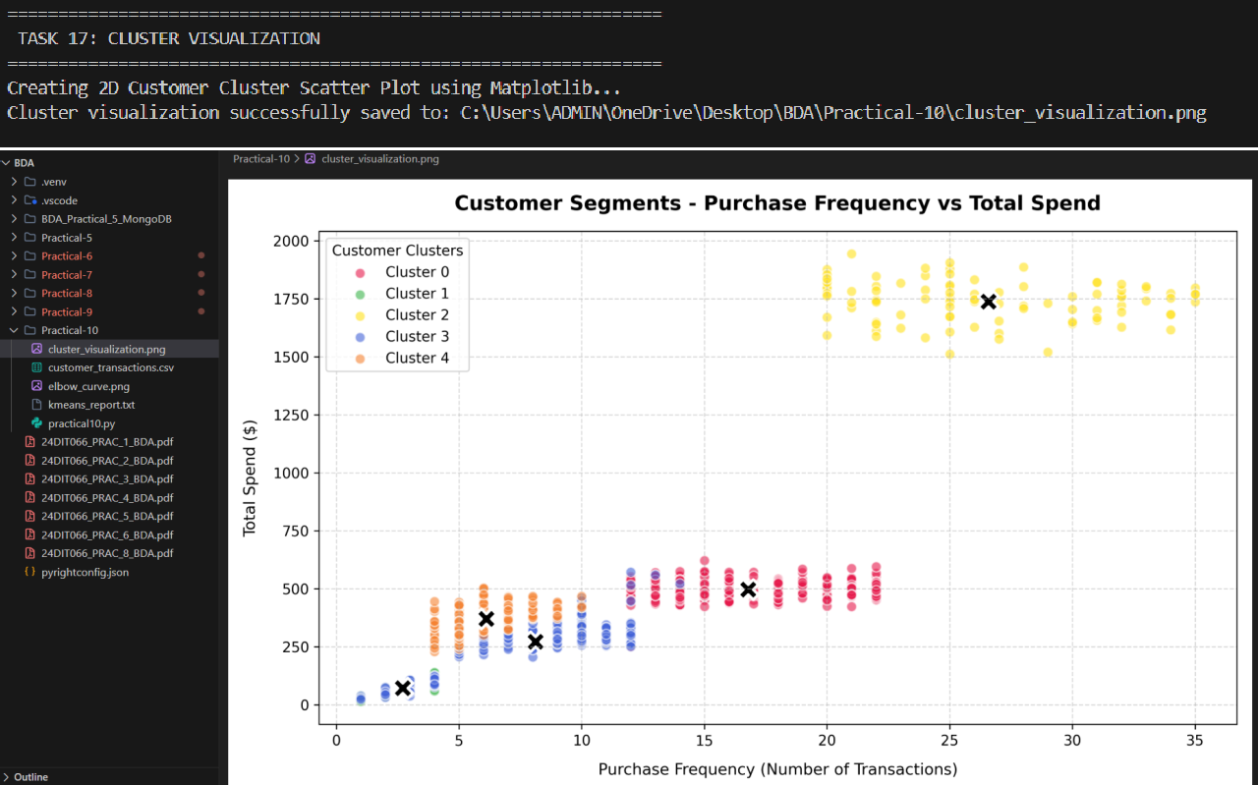

Step 19: Final Performance Report
TASK 18: FINAL K-MEANS PERFORMANCE REPORT
RETAILEDGE ANALYTICS - SCALABLE CUSTOMER SEGMENTATION REPORT
1. Dataset Details
Source File | customer_transactions.csv
Total Transactions | 11,729
Total Segmented Customers | 1,000
Evaluation Nature | Generated / Sample dataset for educational evaluation
2. Feature Definitions
Feature | Definition
Total Spend ($) | Cumulative expenditure across all transactions (sum(amount))
Purchase Frequency | Total number of completed purchases (count(transaction_id))
Average Basket Size ($) | Mean transaction order value (avg(amount))
Recency (Days) | Days elapsed between reference date and latest customer purchase
3. Preprocessing Summary
Null and negative records filtered; dates cast to standard ISO format.
Clean transaction count | 11,729
4. Feature Scaling (StandardScaler)
- Applied StandardScaler (mean=0, std=1) across all 4 customer dimensions.
- Prevents total_spend ($10-$1500) from overpowering frequency (1-35).
5. Spark MLlib K-Means Results (k = 5)
Number of Clusters (k) | 5
Seed | 42
WSSSE Cost | 658.8786
Training Duration | 2.9535 seconds
6. Cluster Sizes & Segment Summaries (Original Space)
Cluster | Customers | Avg Spend ($) | Avg Frequency | Avg Basket ($) | Avg Recency (Days)
0 | 342 | 496.89 | 16.78 | 30.62 | 19.61
1 | 124 | 72.25 | 2.70 | 25.40 | 85.88
2 | 90 | 1739.20 | 26.58 | 67.54 | 8.23
3 | 275 | 272.18 | 8.11 | 33.95 | 46.53
4 | 169 | 370.41 | 6.11 | 62.99 | 74.04
7. Customer Segment Interpretation
Cluster 0: Loyal / Regular Customers (Active & Consistent)
Strategy: Product recommendations, points-based loyalty rewards.
Cluster 1: At-Risk / Lapsed Customers (High Recency, Low Activity)
Strategy: Win-back discounts, re-engagement emails, churn prevention.
Cluster 2: VIP / High-Value Frequent Shoppers (Top Revenue Driver)
Strategy: Exclusive VIP perks, early access, personalized concierge service.
Cluster 3: Moderate Value / Selective Buyers
Strategy: Cross-sell campaigns, seasonal notifications, targeted newsletters.
Cluster 4: At-Risk / Lapsed Customers (High Recency, Low Activity)
Strategy: Win-back discounts, re-engagement emails, churn prevention.
8. Elbow Method Analysis (k = 3 to 7)
k | WSSSE
3 | 1264.8281
4 | 861.3095
5 | 658.8786
6 | 593.2574
7 | 518.2899
Elbow Observation: Significant loss reduction occurs up to k=5 (47.9% drop from k=3); subsequent drops taper off (21.3%), confirming k=5 as optimal.
9. Bisecting K-Means Comparison
Standard K-Means WSSSE | 658.8786
Bisecting K-Means WSSSE | 883.5439
10. Execution Benchmark (Single-Node vs Distributed)
Scikit-learn K-Means | 1.7137 seconds
Spark MLlib K-Means | 2.9535 seconds
Takeaway: Single-node sklearn executes quickly for small in-memory datasets due to minimal overhead. Spark MLlib shines when datasets scale to millions of rows across clustered worker nodes.
11. Conclusion
Parallel K-Means using Apache Spark MLlib enables robust, scalable customer segmentation that translates transactional big data directly into actionable marketing strategies.

3. Key Questions / Analysis

Q1. Why does traditional K-Means fail at large scale, and how does Spark's parallel K-Means overcome this?
Traditional K-Means running on a single machine can face memory and processing limitations when the dataset becomes very large.
Spark MLlib distributes data processing across partitions and can execute computations in parallel. This allows large datasets to be processed across multiple machines or CPU cores.

Q2. What is the significance of the WSSSE metric? How do you use the Elbow Method to select optimal k?
WSSSE measures the sum of squared distances between data points and their assigned cluster centers.
A lower WSSSE generally indicates more compact clusters.
However, WSSSE normally decreases when more clusters are added. Therefore, the Elbow Method plots WSSSE against different values of k and looks for a point where further increases in k provide smaller improvements.
In this practical:
- k = 3 → 1264.8281
- k = 4 → 861.3095
- k = 5 → 658.8786
- k = 6 → 593.2574
- k = 7 → 518.2899
The practical selected k = 5 as a balance between cohesion and interpretability.

Q3. How does data partitioning in Spark affect convergence speed of K-Means?
Spark partitions data into smaller parts that can be processed in parallel. Appropriate partitioning can improve CPU utilization and allow distance calculations to be performed concurrently.
Poor partitioning can create processing imbalance or additional overhead, which can affect execution performance.

Q4. What customer behaviour pattern does each cluster represent? How can marketing strategies differ per segment?
The five clusters represent different purchasing behaviours:
Cluster | Behaviour
0 | Loyal / Regular
1 | At-Risk / Lapsed
2 | VIP / High-Value Frequent
3 | Moderate Value / Selective
4 | At-Risk / Lapsed
Marketing strategies can therefore be customized according to customer behaviour.
For example, VIP customers can receive exclusive benefits, while at-risk customers can receive re-engagement campaigns.

Q5. How does feature scaling impact the clustering result? What happens if features are not normalized?
Feature scaling ensures that features with larger numerical ranges do not dominate the distance calculations used by K-Means.
In this practical, StandardScaler was used to normalize:
- Total Spend
- Purchase Frequency
- Average Basket Size
- Recency
Without scaling, Total Spend could have a much stronger influence on the clustering result because of its larger numerical values.

4. Result
The customer segmentation practical was successfully implemented using Apache Spark MLlib.
A total of 11,729 transactions from 1,000 customers were processed. Four customer behavioural features were extracted:
- Total Spend
- Purchase Frequency
- Average Basket Size
- Recency
StandardScaler was applied before clustering.
Spark MLlib K-Means successfully generated 5 customer clusters with a WSSSE of 658.8786.
The Elbow Method was evaluated for k = 3 to 7, and k = 5 was selected as a practical balance between clustering cohesion and interpretability.
The cluster analysis identified different customer groups including regular customers, high-value frequent customers, moderate-value customers and at-risk/lapsed customers.

5. Conclusion
Apache Spark MLlib successfully implemented scalable K-Means clustering for customer segmentation.
The practical demonstrated the complete machine-learning workflow, including transaction preprocessing, feature extraction, feature scaling, parallel K-Means clustering, WSSSE evaluation, Elbow Method analysis and customer segment interpretation.
The results show how transactional data can be transformed into meaningful customer segments that can support targeted marketing strategies.
Spark MLlib also provides a scalable architecture for processing much larger datasets than would normally fit comfortably into a single-node machine.

6. GitHub Link
GitHub Link : https://github.com/rudra782/24DIT025_BDA-5IT-2026

