PRACTICAL - 2

OBJECTIVE:
The objective of this practical is to learn how to install and configure Hadoop in a Single-Node Cluster environment. It also helps in understanding HDFS operations such as storing, managing, retrieving, and monitoring big data efficiently.
AIM: Hadoop Installation, Configuration and HDFS Operations on Windows/Linux

Problem Definition
You have recently joined DataAnalytics Inc. as a Hadoop Administrator. The organization processes large-scale customer, sales, and marketing data using the Hadoop ecosystem. Due to increasing data volumes, the company has decided to migrate its data storage infrastructure from traditional file systems to Hadoop Distributed File System (HDFS). As a Hadoop Administrator, your responsibility is to install and configure Hadoop in a
Single-Node Cluster environment on Windows/Linux, verify the Hadoop services, manage HDFS storage, and perform data management operations.
Management wants a fully functional Hadoop environment that can store, retrieve, and process big data efficiently.
Your task is to install Hadoop, configure the Hadoop ecosystem, start Hadoop services, and perform HDFS operations using Hadoop commands.

Task:
- Hadoop Installation & Configuration
- Access Hadoop Web UI.
- Create directories in HDFS.
- Upload files to HDFS.
- List HDFS files and directories.
- Display file contents.
- Copy files within HDFS.
- Move files within HDFS.
- Rename files.
- Download files from HDFS.
- Delete files and directories.
- Check HDFS report.
- Verify block information.
- Check Hadoop cluster health.
- Monitor Hadoop processes.
- Check storage utilization.

Tools / Technology Used
  - Windows 10 / Windows 11 / macOS
  - OpenJDK 11 or above
  - Hadoop 3.x / 3.3.6
  - Winutils.exe
  - Command Prompt / PowerShell / zsh Terminal

Step 1: Open Terminal


Step 2: Check Java
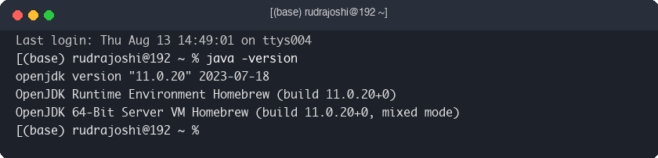

Step 3: Check Hadoop Version
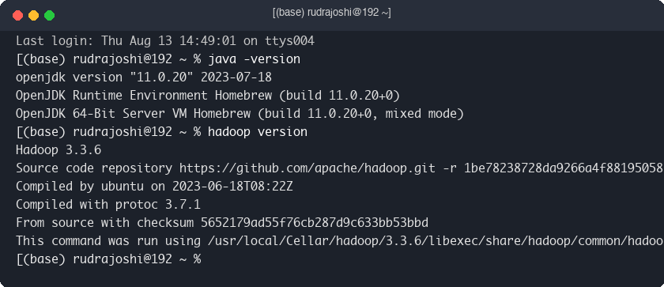

Step 4: Start Hadoop
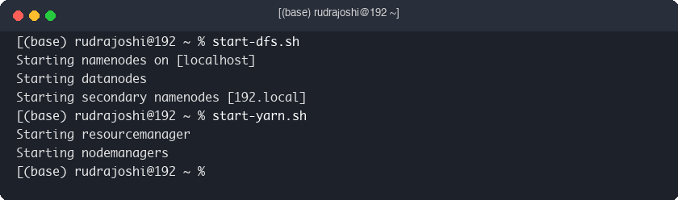

Step 5: Verify Services
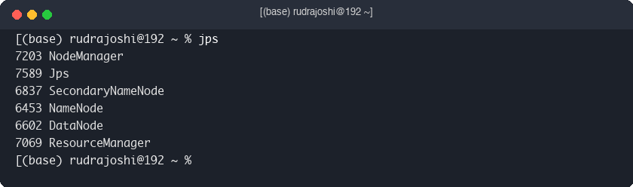

Access Hadoop Web UI
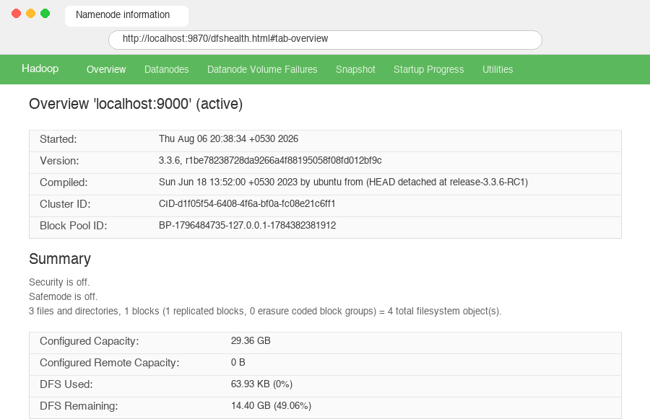

Step 6: Create Dataset
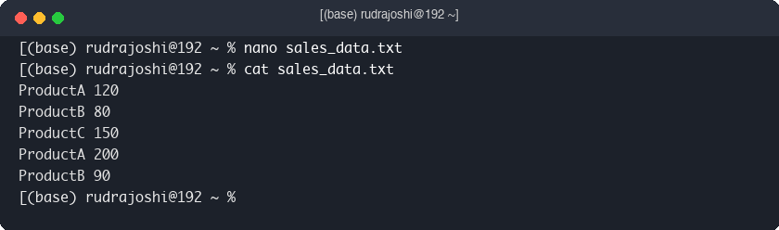

Practical Commands

Create Directory
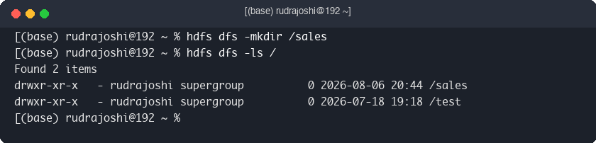

Upload File


List Files & 4 Display File
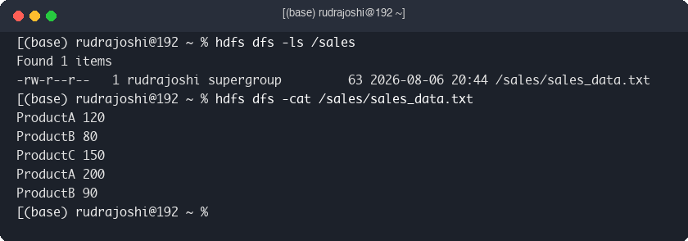

Copy File
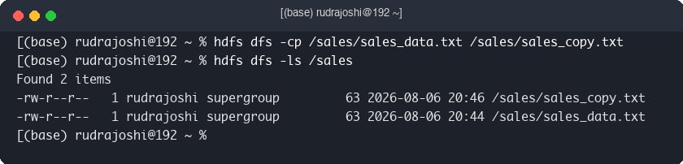

Move File & 7 Rename File
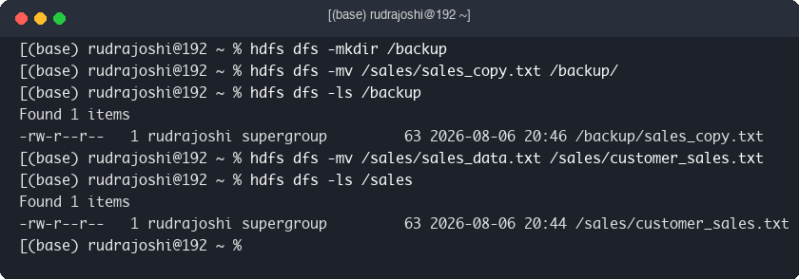

Download File
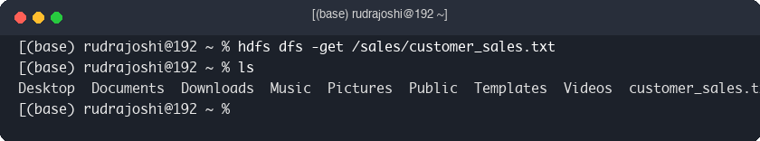

Delete File


HDFS Report
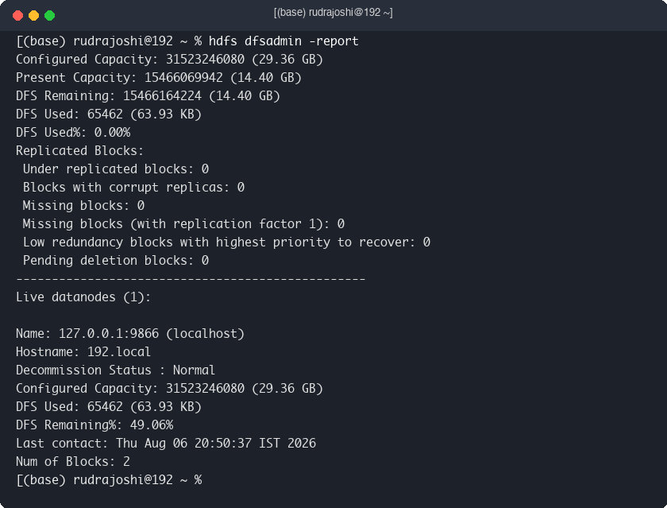

Verify Block Information
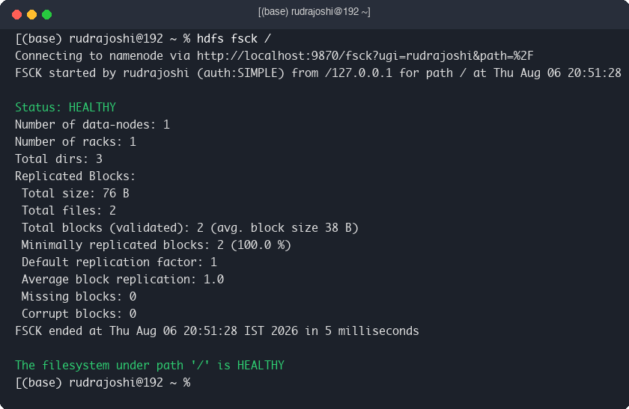

Check Cluster Health
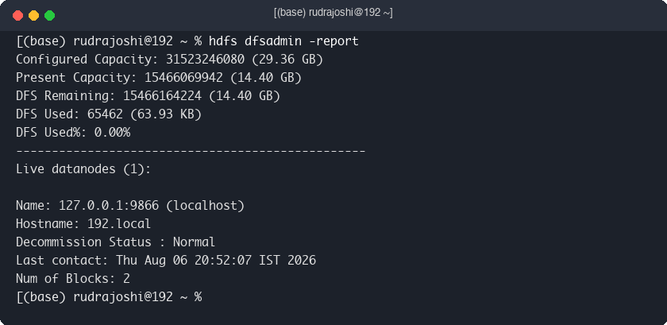

Monitor Hadoop Processes & 14 Storage Utilization
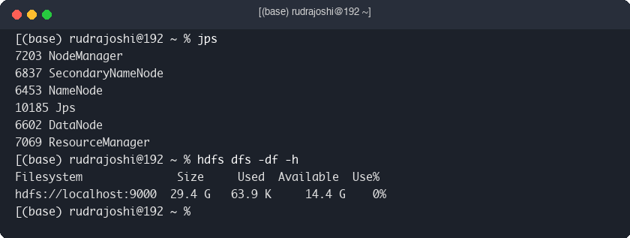

15 Stop Hadoop
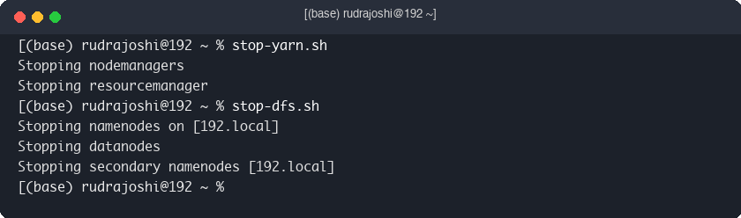

Key Questions / Analysis

Q1. Why is Hadoop preferred for Big Data storage?
Hadoop can store and process very large amounts of data across multiple computers. It is fast, reliable, and cost-effective.

Q2. What is the role of NameNode and DataNode in HDFS?
The NameNode manages file information and keeps track of where data is stored. The DataNode stores the actual data blocks and sends them when requested.

Q3. What is the difference between HDFS and traditional file systems?
HDFS stores data across multiple machines, while a traditional file system stores data on a single computer. HDFS is designed for handle.

Q4. What are the advantages of distributed storage?
Distributed storage improves speed, reliability, scalability, and allows data to remain available even if one machine fails.

Supplementary Questions

Configure Hadoop pseudo-distributed mode.
Pseudo-distributed mode allows Hadoop services to run on a single computer for learning, testing, and development.

Change HDFS replication factor and observe results.
Changing the replication factor changes the number of copies of each data block stored in HDFS, improving data availability and fault tolerance.

Upload a large dataset into HDFS.
A large dataset is uploaded into HDFS using Hadoop commands so it can be stored and processed efficiently.

Analyze HDFS storage utilization.
Storage utilization is checked to understand how much HDFS space is used and how much is available.

Conclusion
In this practical, Hadoop was successfully installed and configured in a Single-Node Cluster environment. HDFS operations such as creating directories, uploading, downloading, moving, renaming, and deleting files were performed successfully. Hadoop services and storage utilization were also monitored. This practical helped in understanding how Hadoop manages and stores large amounts of data efficiently using HDFS.

Key Skills to be Addressed
  - Hadoop Installation and Configuration
  - Environment Variable Configuration
  - HDFS Administration
  - Distributed Storage Management
  - Hadoop Cluster Monitoring

Dataset / TestData
sales_data.txt ProductA 120
ProductB 80
ProductC 150
ProductA 200
ProductB 90

Format
TXT/CSV Files (mb/gb)

