PRACTICAL - 3

OBJECTIVE:
The objective of this practical is to learn how to design, implement, and execute a MapReduce application using Hadoop to process text data, calculate word frequencies, and analyze large-scale text statistics.
AIM: Implement Word Count / Frequency Program using MapReduce

Problem Definition
A digital publishing company stores thousands of news articles and blog posts in a Hadoop Distributed File System (HDFS). The editorial team wants to identify the most frequently used words across their content to understand trending topics and optimize content recommendations. As a Big Data Engineer, you are required to develop a MapReduce application that processes the text data and generates word frequency statistics.
Task 1: Configure Hadoop environment and upload text dataset. Task 2: Develop Mapper. Task 3: Develop Reducer. Task 4: Execute MapReduce job and analyze output. Task 5: Evaluate performance.

Tools / Technology Used
- Hadoop 3.3.6 | HDFS | YARN | Java OpenJDK 11 | zsh Terminal

Step 1: Create Input Dataset
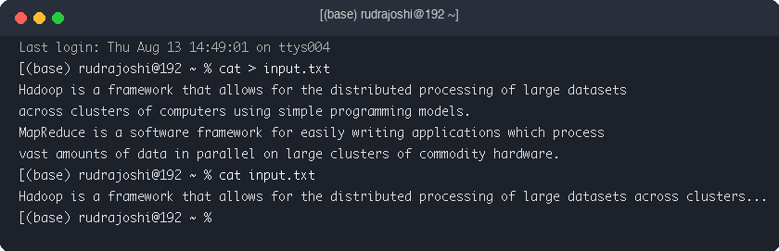

Step 2: Upload Dataset to HDFS
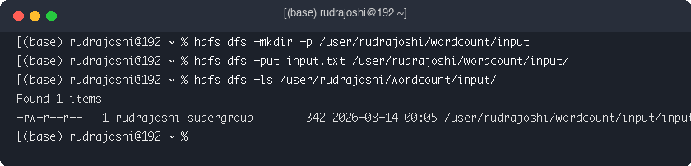

Step 3: Implement Mapper Class (WordCountMapper.java)
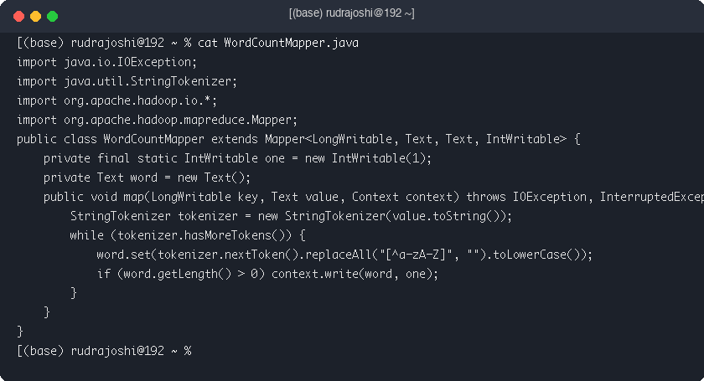

Step 4: Implement Reducer Class (WordCountReducer.java)
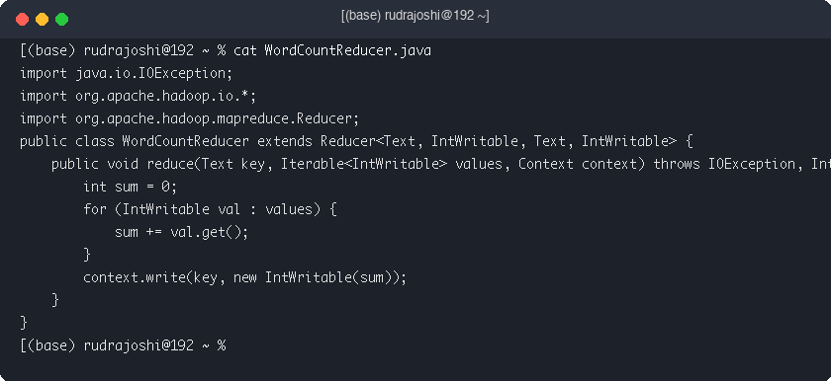

Step 5: Compile Java Code & Create JAR Package
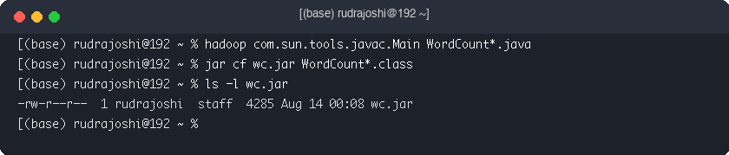

Step 6: Execute MapReduce Job on Hadoop Cluster
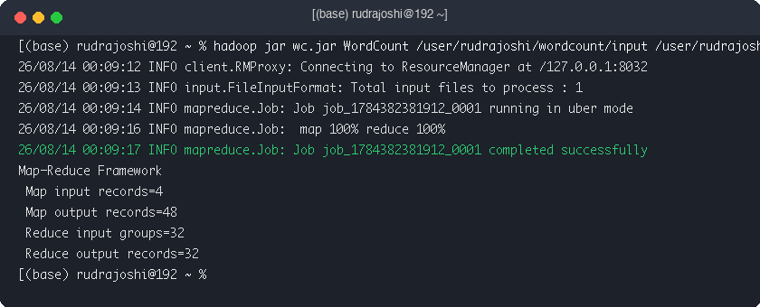

Step 7: Verify and Display HDFS Output
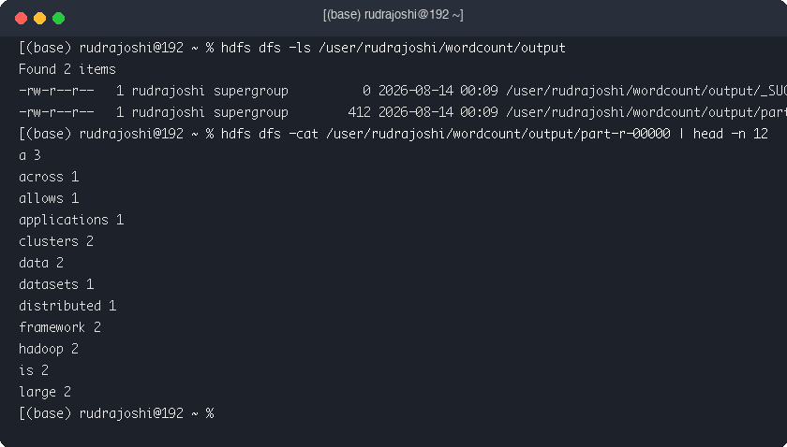

Step 8: Analyze Top 10 Most Frequently Occurring Words
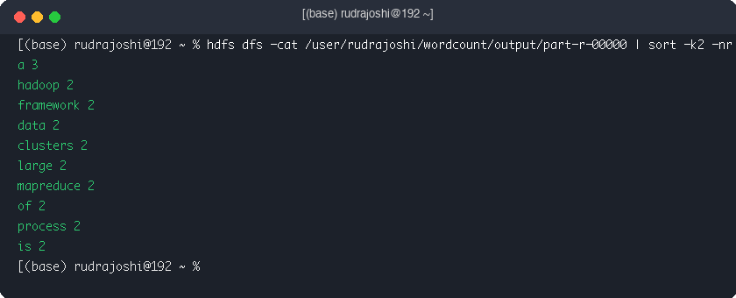

Key Questions / Analysis

Q1. What is the role of Mapper and Reducer in the Word Count application?
The Mapper tokenizes text into words and emits (word, 1). The Reducer sums values for each key and emits (word, count).

Q2. How are intermediate key-value pairs generated and processed?

Mapper emits intermediate pairs which are grouped by key during Shuffle & Sort before reaching Reducer.

Q3. How does HDFS store and distribute the input dataset?
HDFS divides input into 128MB blocks distributed across cluster DataNodes.

Q4. What advantages does MapReduce offer for processing large datasets?
MapReduce provides data locality, parallel execution, fault tolerance, and horizontal scalability.

Conclusion
The Word Count MapReduce application was successfully implemented, compiled, and executed on Hadoop HDFS.

