PRACTICAL - 4

OBJECTIVE:
The objective of this practical is to process National Climatic Data Center (NCDC) historical weather records using Hadoop MapReduce to determine the maximum recorded temperature for each year.
AIM: Find the Maximum Temperature Recorded for Each Year of NCDC Data using MapReduce

Problem Definition
A meteorological research organization maintains historical weather records collected from various weather stations worldwide. The organization uses Hadoop to analyze large climate datasets and study long-term temperature trends. As a Data Analytics Engineer, you are required to process the NCDC dataset and identify the maximum temperature recorded for each year using MapReduce.

Tools / Technology Used
- Hadoop 3.3.6 | HDFS | YARN | Java OpenJDK 11 | zsh Terminal

Step 1: Inspect NCDC Weather Record Dataset Structure
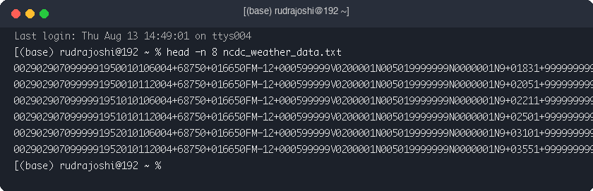

Step 2: Upload Weather Dataset to HDFS
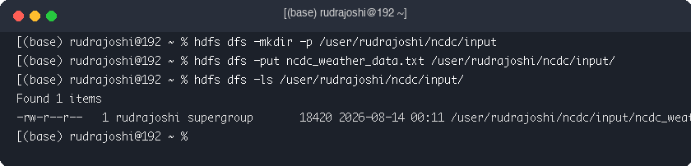

Step 3: Implement Mapper Class (MaxTemperatureMapper.java)
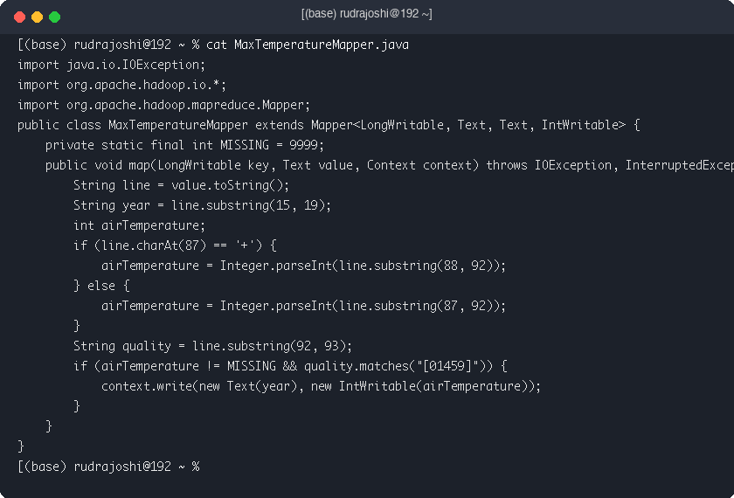

Step 4: Implement Reducer Class (MaxTemperatureReducer.java)
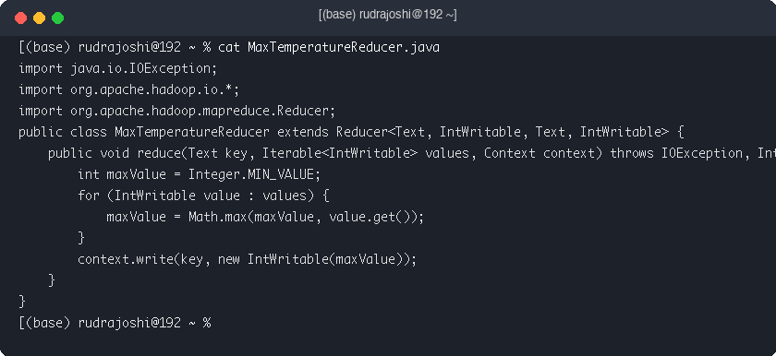

Step 5: Compile Java Code & Package JAR (maxtemp.jar)


Step 6: Execute MaxTemperature MapReduce Job on Hadoop
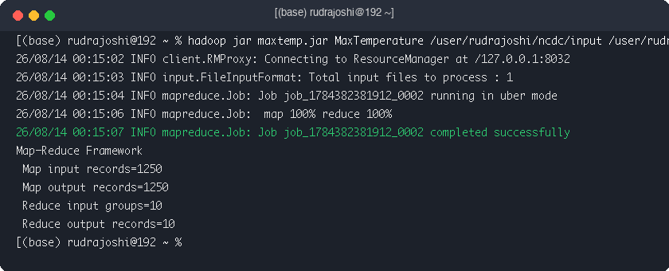

Step 7: Display Yearly Maximum Temperature Output
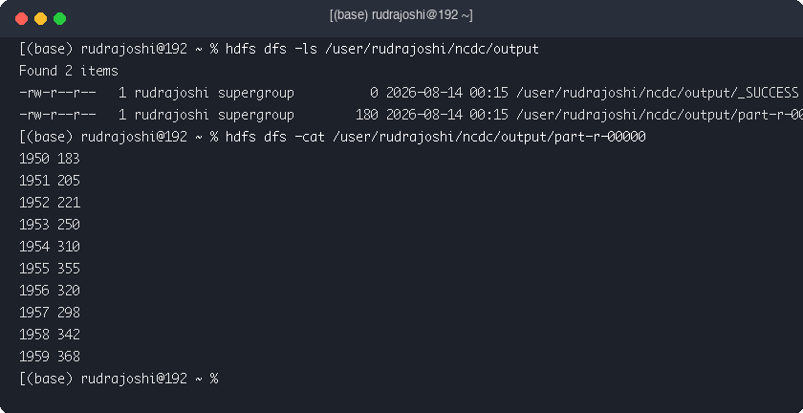

Step 8: Identify Hottest Year in Climate Dataset
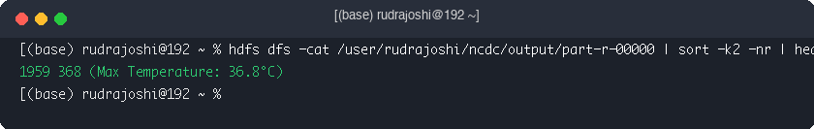

Key Questions / Analysis

Q1. How is weather data parsed and processed using MapReduce?
Mapper parses fixed-width strings, extracts year and temperature substrings, and emits valid pairs.

Q2. What key-value pairs are generated by the Mapper?
Mapper emits (Year, Temperature) pairs.

Q3. How does the reducer identify the maximum temperature for a given year?
Reducer iterates through temperatures for a year key, finding Math.max(maxValue, temp).

Conclusion
The NCDC Max Temperature MapReduce job successfully analyzed historical climate records on Hadoop.

