CHAROTAR UNIVERSITY OF SCIENCE & TECHNOLOGY

Faculty of Technology & Engineering
Devang Patel Institute of Advance Technology and Research (DEPSTAR)

CSUE301 – : Big Data Analytics
Practical File – ODD Semester 2026-27

StudentID: 24DIT025 Student Name: Rudra Joshi

Practical 6

Problem Definition
Scenario:
ShopSmart Analytics Pvt. Ltd. wants to analyze its e-commerce sales data. The company needs to identify high-performing product categories, top-selling products and revenue contribution by city. Since the amount of data is large, Apache Spark is used for scalable data processing and analysis.

Objective
To use PySpark DataFrames to:
  - Load e-commerce sales data
  - Validate the dataset
  - Calculate revenue
  - Find category-wise revenue
  - Find top-selling products
  - Calculate city-wise revenue
  - Sort categories according to revenue
  - Generate analytical summaries
  - Extract business insights


PART A — Practical Execution Step 1: Creating Folder and files

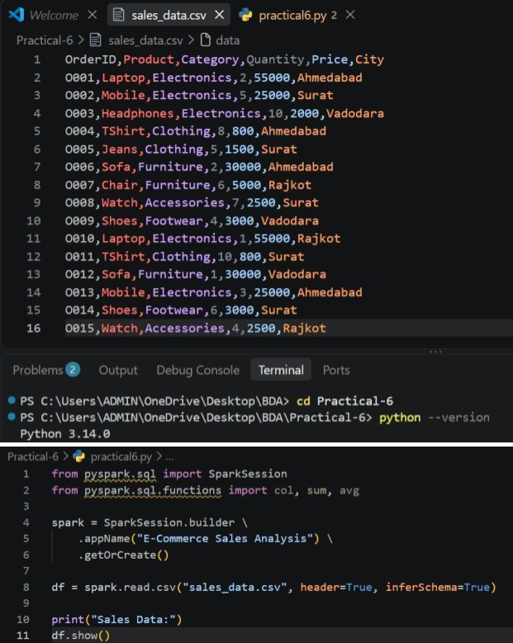

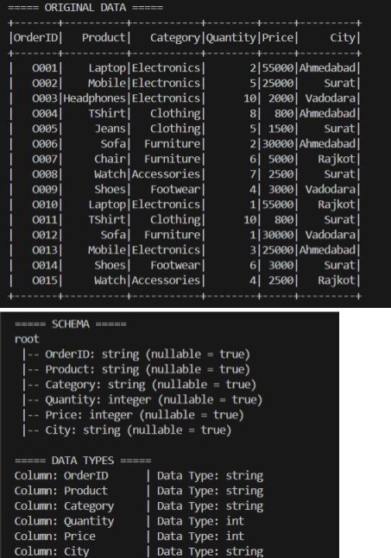
Output of Practical6.py

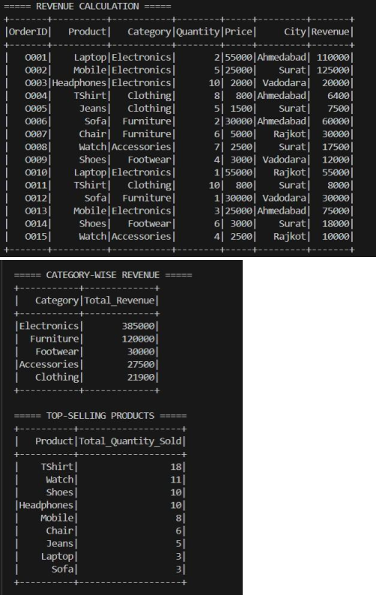

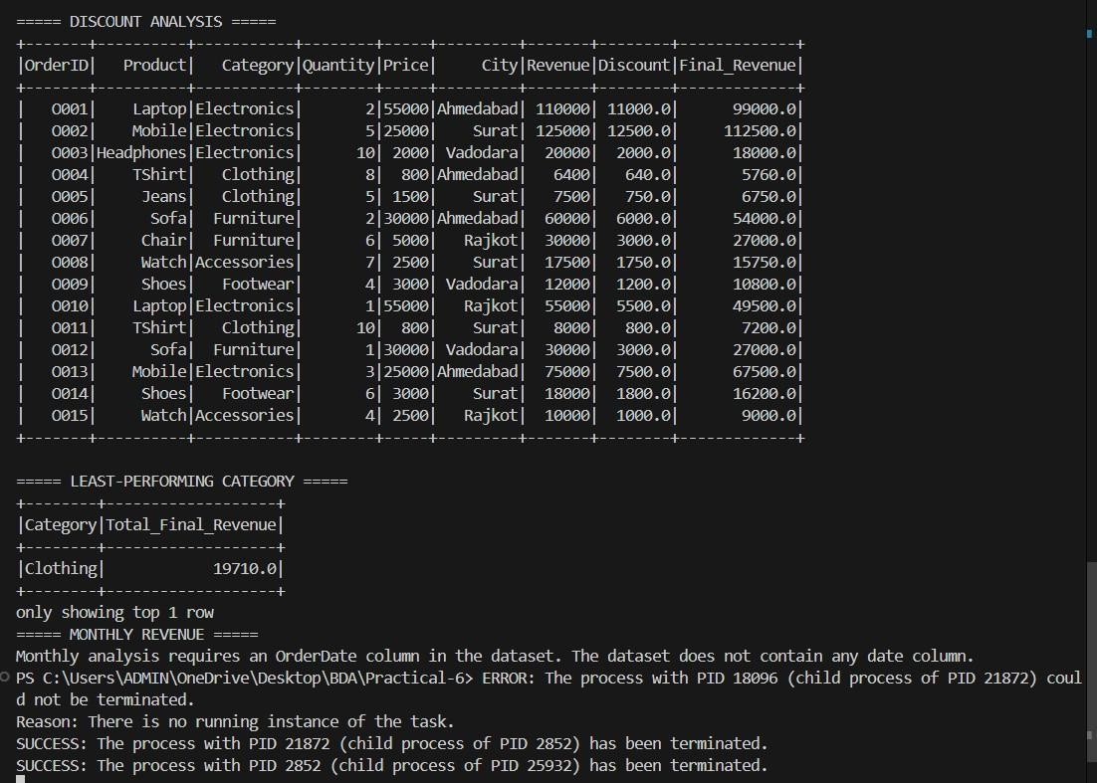

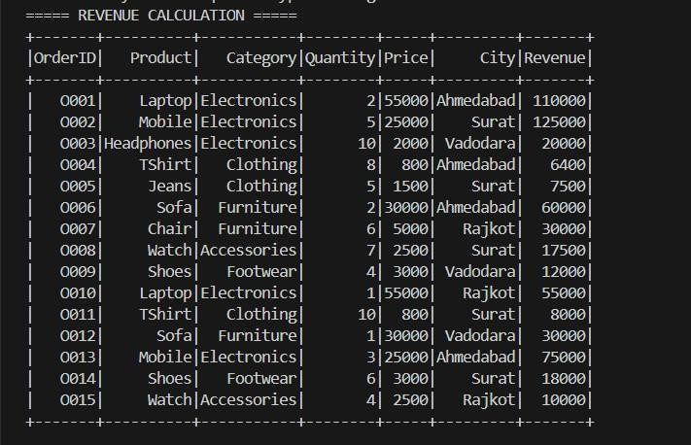
Create Revenue Column

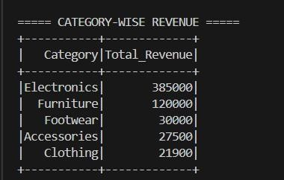
Calculate Category-wise Revenue

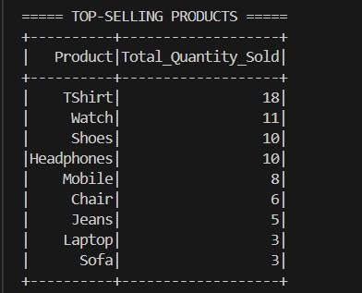
Find Top-Selling Products

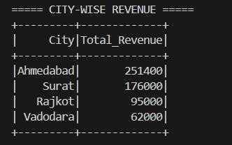
Calculate City-wise Revenue
- Top 3 Revenue-Generating Cities and Average Revenue per Order

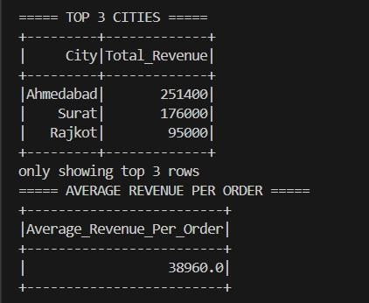

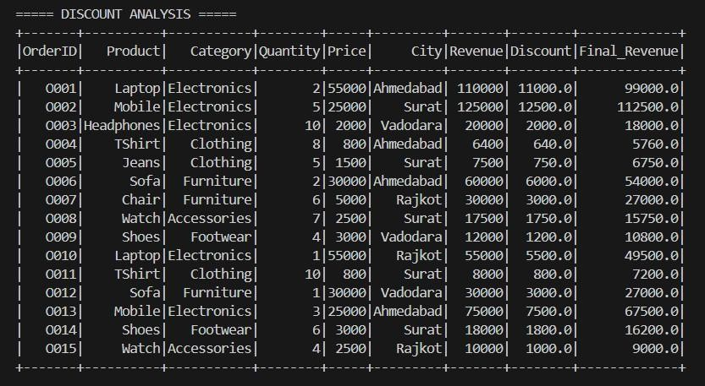
Add Discount Column
- Least-Performing Category
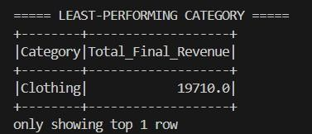

Monthly Revenue Summary
Our current dataset does not contain a date/month column.
So for this supplementary question, we would need to extend the dataset with an OrderDate column.

Key Questions / Analysis
Q1. Why are Spark DataFrames preferred over traditional spreadsheets for large-scale analytics? Spark DataFrames are preferred because they can process very large datasets efficiently using distributed computing. Data can be divided into partitions and processed in parallel across multiple machines. Spreadsheets are more suitable for small or moderate-sized datasets and have limitations when the data becomes very large.

Q2. What is the role of the groupBy() operation in data aggregation?

CSUE301 : Big Data Analytics

24DIT025

The groupBy() operation groups records having the same value in a particular column. It is commonly used with aggregation functions such as sum(), avg(), count(), min() and max().
For example: df.groupBy("Category").sum("Revenue") groups the sales according to product category and calculates the total revenue for each category.

Q3. Explain the difference between transformations and actions in Spark. Transformations create a new DataFrame or RDD from existing data. They are lazily evaluated. Examples: select() filter()
withColumn() groupBy()
Actions trigger the actual execution of Spark operations and return a result or output. Examples: show() count() collect()
Therefore:
Transformation → Defines the operation Action → Executes the operation

Q4. How does Spark improve scalability for e-commerce analytics?
Spark improves scalability by using distributed and parallel processing. Large e-commerce datasets can be divided into partitions and processed simultaneously across multiple computing resources. Spark DataFrames also provide optimized execution, making large-scale sales analysis faster and more efficient.

Q5. Which category contributes the highest revenue and what business action can be taken? The highest-revenue category is identified from the category-wise revenue analysis by sorting categories in descending order of revenue.

Highest Revenue Category:
A suitable business action is to maintain sufficient inventory for high-performing products, continue targeted marketing campaigns, and analyze customer demand to maintain the category's performance.

Page

CSUE301 : Big Data Analytics 24DIT025

Conclusion
The practical successfully demonstrated the use of Apache Spark DataFrames for e-commerce sales analysis. The dataset was loaded and validated, and important business metrics such as revenue, category-wise sales, product quantity, and city-wise revenue were calculated.
The use of operations such as withColumn(), groupBy(), sum(), avg(), orderBy() and limit() helped perform efficient data analysis. Spark provides a scalable approach for processing large e-commerce datasets and generating useful business insights.
The analysis can help businesses identify high-performing categories and products, understand geographical revenue distribution, improve marketing strategies, and make data-driven decisions.

