CHAROTAR UNIVERSITY OF SCIENCE & TECHNOLOGY
Faculty of Technology & Engineering
Devang Patel Institute of Advance Technology and Research (DEPSTAR)
CSUE301 – Big Data Analytics
Practical File – ODD Semester 2026-27
Student ID: 24DIT025
Student Name: Rudra Joshi

Practical 8

1. Problem Definition
You are a Data Analytics Engineer at FinEdge Securities Ltd., a financial services company that provides stock market insights to investors. The company continuously receives stock price updates from multiple exchanges. Investors want to understand stock performance trends and identify the best investment opportunities. Traditional data processing systems struggle to handle the continuously growing volume of financial data.

2. Part A — Practical Execution

Step 1: Creating Folder and Files
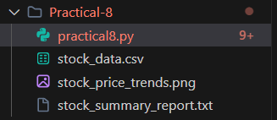

Step 2: Creating Spark Session
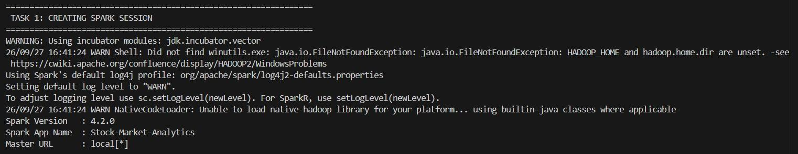

Step 3: Loading Stock Dataset
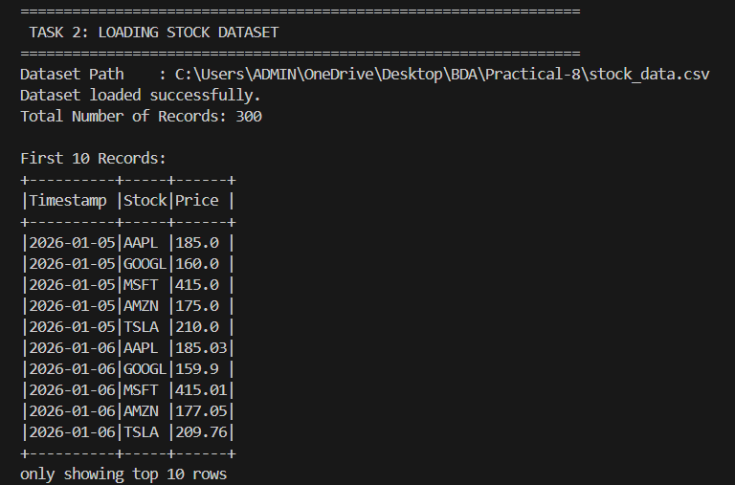

Step 4: Display Dataset Schema
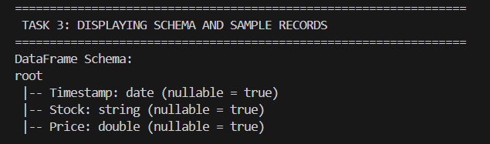

Step 5: Group Records by Stock Symbol
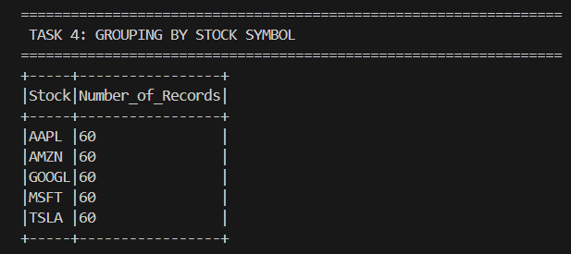

Step 6: Calculate Average Stock Price
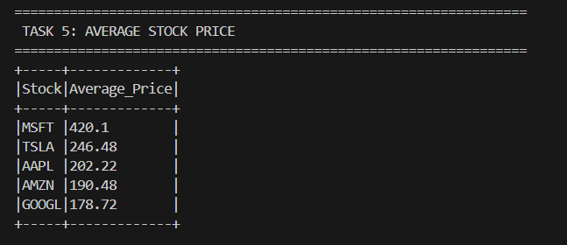

Step 7: Calculate Maximum Stock Price
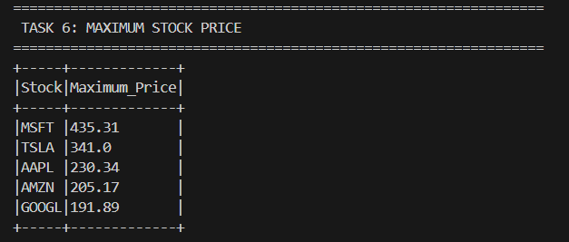

Step 8: Calculate Minimum Stock Price
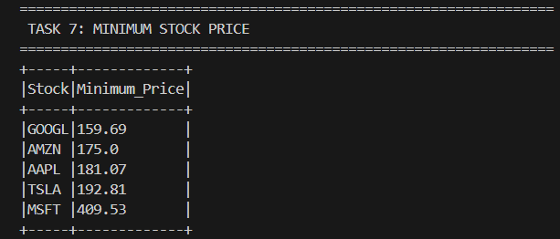

Step 9: Generate Stock Summary Report
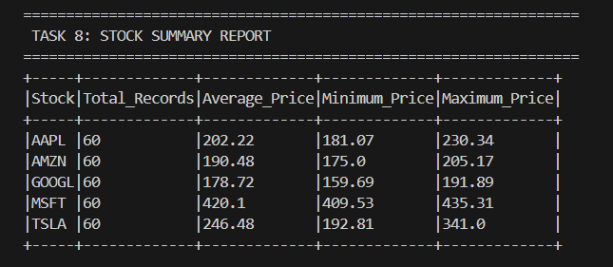

Step 10: Identify Best-Performing Stock
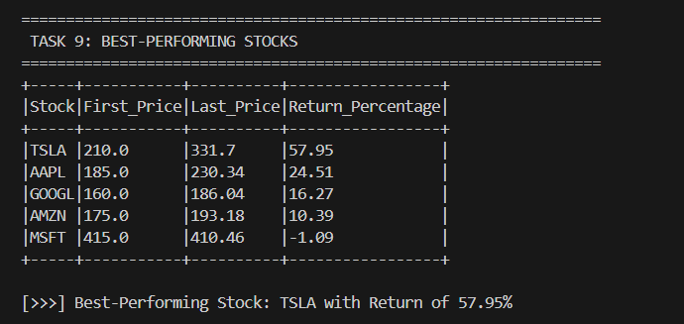

Step 11: Calculate Daily Stock Returns
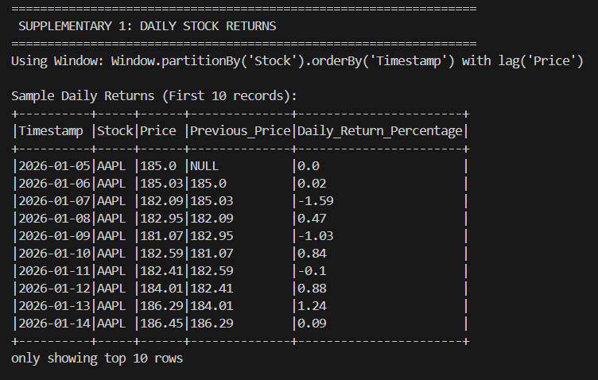

Step 12: Identify Top-Performing Stock
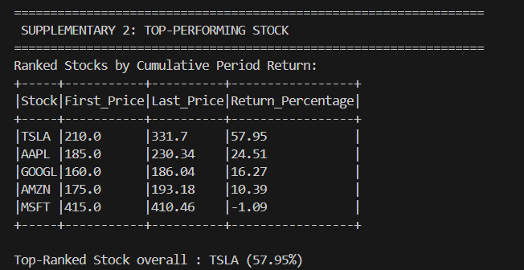

Step 13: Calculate 3-Period Moving Average
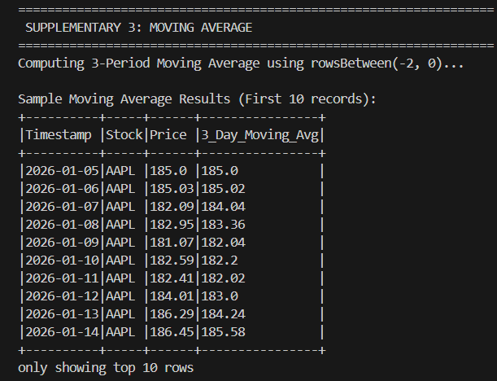

Step 14: Calculate Stock Volatility
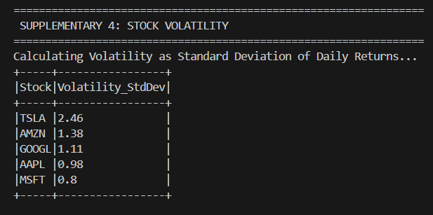

Step 15: Market Trend Analysis
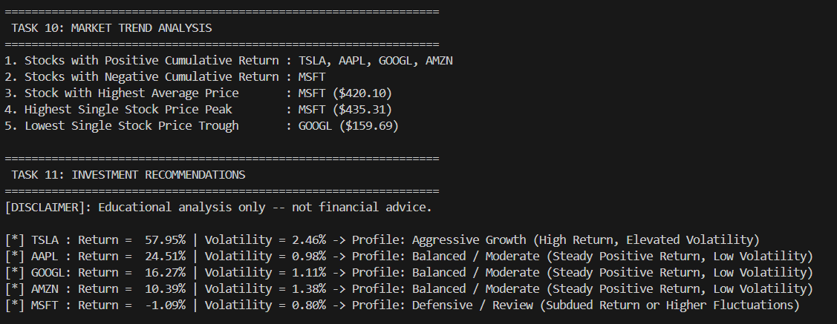

Step 16: Educational Investment Analysis
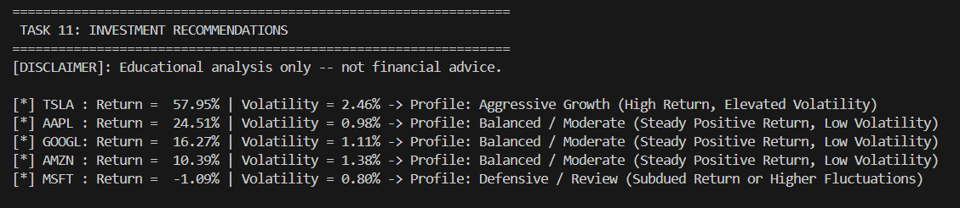

Step 17: Generate Stock Price Visualization
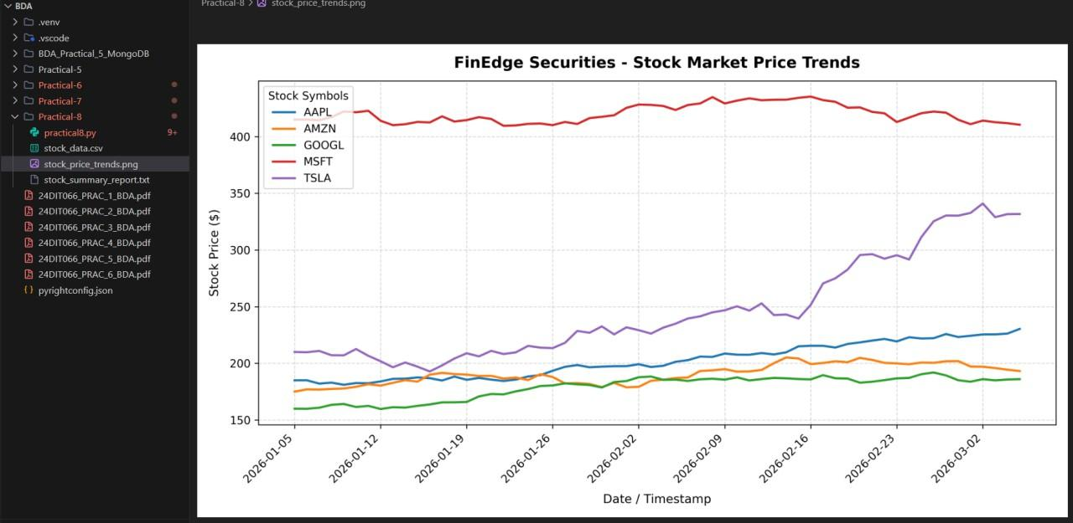

Step 18: Generate Final Stock Summary Report
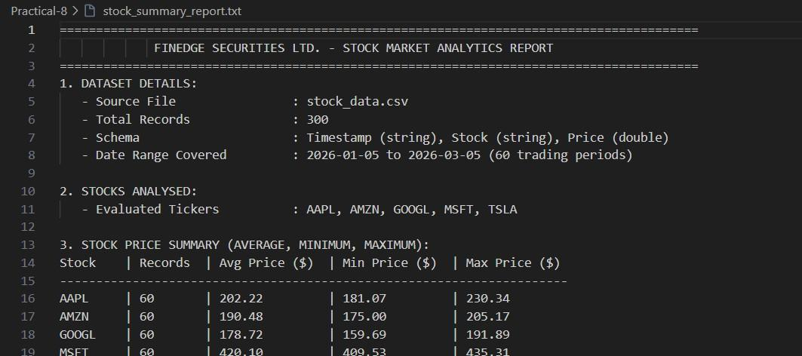

3. Key Questions / Analysis

Q1. Why is Apache Spark suitable for financial analytics?
Apache Spark is suitable for financial analytics because it can process large datasets using distributed and parallel computing. Spark DataFrames and built-in functions can efficiently perform aggregation, filtering and time-series analysis.

Q2. What is the purpose of grouping stock data by stock symbol?
Grouping stock data by stock symbol allows individual companies to be analysed separately.
Aggregation functions such as avg(), min() and max() can then be applied to calculate statistics for each stock.
For example:
df.groupBy("Stock").agg(avg("Price"))
calculates the average price for each stock.

Q3. How does average stock price help investors?
Average stock price provides a summary of the typical price level of a stock over the analysed period. It can be used along with other metrics such as returns and volatility to understand the historical behaviour of the dataset.

Q4. Why are maximum and minimum prices important?
Maximum and minimum prices show the price range observed during the analysed period. They help describe the highest and lowest recorded price levels and provide information about the historical price variation in the dataset.

Q5. How can Spark support real-time stock market monitoring?
Spark can process large volumes of streaming and historical data using distributed processing. Spark-based systems can be used to calculate metrics such as prices, returns and trends as new data becomes available.

4. Conclusion
The practical successfully demonstrated Stock Market Analytics Using Window-Based Analysis with PySpark.
A stock dataset containing 300 records across five stock symbols was loaded into a Spark DataFrame. The schema and sample records were displayed, and aggregation functions were used to calculate average, minimum and maximum stock prices.
Spark Window functions were then used to calculate period returns, daily returns and moving averages. Stock volatility was calculated using the standard deviation of daily returns. The analysis identified the calculated period return values for each stock and generated a stock summary report. The practical also demonstrated how PySpark can be used for time-series analysis and how Window functions such as lag() and rolling windows can perform calculations across ordered records.
A Matplotlib visualization of stock price trends was generated, and the complete analysis was saved in stock_summary_report.txt.
Note: The dataset used in this practical is a sample/generated dataset for educational purposes, so the calculated investment profiles should not be interpreted as real-world financial advice.

5. GitHub Link
GitHub Link : https://github.com/rudra782/24DIT025_BDA-5IT-2026

