CHAROTAR UNIVERSITY OF SCIENCE & TECHNOLOGY
Faculty of Technology & Engineering
Devang Patel Institute of Advance Technology and Research (DEPSTAR)
CSUE301 – Big Data Analytics
Practical File – ODD Semester 2026-27
Student ID: 24DIT025
Student Name: Rudra Joshi

Practical 9

1. Problem Definition
TrendPulse Social Media Analytics monitors social media activity across platforms such as Twitter/X, Instagram, Facebook, and LinkedIn. Large volumes of posts contain hashtags related to technology, sports, entertainment and other topics.
The objective of this practical is to use PySpark to process hashtag data and identify popular and trending topics.
The practical performs hashtag grouping, frequency counting, popularity ranking, daily trend analysis, regional analysis, category analysis and visualization.
Note: The dataset used in this practical is a generated/sample dataset for educational analysis.

2. Part A — Practical Execution

Step 1: Creating Folder and Files
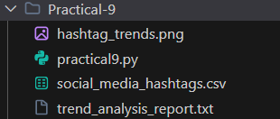

Step 2: Creating Spark Session
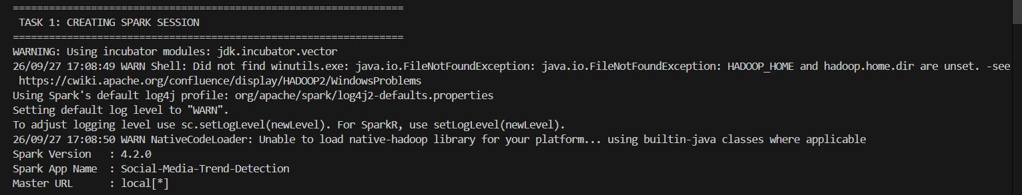

Step 3: Loading Social Media Hashtag Dataset
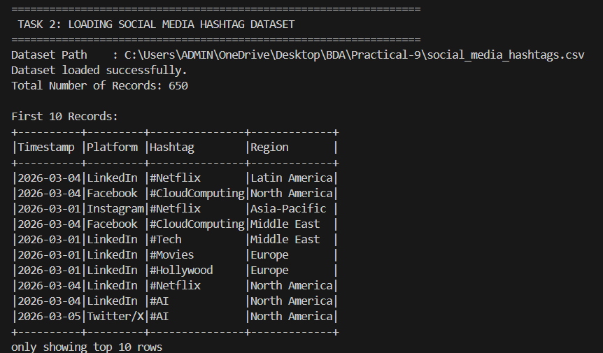

Step 4: Displaying Hashtag Records
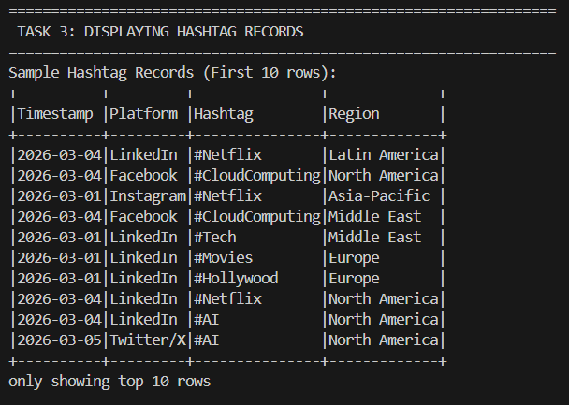

Step 5: Validating Dataset Structure
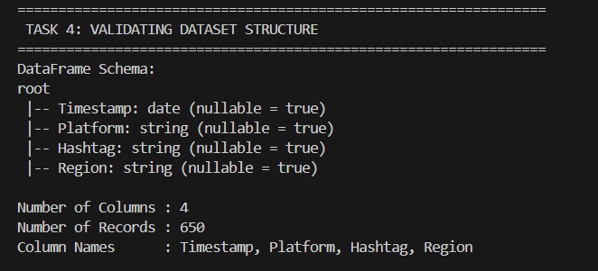

Step 6: Grouping Hashtags
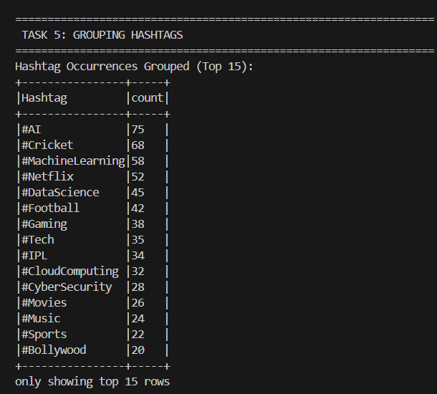

Step 7: Counting Hashtag Occurrences
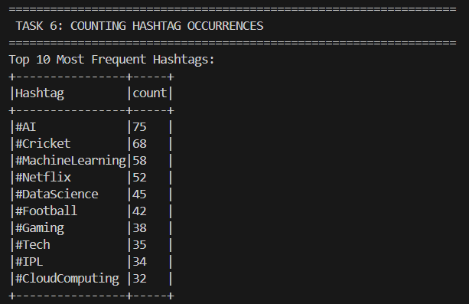

Step 8: Sorting Hashtags by Popularity
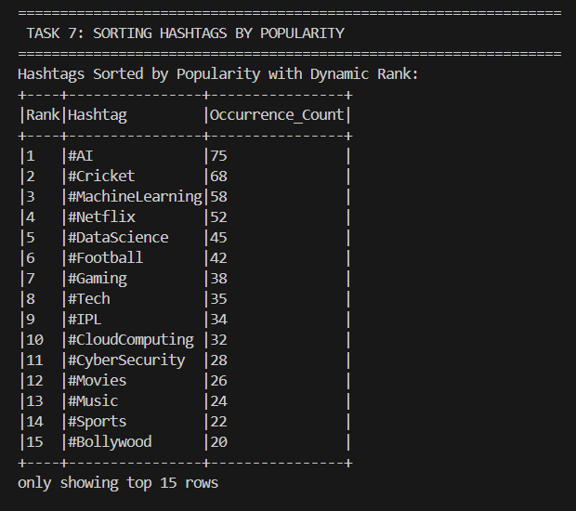

Step 9: Identifying Top Trending Hashtags
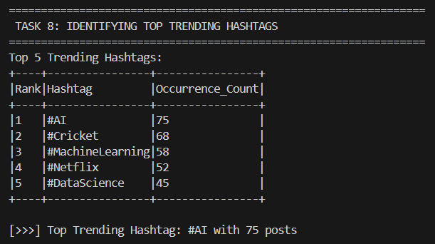

Step 10: Supplementary 1 — Top 3 Trending Hashtags
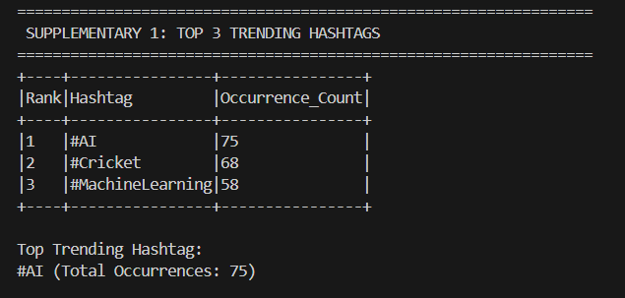

Step 11: Supplementary 2 — Daily Trend Comparison
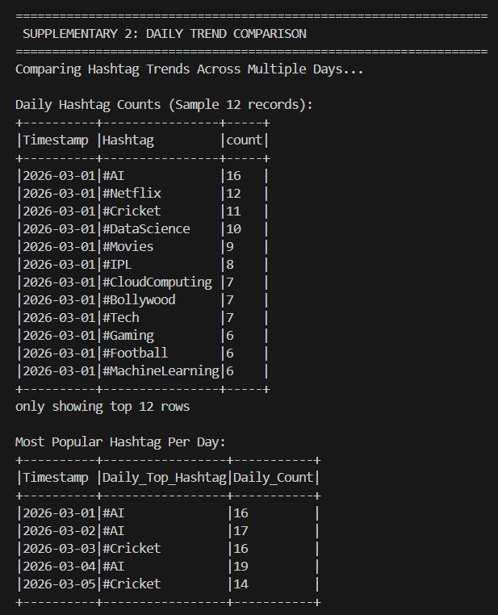

Step 12: Supplementary 3 — Regional Hashtag Analysis
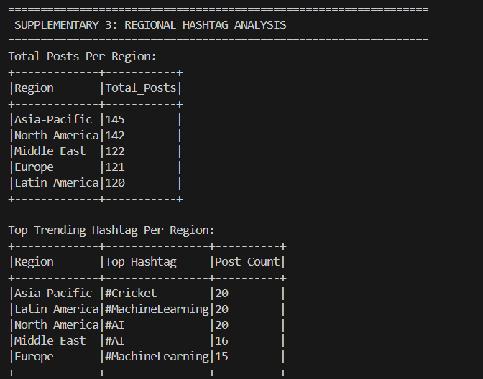

Step 13: Task 10 / Supplementary 4 — User Interest and Hashtag Categories
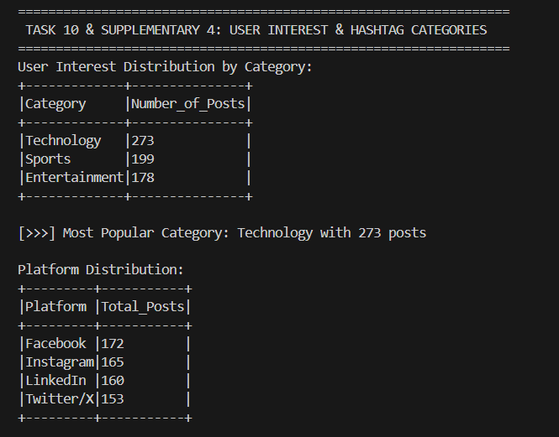

Step 14: Supplementary 5 — Trend Visualization
SUPPLEMENTARY 5: TREND VISUALIZATION
Creating Matplotlib Bar Chart for Top 10 Trending Hashtags...
Chart successfully saved to: C:\Users\ADMIN\OneDrive\Desktop\BDA\Practical-9\hashtag_trends.png
Business Recommendations
[DISCLAIMER]: Educational analysis based on generated/sample social media data.
- Campaign Targeting: Allocate top-tier marketing budgets toward Technology and Sports hashtags.
- Platform Strategy: Cross-post top tech trends on LinkedIn and fan-driven sports topics on Twitter/X.
- Emerging Topics: Monitor real-time daily trend shifts to detect breakout virality early.
- Geo-Targeted Content: Tailor campaigns based on regional preferences (e.g. cricket in Asia-Pacific).
- Community Engagement: Create branded interactive polls around #AI, #Cricket, and #Netflix.
Final Social Media Trend Analysis Report
TRENDPULSE SOCIAL MEDIA TREND DETECTION REPORT
1. Dataset Details
Source File | social_media_hashtags.csv
Total Records | 650
Schema | Timestamp (string), Platform (string), Hashtag (string), Region (string)
Data Nature | Generated / Sample dataset for educational evaluation
2. Total Records
Total Monitored Posts | 650
3. Unique Hashtags
Total Distinct Hashtags | 18
4. Platform Distribution
Platform | Total Posts
Facebook | 172
Instagram | 165
LinkedIn | 160
Twitter/X | 153
5. Region Distribution
Region | Top Hashtag | Post Count
Asia-Pacific | #Cricket | 20
Latin America | #MachineLearning | 20
North America | #AI | 20
Middle East | #AI | 16
Europe | #MachineLearning | 15
6. Hashtag Frequency Analysis
Evaluated across all monitored interactions with dynamic grouping and frequency sorting.
7. Top 10 Hashtags
Rank | Hashtag | Occurrences
1 | #AI | 75
2 | #Cricket | 68
3 | #MachineLearning | 58
4 | #Netflix | 52
5 | #DataScience | 45
6 | #Football | 42
7 | #Gaming | 38
8 | #Tech | 35
9 | #IPL | 34
10 | #CloudComputing | 32
8. Top 5 Trending Hashtags
Rank | Hashtag | Occurrences
1 | #AI | 75
2 | #Cricket | 68
3 | #MachineLearning | 58
4 | #Netflix | 52
5 | #DataScience | 45
9. Top 3 Trending Hashtags
Rank | Hashtag | Occurrences
1 | #AI | 75
2 | #Cricket | 68
3 | #MachineLearning | 58
Top Trending Hashtag: #AI (75 occurrences)
10. Daily Trend Analysis
Date | Daily Top Hashtag | Post Count
2026-03-01 | #AI | 16
2026-03-02 | #AI | 17
2026-03-03 | #Cricket | 16
2026-03-04 | #AI | 19
2026-03-05 | #Cricket | 14
11. Regional Analysis
Region | Top Hashtag | Post Count
Asia-Pacific | #Cricket | 20
Latin America | #MachineLearning | 20
North America | #AI | 20
Middle East | #AI | 16
Europe | #MachineLearning | 15
12. Category Analysis
Category | Number of Posts
Technology | 273
Sports | 199
Entertainment | 178
Leading Category: Technology (273 posts)
13. User Interest Analysis
User attention is primarily concentrated in cutting-edge Technology topics (#AI, #MachineLearning), followed by high-energy Sports discussions (#Cricket, #Football) and Entertainment streaming (#Netflix).
14. Business Recommendations
DISCLAIMER: Educational analysis based on generated/sample social media data.
- Allocate promotional spending to high-affinity topics (#AI, #Cricket, #MachineLearning).
- Leverage multi-platform distribution based on user demographics (Tech -> LinkedIn, Sports -> Twitter/X).
- Monitor daily breakout hashtags to optimize real-time digital marketing responses.
15. Conclusion
PySpark DataFrame transformations, grouping, and window functions offer massive scalability and low latency for parsing unstructured social interaction streams and extracting actionable trends.

3. Key Questions / Analysis

Q1. Why is Apache Spark suitable for social media analytics?
Answer: Apache Spark is suitable for social media analytics because it can process large amounts of data efficiently using distributed computing. Spark DataFrames provide fast operations such as filtering, grouping, aggregation and sorting, which are useful for analysing large social media datasets.

Q2. What is the significance of hashtag frequency?
Answer: Hashtag frequency represents how many times a particular hashtag appears in the dataset. A higher frequency indicates that the topic is receiving more attention in the analyzed sample.

Q3. How can trend analysis support digital marketing campaigns?
Answer: Trend analysis helps marketers identify popular topics and changing user interests. Businesses can use this information to create relevant content, plan campaigns and monitor emerging topics.

Q4. Why do businesses monitor social media trends?
Answer: Businesses monitor social media trends to understand customer interests, identify emerging topics, observe discussions about products or services and improve their marketing strategies.

Q5. How can real-time analytics improve decision making?
Answer: Real-time analytics allows organizations to detect changes in trends quickly. This can help businesses respond faster to emerging topics, customer interests and market changes.

4. Result
The Social Media Trend Detection practical was successfully implemented using PySpark.
The dataset contained 650 social media records and 18 distinct hashtags. Hashtag frequency, popularity ranking, top trends, daily trends, regional trends and category-based user interests were successfully analyzed.
The most frequently occurring hashtag in the sample dataset was #AI with 75 occurrences.
The Technology category had the highest number of posts with 273 posts. A visualization of the top 10 hashtags was also successfully generated using Matplotlib.

5. Conclusion
The practical demonstrated how PySpark DataFrame operations and aggregation techniques can be used for social media trend detection. Hashtags were grouped, counted and ranked according to their frequency.
Daily and regional analysis provided additional information about changing user interests. Category analysis showed the distribution of Technology, Sports and Entertainment topics.
The practical demonstrates that PySpark can be used to process and analyze large-scale social media datasets efficiently and extract useful trends for business analysis.

6. GitHub Link
GitHub Link : https://github.com/rudra782/24DIT025_BDA-5IT-2026

