PROJECT REPORT
HUL Financial Performance Dashboard
Power BI · Data Modeling · DAX · Dashboard Design

Fiscal Years Covered: FY2022 – FY2025
Tool: Power BI Desktop · Power Query · DAX
Format: One-Page Executive Dashboard
Prepared by
Abhishek
MBA, Analytics & Data Science — Manipal University Jaipur

Table of Contents

1. Executive Summary
This report documents the design and build of a one-page Power BI dashboard analyzing Hindustan Unilever Limited's (HUL) financial performance over four fiscal years. The objective was not just to visualize numbers, but to build a decision-grade semantic model — a clean star schema with 40 purpose-built DAX measures — that could support an executive audience asking simple questions (“are we growing? Are we liquid? Which segment is winning?”) and get correct, instantly trustworthy answers regardless of which year(s) they filter to.

2. Objective & Scope
Brief: Connect to Power BI, build a clean data table, create important measures and calculations, build relationships, and deliver a professional one-page dashboard.
Scope decisions made during the build:
- Limit to the data already available: Income Statement, Balance Sheet, and Segment financials, FY2022–FY2025.
- Prioritize correctness of financial ratios over volume of measures — 40 measures, each verified against source figures.
- One page only — meant every visual had to earn its place.

3. Data & Methodology

3.1 Source Data
Four tables loaded from an Excel workbook (HUL_PowerBI_Ready.xlsx):
- Income Statement — 15 line items × 4 years, long format (Year, Metric, Value)
- Balance Sheet — 17 line items × 4 years, long format
- Segment — 3 segments × 4 years, wide format (Revenue, Profit, Margin already split by segment)
- DimYear — one row per fiscal year, the model's date dimension

3.2 Data Quality Issue Found and Fixed
On connecting to the live model, DimYear's header had failed to promote correctly during the original Power Query load — the year column was named “Column1” instead of “Year”, which would have blocked every relationship in the model. This was fixed at the Power Query (M) level by adding the missing Table.PromoteHeaders step, plus a hidden YearNumber integer column used for correct chronological sorting.

3.3 Star Schema
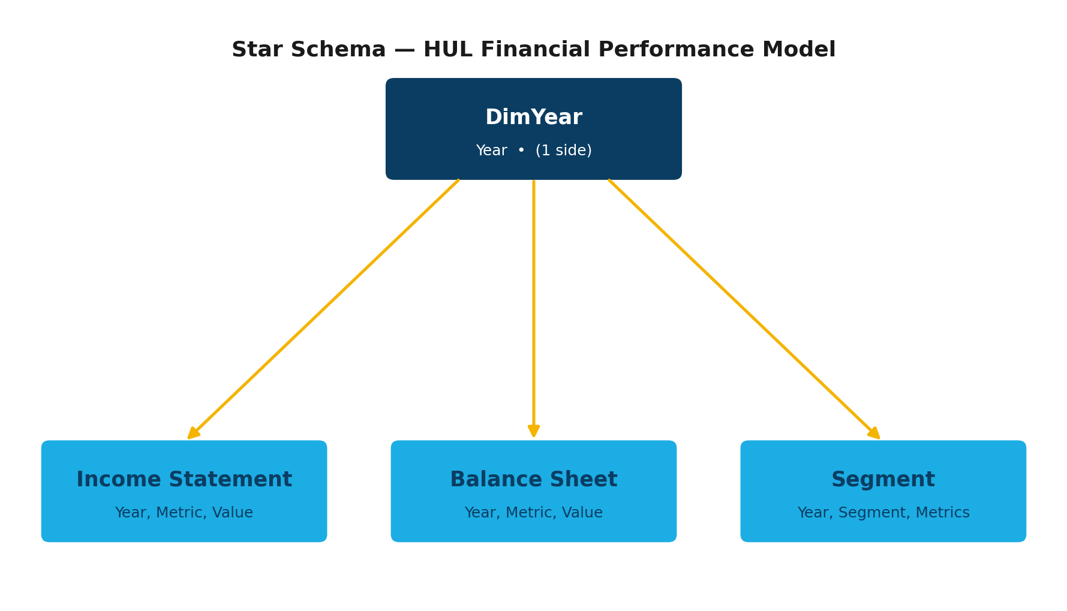
All three fact tables relate to DimYear[Year] on a many-to-one, single-direction basis. This is the simplest possible model that still supports full cross-filtering — selecting a year on the slicer filters every visual through the same dimension.

3.4 Why Long Format Was Kept (Not Pivoted)
Income Statement and Balance Sheet arrived in long format (Year, Metric, Value). Rather than pivoting each metric into its own column in Power Query — which would require updating the M-query's explicit type-casting step every time a line item changes, and risks the M-query/engine desync that comes from editing Power Query logic directly through an XMLA connection — every metric is retrieved through a measure:
Total Revenue =
CALCULATE(
SUM('Income Statement'[Value]),
'Income Statement'[Metric] = "Revenue"
)
This trades a small amount of DAX verbosity for a model that's safer to extend — adding a new line item from the source file requires zero schema changes, only a new measure.

4. DAX Measure Design

4.1 Structure
40 measures across 4 display folders, all housed in a dedicated measure table (named “ Measures” with a leading space, both to avoid a reserved-word conflict and to pin it to the top of the Fields list):
Folder | Count | Examples
01 Income Statement | 15 | Total Revenue, EBITDA Margin %, Net Profit Margin %, Dividend Payout %
02 Balance Sheet | 17 | Current Ratio, Debt to Equity, ROE %, ROA %, ROIC %
03 Segment & Profitability | 5 | Segment Revenue Share %, Segment EBIT Margin %, Best Performing Segment
04 Growth & YoY | 3 | Revenue YoY %, Net Income YoY %, EBITDA YoY %

4.2 Ratio Correctness Principle
A common dashboard bug: pulling a stored “%” row straight from source data and summing it across multiple selected periods, which produces a meaningless number. Every ratio/margin measure in this model is instead computed live from its underlying additive components:
Operating Margin % = DIVIDE([Operating Income (EBIT)], [Total Revenue])
ROE % = DIVIDE([Net Income (PAT)], [Total Equity])
This guarantees correct results whether one year or all four are selected.

4.3 Year-over-Year Growth Without a True Calendar
Since the grain here is fiscal year labels (“FY2022”–“FY2025”) rather than a continuous date column, standard time-intelligence functions don't apply. Instead, YoY measures construct the prior year's label directly and look it up:
Revenue YoY % =
VAR CurYearNum = SELECTEDVALUE(DimYear[YearNumber])
VAR PriorYear = "FY" & (CurYearNum - 1)
VAR PriorRev = CALCULATE([Total Revenue], DimYear[Year] = PriorYear)
RETURN DIVIDE([Total Revenue] - PriorRev, PriorRev)

4.4 The Metric-Selector Pattern (Balance Sheet Snapshot)
The dashboard needed a compact “financial statement” style table — metrics down the rows, years across the columns. Power BI's native approach (swapping the implicit “Values” field between Rows/Columns) proved unreliable in the UI during the build. The more robust fix was a disconnected metric-selector table paired with a single switching measure that returns the correct value — and correct format — depending on which metric row is in context. Because the model's compatibility level didn't support dynamic format-string expressions, the measure returns pre-formatted text, with a hand-built, locale-independent Indian digit-grouping routine rather than relying on FORMAT()'s culture-dependent grouping, which was confirmed during testing to render Western-style (798,800) instead of Indian-style (7,98,800) grouping depending on the evaluation context.

5. Dashboard Design
Layout philosophy: one always-on context chart (the 4-year revenue/net income trend, deliberately excluded from slicer interaction so the full history is always visible) surrounded by slicer-responsive KPI cards and supporting charts — giving viewers both the long-run story and a current-year snapshot simultaneously.
Visual | Purpose
5 KPI cards | Revenue, Net Income, EBITDA Margin, ROE, Current Ratio — headline numbers
Revenue & Net Income trend | Combo chart, always shows all 4 years regardless of slicer
Segment Revenue Share donut | Mix of business across the 3 segments, slicer-responsive
Segment EBIT Margin bar | Profitability comparison across segments
Balance Sheet Snapshot matrix | Metric-selector pattern, full financial-statement view
Best Performing Segment card | Single-line callout

6. Key Financial Insights
Headline Findings
- Growth deceleration: Revenue YoY growth fell from +15.5% (FY23) to +2.4% (FY24) and +2.2% (FY25) — strong post-pandemic recovery followed by a maturing growth curve.
- Margin stability: EBITDA margin held in a tight 23.8%–24.8% band across all four years — no major cost shocks or pricing wins, just consistent execution.
- Segment leadership: Beauty & Personal Care delivers both the largest revenue share (~37%) and the highest margin (25.6%–27.6%) every single year — the clear profit engine of the portfolio.
- Capital efficiency improving: ROE rose from 18.1% (FY22) to 21.5% (FY25) while leverage stayed minimal (Debt-to-Equity 0.02–0.03) — returns are being driven by operational efficiency, not borrowed capital.
- Liquidity tightened in FY25: Current Ratio fell from a four-year high of 1.66 (FY24) to 1.33 (FY25), driven by a 28% jump in current liabilities — worth flagging as a working-capital watch item.
- Shareholder-friendly but aggressive payout: Dividend payout ratio exceeded 100% in FY22 (135%), meaning HUL returned more cash to shareholders than it earned that year.

7. Challenges & Resolutions
Challenge | Resolution
Broken DimYear header blocking relationships | Added missing Table.PromoteHeaders step in Power Query
New relationships not resolving in DAX queries | Triggered a Calculate-type partition refresh to force model recalculation
Trend chart collapsing to one year under slicer filter | Used Edit Interactions → None to decouple the always-on trend chart from the Year slicer
KPI cards auto-abbreviating currency to “K” | Disabled auto display units on each card
Matrix “Values” axis swap unreliable in the Power BI UI | Replaced with a disconnected metric-selector table + single switching measure
Currency formatting culture-dependent in DAX FORMAT() | Built a manual, locale-independent Indian digit-grouping routine

8. Future Enhancements
- Add a drill-through page per segment for deeper line-item analysis
- Bring in quarterly data (if available) to support intra-year trend analysis
- Add a “What-If” parameter for scenario modeling (e.g. revenue growth sensitivity on ROE)
- Extend the metric-selector pattern to the Income Statement for a full P&L snapshot matrix
Source: Company financials, FY2022–FY2025 · Built in Power BI

