Flow of Program -

Flowchart & Pseudocode

Flowchart
- Flow chart uses the following symbols for representing various functions

Is represented | By
Start / Stop | Ellipse Or Oval
Input / Output | Parallelogram
Processing | Rectangle
Condition | Rhombus Or Diamond
- Used to visualize our thought process
- Sometimes used to describe complex architecture

Flow Exercise - 1:
Take a name and output hello name

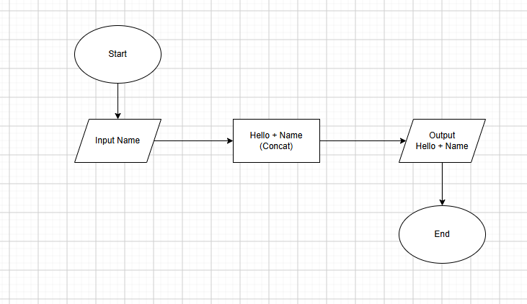
Flow Exercise - 2:
Take input of a salary and if the salary is greater than 10,000 then add a bonus of 2000, Otherwise add a bonus of 1000
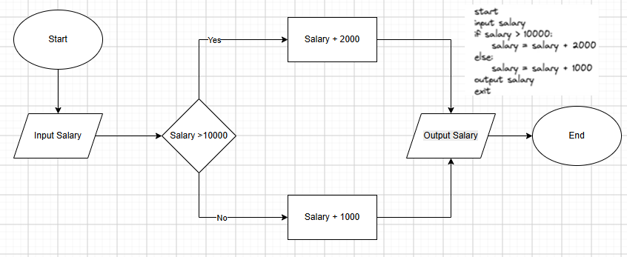

Flow Exercise - 3:
Input a number check if it is prime or not
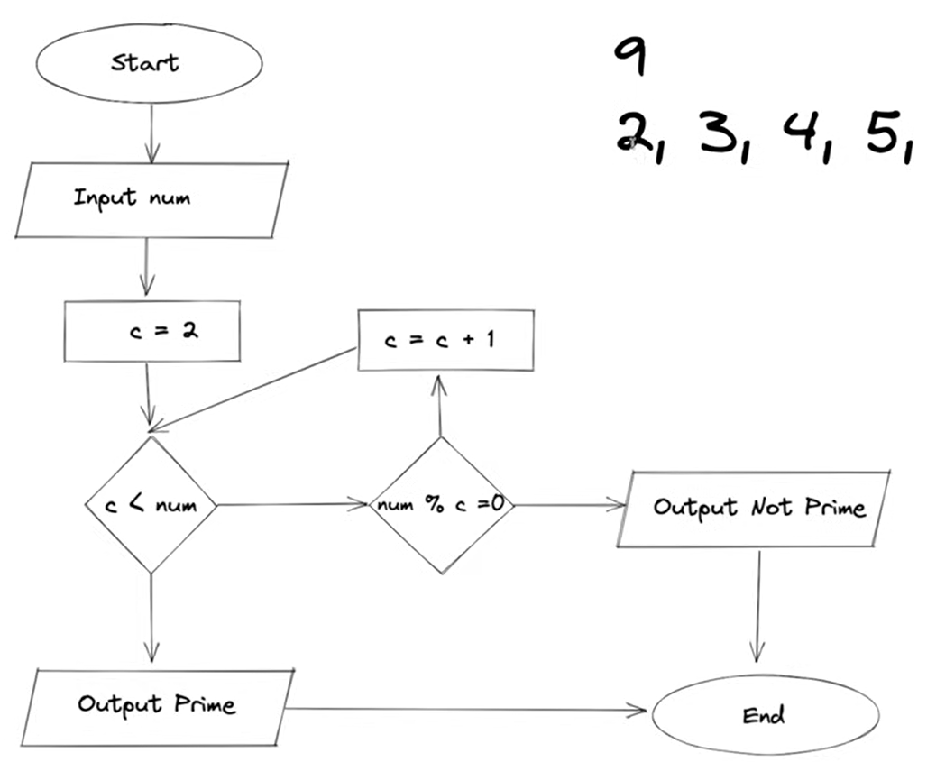

Pseudocode
- If we want to share algorithms with someone we share it with them in the form of pseudocode. Programming language doesn't matter. It captures the essence of what an algorithm does.
- Basically a rough code.
- Looks as shown below
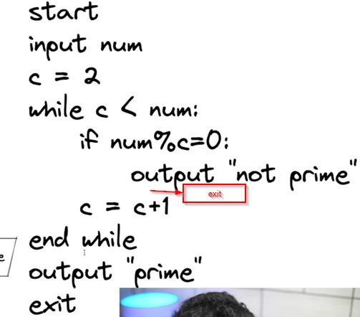
- Tab space is used after the while condition to represent what is running after while is running when the condition specified inside the loop is satisfied.
- So, c < num should be true and the if statement should check its condition while c < num is true.
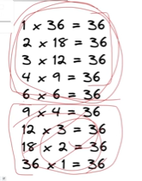
- Here in the prime not prime program, if the number is large, While checking the condition, the number repeats itself as shown below.
- So, while checking 36 as prime or not, if we check the divisibility only up to 6 that would be fine as other cases repeat themself.
- So, we need to only check up to the square root of the number. Here, √36 = 6. So, we need to check only up to 6.
- This would reduce the complexity of the program by its square root. So, in the above image, it should be √num.

