Boiler Plate →
- In Java, every file which ends with .java is a class by itself
- Class → is a named group of properties and functions
- In every file, the name of the class will always be the same as the name of the file. If not, the compiler throws an error.
- The whole code will be written in that class
- Class name starts with a capital letter. (Generally used convention)
- Many classes can be written in a .java file. But, the class name which is the same as the file name should always be a public class.
- Public → Can be seen by all. Even from other files. Can be accessed from anywhere. Called as Access modifiers.
- Inside the class, we should create a function. And the function name has to be main.
- Function / Method → is a block or collection of code that is reusable.
- main → is the function where the program starts. It is the entry point to the program. Main function is searched first, and this is the first function which to be executed
- static → The static variables and functions do not depend upon the objects (The instances which are created from the classes)
- Here, Demo or Main is the class name in the file. Which is not yet executed to create an instance (Object) of that class. So, as discussed above, static objects do not depend on the objects. So the first function which should run in the class should be independent of the class or object. So, that is why static is used before the main function. Or the main function is made static.
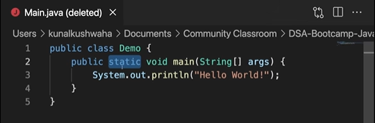
- Void → This is the return type of the function. Void means this doesn't return anything.
- String[ ] args → These are command line arguments. Which is a collection of strings.
- The arguments which we are given in the terminal are stored in the arguments as an array of strings.
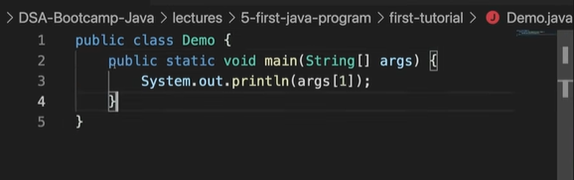

- The above will print out the command line arguments provided by us in the terminal.
- Same as we print the entries of an array or characters in a string.

Javac →
javac -d . Main.java
- The above will save the byte code in the same folder.

javac -d .. Main.java
- The above will save the byte code in the previous folder.
- Generally the byte code will go to the previous folder of the source code (src) folder. Which is good practice.
- Where javac, java, git, python are located in the computer.

where javac
where java
where git
where python
- The above commands will give the address or path of the directory as where they are located in the computer.

ls /usr/bin
- Gives us the list of the files contained in this folder.
- All these files will be the .exe files.

ls /usr/bin | grep javac
- The above applies filter to the command like if javac exists……
- When we execute the command in the command line, the system will search if the git or javac or java file exists or not in the system though the path variables and environment variables.

echo $PATH
- The above command will show all the path variables. i. e., it shows all the paths where the system searched for to find the file. When it finds the file, it will stop searching and start executing.

IntellijIDEA →
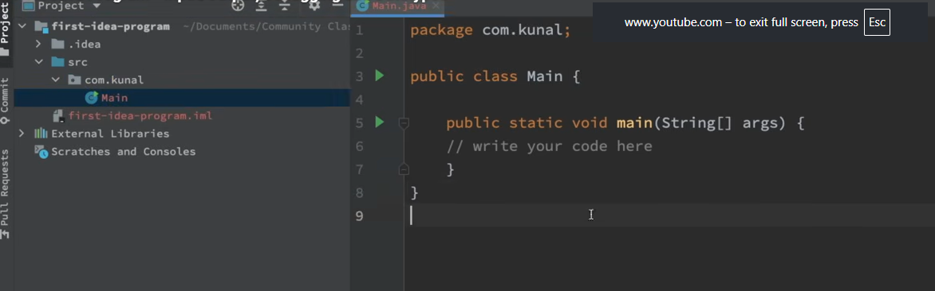
- The above is an IntellijIDEA screen. It will show the selected folder, in the folder, we can see the src file.
- Src → file contains the source code and the package.
- We can make a class public, only when the name of the file matches with the name of the class. Other classes cannot be made public in a file.

// The file MUST be named MainApp.java because this class is public
public class MainApp {
public static void main(String[] args) {
HelperTool tool = new HelperTool();
tool.displayMessage();
}
}

// This additional class cannot be public
class HelperTool {
void displayMessage() {
System.out.println("Hello from the helper class!");
}
}
//for further reference
- Package → is a folder in which a java file lies. So, the files in this package or folder are inaccessible to the files in other folders.
- This is like an extra layer of security. Access modifiers. Fully discussed during OOPs concept.
- Java contains some basic methods or functions which we can use for example: input, output,debugging, print, etc.
- The lang package contains all these functions. This is inherited by default.
- Ctrl + click (or) Cmd + click to navigate to that class where the function is stored.

Output →
- So, the system class has a variable called out (which is of printstream). And out has a method called println()
- Out is of printstream. So, println will be also in printstream.
- More about this in OOP.

System.out.println("Hello from the helper class!")
- The above is used for printing out the result on the command line.
- println() → adds a new line at the end.
- print() → Does not add a new line at the end.

Input →
- Input is taken into the system using scanner class.
- Scanner is available in the java.util package.

Scanner input = new scanner() //provide the object inside () from where input is being taken from
Scanner input = new scanner(System.in) // As shown here System.in means input is from the keyboard. by making changes, we can make it a text file and so on...
- System.out → is the standard output stream. Command line is the standard out stream In that standard output stream, println(“....something….”).
- If out is assigned to a file, then the println(“....something….”) will add ....something…. To that file.
- But, for input we have to create a new variable with a new keyword and initialize it with a constructor.
- System.in → is the standard input stream. Which is the keyboard. Initially it is also null.
- If system.in is replaced with a file name, then it reads input from that file.
- Basically if before a variable, scanner is written, that means the variable will read what we want to read.
- The new Scanner(system.in) object will read input from system.in or keyboard. If it is assigned to a file then it will read from that file.
- Scanner is a class which allows us to take input.
- Input is a variable which is pointing to the scanner class.

Data Types →

Primitive Data Type →
The datatype which cannot be broken into other datatypes.
byte →
- Size: 1 byte (8 bits)
- Range: -128 to 127
- Default value: 0 (for class fields)
- Used to store small whole numbers and save memory.
Short →
- Size: 2 bytes (16 bits)
- Range: -32,768 to 32,767
- Default value: 0 (for class fields)
- Used to store whole numbers that are larger than byte but smaller than int.
int →
- Used to store numbers (-ve, 0, +ve)
- Size 4 bytes.
- int RollNum = 33;
- A number cannot be broken further into other datatypes. So, primitive
- int is the most commonly used integer type.
char →
- Used to store characters or letters.
- Size 2 bytes
- char letter = ‘r’;
- Char starts with single quotes ‘.
- String starts with double quotes “.
- char stores a single character enclosed in single quotes ('A').
float →
- Used to store floating point numbers or decimals.
- Size 4 bytes.
- float marks = 98.81f;
double →
- Used to store large decimal numbers.
- Size 8 bytes.
- Double LargeDecimalNum = 7889632541.4536;
- double is the default type for decimal numbers.
long →
- Used to store large integer values.
- Size 8 bytes
- Long LargeRollNum = 7852145569L;
boolean →
- To store true or false values one at a time.
- boolean check = true;
- boolean value = false;
- boolean stores only true or false.

Data Type | Size | Range (Approx.) | Example
byte | 1 byte (8 bits) | -128 to 127 | byte age = 25;
short | 2 bytes (16 bits) | -32,768 to 32,767 | short year = 2025;
int | 4 bytes (32 bits) | -2,147,483,648 to 2,147,483,647 | int salary = 50000;
long | 8 bytes (64 bits) | Very large integers | long population = 8000000000L;
float | 4 bytes | About 6–7 decimal digits | float price = 19.99f;
double | 8 bytes | About 15–16 decimal digits | double pi = 3.141592653589793;
char | 2 bytes (16 bits) | A single Unicode character | char grade = 'A';
boolean | JVM-dependent (typically 1 byte in memory) | true or false | boolean isPassed = true;

- Written numbers like 42 are treated as int (32-bit) by default. Adding L forces the compiler to read it as a long (64-bit).
- All the decimals are of type double by default. To store this double in float, we need to use f at the end.
- Written numbers with points like 3.14 are treated as double (64-bit) by default. Adding f forces the compiler to read it as a float (32-bit).
- The primitive datatypes contain classes as well.
- Wrapper classes are used to add extra functionality to the primitives. More on this in later.
- Whole numbers: byte, short, int, long
- Decimal numbers: float, double
- Character: char
- True/False: boolean
- In most Java programs, int is the preferred integer type unless you have a specific reason to use byte or short, such as reducing memory usage or working with binary data.
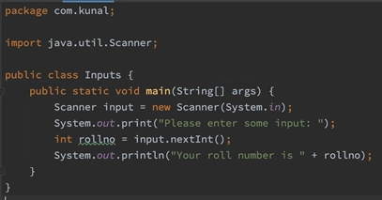
- The above program prints roll no. as output when roll no. is provided as input.

Literals and Identifiers →

1. Identifiers
Identifiers are the names given to program elements such as variables, methods, classes, interfaces, and packages.
Examples:
int age = 20; // age is an identifier
String name; // name is an identifier
class Student { } // Student is an identifier
void display() { } // display is an identifier


Rules for Identifiers:
- Can contain letters, digits, _ (underscore), and $.
- Must begin with a letter, _, or $.
- Cannot start with a digit.
- Cannot be a Java keyword (e.g., int, class, if).
- Are case-sensitive (Age and age are different).
Valid identifiers:
studentName
_age
$price
num1


Invalid identifiers:
1name // starts with a digit
class // keyword
student-name // contains hyphen




2. Literals
Literals are fixed values written directly in the source code.
Examples:
int x = 10; // 10 is an integer literal
double pi = 3.14; // 3.14 is a floating-point literal
char ch = 'A'; // 'A' is a character literal
String s = "Java"; // "Java" is a string literal
boolean b = true; // true is a boolean literal


Types of Literals in Java:

Type | Example
Integer Literal | 10, 100, 0x1A
Floating-point Literal | 3.14, 2.5e3
Character Literal | 'A', '\n'
String Literal | "Hello"
Boolean Literal | true, false
Null Literal | null
Example Combining Both

public class Test {
public static void main(String[] args) {
int age = 21;
String name = "John";
}
}


- Identifiers: Test, main, args, age, name
- Literals: 21, "John"
In short:
- Identifier = Name given to a program element.
- Literal = Constant value written directly in the code.

Type conversion and casting →
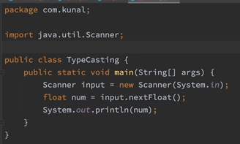
- For the above, if we give input as 67. It will give us an output of 67.0
- Automatically, the type of the variable is converted from integer to float.
- When is this possible
  - The type should be compatible. As shown above, float is taken in the main function. And the input given is an integer. So, it gets converted. But if as input a string is provided, the compiler throws an error.
  - The destination type should be > the source type. I.e., in the above image, the destination is float and integer is provided. So, it works. Generally, floats always have numbers after the point. Which is extra. So float is > integer.
    - When the destination is float and integer is provided, .0 can be appended at the end. So that it is converted to a float. But, if the destination is integer and if we provide decimal value, the system can't decide on its own to round or truncate the decimal value provided. So , it throws an error.

int num = (int)(67.56f);
System.out.println(num);

- The above gives an output 67.
- This is type casting. Now we explicitly mentioned converting 67.56 to int. Which will round it to zero decimal places or truncate the decimal value.

int a = 257;
byte b = (byte)(a);
System.out.println(b);

- The above will give an output of 1
- Byte can only store values up to 256. But, given 257, byte can’t store it. So, it returns the remainder 257 % 256 = 1.

Byte a = 40;
Byte b = 50;
Byte c = 100;
int d = a * b / c;
System.out.println(d);

- In the above code, a * b produces 2000 which is > 256. But still the compiler doesn’t throw an error because d is declared as int. 2000 is converted to int which is acceptable.

byte b = 50;
b = b * 2;
System.out.println(b);

- This throws an error. b * 2 is an operation which should be performed between integers. After that it is being assigned to a byte.

int number = ‘A’;
System.out.println(number);

- This gives an output of 65. a in place of A gives 97. These are the ASCII values of those characters.
- Java works on unicode values. Every language can be printed on the command line.

