Introduction
- The machine understands zeros and ones. We can't write everything in zeros and ones. So, we write in a human readable format as a programming language.
- What we write in a human readable format is written in a .java file for java. In a .cpp file for c++ and in a .c file for c.
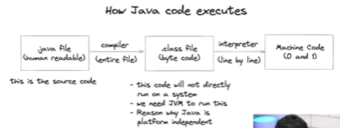
- .java → file contains all the code which we write in human readable format.
- Generally in C and C++, after writing the code, the file is given to the compiler. Which will turn the whole source code into the machine code (0’s and 1’s).
- But Java is different. The compiler turns the source code into Byte code (which is stored in a .class file) which is not machine code. This is an intermediary step. The entire file is turned into byte code.
- The byte code cannot run on the machine. JVM should convert it into machine code. Only then the machine can understand it and execute it.
- JVM will interpret the byte code into machine code line by line. Then the machine will be able to read and execute it.
- The middle step is skipped in C and C++. They directly perform the last step which gives the .exe file.
- The middle step makes the java platform independent. It can run on any device which contains JVM.
- Platform independence means byte code can run on any operating system.
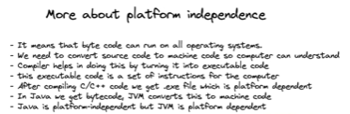
- For example, Source code is compiled to byte code on a Mac. But, it can run on a linux system or a windows system. This is called platform independence.
- So, source code is compiled on a system. The compiled code can run on any other system.
- The .exe file is platform dependent. If it is compiled on one OS, it doesn’t run on another OS. the code needs to be compiled again.
- The .exe file is basically a set of instructions to the computer. They are dependent on the architecture of the machine.
- Java is platform independent. But, JVM is platform dependent. So, based on the system OS that specific JVM is downloaded and installed.
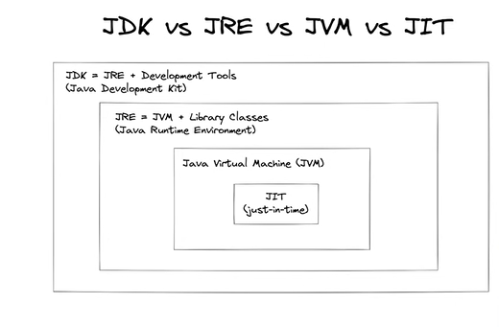
JDK →
- A package or a set of files to be downloaded from the internet. Which provides environment to develop and run the java program
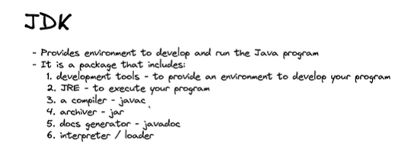
- javac - used to compile .java code to byte code.
- Archiver - used to archive files
- To generate docs, javadoc is used.
JRE →
- JRE is also an installation package used to run the java code. It does not help in development of the program

