Switch Statement, Break, Nested Switch Statement

String a = “Kunal”;
String b = “Kunal”;
System.Out.Println(a == b)
// will print true.
a.equals(b)

- Here, a.equals(b) only checks the value. It doesn’t check the reference variable. Only checks if the value of a is equal to the value of b or not.
- But, a == b will check both the value and the reference variable. So, in the above case, there is only one “kunal” object and both the variables a and b are pointing towards that.

Switch Statement →
- Used to write multiple if-else statements at once.

Switch ( Expression ){
Case-1:
// Do Something
break;

Case-2:
// Do Something
break;

Case-3:
// Do Something
break;

default:
// Do Something
}

- We can jump to various cases based on expressions.
- In the above syntax, the expression is the variable which we are iterating on. And the possible values of that expression are written in the case statements. So, when the expression's value is equal to any of the cases, the specified work is performed.
- The cases have to be the same type as of the expression types.
- Duplicate cases are not allowed
- Break is used to terminate the sequence, if not written, it will continue to the next case.
- If none are true, the default will execute.
- If default is not at the end use break. After default, break is not needed.

Below is enhanced switch statement
Switch (expression) {
Case value-1 -> // Do something
Case value-2 -> // Do something
Default -> // Do something
}

- Both the below are correct and produce the same results.

Scanner in = new Scanner(System.in);
int day = in.nextInt();
Switch ( Day ){
Case 1:
System.Out.Println(“Monday”);
Break;
Case 2:
System.Out.Println(“Tuesday”);
Break;
Case 3:
System.Out.Println(“Wednesday”);
Break;
Case 4:
System.Out.Println(“Thursday”);
break;
Case 5:
System.Out.Println(“Friday”);
break;
Case 6:
System.Out.Println(“Saturday”);
break;
Case 7:
System.Out.Println(“Sunday”);
break;
}

—------------------Or—------------------------

Scanner in = new Scanner(System.in);
int day = in.nextInt();
Switch ( Day ){
Case 1 -> System.Out.Println(“Monday”);
Case 2 -> System.Out.Println(“Tuesday”);
Case 3 -> System.Out.Println(“Wednesday”);
Case 4 -> System.Out.Println(“Thursday”);
Case 5 -> System.Out.Println(“Friday”);
Case 6 -> System.Out.Println(“Saturday”);
Case 7 -> System.Out.Println(“Sunday”);
}

- Weekdays and weekends program

int day = in.nextInt();
Switch ( Day ){
Case 1:
Case 2:
Case 3:
Case 4:
Case 5:
System.Out.Println(“Weekday”);
break;
Case 6:
Case 7:
System.Out.Println(“Weekend”);
break;
}

—---------or—----------

int day = in.nextInt();
Switch ( Day ){
Case 1, 2, 3, 4, 5 -> System.Out.Println(“Weekday”);
Case 6, 7-> System.Out.Println(“Weekend”);
}

Nested Switch Statement →
- The switch case inside a switch case is a nested switch case.
- Below is the syntax

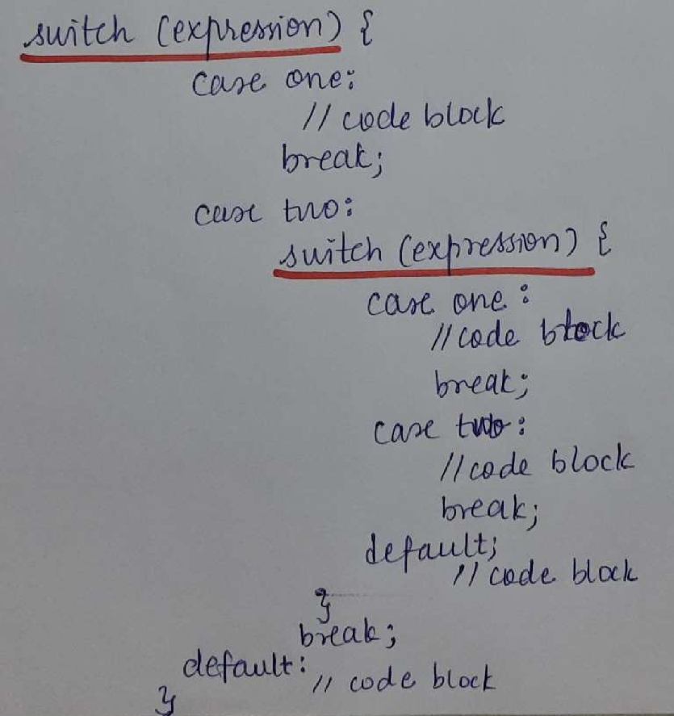

- Below is the example for a nested switch statement.

Scanner in = new Scanner(System.in);
int empID = in.nextInt();
String department = in.next();

switch (empID) {
case 1:
System.out.println("Kunal Kushwaha");
break;
case 2:
System.out.println("Rahul Rana");
break;
case 3:
System.out.println("Emp Number 3");
switch (department) {
case "IT":
System.out.println("IT Department");
break;
case "Management":
System.out.println("Management Department");
break;
default:
System.out.println("No department entered");
}
break;
default:
System.out.println("Enter correct EmpID");
}

// better way to write
switch (empID) {
case 1 -> System.out.println("Kunal Kushwaha");
case 2 -> System.out.println("Rahul Rana");
case 3 -> {
System.out.println("Emp Number 3");
switch (department) {
case "IT" -> System.out.println("IT Department");
case "Management" -> System.out.println("Management Department");
default -> System.out.println("No department entered");
}
}
default -> System.out.println("Enter correct EmpID");
}

