RESEARCH DOCUMENTATION
────────────────────────────────────────────────────────────────────────────────────────────
SYNCODE NEXTGEN
A Privacy-Oriented, AI-Assisted Real-Time Collaborative Development Environment

GL BAJAJ INSTITUTE OF TECHNOLOGY & MANAGEMENT
Greater Noida, Uttar Pradesh, India
PRIMARY AUTHOR
Rudraksh Kumar
Team Members: Sandeep Kushwaha • Sagar Gautam • Sanjay Prajapati
Department of Computer Science & Engineering
Academic Project / Research Documentation
PROJECT SYNOPSIS
SyncCode NextGen is a browser-based collaborative development environment designed to combine multi-user code editing, file management, persistent project state, version history, secure local backup, peer-assisted synchronization, code execution support, and AI-assisted software engineering in one workspace. The system reduces context switching by keeping editor, collaboration, AI, execution, recovery, and project-state features inside a single development surface. Its architecture separates presentation, API, real-time communication, persistent storage, execution, and intelligence concerns, enabling a modular path for future research on local-first and distributed development workflows.
Submitted for academic documentation and project evaluation

ABSTRACT
Modern software development increasingly depends on multiple disconnected tools for coding, communication, AI assistance, execution, project storage, and recovery. This fragmentation creates context switching and makes collaborative debugging harder to manage. SyncCode NextGen presents a unified browser-based development workspace that combines a Monaco-based code editor with real-time room collaboration, project persistence, file management, version snapshots, execution support, encrypted backup, recovery mechanisms, and AI-assisted analysis. The system is structured around a React/Vite client, Node.js and Express services, Socket.IO for event-based real-time communication, MongoDB for project and version persistence, WebRTC-oriented peer services, Web Crypto based local protection, and AI service integration. The research documentation emphasizes the system architecture, working workflow, synchronization and recovery pipeline, folder organization, security model, and evaluation methodology rather than a day-wise implementation history. The design also provides a foundation for future local-first and conflict-resilient collaboration experiments. The paper positions the platform as an academic prototype for investigating how collaborative programming, AI assistance, persistence, and recovery can be integrated without forcing developers to switch between separate applications.
Index Terms— collaborative software development, real-time synchronization, Monaco Editor, Socket.IO, WebRTC, MongoDB, AI-assisted development, version history, recovery, secure backup.

AUTHOR SYNOPSIS
Field | Details
Primary Author | Rudraksh Kumar
Team Members | Sandeep Kushwaha; Sagar Gautam; Sanjay Prajapati
Institute | GL Bajaj Institute of Technology & Management, Greater Noida
Department | Computer Science & Engineering
Project Type | Collaborative IDE / Research Prototype
Project Repository | https://github.com/rudrak2005/SYNC-CODE-AI

RESEARCH OBJECTIVE
The objective is to design and document a practical collaborative coding environment in which editing, collaboration, persistence, execution, AI assistance, security, and recovery are coordinated through a single project workspace. The work focuses on software architecture and reproducible engineering rather than presenting unverified performance claims.

SCOPE AND CONTRIBUTION
- Real-time shared workspace with room isolation, presence, collaborative code events, and cursor-oriented interaction.
- Persistent project representation with revision tracking, snapshot creation, restoration, and recovery support.
- Integrated AI assistance for explanation, review, bug detection, test generation, planning, workflow proposals, and code-diff application.
- Client-side encrypted backup and room-encryption mechanisms designed to reduce exposure of stored local project data.
- A documented end-to-end workflow connecting user action, synchronization, persistence, intelligence, execution, and recovery.

I. INTRODUCTION
Collaborative programming has evolved from local IDE workflows to shared browser environments in which multiple users may edit the same project, inspect runtime output, and communicate while preserving a common state. A typical developer workflow, however, still spans several interfaces. The resulting context switching can interrupt concentration and create duplicated effort during review, debugging, and explanation.
SyncCode NextGen addresses this fragmentation by treating the collaborative workspace as a system rather than a single editor widget. The project combines a browser client, authentication and API services, real-time socket events, persistent project storage, version management, peer-oriented services, and AI tools. The architectural goal is to make each subsystem replaceable while maintaining a consistent project-state model.

A. Problem Statement
- Multiple tools are often required for coding, communication, AI support, execution, and project recovery.
- Real-time collaboration requires consistent propagation of file and code changes while preserving room isolation.
- Project state must survive refreshes, network interruptions, and deliberate snapshot restoration.
- AI assistance should operate on the current code context and return actionable results without forcing users to leave the workspace.
- Security controls must distinguish authentication, transport, encrypted local backup, and execution isolation concerns.

B. Related Concepts
The architecture draws on established concepts in real-time collaboration and software tooling. CRDT research provides a theoretical basis for concurrent data convergence, while event-driven WebSocket communication provides a practical transport for presence and room events [6]. Monaco supplies an editor engine suitable for browser-based IDE experiences [7]. WebRTC exposes browser-native peer communication primitives [8]. MongoDB provides a document database suitable for project metadata and snapshots [9]. AES-GCM is a standardized authenticated-encryption construction relevant to local encrypted storage [10]. IEEE guidance recommends an abstract, introduction, methodology, results/discussion, conclusion, and references structure for scholarly technical writing [1], [2].

C. Methodology
The methodology is architecture-first. Requirements are mapped into independently testable layers: authentication, workspace routing, editor state, collaboration transport, persistence, versioning, AI services, execution, recovery, and security. Functional validation is organized around user journeys such as authentication to dashboard, room creation to editor, editor to collaboration, edit to persistence, snapshot to restore, and code input to execution output. Future experimental work can extend this baseline with measured latency, recovery time, concurrent-user load, and network overhead, but this paper does not invent numerical results that have not been measured.

D. Design Principles
- modularity and clear service boundaries
- observable project revision/state
- human-in-the-loop AI application
- recovery as a first-class capability
- security-by-layer rather than security-by-feature

II. SYSTEM ARCHITECTURE
The system follows a layered architecture. The presentation layer is responsible for routing, editor rendering, file navigation, panels, and local UI state. The application layer handles authentication, projects, rooms, versions, execution requests, and AI orchestration. The real-time layer carries collaborative events and presence. The persistence layer stores projects, files, revisions, and snapshots. Peer-oriented services support direct or near-direct synchronization experiments. Security services protect sessions, transport, local backup, and execution boundaries.
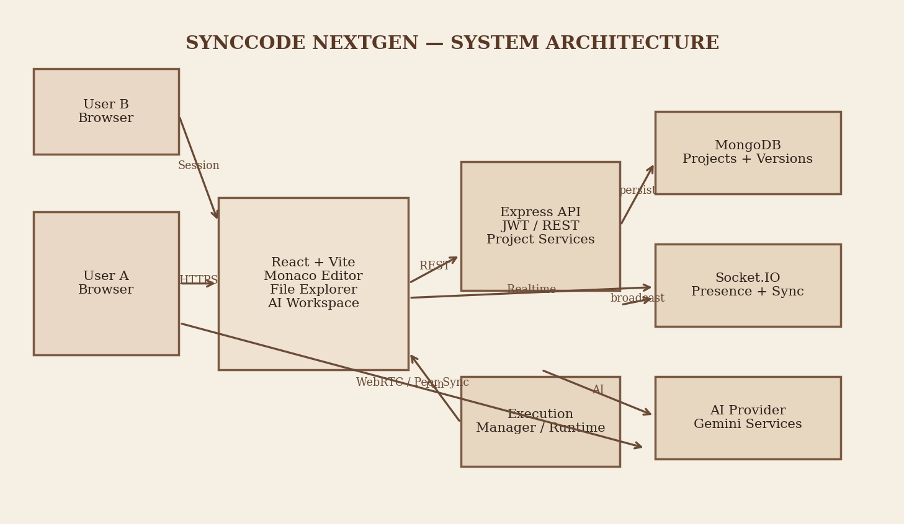
Fig. 1. High-level SyncCode NextGen system architecture and service boundaries.

A. Architecture Components
Layer | Primary Responsibility
Client | React + Vite, Monaco Editor, routing, editor state, file tree, AI panels, terminal, recovery controls.
API Services | Node.js/Express endpoints for authentication, projects, rooms, versions, and execution coordination.
Realtime Layer | Socket.IO events for room join, code updates, file events, presence, terminal output, and synchronization.
Persistence | MongoDB documents for projects, files, revision metadata, users, and version snapshots.
Peer / Secure Services | WebRTC-oriented peer communication and Web Crypto based encrypted local backup / room security experiments.
AI Layer | AI endpoints for explanation, review, bug analysis, test generation, planning, workflow proposals, and diff application.
Execution Layer | Language detection and execution manager that routes supported code to an appropriate runtime path while keeping execution separate from editor state.

B. Data Model View
The project model contains identifiers, project metadata, a file collection, and revision state. A version records revision information, author information, snapshot content, and creation time. A room identifies the collaborative context in which participants operate. This separation allows persistent project state to coexist with transient collaboration events.

III. WORKING FLOW AND COLLABORATION PIPELINE
The working flow begins when an authenticated user enters a room. The client establishes the collaboration session, loads the project state, renders the file tree and active file, and subscribes to real-time events. When a user edits a file, the client updates local editor state immediately and emits a structured change event. The collaboration layer propagates the update to room participants and peer-oriented channels where enabled. The application updates revision state and persists project changes through its storage path. Snapshots and recovery mechanisms provide durable checkpoints.
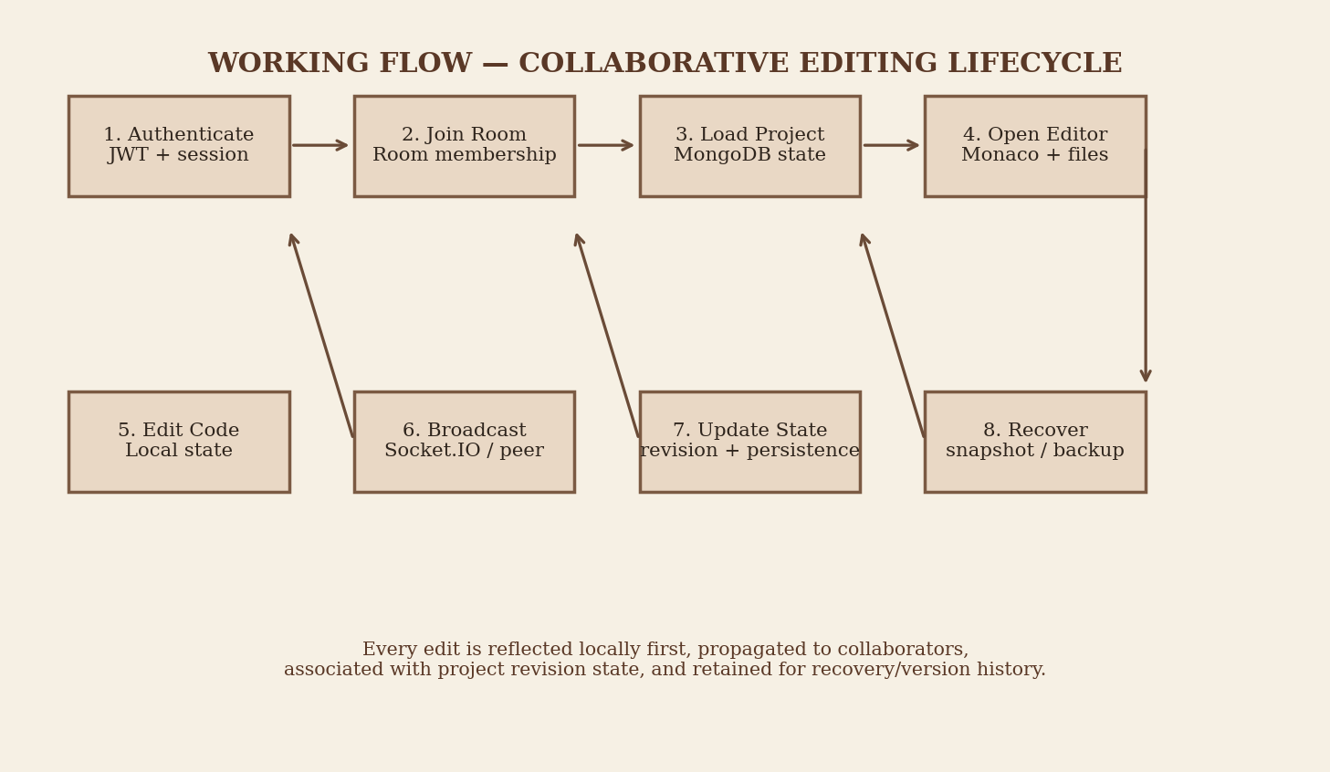
Fig. 2. End-to-end working flow from authentication to recovery.

A. Processing Pipeline
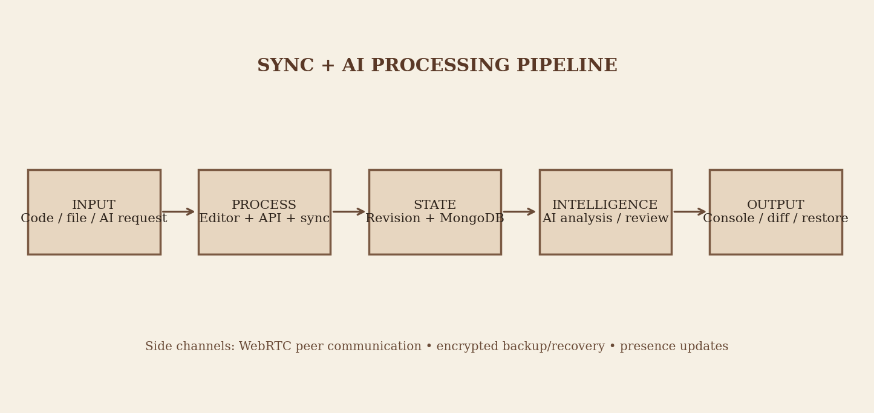
Fig. 3. Unified synchronization, persistence, AI, and output pipeline.

Integrated Working Paths
Code editing follows a local-first visual response followed by structured room events; remote updates are validated and merged while persistence remains separate from ephemeral presence. The AI path consumes the current code context, returns explanation/review/test/plan/diff results, and requires human approval before any generated code re-enters the editor change path.

IV. PROJECT FOLDER STRUCTURE
SyncCode-NextGen/
├── client/
│ ├── src/
│ │ ├── components/ # editor UI, AI panels, users, tabs, terminal
│ │ ├── pages/ # home, auth, dashboard, room, editor
│ │ ├── context/ # authentication/session context
│ │ ├── hooks/ # realtime, peer, recovery, encrypted sync
│ │ ├── services/ # API, socket, execution, version services
│ │ ├── lib/ # execution and supporting libraries
│ │ ├── utils/ # language/file helpers
│ │ └── routes/ # application routing / protection
│ └── package.json
├── server/
│ ├── controllers/ # request handling
│ ├── routes/ # API route definitions
│ ├── models/ # MongoDB / Mongoose models
│ ├── middleware/ # auth and request middleware
│ ├── services/ # execution / application services
│ ├── utils/ # shared backend helpers
│ └── server.js # HTTP + Socket.IO entry point
├── README.md
└── documentation/ # research, architecture and project material
Fig. 4. Simplified repository structure for documentation; secret files such as .env are intentionally omitted.

A. Implementation Stack
Area | Technologies / Role
Frontend | React, Vite, React Router, Monaco Editor, CSS-based interface components.
Backend | Node.js, Express, Socket.IO, JWT authentication, Mongoose.
Database | MongoDB for users, projects, room-related state, revisions, and versions.
Realtime | Socket.IO room events, collaborator presence, file and code updates; WebRTC-oriented peer channel.
Security | JWT sessions, HTTPS in deployment, Web Crypto encrypted backup, room/local encryption controls.
AI | Gemini-backed services for explanation, review, bug detection, tests, planning, workflow and diffs.
Execution | Language-aware execution manager with JavaScript, Python, C/C++/Java paths represented by the client execution layer.

B. Security and Reliability
- Authentication and authorization are separated from collaborative data channels.
- Encrypted local backup uses password-derived protection and authenticated encryption primitives through the Web Crypto based storage path.
- Recovery snapshots provide a second state path when live synchronization or connectivity is interrupted.
- Revision tracking makes state changes explicit and supports version history and restoration.
- Execution isolation is treated as a distinct security boundary; arbitrary code should not be executed directly inside the primary API process.

C. Evaluation Plan
A reproducible evaluation should measure synchronization latency, revision propagation delay, recovery time, peer connection success, CPU and memory use, execution response time, and behavior under increasing collaborative load. The test matrix can include 2, 5, 10, and 20 simultaneous participants, with each scenario repeated under stable and degraded network conditions. Final experimental numbers should be generated from actual measurements rather than estimates.

V. RESULTS AND DISCUSSION
The implemented prototype demonstrates an integrated workflow in which collaborative editing, project persistence, version history, AI tooling, execution support, and recovery coexist in the same browser workspace. The architectural evidence collected during development indicates that the revision model provides a useful common reference for persistence and versioning, while Socket.IO provides a practical event transport for interactive room features. The interface can expose multiple tools without moving the user away from the editor, which directly addresses the context-switching motivation.
The platform is an academic prototype, so latency, scalability, and reliability claims should be made only after controlled experiments. Future work includes stronger conflict-resilient synchronization, broader execution isolation, richer collaboration surfaces, and empirical benchmarking.

A. Limitations
- Synchronization strategy remains an evolving research area and can be strengthened with a formally verified conflict-free document model.
- Execution coverage and isolation require platform-specific validation.
- AI output is probabilistic and requires human approval.
- Large-room performance needs systematic load testing.

VI. CONCLUSION
SyncCode NextGen unifies coding, real-time collaboration, persistence, AI assistance, execution, and recovery around explicit project state and separable communication channels. The resulting platform is suitable for academic experimentation on collaborative and AI-assisted software engineering workflows.

Project and Reference Links
Project Repository: https://github.com/rudrak2005/SYNC-CODE-AI
Institute Website: https://www.glbitm.org/
IEEE Article Structure: https://journals.ieeeauthorcenter.ieee.org/create-your-ieee-journal-article/create-the-text-of-your-article/structure-your-article/
IEEE Conference Paper Structure: https://conferences.ieeeauthorcenter.ieee.org/write-your-paper/structure-your-paper/
Monaco Editor: https://microsoft.github.io/monaco-editor/
Socket.IO: https://socket.io/docs/v4/
WebRTC API: https://developer.mozilla.org/en-US/docs/Web/API/WebRTC_API
MongoDB: https://www.mongodb.com/docs/

VII. REFERENCES
[1] IEEE Author Center, “Structure Your Article,” IEEE, 2026. Available: https://journals.ieeeauthorcenter.ieee.org/create-your-ieee-journal-article/create-the-text-of-your-article/structure-your-article/.
[2] IEEE Author Center Conferences, “Structure Your Paper,” IEEE, 2026. Available: https://conferences.ieeeauthorcenter.ieee.org/write-your-paper/structure-your-paper/.
[3] IEEE Author Center, “IEEE Article Templates,” IEEE, 2026. Available: https://journals.ieeeauthorcenter.ieee.org/create-your-ieee-journal-article/authoring-tools-and-templates/tools-for-ieee-authors/ieee-article-templates/.
[4] SyncCode NextGen project architecture and implementation notes, project documentation, 2026.
[5] G. C. D. W. M. Petri, L. Lamport, and collaborators, “A comprehensive approach to conflict-free replicated data types,” distributed systems literature; used here as conceptual background for conflict-resilient synchronization.
[6] Socket.IO Documentation, “Introduction,” Socket.IO, 2026. Available: https://socket.io/docs/v4/.
[7] Microsoft, “Monaco Editor,” open-source browser code editor component. Available: https://microsoft.github.io/monaco-editor/.
[8] MDN Web Docs, “WebRTC API,” Mozilla. Available: https://developer.mozilla.org/en-US/docs/Web/API/WebRTC_API.
[9] MongoDB, “MongoDB Documentation,” MongoDB Inc. Available: https://www.mongodb.com/docs/.
[10] NIST, “Recommendation for Block Cipher Modes of Operation: Galois/Counter Mode (GCM) and GMAC,” SP 800-38D, 2007. Available: https://csrc.nist.gov/pubs/sp/800/38/d/final.
[11] MDN Web Docs, “Web Crypto API,” Mozilla. Available: https://developer.mozilla.org/en-US/docs/Web/API/Web_Crypto_API.
[12] React Documentation, “React,” Meta Open Source. Available: https://react.dev/.
[13] Google, “Gemini API Documentation,” Google AI for Developers. Available: https://ai.google.dev/gemini-api/docs.

