**O.S.T Practical 1**

* **Steps to Install Virtual Box**

1. Open Virtual Box
2. Click on ‘New’
3. Name and Operating System. Enter name and select ‘LINUX’ in Type.
4. Select Memory Size to **2048 MB**.
5. Create a Virtual hard disk now.
6. Hard disk file type **VDI** (Virtual Disk Image).
7. Storage on physical hard disk select between “Dynamically Allocated” and “fixed size” any.
8. File will be created….

* **Steps to Install Ubuntu**

1. Install Ubuntu
2. Keyboard Layout 🡪 **Continue**
3. Updates and other software 🡪 **Continue**
4. Installation type :- Install Now
5. Where are you ? (Default Kolkata) 🡪 Click **Continue**
6. Who are you ?

Enter Your Name :- **Rudhra**

Your Computer’s Name :- **OS By Rudhra**

Pick a username :- **rudrakanwar2004**

Choose password :- *******

**Continue**

**O.S.T Practical 2**

Step 1 :- Visit <https://www.libreoffice.org> and Download LibreOffice.

Step 2 :- Choose the compatibility of your computer ie. OS type :- 64-bit or 32-bit Windows or MacOS etc.

Step 3 :-

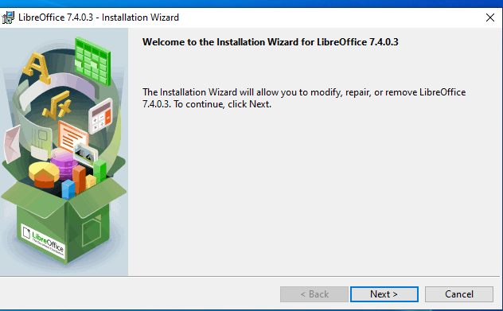

Step 4 :-

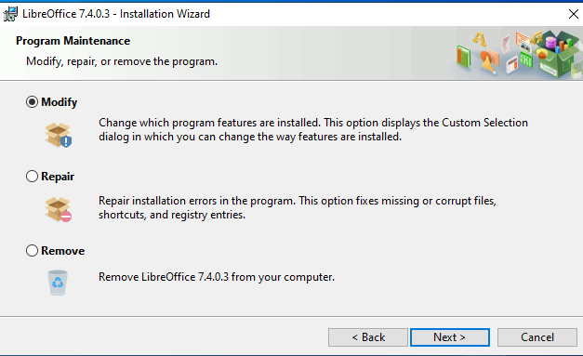

Step 5 :-

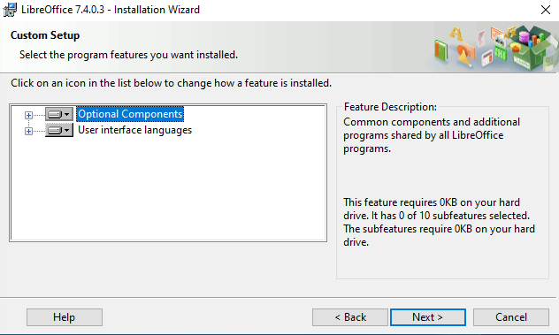

Step 6 :-

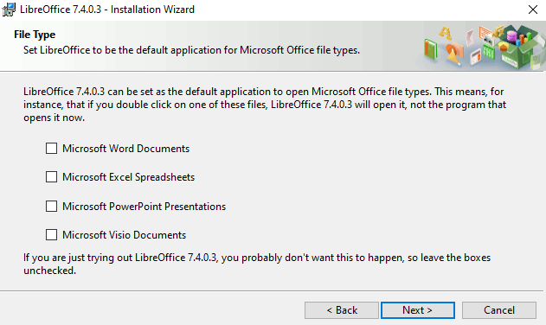

Step 7 :-

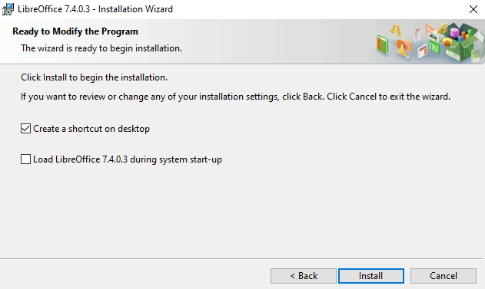

1. LibreOffice Writer

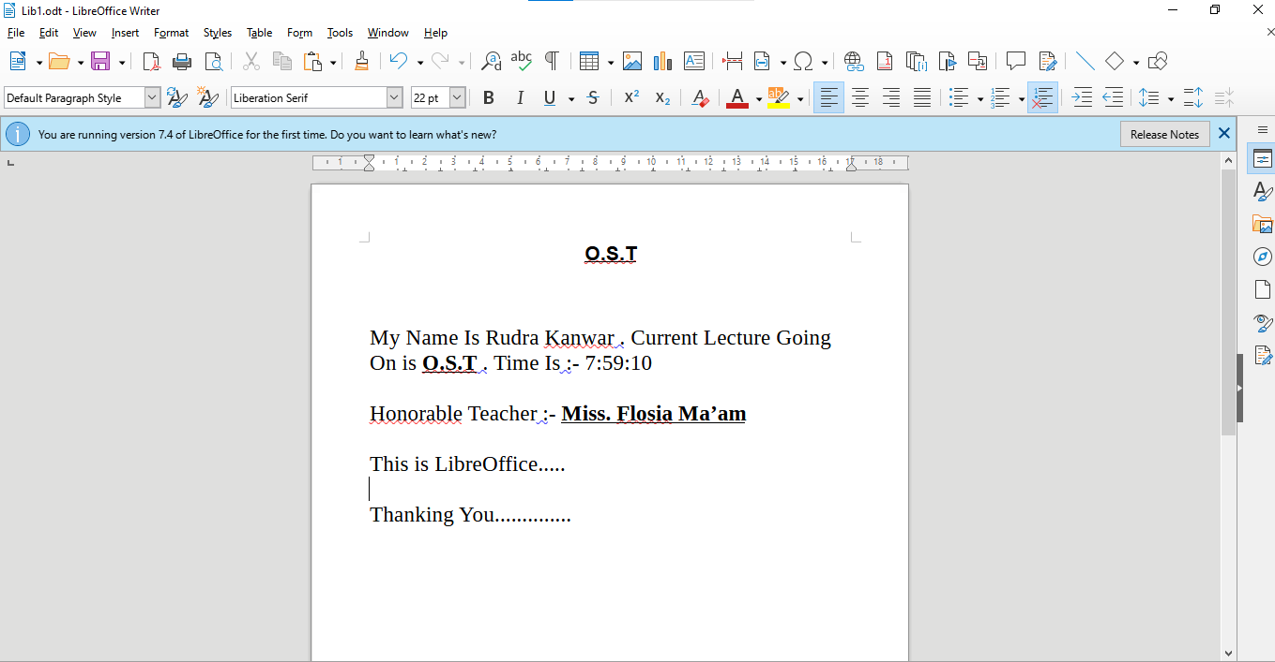

1. LibreOffice Calc Spreadsheet

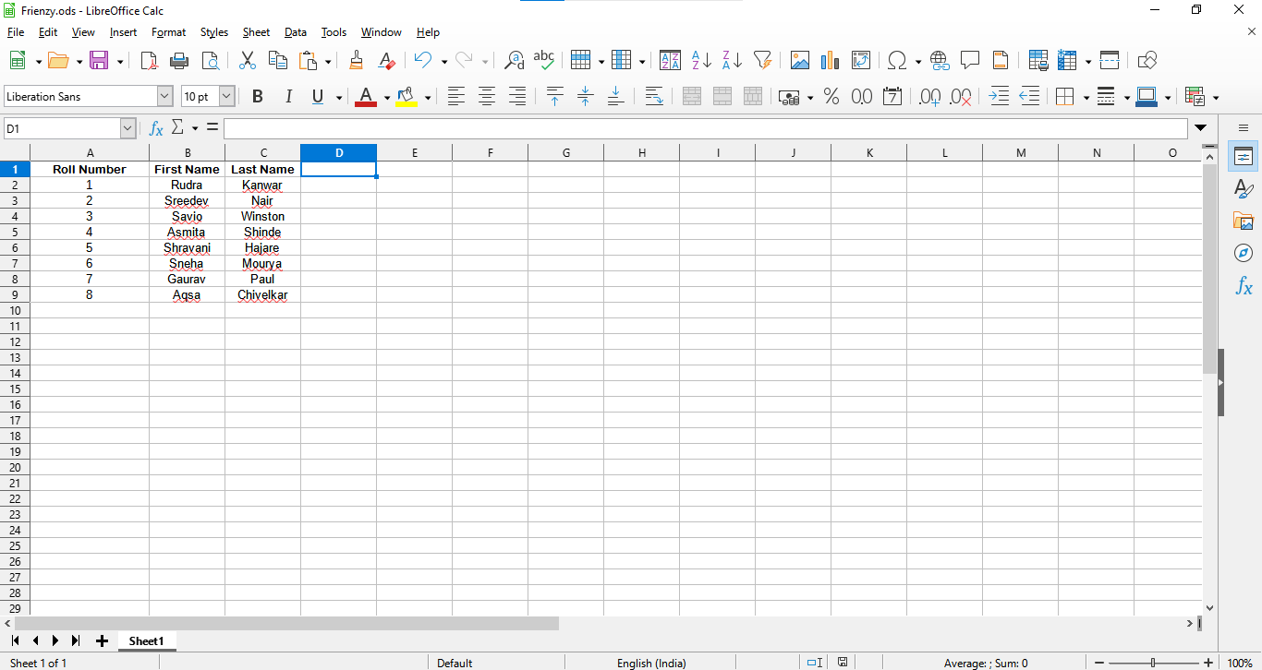

1. LibreOffice Impress Presentation

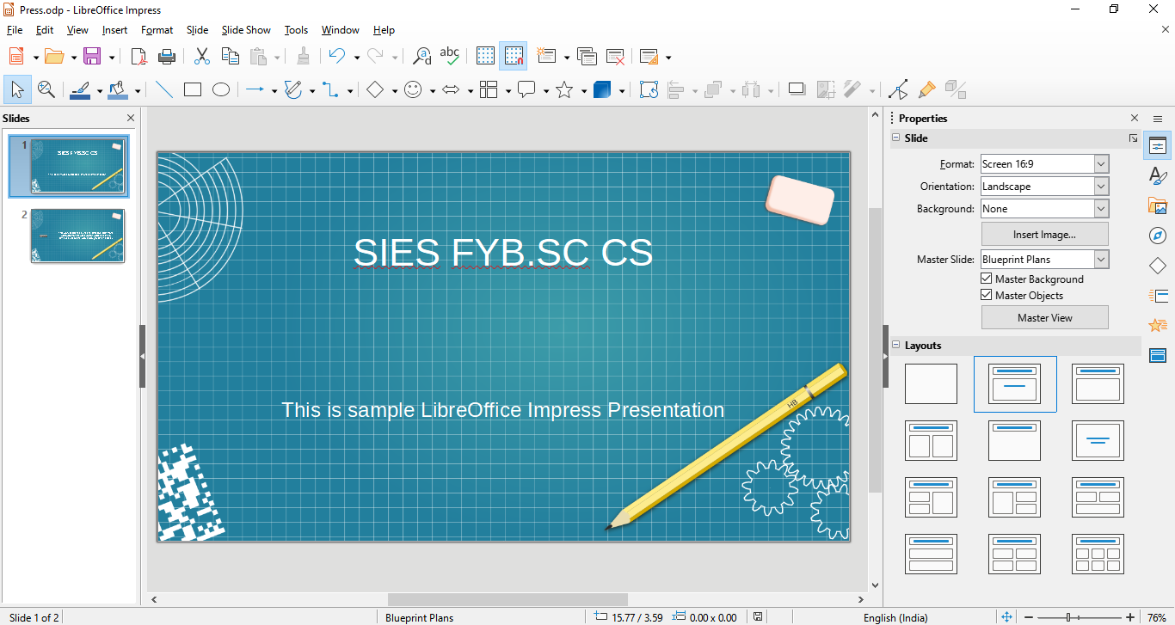

1. LibreOffice Draw Tools

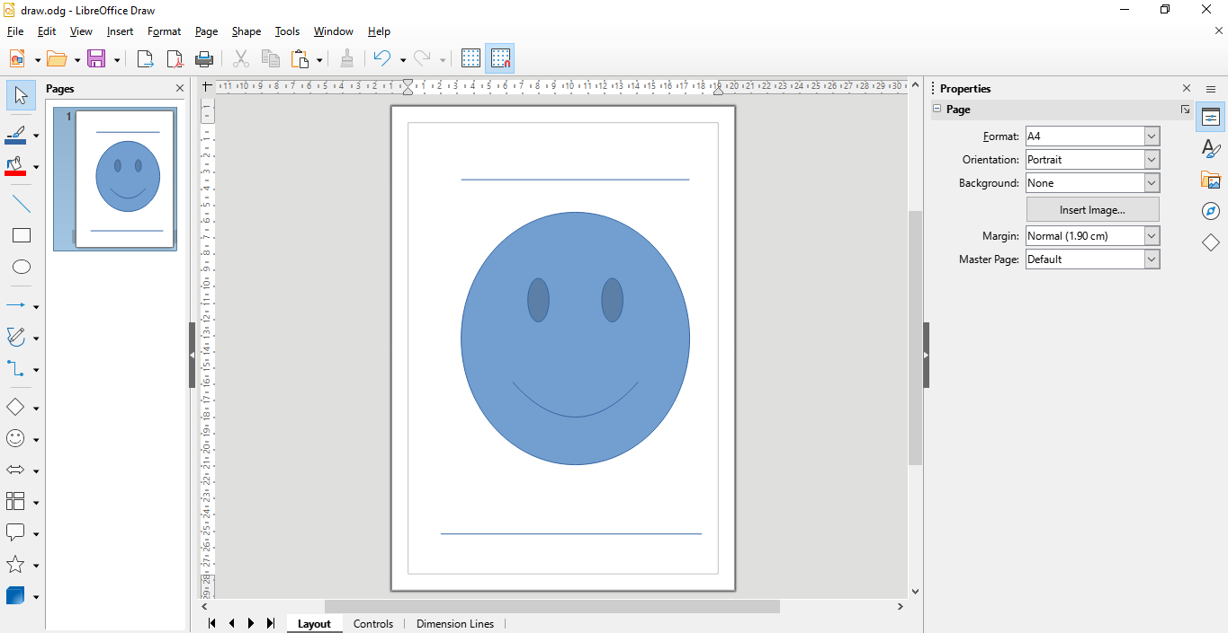

1. LibreOffice Math Tools

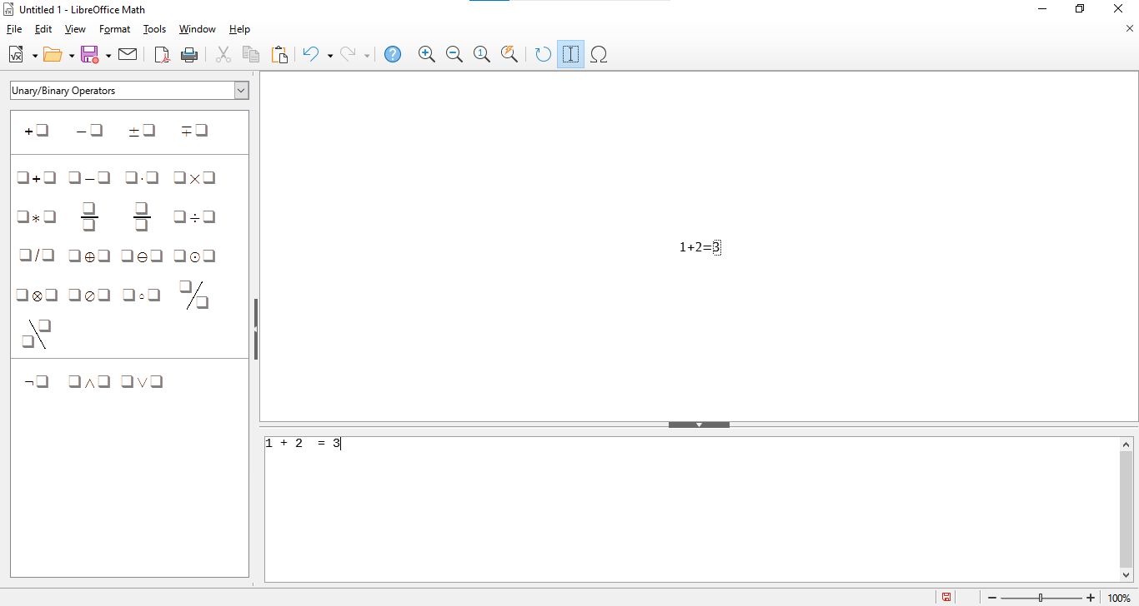

**O.S.T Practical 3**

GIMP

Steps To install Gimp:-

1. Open Setup and Click **‘Install For All Users’ .**

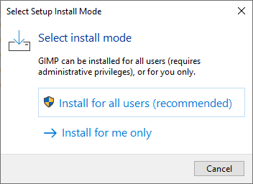

1. Select Language .(Default English)

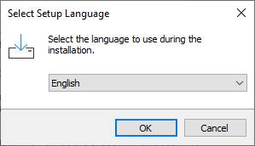

1. Among Other Three options select and click on **“Install”** .

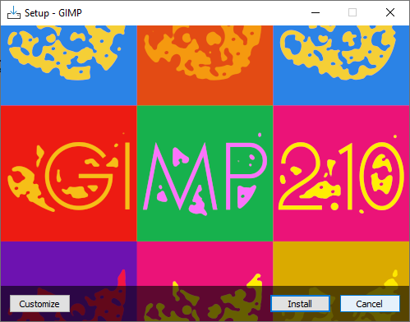

FOR EG.

