**CS312 - Artificial Intelligence Lab**

**Assignment 3**

Group 10

Rudraksh (190030038), Sumedhsingh (190030042)

Likhilesh (190030024)

**Introduction**

In this task, Heuristic Search Algorithms had to be implemented. Uniform Random-4-SAT is a family of SAT problems distributions obtained by randomly generating 3-CNF formulae in the following way: For an instance with n = 4 variables and k = 5 clauses, each of the k clauses is constructed from 3 literals which are randomly drawn from the 2n possible literals (the n variables and their negations) such that each possible literal is selected with the same probability of 1/2n. Clauses are not accepted for the construction of the problem instance if they contain multiple copies of the same literal or if they are tautological (i.e., they contain a variable and its negation as a literal). Each choice of n and k thus induces a distribution of Random-4-SAT instances. Uniform Random-4-SAT is the union of these distributions over all n and k.

**1 Description of Domain**

**1.1 State Space:** A state space is the set of all possible configurations of a system. In this case we have a state representation by string of size 4 representing 4 literals. And each literal takes two values 0 or 1. In case of Tabu Search, the state representation is modified a bit and one more list to store Tabu Tenure values is added to state as below

**1.2 Start State & Goal State**

We are starting with all literal values 0 and it is allowed to change any literal in the next move. And Goal state implies if we get all the clauses value to 1.

**1.3 Pseudo Codes**

The section below has pseudo codes of a few important functions.

**1.3.1 moveGen(state)**

This function generates and returns the states that can be reached from a given state in one step. Note that at most 6 new neighbours are possible for a given state.

Algorithm 1 moveGen(state)

moveGen(state,k)

neighboursList

if(k==1):

neighboursList <=get all states by changing one one bit

else if(k==2):

neighboursList <=get all states by changing one two bits

else if(k==3):

neighboursList <=get all states by changing one three bits

else if(k==4):

neighboursList <=get all states by changing one four bits

return neighboursList

**1.3.2 goalTest(state, goalState)**

This function returns true if the given state is goal state otherwise returns false.

Algorithm 2 goalTest(state, goalState)

goalTest(state)

if [a, b, c, d] satisfies CNF then

return true

return false

**1.3.3 Beam Search**

Beam search is extension of Best first Search based on Heuristic Algorithm. The only difference is now we take multiple best nodes based on beam width instead on one best node and carry on the same way.

Algorithm 3 Beam Search

Data: Graph (G), start node (s), goal node (g), beam width (B)

Result: Path with lowest cost

Function beamSearch(G,s,g,B)

open Lists <- s

closed List <- empty list

path <- empty list

while open list is not empty do

b <- best node from open List

openList.remove(b)

closedList.add(b)

if b is g then

path.add(b)

return path

end

N <- neighbors(b)

for n in N do

if n is in neither closedList nor openList then

open List.add(n)

else if n is in open List then

if path with current parent <= path with old parent

then

Replace parents of n

end

else if n is not in closed List then

openList.add(n)

end

end

if number of nodes in open List > B then

openList <- best B nodes in open List

end

end

return path

end

**1.3.4 Variable Neighbourhood Descent**

The variable neighbourhood descent (VND) method is obtained if a change of neighbourhoods is performed in a deterministic way. Where neighbourhoods are denoted as Nk, k= 1 ... kmax.

Algorithm 4 Variable Neighbourhood Descent

input : starting solution,s0

input : neighborhood operators ,{Nk},k=1,..,kmax

input : evaluation function ,f

k <= 1

while k<=kmax do

s <= the best neighbor in Nk (current)

if f(s) < f(currrent) then

current <=s

k<=1

else

k<= k+1

end if

end while

**1.3.5 Tabu Search**

We have used tabu search as shown below.

Algorithm 5 Tabu Search

Sbest = S0 /Construct Initial Solution/

bestCandidate = Sbest

TabuList <- [] /Initialize TabuList/

while (NOT StoppingCondition ()) do

Generate candidate solutions in the neighborhood of Sbest

set Scandidate as the first candidate in the Sbest Neighborhood

for (Scandidate in Sbest Neighborhood) do

if (Scandidate NOT in TabuList AND fitness(SCandidate) > fitness(bestCandidate)) then

best Candidate <- Scandidate

end if

end for

if (fitness(bestCandidate) > fitness(Sbest)) then

Sbest <- bestCandidate

end if

Update TabuList (push the best Candidate)

if (tabutenure is over for candidate)

Remove the candidate from the Tabu List

end if

end while

return Sbest

**2 Heuristic Function**

Our Heuristic value ranges from 0 to 5, based on logic mentioned below.

Algorithm 3 Heuristic function

if(clauseSatisfied()){

value++;

} else continue;

return value;

**3 Beam Search Analysis**

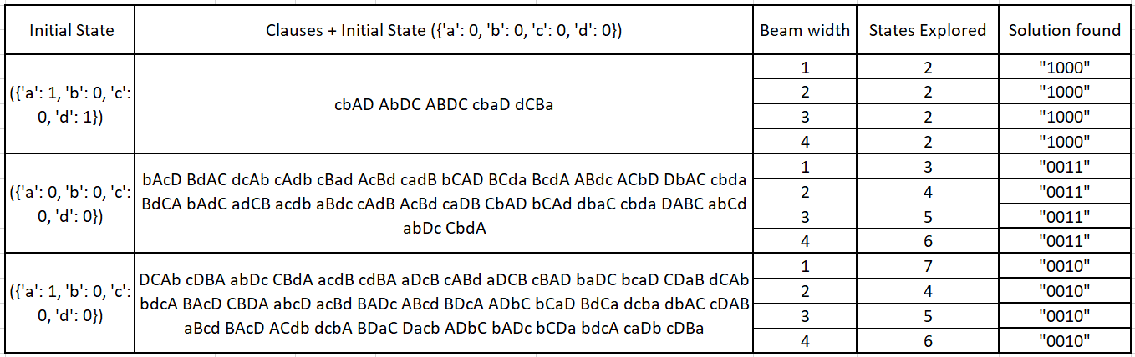

**4 Tabu Search Analysis**

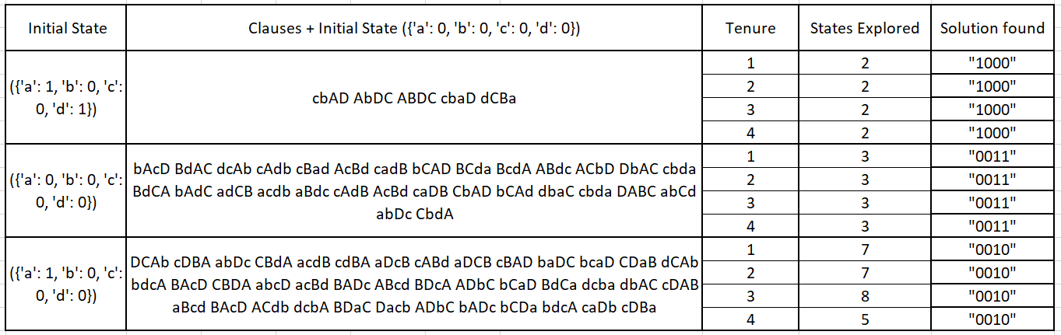

**5 Comparison of above searches**

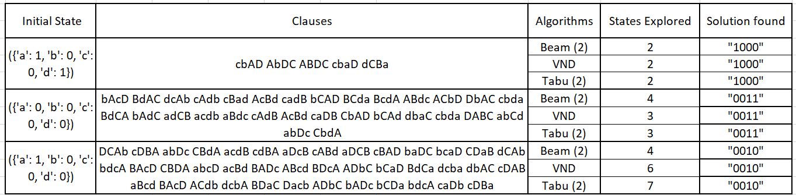

**6 Overall Observations and Conclusions**

1. For above comparison we have considered beam width = 2 and tabu tenure = 2.
2. Beam Search is same as hill climbing but better, as chances of getting to the solution is more.
3. VND is better than tabu in term of state explored because tabu barred some state which might be possible solution.